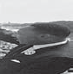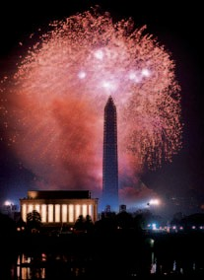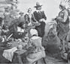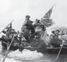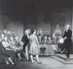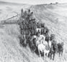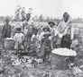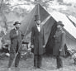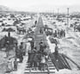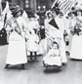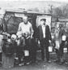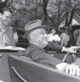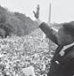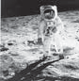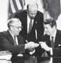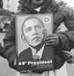

**OUTLINE OF**

**U.S.**

**History**

Early Settlement

Colonial Period Road to Independence Forming a Government Westward Expansion

Sectional Conflict Civil War Economic Growth

Discontent and Reform War, Prosperity, and Depression The New Deal and World War II

Postwar Prosperity

Civil Rights and Social Change A New World Order

Bridge to the 21st Century 2008 Presidential Election

**U.S. HISTORY**

**OUTLIN E O F**

Bureau of International Information Programs

U.S. Department of State

2011

**U.S. HISTORY**

**OUTLIN E O F**

C O N T E N T S

**CHAPTER** 1 **Early America 4**

**CHAPTER** 2 **The Colonial Period 22**

**CHAPTER** 3 **The Road to Independence 50**

**CHAPTER** 4 **The Formation of a National Government 66**

**CHAPTER** 5 **Westward Expansion and Regional Differences 110**

**CHAPTER** 6 **Sectional Conflict 128**

**CHAPTER** 7 **The Civil War and Reconstruction 140**

**CHAPTER** 8 **Growth and Transformation 154**

**CHAPTER** 9 **Discontent and Reform 188**

**CHAPTER** 10 **War, Prosperity, and Depression 202**

**CHAPTER** 11 **The New Deal and World War II 212**

**CHAPTER** 12 **Postwar America 256**

**CHAPTER** 13 **Decades of Change: 1960-1980 274**

**CHAPTER** 14 **The New Conservatism and a New World Order 304**

**CHAPTER** 15 **Bridge to the 21st Century 320**

**CHAPTER** 16 **Politics of Hope 340**

**PICTURE PROFILES**

**Becoming a Nation 38**

**Transforming a Nation 89**

**Monuments and Memorials 161**

**Turmoil and Change 229**

**21st Century Nation 293**

**Bibliography 346**

**Index 349**

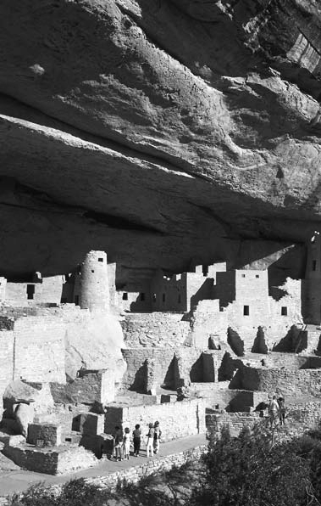

4

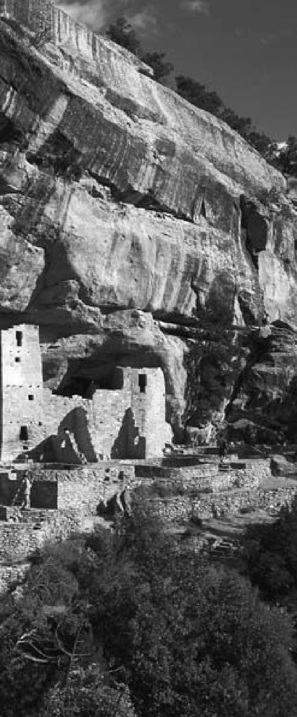

**C H A P T E R**

1

## EARLY AMERICA

Mesa Verde settlement in Colorado, 13th century.

“Heaven and Earth never agreed better to frame a place for man’s habitation.”

Jamestown founder John Smith, 1607

**THE FIRST AMERICANS**

# A

ancestors had for thousands of years, along the Siberian coast and then

t the height of the Ice Age, be- tween 34,000 and 30,000 B.C., much of the world’s water was locked up in vast continental ice sheets. As a result, the Bering Sea was hundreds of meters below its current level, and a land bridge, known as Beringia, emerged between Asia and North America. At its peak, Beringia is thought to have been some 1,500 ki- lometers wide. A moist and treeless tundra, it was covered with grasses and plant life, attracting the large animals that early humans hunted for their survival.

The first people to reach North America almost certainly did so without knowing they had crossed into a new continent. They would have been following game, as their

across the land bridge.

Once in Alaska, it would take these first North Americans thou- sands of years more to work their way through the openings in great glaciers south to what is now the United States. Evidence of early life in North America continues to be found. Little of it, however, can be reliably dated before 12,000 B.C.; a recent discovery of a hunting look- out in northern Alaska, for exam- ple, may date from almost that time. So too may the finely crafted spear points and items found near Clovis, New Mexico.

Similar artifacts have been found at sites throughout North and South America, indicating that life was probably already well established in

much of the Western Hemisphere by some time prior to 10,000 B.C.

Around that time the mammoth began to die out and the bison took its place as a principal source of food and hides for these early North Americans. Over time, as more and more species of large game van- ished — whether from overhunting or natural causes — plants, berries, and seeds became an increasingly important part of the early Ameri- can diet. Gradually, foraging and the first attempts at primitive agri- culture appeared. Native Americans in what is now central Mexico led the way, cultivating corn, squash, and beans, perhaps as early as 8,000

B.C. Slowly, this knowledge spread northward.

By 3,000 B.C., a primitive type of corn was being grown in the river valleys of New Mexico and Arizo- na. Then the first signs of irrigation began to appear, and, by 300 B.C., signs of early village life.

By the first centuries A.D., the Hohokam were living in settlements near what is now Phoenix, Arizo- na, where they built ball courts and pyramid-like mounds reminiscent of those found in Mexico, as well as a canal and irrigation system.

#### MOUND BUILDERS AND PUEBLOS

**T**he first Native-American group to build mounds in what is now the United States often are called the

Adenans. They began construct-

ing earthen burial sites and forti- fications around 600 B.C. Some mounds from that era are in the shape of birds or serpents; they probably served religious purposes not yet fully understood.

The Adenans appear to have been absorbed or displaced by vari- ous groups collectively known as Hopewellians. One of the most im- portant centers of their culture was found in southern Ohio, where the remains of several thousand of these mounds still can be seen. Believed to be great traders, the Hopewel- lians used and exchanged tools and materials across a wide region of hundreds of kilometers.

By around 500 A.D., the Hopewellians disappeared, too, gradually giving way to a broad group of tribes generally known as the Mississippians or Temple Mound culture. One city, Ca- hokia, near Collinsville, Illinois, is thought to have had a population of about 20,000 at its peak in the early 12th century. At the center of the city stood a huge earthen mound, flattened at the top, that was 30 meters high and 37 hectares at the base. Eighty other mounds have been found nearby.

Cities such as Cahokia depend- ed on a combination of hunting, foraging, trading, and agriculture for their food and supplies. Influ- enced by the thriving societies to the south, they evolved into complex hi- erarchical societies that took slaves and practiced human sacrifice.

In what is now the southwest United States, the Anasazi, ancestors of the modern Hopi Indians, began building stone and adobe pueblos around the year 900. These unique and amazing apartment-like struc- tures were often built along cliff faces; the most famous, the “cliff palace” of Mesa Verde, Colorado, had more than 200 rooms. Another site, the Pueblo Bonito ruins along New Mexico’s Chaco River, once contained more than 800 rooms.

Perhaps the most affluent of the pre-Columbian Native Americans lived in the Pacific Northwest, where the natural abundance of fish and raw materials made food supplies plentiful and permanent villages pos- sible as early as 1,000 B.C. The opu- lence of their “potlatch” gatherings remains a standard for extravagance and festivity probably unmatched in early American history.

#### NATIVE-AMERICAN CULTURES

**T**he America that greeted the first Europeans was, thus, far from an empty wilderness. It is now thought

that as many people lived in the Western Hemisphere as in West- ern Europe at that time — about 40 million. Estimates of the number of Native Americans living in what is now the United States at the onset of European colonization range from two to 18 million, with most histori- ans tending toward the lower figure. What is certain is the devastating ef- fect that European disease had on

the indigenous population practi- cally from the time of initial con- tact. Smallpox, in particular, ravaged whole communities and is thought to have been a much more direct cause of the precipitous decline in the Indian population in the 1600s than the numerous wars and skir- mishes with European settlers.

Indian customs and culture at the time were extraordinarily diverse, as could be expected, given the ex- panse of the land and the many dif- ferent environments to which they had adapted. Some generalizations, however, are possible. Most tribes, particularly in the wooded eastern region and the Midwest, combined aspects of hunting, gathering, and the cultivation of maize and other products for their food supplies. In many cases, the women were responsible for farming and the distribution of food, while the men hunted and participated in war.

By all accounts, Native-American society in North America was closely tied to the land. Identification with nature and the elements was integral to religious beliefs. Their life was essentially clan-oriented and com- munal, with children allowed more freedom and tolerance than was the European custom of the day.

Although some North Ameri- can tribes developed a type of hi- eroglyphics to preserve certain texts, Native-American culture was primarily oral, with a high value placed on the recounting of tales and dreams. Clearly, there was a good deal of trade among various

groups and strong evidence exists that neighboring tribes maintained extensive and formal relations — both friendly and hostile.

#### THE FIRST EUROPEANS

**T**he first Europeans to arrive in North America — at least the first for whom there is solid evidence

— were Norse, traveling west from Greenland, where Erik the Red had founded a settlement around the year 985. In 1001 his son Leif is thought to have explored the north- east coast of what is now Canada and spent at least one winter there.

While Norse sagas suggest that Viking sailors explored the Atlan- tic coast of North America down as far as the Bahamas, such claims remain unproven. In 1963, however, the ruins of some Norse houses dat- ing from that era were discovered at L’Anse-aux-Meadows in northern Newfoundland, thus supporting at least some of the saga claims.

In 1497, just five years after Christopher Columbus landed in the Caribbean looking for a west- ern route to Asia, a Venetian sail- or named John Cabot arrived in Newfoundland on a mission for the British king. Although quickly forgotten, Cabot’s journey was later to provide the basis for British claims to North America. It also opened the way to the rich fishing grounds off George’s Banks, to which Eu- ropean fishermen, particularly the Portuguese, were soon making reg- ular visits.

Columbus never saw the main- land of the future United States, but the first explorations of it were launched from the Spanish posses- sions that he helped establish. The first of these took place in 1513 when a group of men under Juan Ponce de León landed on the Florida coast near the present city of St. Augustine.

With the conquest of Mexico in 1522, the Spanish further solidi- fied their position in the Western Hemisphere. The ensuing discov- eries added to Europe’s knowledge of what was now named America

— after the Italian Amerigo Ves- pucci, who wrote a widely popular account of his voyages to a “New World.” By 1529 reliable maps of the Atlantic coastline from Labrador to Tierra del Fuego had been drawn up, although it would take more than another century before hope of dis- covering a “Northwest Passage” to Asia would be completely abandoned. Among the most significant ear-

ly Spanish explorations was that of Hernando De Soto, a veteran con- quistador who had accompanied Francisco Pizarro in the conquest of Peru. Leaving Havana in 1539, De Soto’s expedition landed in Florida and ranged through the southeast- ern United States as far as the Missis- sippi River in search of riches.

Another Spaniard, Francis- co Vázquez de Coronado, set out from Mexico in 1540 in search of the mythical Seven Cities of Cibo- la. Coronado’s travels took him to the Grand Canyon and Kansas, but

failed to reveal the gold or treasure his men sought. However, his par- ty did leave the peoples of the re- gion a remarkable, if unintended, gift: Enough of his horses escaped to transform life on the Great Plains. Within a few generations, the Plains Indians had become masters of horsemanship, greatly expanding the range of their activities.

While the Spanish were pushing up from the south, the northern por- tion of the present-day United States was slowly being revealed through the journeys of men such as Giovan- ni da Verrazano. A Florentine who sailed for the French, Verrazano made landfall in North Carolina in 1524, then sailed north along the At- lantic Coast past what is now New York harbor.

A decade later, the Frenchman Jacques Cartier set sail with the hope

— like the other Europeans before him — of finding a sea passage to Asia. Cartier’s expeditions along the St. Lawrence River laid the founda- tion for the French claims to North America, which were to last until 1763.

Following the collapse of their first Quebec colony in the 1540s, French Huguenots attempted to set- tle the northern coast of Florida two decades later. The Spanish, viewing the French as a threat to their trade route along the Gulf Stream, de- stroyed the colony in 1565. Ironical- ly, the leader of the Spanish forces, Pedro Menéndez, would soon estab- lish a town not far away — St. Au- gustine. It was the first permanent

European settlement in what would become the United States.

The great wealth that poured into Spain from the colonies in Mexico, the Caribbean, and Peru provoked great interest on the part of the other European powers. Emerging mari- time nations such as England, drawn in part by Francis Drake’s success- ful raids on Spanish treasure ships, began to take an interest in the New World.

In 1578 Humphrey Gilbert, the author of a treatise on the search for the Northwest Passage, received a patent from Queen Elizabeth to colonize the “heathen and barba- rous landes” in the New World that other European nations had not yet claimed. It would be five years before his efforts could begin. When he was lost at sea, his half-brother, Walter Raleigh, took up the mission.

In 1585 Raleigh established the first British colony in North Amer- ica, on Roanoke Island off the coast of North Carolina. It was later aban- doned, and a second effort two years later also proved a failure. It would be 20 years before the British would try again. This time — at Jamestown in 1607 — the colony would succeed, and North America would enter a new era.

#### EARLY SETTLEMENTS

**T**he early 1600s saw the begin- ning of a great tide of emigration from Europe to North America.

Spanning more than three centuries, this movement grew from a trickle

of a few hundred English colonists to a flood of millions of newcomers. Impelled by powerful and diverse motivations, they built a new civi- lization on the northern part of the continent.

The first English immigrants to what is now the United States crossed the Atlantic long after thriv- ing Spanish colonies had been estab- lished in Mexico, the West Indies, and South America. Like all early travelers to the New World, they came in small, overcrowded ships. During their six- to 12-week voy- ages, they lived on meager rations. Many died of disease, ships were often battered by storms, and some were lost at sea.

Most European emigrants left their homelands to escape political oppression, to seek the freedom to practice their religion, or to find op- portunities denied them at home. Between 1620 and 1635, economic difficulties swept England. Many people could not find work. Even skilled artisans could earn little more than a bare living. Poor crop yields added to the distress. In ad- dition, the Commercial Revolution had created a burgeoning textile industry, which demanded an ever- increasing supply of wool to keep the looms running. Landlords en- closed farmlands and evicted the peasants in favor of sheep cultiva- tion. Colonial expansion became an outlet for this displaced peasant population.

The colonists’ first glimpse of the new land was a vista of dense

woods. The settlers might not have survived had it not been for the help of friendly Indians, who taught them how to grow native plants — pumpkin, squash, beans, and corn. In addition, the vast, virgin forests, extending nearly 2,100 kilometers along the Eastern seaboard, proved a rich source of game and firewood. They also provided abundant raw materials used to build houses, fur- niture, ships, and profitable items for export.

Although the new continent was remarkably endowed by nature, trade with Europe was vital for ar- ticles the settlers could not produce. The coast served the immigrants well. The whole length of shore pro- vided many inlets and harbors. Only two areas — North Carolina and southern New Jersey — lacked har- bors for ocean-going vessels.

Majestic rivers — the Kennebec, Hudson, Delaware, Susquehanna, Potomac, and numerous others — linked lands between the coast and the Appalachian Mountains with the sea. Only one river, however, the St. Lawrence — dominated by the French in Canada — offered a water passage to the Great Lakes and the heart of the continent. Dense forests, the resistance of some Indian tribes, and the formidable barrier of the Appalachian Mountains discour- aged settlement beyond the coastal plain. Only trappers and traders ventured into the wilderness. For the first hundred years the colonists built their settlements compactly along the coast.

Political considerations influ- enced many people to move to America. In the 1630s, arbitrary rule by England’s Charles I gave impetus to the migration. The subsequent re- volt and triumph of Charles’ oppo- nents under Oliver Cromwell in the 1640s led many cavaliers — “king’s men” — to cast their lot in Virginia. In the German-speaking regions of Europe, the oppressive policies of various petty princes — particularly with regard to religion — and the devastation caused by a long series of wars helped swell the movement to America in the late 17th and 18th centuries.

The journey entailed careful planning and management, as well as considerable expense and risk. Settlers had to be transported nearly 5,000 kilometers across the sea. They needed utensils, clothing, seed, tools, building materials, livestock, arms, and ammunition. In contrast to the colonization policies of other coun- tries and other periods, the emigra- tion from England was not directly sponsored by the government but by private groups of individuals whose chief motive was profit.

#### JAMESTOWN

**T**he first of the British colonies to take hold in North America was Jamestown. On the basis of a char-

ter which King James I granted to the Virginia (or London) Company, a group of about 100 men set out for the Chesapeake Bay in 1607. Seeking to avoid conflict with the Spanish,

they chose a site about 60 kilometers up the James River from the bay.

Made up of townsmen and ad- venturers more interested in finding gold than farming, the group was unequipped by temperament or abil- ity to embark upon a completely new life in the wilderness. Among them, Captain John Smith emerged as the dominant figure. Despite quarrels, starvation, and Native-American attacks, his ability to enforce disci- pline held the little colony together through its first year.

In 1609 Smith returned to Eng- land, and in his absence, the colony descended into anarchy. During the winter of 1609-1610, the majority of the colonists succumbed to disease. Only 60 of the original 300 settlers were still alive by May 1610. That same year, the town of Henrico (now Richmond) was established farther up the James River.

It was not long, however, before a development occurred that revo- lutionized Virginia’s economy. In 1612 John Rolfe began cross-breed- ing imported tobacco seed from the West Indies with native plants and produced a new variety that was pleasing to European taste. The first shipment of this tobacco reached London in 1614. Within a decade it had become Virginia’s chief source of revenue.

Prosperity did not come quickly, however, and the death rate from disease and Indian attacks remained extraordinarily high. Between 1607 and 1624 approximately 14,000 peo- ple migrated to the colony, yet only

1,132 were living there in 1624. On recommendation of a royal commis- sion, the king dissolved the Virginia Company, and made it a royal colony that year.

#### MASSACHUSETTS

**D**uring the religious upheavals of the 16th century, a body of men and women called Puritans sought

to reform the Established Church of England from within. Essentially, they demanded that the rituals and structures associated with Roman Catholicism be replaced by simpler Calvinist Protestant forms of faith and worship. Their reformist ideas, by destroying the unity of the state church, threatened to divide the people and to undermine royal authority.

In 1607 a small group of Sepa- ratists — a radical sect of Puritans who did not believe the Established Church could ever be reformed — departed for Leyden, Holland, where the Dutch granted them asylum. However, the Calvinist Dutch re- stricted them mainly to low-paid la- boring jobs. Some members of the congregation grew dissatisfied with this discrimination and resolved to emigrate to the New World.

In 1620, a group of Leyden Puri- tans secured a land patent from the Virginia Company. Numbering 101, they set out for Virginia on the *May- flower*. A storm sent them far north and they landed in New England on Cape Cod. Believing themselves outside the jurisdiction of any orga-

nized government, the men drafted a formal agreement to abide by “just and equal laws” drafted by leaders of their own choosing. This was the Mayflower Compact.

In December the *Mayflower* reached Plymouth harbor; the Pil- grims began to build their settle- ment during the winter. Nearly half the colonists died of exposure and disease, but neighboring Wampa- noag Indians provided the informa- tion that would sustain them: how to grow maize. By the next fall, the Pilgrims had a plentiful crop of corn, and a growing trade based on furs and lumber.

A new wave of immigrants ar- rived on the shores of Massachusetts Bay in 1630 bearing a grant from King Charles I to establish a colony. Many of them were Puritans whose religious practices were increasingly prohibited in England. Their leader, John Winthrop, urged them to cre- ate a “city upon a hill” in the New World — a place where they would live in strict accordance with their religious beliefs and set an example for all of Christendom.

The Massachusetts Bay Colony was to play a significant role in the development of the entire New Eng- land region, in part because Win- throp and his Puritan colleagues were able to bring their charter with them. Thus the authority for the col- ony’s government resided in Massa- chusetts, not in England.

Under the charter’s provisions, power rested with the General Court, which was made up of “free-

men” required to be members of the Puritan, or Congregational, Church. This guaranteed that the Puritans would be the dominant political as well as religious force in the colony. The General Court elected the gov- ernor, who for most of the next gen- eration would be John Winthrop.

The rigid orthodoxy of the Pu- ritan rule was not to everyone’s lik- ing. One of the first to challenge the General Court openly was a young clergyman named Roger Williams, who objected to the colony’s seizure of Indian lands and advocated sepa- ration of church and state. Another dissenter, Anne Hutchinson, chal- lenged key doctrines of Puritan the- ology. Both they and their followers were banished.

Williams purchased land from the Narragansett Indians in what is now Providence, Rhode Island, in 1636. In 1644, a sympathetic Puri- tan-controlled English Parliament gave him the charter that established Rhode Island as a distinct colony where complete separation of church and state as well as freedom of reli- gion was practiced.

So-called heretics like Williams were not the only ones who left Mas- sachusetts. Orthodox Puritans, seek- ing better lands and opportunities, soon began leaving Massachusetts Bay Colony. News of the fertility of the Connecticut River Valley, for in- stance, attracted the interest of farm- ers having a difficult time with poor land. By the early 1630s, many were ready to brave the danger of Indian attack to obtain level ground and

deep, rich soil. These new commu- nities often eliminated church mem- bership as a prerequisite for voting, thereby extending the franchise to ever larger numbers of men.

At the same time, other settle- ments began cropping up along the New Hampshire and Maine coasts, as more and more immigrants sought the land and liberty the New World seemed to offer.

#### NEW NETHERLAND AND MARYLAND

**H**ired by the Dutch East India Company, Henry Hudson in 1609 explored the area around what is

now New York City and the river that bears his name, to a point prob- ably north of present-day Albany, New York. Subsequent Dutch voy- ages laid the basis for their claims and early settlements in the area.

As with the French to the north, the first interest of the Dutch was the fur trade. To this end, they cultivated close relations with the Five Nations of the Iroquois, who were the key to the heartland from which the furs came. In 1617 Dutch settlers built a fort at the junction of the Hudson and the Mohawk Rivers, where Al- bany now stands.

Settlement on the island of Man- hattan began in the early 1620s. In 1624, the island was purchased from local Native Americans for the re- ported price of $24. It was promptly renamed New Amsterdam.

In order to attract settlers to the Hudson River region, the Dutch en-

couraged a type of feudal aristocra- cy, known as the “patroon” system. The first of these huge estates were established in 1630 along the Hud- son River. Under the patroon sys- tem, any stockholder, or patroon, who could bring 50 adults to his es- tate over a four-year period was giv- en a 25-kilometer river-front plot, exclusive fishing and hunting privi- leges, and civil and criminal juris- diction over his lands. In turn, he provided livestock, tools, and build- ings. The tenants paid the patroon rent and gave him first option on surplus crops.

Further to the south, a Swedish trading company with ties to the Dutch attempted to set up its first settlement along the Delaware Riv- er three years later. Without the re- sources to consolidate its position, New Sweden was gradually absorbed into New Netherland, and later, Pennsylvania and Delaware.

In 1632 the Catholic Calvert fam- ily obtained a charter for land north of the Potomac River from King Charles I in what became known as Maryland. As the charter did not ex- pressly prohibit the establishment of non-Protestant churches, the colony became a haven for Catholics. Mary- land’s first town, St. Mary’s, was established in 1634 near where the Potomac River flows into the Chesa- peake Bay.

While establishing a refuge for Catholics, who faced increasing per- secution in Anglican England, the Calverts were also interested in cre- ating profitable estates. To this end,

and to avoid trouble with the British government, they also encouraged Protestant immigration.

Maryland’s royal charter had a mixture of feudal and modern elements. On the one hand the Calvert family had the power to create manorial estates. On the oth- er, they could only make laws with the consent of freemen (property holders). They found that in order to attract settlers — and make a profit from their holdings — they had to offer people farms, not just tenancy on manorial estates. The number of independent farms grew in consequence. Their owners de- manded a voice in the affairs of the colony. Maryland’s first legislature met in 1635.

#### COLONIAL-INDIAN RELATIONS

**B**y 1640 the British had solid colonies established along the New England coast and the Chesapeake

Bay. In between were the Dutch and the tiny Swedish community. To the west were the original Americans, then called Indians.

Sometimes friendly, sometimes hostile, the Eastern tribes were no longer strangers to the Europeans. Although Native Americans ben- efited from access to new technol- ogy and trade, the disease and thirst for land that the early settlers also brought posed a serious challenge to their long-established way of life.

At first, trade with the European settlers brought advantages: knives,

axes, weapons, cooking utensils, fishhooks, and a host of other goods. Those Indians who traded initial- ly had significant advantage over rivals who did not. In response to European demand, tribes such as the Iroquois began to devote more at- tention to fur trapping during the 17th century. Furs and pelts pro- vided tribes the means to purchase colonial goods until late into the 18th century.

Early colonial-Native-American relations were an uneasy mix of co- operation and conflict. On the one hand, there were the exemplary rela- tions that prevailed during the first half century of Pennsylvania’s exis- tence. On the other were a long series of setbacks, skirmishes, and wars, which almost invariably resulted in an Indian defeat and further loss of land.

The first of the important Native- American uprisings occurred in Vir- ginia in 1622, when some 347 whites were killed, including a number of missionaries who had just recently come to Jamestown.

White settlement of the Con- necticut River region touched off the Pequot War in 1637. In 1675 King Philip, the son of the native chief who had made the original peace with the Pilgrims in 1621, attempted to unite the tribes of southern New England against further Europe- an encroachment of their lands. In the struggle, however, Philip lost his life and many Indians were sold into servitude.

The steady influx of settlers into the backwoods regions of the Eastern colonies disrupted Native-American life. As more and more game was killed off, tribes were faced with the difficult choice of going hungry, go- ing to war, or moving and coming into conflict with other tribes to the west.

The Iroquois, who inhabited the area below lakes Ontario and Erie in northern New York and Pennsyl- vania, were more successful in re- sisting European advances. In 1570 five tribes joined to form the most complex Native-American nation of its time, the “Ho-De-No-Sau- Nee,” or League of the Iroquois. The league was run by a council made up of 50 representatives from each of the five member tribes. The council dealt with matters common to all the tribes, but it had no say in how the free and equal tribes ran their day- to-day affairs. No tribe was allowed to make war by itself. The council passed laws to deal with crimes such as murder.

The Iroquois League was a strong power in the 1600s and 1700s. It traded furs with the British and sided with them against the French in the war for the dominance of America between 1754 and 1763. The British might not have won that war otherwise.

The Iroquois League stayed strong until the American Revolu- tion. Then, for the first time, the council could not reach a unani- mous decision on whom to support. Member tribes made their own de-

cisions, some fighting with the Brit- ish, some with the colonists, some remaining neutral. As a result, ev- eryone fought against the Iroquois. Their losses were great and the league never recovered.

#### SECOND GENERATION OF BRITISH COLONIES

**T**he religious and civil conflict in England in the mid-17th century limited immigration, as well as the

attention the mother country paid the fledgling American colonies.

In part to provide for the defense measures England was neglect- ing, the Massachusetts Bay, Plym- outh, Connecticut, and New Haven colonies formed the New England Confederation in 1643. It was the European colonists’ first attempt at regional unity.

The early history of the British settlers reveals a good deal of con- tention — religious and political — as groups vied for power and posi- tion among themselves and their neighbors. Maryland, in particular, suffered from the bitter religious ri- valries that afflicted England during the era of Oliver Cromwell. One of the casualties was the state’s Tolera- tion Act, which was revoked in the 1650s. It was soon reinstated, howev- er, along with the religious freedom it guaranteed.

With the restoration of King Charles II in 1660, the British once again turned their attention to North America. Within a brief span, the first European settlements were

established in the Carolinas and the Dutch driven out of New Nether- land. New proprietary colonies were established in New York, New Jersey, Delaware, and Pennsylvania.

The Dutch settlements had been ruled by autocratic governors ap- pointed in Europe. Over the years, the local population had become estranged from them. As a result, when the British colonists began en- croaching on Dutch claims in Long Island and Manhattan, the unpopu- lar governor was unable to rally the population to their defense. New Netherland fell in 1664. The terms of the capitulation, however, were mild: The Dutch settlers were able to retain their property and worship as they pleased.

As early as the 1650s, the Albe- marle Sound region off the coast of what is now northern North Caroli- na was inhabited by settlers trickling down from Virginia. The first pro- prietary governor arrived in 1664. The first town in Albemarle, a re- mote area even today, was not estab- lished until the arrival of a group of French Huguenots in 1704.

In 1670 the first settlers, drawn from New England and the Carib- bean island of Barbados, arrived in what is now Charleston, South Carolina. An elaborate system of government, to which the British philosopher John Locke contribut- ed, was prepared for the new colony. One of its prominent features was a failed attempt to create a hereditary nobility. One of the colony’s least ap- pealing aspects was the early trade in

Indian slaves. With time, however, timber, rice, and indigo gave the col- ony a worthier economic base.

In 1681 William Penn, a wealthy Quaker and friend of Charles II, re- ceived a large tract of land west of the Delaware River, which became known as Pennsylvania. To help populate it, Penn actively recruited a host of religious dissenters from England and the continent — Quak- ers, Mennonites, Amish, Moravians, and Baptists.

When Penn arrived the follow- ing year, there were already Dutch, Swedish, and English settlers liv- ing along the Delaware River. It was there he founded Philadelphia, the “City of Brotherly Love.”

In keeping with his faith, Penn was motivated by a sense of equal- ity not often found in other Amer- ican colonies at the time. Thus, women in Pennsylvania had rights long before they did in other parts of America. Penn and his deputies also paid considerable attention to the colony’s relations with the Del- aware Indians, ensuring that they were paid for land on which the Eu- ropeans settled.

Georgia was settled in 1732, the last of the 13 colonies to be established. Lying close to, if not actually inside the boundaries of Spanish Florida, the region was viewed as a buffer against Spanish incursion. But it had another unique quality: The man charged with Georgia’s fortifications, General James Oglethorpe, was a reformer who deliberately set out to create a

refuge where the poor and former prisoners would be given new opportunities.

#### SETTLERS, SLAVES, AND SERVANTS

**M**en and women with little active interest in a new life in America were often induced to make the move to

the New World by the skillful per- suasion of promoters. William Penn, for example, publicized the oppor- tunities awaiting newcomers to the Pennsylvania colony. Judges and prison authorities offered convicts a chance to migrate to colonies like Georgia instead of serving prison sentences.

But few colonists could finance the cost of passage for themselves and their families to make a start in the new land. In some cases, ships’ cap- tains received large rewards from the sale of service contracts for poor mi- grants, called indentured servants, and every method from extravagant promises to actual kidnapping was used to take on as many passengers as their vessels could hold.

In other cases, the expenses of transportation and maintenance were paid by colonizing agencies like the Virginia or Massachusetts Bay Companies. In return, indentured servants agreed to work for the agen- cies as contract laborers, usually for four to seven years. Free at the end of this term, they would be given “free- dom dues,” sometimes including a small tract of land.

Perhaps half the settlers living in the colonies south of New England came to America under this system. Although most of them fulfilled their obligations faithfully, some ran away from their employers. Never- theless, many of them were eventu- ally able to secure land and set up homesteads, either in the colonies in which they had originally settled or in neighboring ones. No social stig- ma was attached to a family that had its beginning in America under this semi-bondage. Every colony had its share of leaders who were former in- dentured servants.

There was one very important exception to this pattern: African slaves. The first black Africans were brought to Virginia in 1619, just 12 years after the founding of James- town. Initially, many were regarded as indentured servants who could earn their freedom. By the 1660s, however, as the demand for planta- tion labor in the Southern colonies grew, the institution of slavery be- gan to harden around them, and Af- ricans were brought to America in shackles for a lifetime of involuntary servitude. 9

CHAPTER 1: EARLY AMERICA

**THE ENDURING MYSTERY OF THE ANASAZI**

**T**ime-worn pueblos and dramatic cliff towns, set amid the stark, rugged me- sas and canyons of Colorado and New Mexico, mark the settlements of some of

the earliest inhabitants of North America, the Anasazi (a Navajo word meaning “ancient ones”).

By 500 A.D. the Anasazi had established some of the first villages in the American Southwest, where they hunted and grew crops of corn, squash, and beans. The Anasazi flourished over the centuries, developing sophisticated dams and irrigation systems; creating a masterful, distinctive pottery tradi-

tion; and carving multiroom dwellings into the sheer sides of cliffs that remain among the most striking archaeological sites in the United States today.

Yet by the year 1300, they had abandoned their settlements, leaving their pottery, implements, even clothing — as though they intended to return — and seemingly vanished into history. Their homeland remained empty of human beings for more than a century — until the arrival of new tribes, such as the Navajo and the Ute, followed by the Spanish and other European settlers.

The story of the Anasazi is tied inextricably to the beautiful but harsh environment in which they chose to live. Early settlements, consisting of simple pithouses scooped out of the ground, evolved into sunken kivas (underground rooms) that served as meeting and religious sites. Later generations developed the masonry techniques for building square, stone pueblos. But the most dra- matic change in Anasazi living was the move to the cliff sides below the flat- topped mesas, where the Anasazi carved their amazing, multilevel dwellings.

The Anasazi lived in a communal society. They traded with other peoples in the region, but signs of warfare are few and isolated. And although the Ana- sazi certainly had religious and other leaders, as well as skilled artisans, social or class distinctions were virtually nonexistent.

Religious and social motives undoubtedly played a part in the building of the cliff communities and their final abandonment. But the struggle to raise food in an increasingly difficult environment was probably the paramount fac- tor. As populations grew, farmers planted larger areas on the mesas, causing some communities to farm marginal lands, while others left the mesa tops for the cliffs. But the Anasazi couldn’t halt the steady loss of the land’s fertility

from constant use, nor withstand the region’s cyclical droughts. Analysis of tree rings, for example, shows that a drought lasting 23 years, from 1276 to 1299, finally forced the last groups of Anasazi to leave permanently.

Although the Anasazi dispersed from their ancestral homeland, their legacy remains in the remarkable archaeological record that they left behind, and in the Hopi, Zuni, and other Pueblo peoples who are their descendants. ◆

20

OUTLINE OF U.S. HISTORY

21

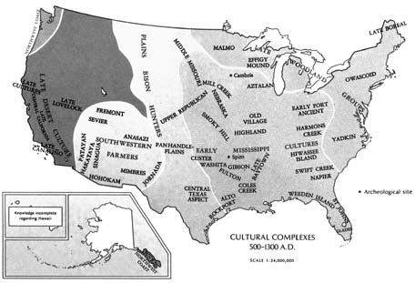

Major Native American cultural groupings, A.D. 500-1300.

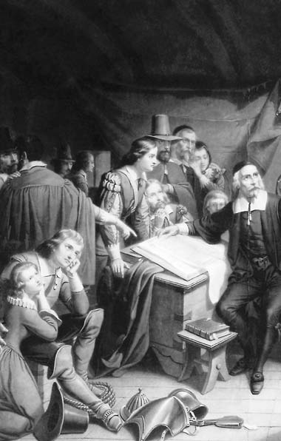

22

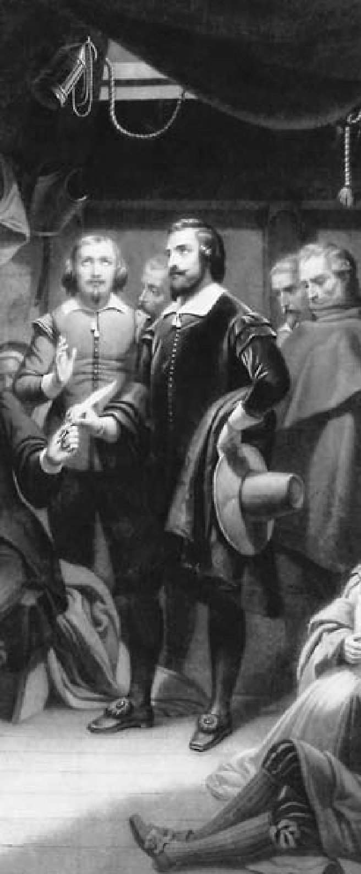

**C H A P T E R**

2

**THE COLONIAL PERIOD**

Pilgrims signing the Mayflower Compact aboard ship, 1620.

“What then is the American, this new man?”

American author and agriculturist

J. Hector St. John de Crèvecoeur, 1782

#### NEW PEOPLES

**M**ost settlers who came to Amer- ica in the 17th century were English, but there were also Dutch, Swedes,

and Germans in the middle region, a few French Huguenots in South Carolina and elsewhere, slaves from Africa, primarily in the South, and a scattering of Spaniards, Italians, and Portuguese throughout the colonies. After 1680 England ceased to be the chief source of immigration, sup- planted by Scots and “Scots-Irish” (Protestants from Northern Ire- land). In addition, tens of thousands of refugees fled northwestern Eu- rope to escape war, oppression, and absentee-landlordism. By 1690 the American population had risen to a quarter of a million. From then on, it doubled every 25 years until, in 1775, it numbered more than 2.5 million. Although families occa- sionally moved from one colony to another, distinctions between indi- vidual colonies were marked. They

were even more so among the three regional groupings of colonies.

#### NEW ENGLAND

**T**he northeastern New England colonies had generally thin, stony soil, relatively little level land, and

long winters, making it difficult to make a living from farming. Turn- ing to other pursuits, the New Eng- landers harnessed waterpower and established grain mills and saw- mills. Good stands of timber en- couraged shipbuilding. Excellent harbors promoted trade, and the sea became a source of great wealth. In Massachusetts, the cod industry alone quickly furnished a basis for prosperity.

With the bulk of the early settlers living in villages and towns around the harbors, many New England- ers carried on some kind of trade or business. Common pastureland and woodlots served the needs of towns- people, who worked small farms

nearby. Compactness made possible the village school, the village church, and the village or town hall, where citizens met to discuss matters of common interest.

The Massachusetts Bay Colony continued to expand its commerce. From the middle of the 17th century onward it grew prosperous, so that Boston became one of America’s greatest ports.

Oak timber for ships’ hulls, tall pines for spars and masts, and pitch for the seams of ships came from the Northeastern forests. Building their own vessels and sailing them to ports all over the world, the shipmasters of Massachusetts Bay laid the foun- dation for a trade that was to grow steadily in importance. By the end of the colonial period, one-third of all vessels under the British flag were built in New England. Fish, ship’s stores, and woodenware swelled the exports. New England merchants and shippers soon discovered that rum and slaves were profitable com- modities. One of their most enter- prising — if unsavory — trading practices of the time was the “trian- gular trade.” Traders would purchase slaves off the coast of Africa for New England rum, then sell the slaves in the West Indies where they would buy molasses to bring home for sale to the local rum producers.

#### THE MIDDLE COLONIES

**S**ociety in the middle colonies was far more varied, cosmopolitan, and tolerant than in New England.

Under William Penn, Pennsylvania functioned smoothly and grew rap- idly. By 1685, its population was al- most 9,000. The heart of the colony was Philadelphia, a city of broad, tree-shaded streets, substantial brick and stone houses, and busy docks. By the end of the colonial period, nearly a century later, 30,000 people lived there, representing many lan- guages, creeds, and trades. Their tal- ent for successful business enterprise made the city one of the thriving centers of the British Empire.

Though the Quakers dominated in Philadelphia, elsewhere in Penn- sylvania others were well represent- ed. Germans became the colony’s most skillful farmers. Important, too, were cottage industries such as weaving, shoemaking, cabinetmak- ing, and other crafts. Pennsylvania was also the principal gateway into the New World for the Scots-Irish, who moved into the colony in the early 18th century. “Bold and indi- gent strangers,” as one Pennsylvania official called them, they hated the English and were suspicious of all government. The Scots-Irish tended to settle in the backcountry, where they cleared land and lived by hunt- ing and subsistence farming.

New York best illustrated the polyglot nature of America. By 1646 the population along the Hudson River included Dutch, French, Danes, Norwegians, Swedes, English, Scots, Irish, Germans, Poles, Bohemians, Portuguese, and Italians. The Dutch continued to exercise an important social and economic influence on

the New York region long after the fall of New Netherland and their in- tegration into the British colonial system. Their sharp-stepped gable roofs became a permanent part of the city’s architecture, and their merchants gave Manhattan much of its original bustling, commercial atmosphere.

#### THE SOUTHERN COLONIES

**I**n contrast to New England and the middle colonies, the Southern colonies were predominantly rural

settlements.

By the late 17th century, Virgin- ia’s and Maryland’s economic and social structure rested on the great planters and the yeoman farmers. The planters of the Tidewater re- gion, supported by slave labor, held most of the political power and the best land. They built great houses, adopted an aristocratic way of life, and kept in touch as best they could with the world of culture overseas.

The yeoman farmers, who worked smaller tracts, sat in popular assem- blies and found their way into political office. Their outspoken independence was a constant warning to the oligar- chy of planters not to encroach too far upon the rights of free men.

The settlers of the Carolinas quickly learned to combine agricul- ture and commerce, and the mar- ketplace became a major source of prosperity. Dense forests brought revenue: Lumber, tar, and resin from the longleaf pine provided some of the best shipbuilding materials in

the world. Not bound to a single crop as was Virginia, North and South Carolina also produced and exported rice and indigo, a blue dye obtained from native plants that was used in coloring fabric. By 1750 more than 100,000 people lived in the two colonies of North and South Caroli- na. Charleston, South Carolina, was the region’s leading port and trading center.

In the southernmost colonies, as everywhere else, population growth in the backcountry had special sig- nificance. German immigrants and Scots-Irish, unwilling to live in the original Tidewater settlements where English influence was strong, pushed inland. Those who could not secure fertile land along the coast, or who had exhausted the lands they held, found the hills farther west a bountiful refuge. Although their hardships were enormous, restless settlers kept coming; by the 1730s they were pouring into the Shenan- doah Valley of Virginia. Soon the in- terior was dotted with farms.

Living on the edge of Native American country, frontier families built cabins, cleared the wilderness, and cultivated maize and wheat. The men wore leather made from the skin of deer or sheep, known as buckskin; the women wore gar- ments of cloth they spun at home. Their food consisted of venison, wild turkey, and fish. They had their own amusements: great barbecues, dances, housewarmings for newly married couples, shooting matches, and contests for making quilted

blankets. Quilt-making remains an American tradition today.

#### SOCIETY, SCHOOLS, AND CULTURE

**A** significant factor deterring the emergence of a powerful aristocratic or gentry class in the colonies was

the ability of anyone in an estab- lished colony to find a new home on the frontier. Time after time, domi- nant Tidewater figures were obliged to liberalize political policies, land- grant requirements, and religious practices by the threat of a mass exo- dus to the frontier.

Of equal significance for the future were the foundations of American education and culture es- tablished during the colonial period. Harvard College was founded in 1636 in Cambridge, Massachusetts. Near the end of the century, the College of William and Mary was established in Virginia. A few years later, the Collegiate School of Connecticut, later to become Yale University, was chartered.

Even more noteworthy was the growth of a school system main- tained by governmental authority. The Puritan emphasis on reading directly from the Scriptures under- scored the importance of literacy. In 1647 the Massachusetts Bay Colony enacted the “ye olde deluder Satan” Act, requiring every town having more than 50 families to establish a grammar school (a Latin school to prepare students for college). Shortly thereafter, all the other New Eng-

land colonies, except for Rhode Is- land, followed its example.

The Pilgrims and Puritans had brought their own little librar- ies and continued to import books from London. And as early as the 1680s, Boston booksellers were do- ing a thriving business in works of classical literature, history, politics, philosophy, science, theology, and belles-lettres. In 1638 the first print- ing press in the English colonies and the second in North America was in- stalled at Harvard College.

The first school in Pennsylvania was begun in 1683. It taught reading, writing, and keeping of accounts. Thereafter, in some fashion, every Quaker community provided for the elementary teaching of its children. More advanced training — in classi- cal languages, history, and literature

— was offered at the Friends Public School, which still operates in Phila- delphia as the William Penn Charter School. The school was free to the poor, but parents were required to pay tuition if they were able.

In Philadelphia, numerous private schools with no religious affiliation taught languages, mathematics, and natural science; there were also night schools for adults. Women were not entirely overlooked, but their edu- cational opportunities were limited to training in activities that could be conducted in the home. Private teachers instructed the daughters of prosperous Philadelphians in French, music, dancing, painting, singing, grammar, and sometimes bookkeeping.

In the 18th century, the intel- lectual and cultural development of Pennsylvania reflected, in large measure, the vigorous personalities of two men: James Logan and Benja- min Franklin. Logan was secretary of the colony, and it was in his fine li- brary that young Franklin found the latest scientific works. In 1745 Logan erected a building for his collection and bequeathed both building and books to the city.

Franklin contributed even more to the intellectual activity of Phila- delphia. He formed a debating club that became the embryo of the American Philosophical Society. His endeavors also led to the founding of a public academy that later devel- oped into the University of Penn- sylvania. He was a prime mover in the establishment of a subscription library, which he called “the mother of all North American subscription libraries.”

In the Southern colonies, wealthy planters and merchants imported pri- vate tutors from Ireland or Scotland to teach their children. Some sent their children to school in England. Having these other opportunities, the upper classes in the Tidewater were not interested in supporting pub- lic education. In addition, the diffu- sion of farms and plantations made the formation of community schools difficult. There were only a few free schools in Virginia.

The desire for learning did not stop at the borders of established communities, however. On the fron- tier, the Scots-Irish, though living in

primitive cabins, were firm devotees of scholarship, and they made great efforts to attract learned ministers to their settlements.

Literary production in the colo- nies was largely confined to New England. Here attention concen- trated on religious subjects. Ser- mons were the most common products of the press. A famous Pu- ritan minister, the Reverend Cot- ton Mather, wrote some 400 works. His masterpiece, *Magnalia Chris- ti Americana*, presented the pag- eant of New England’s history. The most popular single work of the day was the Reverend Michael Wiggles- worth’s long poem, “The Day of Doom,” which described the Last Judgment in terrifying terms.

In 1704 Cambridge, Massachu- setts, launched the colonies’ first successful newspaper. By 1745 there were 22 newspapers being published in British North America.

In New York, an important step in establishing the principle of free- dom of the press took place with the case of John Peter Zenger, whose *New York Weekly Journal*, begun in 1733, represented the opposition to the government. After two years of publication, the colonial governor could no longer tolerate Zenger’s sa- tirical barbs, and had him thrown into prison on a charge of seditious libel. Zenger continued to edit his paper from jail during his nine- month trial, which excited intense interest throughout the colonies. Andrew Hamilton, the prominent lawyer who defended Zenger, argued

that the charges printed by Zenger were true and hence not libelous. The jury returned a verdict of not guilty, and Zenger went free.

The increasing prosperity of the towns prompted fears that the dev- il was luring society into pursuit of worldly gain and may have contrib- uted to the religious reaction of the 1730s, known as the Great Awaken- ing. Its two immediate sources were George Whitefield, a Wesleyan re- vivalist who arrived from England in 1739, and Jonathan Edwards, who served the Congregational Church in Northampton, Massachusetts.

Whitefield began a religious re- vival in Philadelphia and then moved on to New England. He enthralled audiences of up to 20,000 people at a time with histrionic displays, ges- tures, and emotional oratory. Reli- gious turmoil swept throughout New England and the middle colonies as ministers left established churches to preach the revival.

Edwards was the most prominent of those influenced by Whitefield and the Great Awakening. His most memorable contribution was his 1741 sermon, “Sinners in the Hands of an Angry God.” Rejecting theat- rics, he delivered his message in a quiet, thoughtful manner, arguing that the established churches sought to deprive Christianity of its func- tion of redemption from sin. His magnum opus, *Of Freedom of Will* (1754), attempted to reconcile Cal- vinism with the Enlightenment.

The Great Awakening gave rise to evangelical denominations (those

Christian churches that believe in personal conversion and the iner- rancy of the Bible) and the spirit of revivalism, which continue to play significant roles in American reli- gious and cultural life. It weakened the status of the established clergy and provoked believers to rely on their own conscience. Perhaps most important, it led to the proliferation of sects and denominations, which in turn encouraged general accep- tance of the principle of religious toleration.

#### EMERGENCE OF COLONIAL GOVERNMENT

**I**n the early phases of colonial de- velopment, a striking feature was the lack of controlling influence by the

English government. All colonies ex- cept Georgia emerged as companies of shareholders, or as feudal propri- etorships stemming from charters granted by the Crown. The fact that the king had transferred his immedi- ate sovereignty over the New World settlements to stock companies and proprietors did not, of course, mean that the colonists in America were necessarily free of outside control. Under the terms of the Virginia Company charter, for example, full governmental authority was vested in the company itself. Nevertheless, the crown expected that the com- pany would be resident in England. Inhabitants of Virginia, then, would have no more voice in their govern- ment than if the king himself had retained absolute rule.

Still, the colonies considered themselves chiefly as common- wealths or states, much like England itself, having only a loose association with the authorities in London. In one way or another, exclusive rule from the outside withered away. The colonists — inheritors of the long English tradition of the struggle for political liberty — incorporated concepts of freedom into Virginia’s first charter. It provided that Eng- lish colonists were to exercise all liberties, franchises, and immuni- ties “as if they had been abiding and born within this our Realm of Eng- land.” They were, then, to enjoy the benefits of the Magna Carta — the charter of English political and civ- il liberties granted by King John in 1215 — and the common law — the English system of law based on legal precedents or tradition, not statutory law. In 1618 the Virginia Company issued instructions to its appointed governor providing that free inhab- itants of the plantations should elect representatives to join with the gov- ernor and an appointive council in passing ordinances for the welfare of the colony.

These measures proved to be some of the most far-reaching in the entire colonial period. From then on, it was generally accepted that the colonists had a right to participate in their own government. In most in- stances, the king, in making future grants, provided in the charter that the free men of the colony should have a voice in legislation affecting them. Thus, charters awarded to the

Calverts in Maryland, William Penn in Pennsylvania, the proprietors in North and South Carolina, and the proprietors in New Jersey specified that legislation should be enacted with “the consent of the freemen.”

In New England, for many years, there was even more complete self- government than in the other col- onies. Aboard the *Mayflower*, the Pilgrims adopted an instrument for government called the “Mayflower Compact,” to “combine ourselves to- gether into a civil body politic for our better ordering and preservation ... and by virtue hereof [to] enact, con- stitute, and frame such just and equal laws, ordinances, acts, constitutions, and offices ... as shall be thought most meet and convenient for the general good of the colony ”

Although there was no legal basis for the Pilgrims to establish a system of self-government, the action was not contested, and, under the com- pact, the Plymouth settlers were able for many years to conduct their own affairs without outside interference.

A similar situation developed in the Massachusetts Bay Company, which had been given the right to govern itself. Thus, full authority rested in the hands of persons re- siding in the colony. At first, the dozen or so original members of the company who had come to America attempted to rule autocratically. But the other colonists soon demanded a voice in public affairs and indi- cated that refusal would lead to a mass migration.

The company members yield-

ed, and control of the government passed to elected representatives. Subsequently, other New England colonies — such as Connecticut and Rhode Island — also succeeded in becoming self-governing simply by asserting that they were beyond any governmental authority, and then setting up their own political sys- tem modeled after that of the Pil- grims at Plymouth.

In only two cases was the self- government provision omitted. These were New York, which was granted to Charles II’s brother, the Duke of York (later to become King James II), and Georgia, which was granted to a group of “trustees.” In both instances the provisions for governance were short-lived, for the colonists demanded legislative rep- resentation so insistently that the au- thorities soon yielded.

In the mid-17th century, the English were too distracted by their Civil War (1642-49) and Oliver Cromwell’s Puritan Com- monwealth to pursue an effective colonial policy. After the restora- tion of Charles II and the Stuart dynasty in 1660, England had more opportunity to attend to colonial administration. Even then, how- ever, it was inefficient and lacked a coherent plan. The colonies were left largely to their own devices.

The remoteness afforded by a vast ocean also made control of the colo- nies difficult. Added to this was the character of life itself in early Amer- ica. From countries limited in space and dotted with populous towns,

the settlers had come to a land of seemingly unending reach. On such a continent, natural conditions pro- moted a tough individualism, as people became used to making their own decisions. Government pene- trated the backcountry only slowly, and conditions of anarchy often pre- vailed on the frontier.

Yet the assumption of self-gov- ernment in the colonies did not go entirely unchallenged. In the 1670s, the Lords of Trade and Plantations, a royal committee established to en- force the mercantile system in the colonies, moved to annul the Massa- chusetts Bay charter because the col- ony was resisting the government’s economic policy. James II in 1685 approved a proposal to create a Do- minion of New England and place colonies south through New Jersey under its jurisdiction, thereby tight- ening the Crown’s control over the whole region. A royal governor, Sir Edmund Andros, levied taxes by ex- ecutive order, implemented a num- ber of other harsh measures, and jailed those who resisted.

When news of the Glorious Rev- olution (1688-89), which deposed James II in England, reached Boston, the population rebelled and impris- oned Andros. Under a new charter, Massachusetts and Plymouth were united for the first time in 1691 as the royal colony of Massachusetts Bay. The other New England colo- nies quickly reinstalled their previ- ous governments.

The English Bill of Rights and the Toleration Act of 1689 affirmed

freedom of worship for Christians in the colonies as well as in England and enforced limits on the Crown. Equally important, John Locke’s *Sec- ond Treatise on Government* (1690), the Glorious Revolution’s major theoretical justification, set forth a theory of government based not on divine right but on contract. It contended that the people, endowed with natural rights of life, liberty, and property, had the right to reb- el when governments violated their rights.

By the early 18th century, almost all the colonies had been brought under the direct jurisdiction of the British Crown, but under the rules established by the Glorious Revolu- tion. Colonial governors sought to exercise powers that the king had lost in England, but the colonial as- semblies, aware of events there, at- tempted to assert their “rights” and “liberties.” Their leverage rested on two significant powers similar to those held by the English Parlia- ment: the right to vote on taxes and expenditures, and the right to ini- tiate legislation rather than merely react to proposals of the governor.

The legislatures used these rights to check the power of royal gover- nors and to pass other measures to expand their power and influence. The recurring clashes between gov- ernor and assembly made colonial politics tumultuous and worked in- creasingly to awaken the colonists to the divergence between American and English interests. In many cases, the royal authorities did not under-

stand the importance of what the colonial assemblies were doing and simply neglected them. Nonetheless, the precedents and principles estab- lished in the conflicts between as- semblies and governors eventually became part of the unwritten “con- stitution” of the colonies. In this way, the colonial legislatures asserted the right of self-government.

#### THE FRENCH AND INDIAN WAR

**F**rance and Britain engaged in a succession of wars in Europe and the Caribbean throughout the 18th

century. Though Britain secured certain advantages — primarily in the sugar-rich islands of the Carib- bean — the struggles were generally indecisive, and France remained in a powerful position in North Ameri- ca. By 1754, France still had a strong relationship with a number of Na- tive American tribes in Canada and along the Great Lakes. It controlled the Mississippi River and, by estab- lishing a line of forts and trading posts, had marked out a great cres- cent-shaped empire stretching from Quebec to New Orleans. The British remained confined to the narrow belt east of the Appalachian Moun- tains. Thus the French threatened not only the British Empire but also the American colonists themselves, for in holding the Mississippi Valley, France could limit their westward expansion.

An armed clash took place in 1754 at Fort Duquesne, the site where

Pittsburgh, Pennsylvania, is now lo- cated, between a band of French reg- ulars and Virginia militiamen under the command of 22-year-old George Washington, a Virginia planter and surveyor. The British government attempted to deal with the conflict by calling a meeting of representa- tives from New York, Pennsylvania, Maryland, and the New England colonies. From June 19 to July 10, 1754, the Albany Congress, as it came to be known, met with the Iro- quois in Albany, New York, in order to improve relations with them and secure their loyalty to the British.

But the delegates also declared a union of the American colonies “ab- solutely necessary for their preserva- tion” and adopted a proposal drafted by Benjamin Franklin. The Albany Plan of Union provided for a pres- ident appointed by the king and a grand council of delegates chosen by the assemblies, with each colony to be represented in proportion to its financial contributions to the gen- eral treasury. This body would have charge of defense, Native American relations, and trade and settlement of the west. Most importantly, it would have independent authority to levy taxes. But none of the colonies accepted the plan, since they were not prepared to surrender either the power of taxation or control over the development of the western lands to a central authority.

England’s superior strategic posi- tion and her competent leadership ultimately brought victory in the

conflict with France, known as the French and Indian War in Ameri- ca and the Seven Years’ War in Eu- rope. Only a modest portion of it was fought in the Western Hemisphere.

In the Peace of Paris (1763), France relinquished all of Canada, the Great Lakes, and the territory east of the Mississippi to the Brit- ish. The dream of a French empire in North America was over.

Having triumphed over France, Britain was now compelled to face a problem that it had hitherto ne- glected, the governance of its em- pire. London thought it essential to organize its now vast possessions to facilitate defense, reconcile the diver- gent interests of different areas and peoples, and distribute more evenly the cost of imperial administration.

In North America alone, British territories had more than doubled. A population that had been predom- inantly Protestant and English now included French-speaking Catholics from Quebec, and large numbers of partly Christianized Native Ameri- cans. Defense and administration of the new territories, as well as of the old, would require huge sums of money and increased personnel. The old colonial system was obviously inadequate to these tasks. Measures to establish a new one, however, would rouse the latent suspicions of colonials who increasingly would see Britain as no longer a protector of their rights, but rather a danger to them. 9

CHAPTER 2: THE COLONIAL PERIOD

**AN EXCEPTIONAL NATION?**

**T**he United States of America did not emerge as a nation until about 175 years after its establishment as a group of mostly British colonies. Yet from the

beginning it was a different society in the eyes of many Europeans who viewed it from afar, whether with hope or apprehension. Most of its settlers — whether the younger sons of aristocrats, religious dissenters, or impoverished inden- tured servants — came there lured by a promise of opportunity or freedom not available in the Old World. The first Americans were reborn free, establishing themselves in a wilderness unencumbered by any social order other than that of the primitive aboriginal peoples they displaced. Having left the baggage of a feudal order behind them, they faced few obstacles to the development of a society built on the principles of political and social liberalism that emerged with difficulty in 17th- and 18th-century Europe. Based on the thinking of the philosopher John Locke, this sort of liberalism emphasized the rights of the individual and constraints on government power.

Most immigrants to America came from the British Isles, the most liberal of the European polities along with The Netherlands. In religion, the majority adhered to various forms of Calvinism with its emphasis on both divine and secular contractual relationships. These greatly facilitated the emergence of a social order built on individual rights and social mobility. The development of a more complex and highly structured commercial society in coastal cities by the mid-18th century did not stunt this trend; it was in these cities that the American Revolution was made. The constant reconstruction

of society along an ever-receding Western frontier equally contributed to a liberal-democratic spirit.

In Europe, ideals of individual rights advanced slowly and unevenly; the concept of democracy was even more alien. The attempt to establish both in continental Europe’s oldest nation led to the French Revolution. The effort to destroy a neofeudal society while establishing the rights of man and democrat- ic fraternity generated terror, dictatorship, and Napoleonic despotism. In the end, it led to reaction and gave legitimacy to a decadent old order. In America, the European past was overwhelmed by ideals that sprang naturally from the process of building a new society on virgin land. The principles of liberalism and democracy were strong from the beginning. A society that had thrown off the burdens of European history would naturally give birth to a nation that saw itself as exceptional. ◆

34

**THE WITCHES OF SALEM**

OUTLINE OF U.S. HISTORY

**I**n 1692 a group of adolescent girls in Salem Village, Massachusetts, became subject to strange fits after hearing tales told by a West Indian slave. They

accused several women of being witches. The townspeople were appalled but not surprised: Belief in witchcraft was widespread throughout 17th-century America and Europe. Town officials convened a court to hear the charges of witchcraft. Within a month, six women were convicted and hanged.

The hysteria grew, in large measure because the court permitted wit- nesses to testify that they had seen the accused as spirits or in visions. Such “spectral evidence” could neither be verified nor made subject to objective examination. By the fall of 1692, 20 victims, including several men, had been executed, and more than 100 others were in jail (where another five victims died) — among them some of the town’s most prominent citizens. When the charges threatened to spread beyond Salem, ministers throughout the colony called for an end to the trials. The governor of the colony agreed. Those still in jail were later acquitted or given reprieves.

Although an isolated incident, the Salem episode has long fascinated Americans. Most historians agree that Salem Village in 1692 experienced a kind of public hysteria, fueled by a genuine belief in the existence of witch- craft. While some of the girls may have been acting, many responsible adults became caught up in the frenzy as well.

Even more revealing is a closer analysis of the identities of the ac- cused and the accusers. Salem Village, as much of colonial New England, was undergoing an economic and political transition from a largely agrarian,

Puritan-dominated community to a more commercial, secular society. Many of the accusers were representatives of a traditional way of life tied to farming and the church, whereas a number of the accused witches were members of a rising commercial class of small shopkeepers and tradesmen. Salem’s obscure struggle for social and political power between older traditional groups and a newer commercial class was one repeated in communities throughout Ameri- can history. It took a bizarre and deadly detour when its citizens were swept up by the conviction that the devil was loose in their homes.

The Salem witch trials also serve as a dramatic parable of the deadly consequences of making sensational, but false, charges. Three hundred years later, we still call false accusations against a large number of people a

“witch hunt.” ◆

35

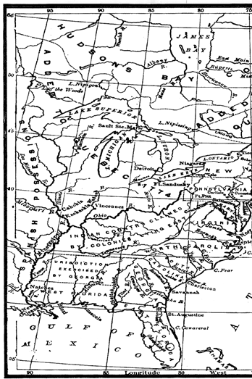CHAPTER 2: THE COLONIAL PERIOD

Map depicting the English colonies and western territories, 1763-1775.

OUTLINE OF U.S. HISTORY

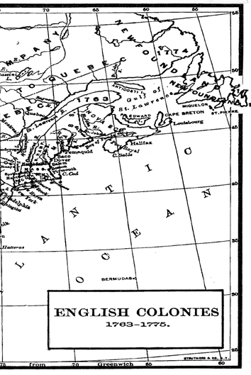

37

John Smith, the stalwart

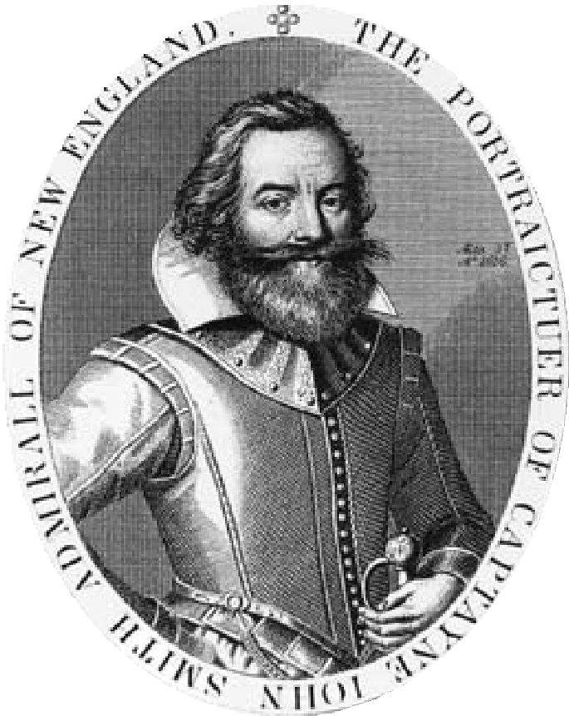

English explorer and settler whose

leadership helped save Jamestown from

collapse during its critical early years.

B E C O M I N G A

NATION

A PICTURE PROFILE

**The United States of America was transformed in the two centuries from the first English settlement at Jamestown in 1607 to the beginning of the 19th century. From a series of isolated colonial settlements hugging the Atlantic Coast, the United States evolved into a new nation, born in revolution, and guided by a Constitution embodying the principles of democratic self-government.**

38

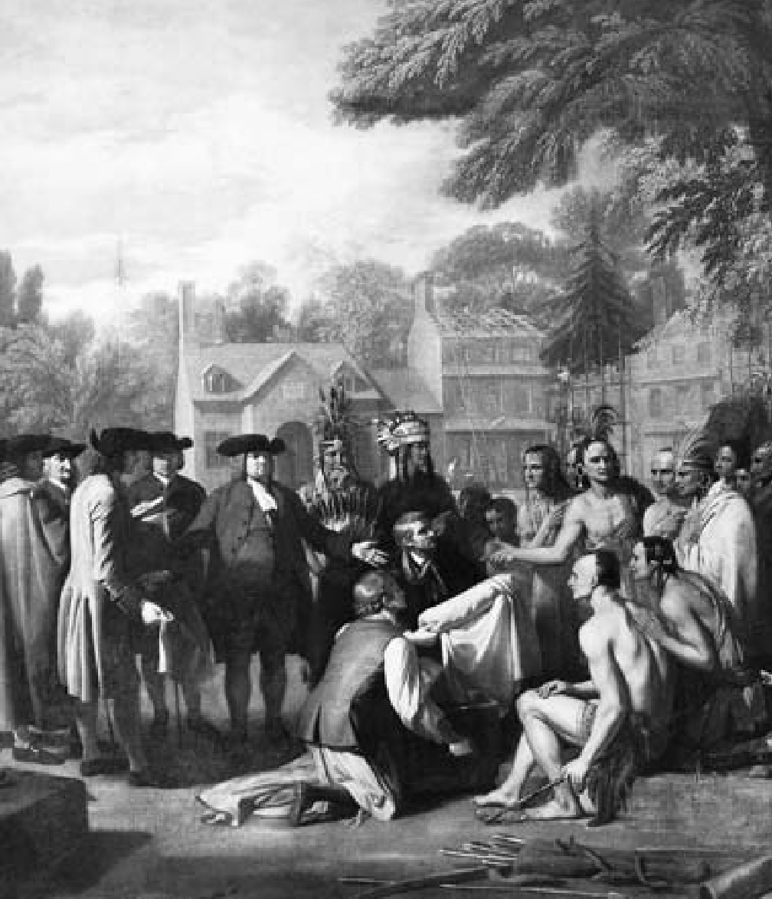

Detail from a painting by American artist Benjamin West (1738-1820), which depicts William Penn’s treaty with the Native Americans living where he founded the colony of Pennsylvania as a haven for Quakers and others seeking religious freedom. Penn’s fair treatment of the Delaware Indians led to long-term, friendly relations, unlike the conflicts

between European settlers and Indian tribes in other colonies.

39

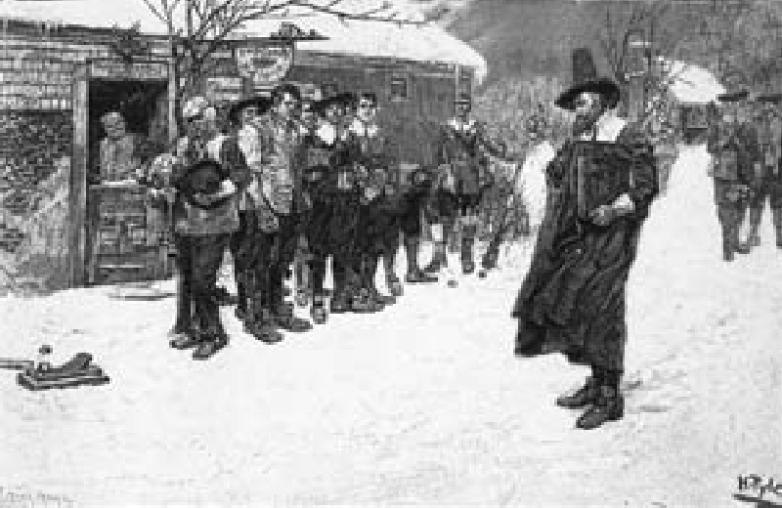

A devout Puritan elder (right) confronts patrons drinking ale outside a tavern. Tensions between the strictly religious Puritans, who first settled the region, and the more secular population were characteristic of the colonial era in New England.

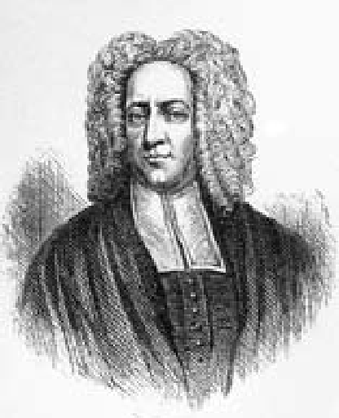Cotton Mather was one of the leading Puritan figures of the late 17th and early 18th centuries. His massive *Ecclesiastical History of New England* (1702) is an exhaustive chronicle of the settlement of New England and the Puritan effort to establish a kingdom of God in the wilderness of the New World.

40

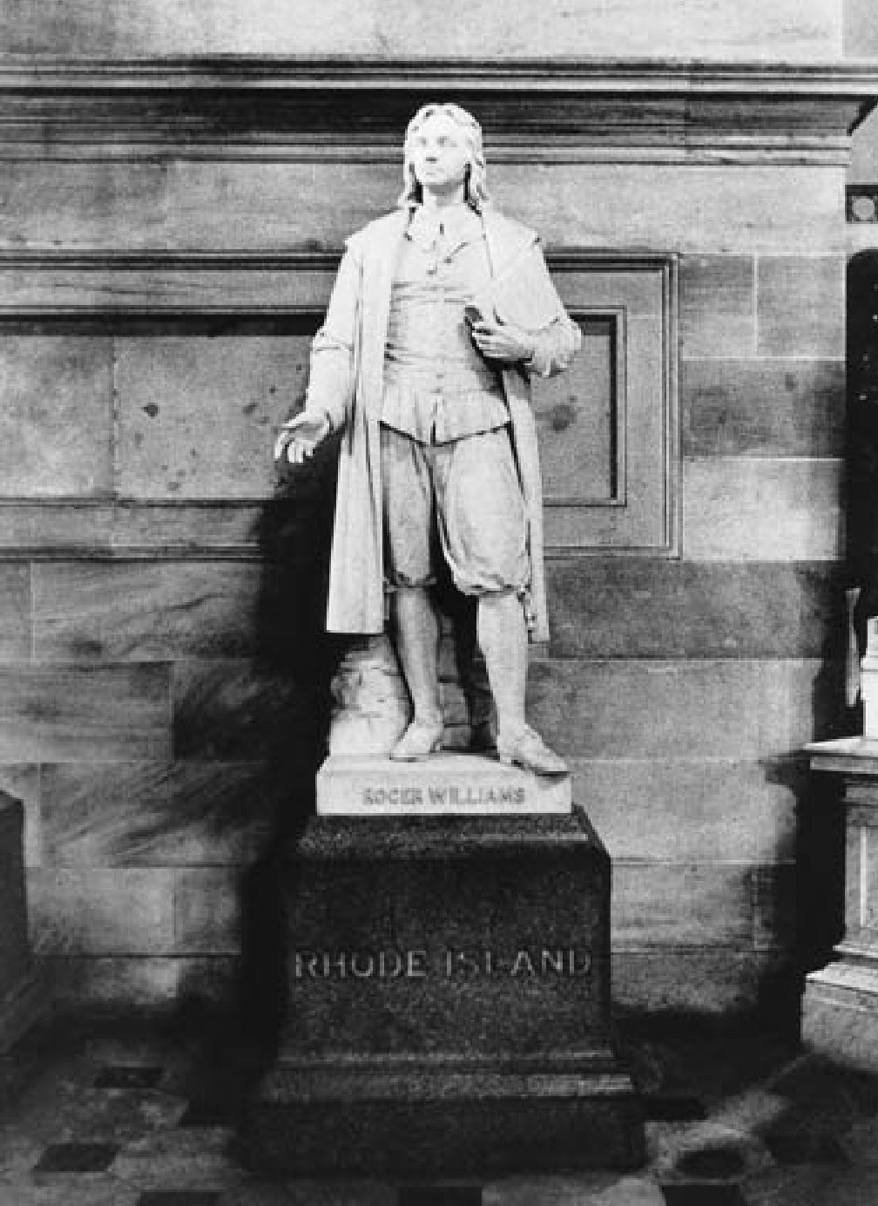

Statue of Roger Williams, early champion of religious freedom

and the separation of church and state. Williams founded the colony of Rhode Island after leaving Massachusetts because of his disapproval

of its religious ties to the Church of England.

41

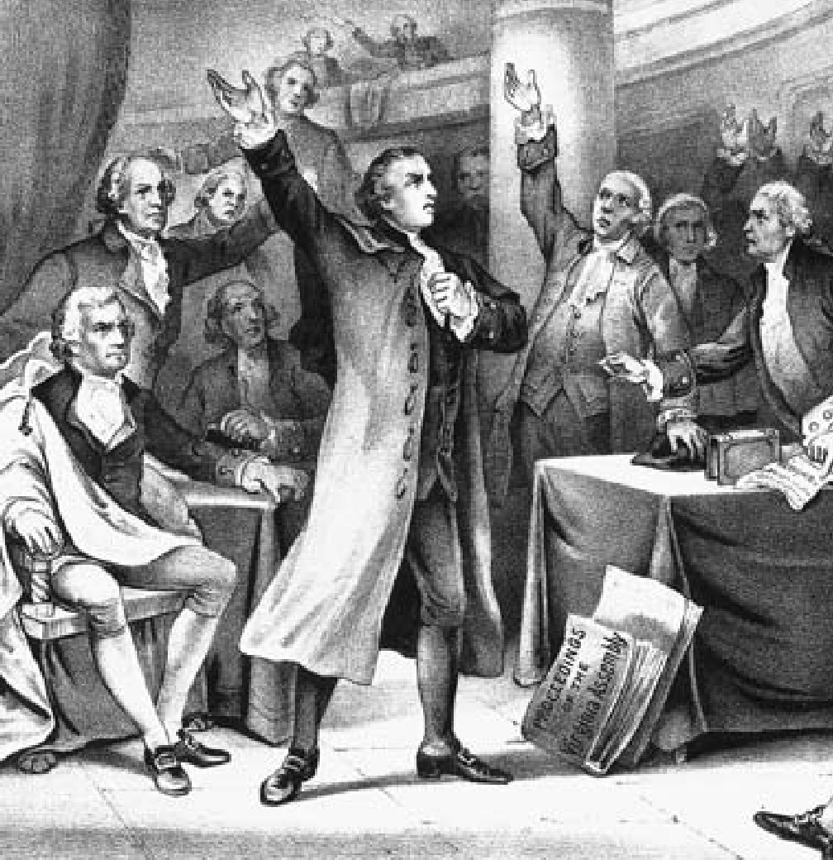

Drawing of revolutionary firebrand Patrick Henry (standing to the left) uttering perhaps the most famous words of the American Revolution — “Give me liberty or give me death!”

— in a debate before the Virginia Assembly in 1775.

42

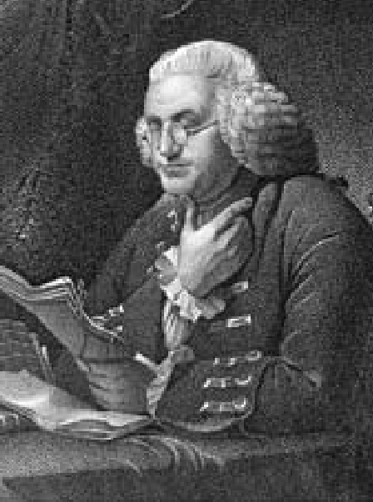

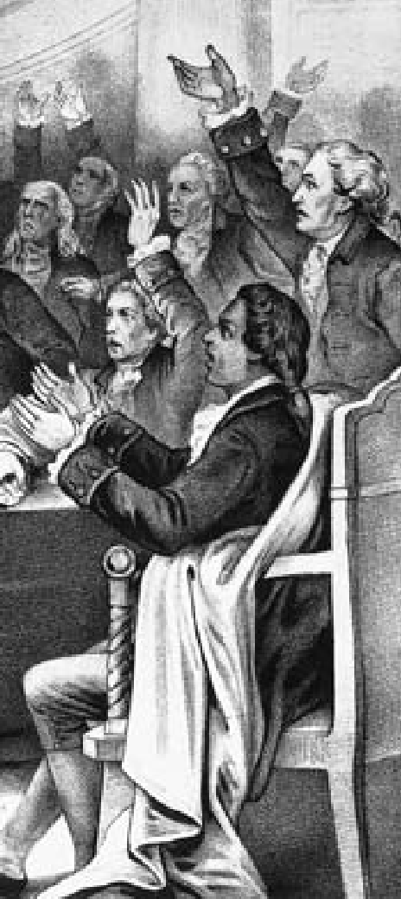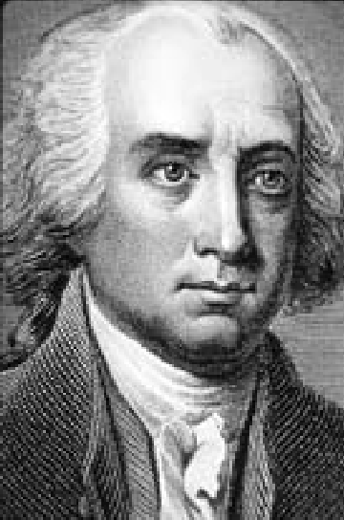Benjamin Franklin: scientist, inventor, writer, newspaper publisher, city father of Philadelphia, diplomat, and signer of both the Declaration of Independence and the Constitution. Franklin embodied the virtues of shrewd practicality and the optimistic belief in self-improvement often associated with America itself.

James Madison, fourth president of the United States, is often regarded as the “Father of the Constitution.” His essays in the debate over ratification of the Constitution were collected with those of Alexander Hamilton and John Jay as *The Federalist Papers*. Today, they are regarded as a classic defense of republican government, in which the executive, legislative, and judicial branches check and balance each other to protect the rights and freedoms of the people.

43

Artist’s depiction of the first shots of the American Revolution, fired at Lexington, Massachusetts,

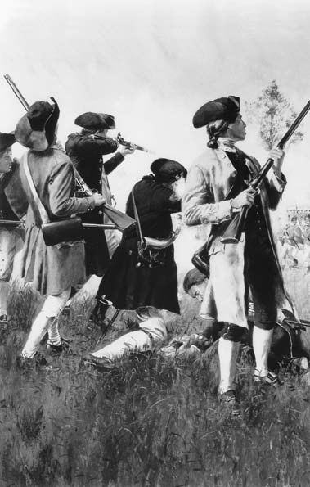

on April 19, 1775. Local militia confronted British troops marching to seize colonial armaments

in the nearby town of Concord.

44

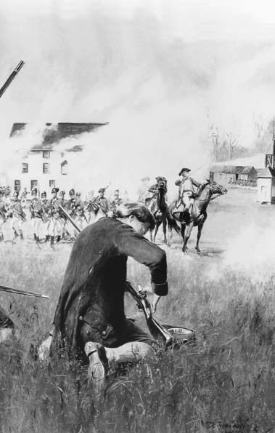

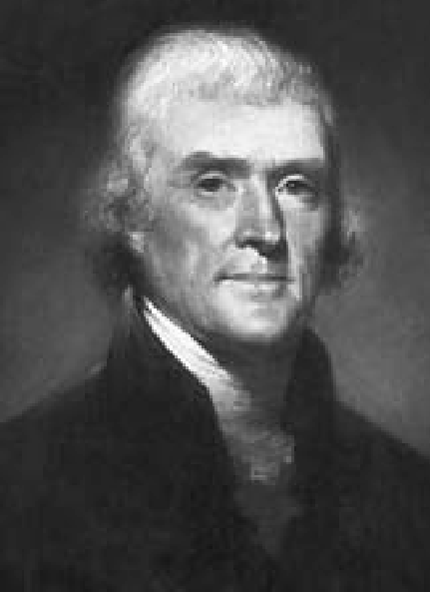

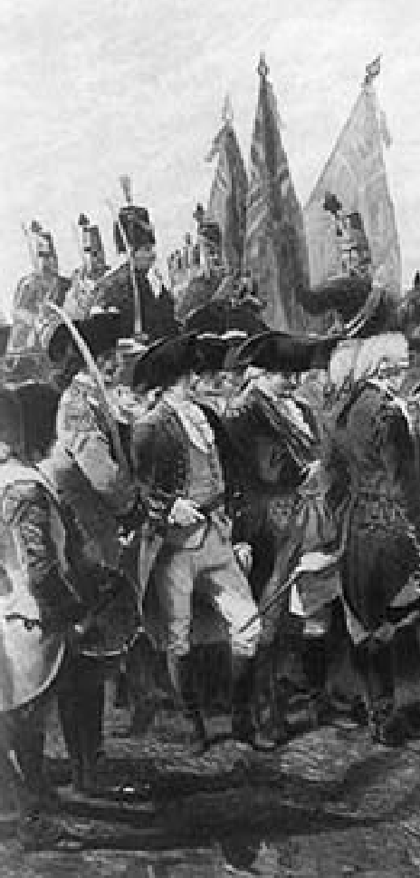Thomas Jefferson, author of the Declaration of Independence and third president of

the United States. Jefferson also founded the University of Virginia and built one

of America’s most celebrated houses, Monticello, in Charlottesville, Virginia.

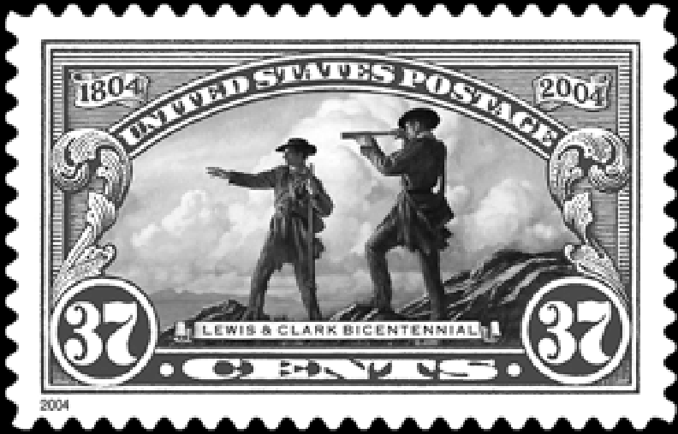

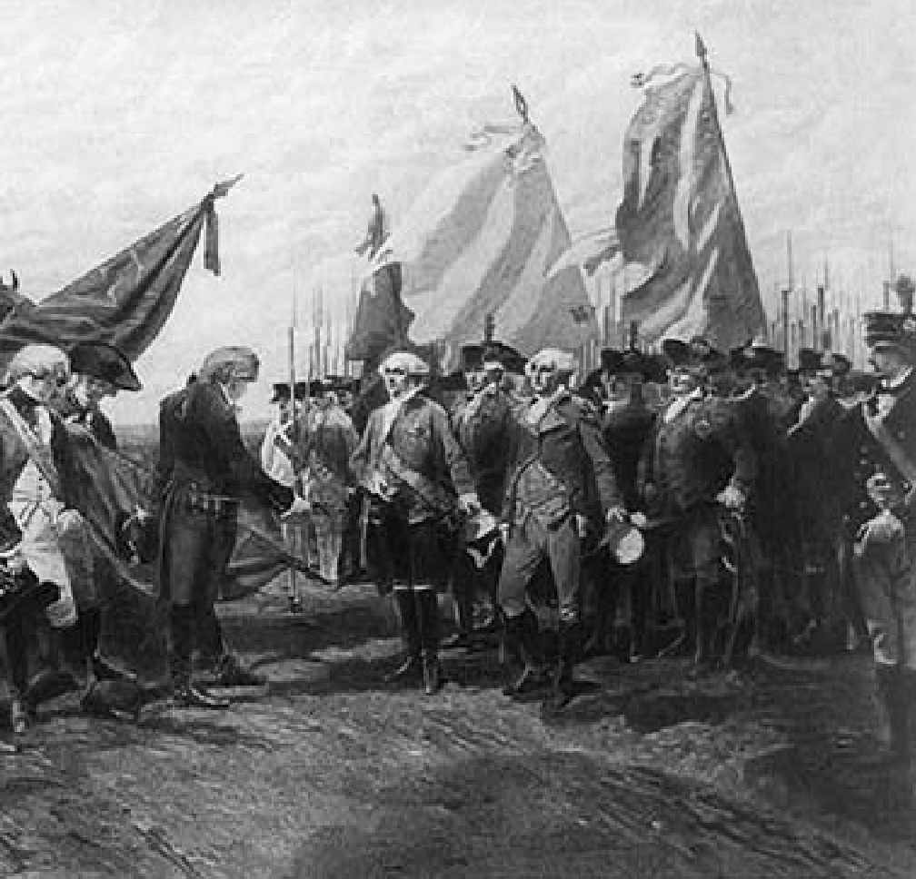

Above: Surrender of Lord Cornwallis and the British army to American and French forces commanded by George Washington at Yorktown, Virginia, on October 19, 1781. The battle of Yorktown led to the end of the war and American independence, secured in the 1783 Treaty of Paris.

Left: U.S. postage stamp commemorating the bicentennial of the Lewis and Clark expedition, one of Thomas Jefferson’s visionary projects.

Meriwether Lewis, Jefferson’s secretary, and his friend, William Clark, accompanied by a party of more than 30 persons, set out on a journey into the uncharted West that lasted four years. They traveled thousands of miles, from Camp Wood, Illinois, to Oregon, through lands that eventually became 11 American states.

47

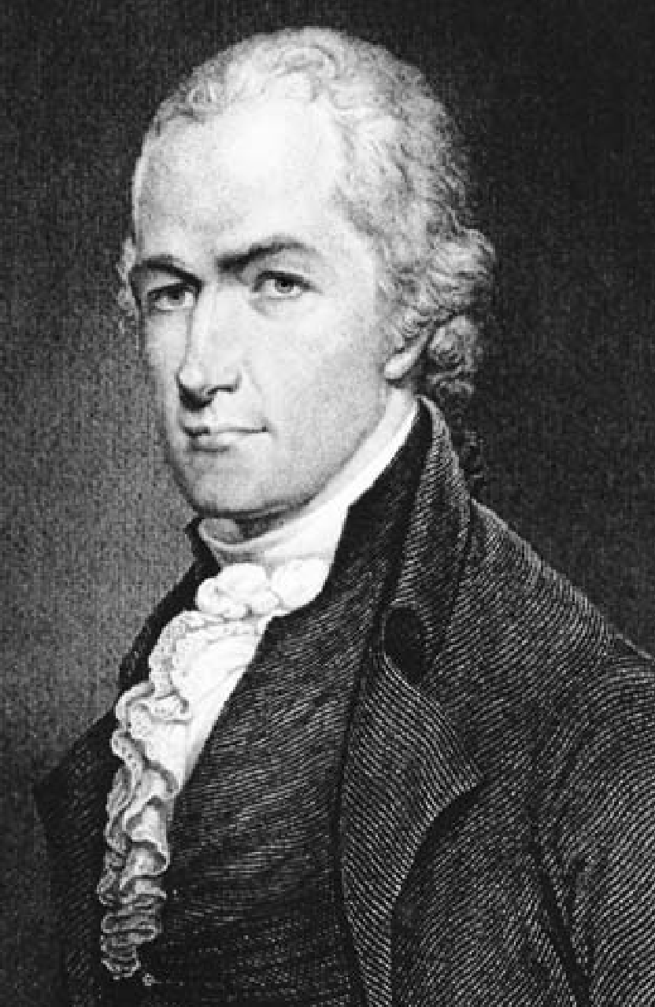

Alexander Hamilton, secretary of the treasury in the administration of President George Washington. Hamilton advocated a strong federal government

and the encouragement of industry. He was opposed by Thomas Jefferson, a believer in decentralized government, states’ rights, and the virtues of

the independent farmers and land owners.

48

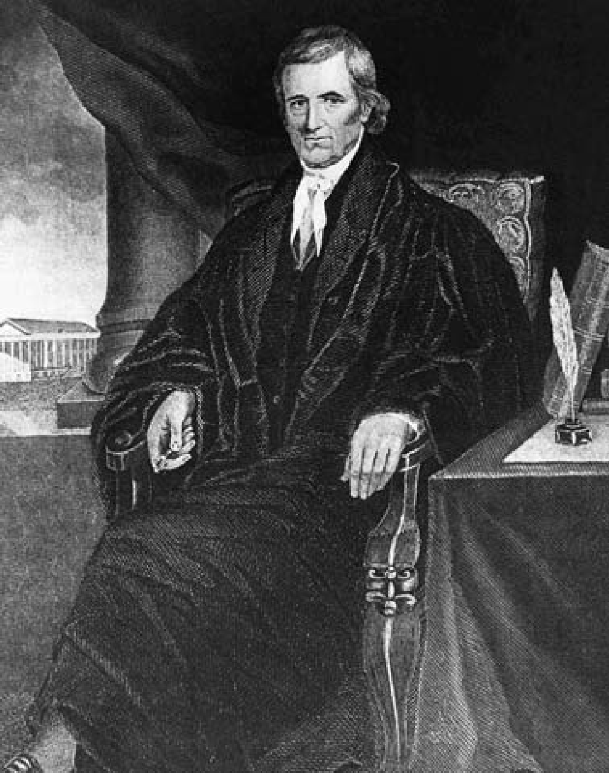John Marshall, chief justice of the U.S. Supreme Court from 1801 to 1835, in a portrait by Alonzo Chappel. In a series of landmark cases, Marshall established the principle of judicial review — the right of the courts to determine if any act of Congress or the executive branch is constitutional, and therefore valid and legal.

49

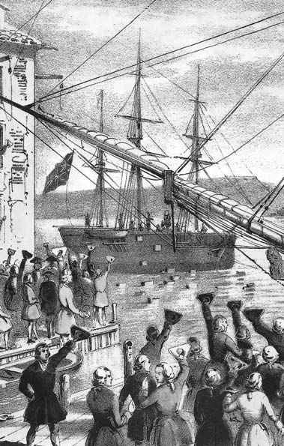

50

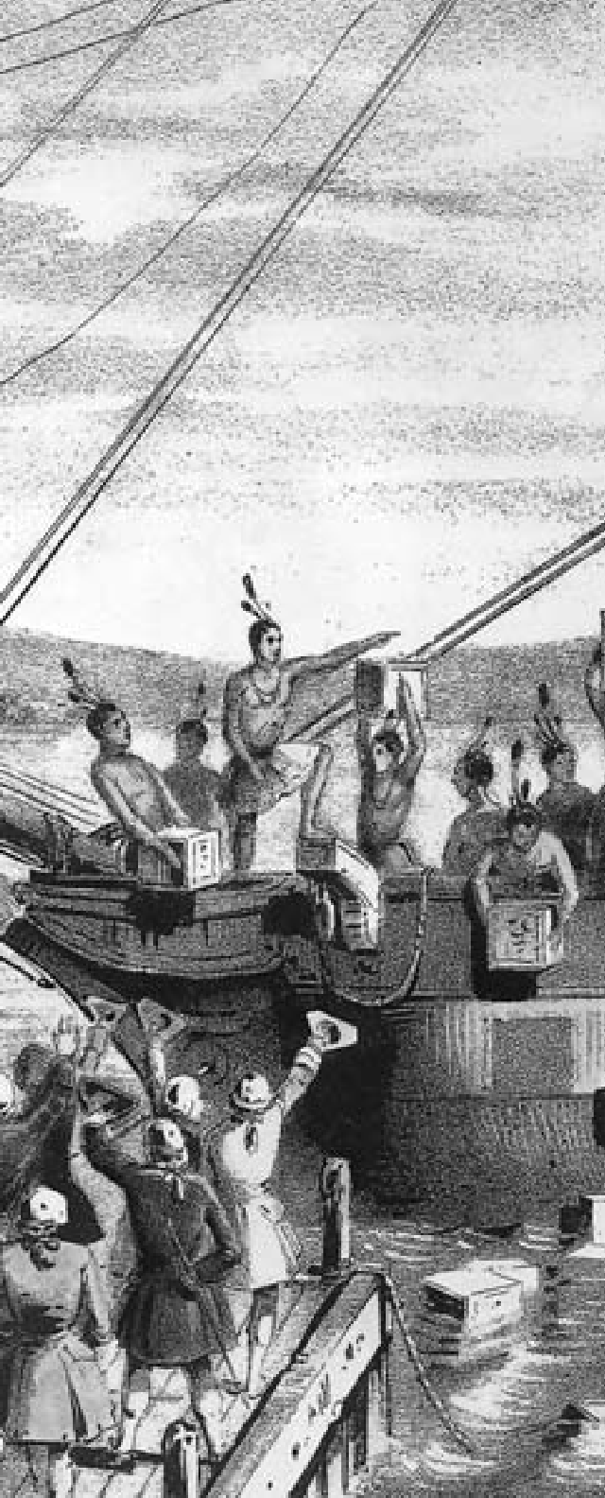

**C H A P T E R**

3

**THE ROAD TO INDEPENDENCE**

The protest against British taxes known as the “Boston Tea Party,” 1773.

“The Revolution was effected before the war commenced.

The Revolution was in the hearts and minds of the people.”

Former President John Adams, 1818

Throughout the 18th century, the maturing British North American colonies inevitably forged a distinct identity. They grew vastly in eco- nomic strength and cultural attain- ment; virtually all had long years of self-government behind them. In the 1760s their combined pop- ulation exceeded 1,500,000 — a six-fold increase since 1700. None- theless, England and America did not begin an overt parting of ways until 1763, more than a century and a half after the founding of the first permanent settlement at James- town, Virginia.

#### A NEW COLONIAL SYSTEM

**I**n the aftermath of the French and Indian War, London saw a need for a new imperial design that would

involve more centralized control,

spread the costs of empire more eq- uitably, and speak to the interests of both French Canadians and North American Indians. The colonies, on the other hand, long accustomed to a large measure of independence, ex- pected more, not less, freedom. And, with the French menace eliminated, they felt far less need for a strong British presence. A scarcely compre- hending Crown and Parliament on the other side of the Atlantic found itself contending with colonists trained in self-government and im- patient with interference.

The organization of Canada and of the Ohio Valley necessitated policies that would not alienate the French and Indian inhabitants. Here London was in fundamental conflict with the interests of the colonies. Fast increasing in population, and needing more land for settlement,

they claimed the right to extend their boundaries as far west as the Mississippi River.

The British government, fear- ing a series of Indian wars, believed that the lands should be opened on a more gradual basis. Restricting movement was also a way of ensur- ing royal control over existing settle- ments before allowing the formation of new ones. The Royal Proclama- tion of 1763 reserved all the west- ern territory between the Allegheny Mountains, Florida, the Mississippi River, and Quebec for use by Na- tive Americans. Thus the Crown at- tempted to sweep away every western land claim of the 13 colonies and to stop westward expansion. Although never effectively enforced, this mea- sure, in the eyes of the colonists, con- stituted a high-handed disregard of their fundamental right to occupy and settle western lands.

More serious in its repercus- sions was the new British revenue policy. London needed more money to support its growing empire and faced growing taxpayer discontent at home. It seemed reasonable enough that the colonies should pay for their own defense. That would involve new taxes, levied by Parliament — at the expense of colonial self-government.

The first step was the replacement of the Molasses Act of 1733, which placed a prohibitive duty, or tax, on the import of rum and molas- ses from non-English areas, with the Sugar Act of 1764. This act outlawed the importation of foreign rum; it also put a modest duty on molas-

ses from all sources and levied taxes on wines, silks, coffee, and a num- ber of other luxury items. The hope was that lowering the duty on mo- lasses would reduce the temptation to smuggle the commodity from the Dutch and French West Indies for the rum distilleries of New England. The British government enforced the Sugar Act energetically. Customs of- ficials were ordered to show more effectiveness. British warships in American waters were instructed to seize smugglers, and “writs of assis- tance,” or warrants, authorized the king’s officers to search suspected premises.

Both the duty imposed by the Sug- ar Act and the measures to enforce it caused consternation among New England merchants. They contended that payment of even the small duty imposed would be ruinous to their businesses. Merchants, legislatures, and town meetings protested the law. Colonial lawyers protested “taxation without representation,” a slogan that was to persuade many Ameri- cans they were being oppressed by the mother country.

Later in 1764, Parliament enact- ed a Currency Act “to prevent pa- per bills of credit hereafter issued in any of His Majesty’s colonies from being made legal tender.” Since the colonies were a deficit trade area and were constantly short of hard cur- rency, this measure added a serious burden to the colonial economy. Equally objectionable from the co- lonial viewpoint was the Quartering Act, passed in 1765, which required

colonies to provide royal troops with provisions and barracks.

#### THE STAMP ACT

**A** general tax measure sparked the greatest organized resistance. Known as the “Stamp Act,” it re-

quired all newspapers, broadsides, pamphlets, licenses, leases, and oth- er legal documents to bear revenue stamps. The proceeds, collected by American customs agents, would be used for “defending, protecting, and securing” the colonies.

Bearing equally on people who did any kind of business, the Stamp Act aroused the hostility of the most powerful and articulate groups in the American population: journal- ists, lawyers, clergymen, merchants and businessmen, North and South, East and West. Leading merchants organized for resistance and formed nonimportation associations.

Trade with the mother country fell off sharply in the summer of 1765, as prominent men organized themselves into the “Sons of Liber- ty” — secret organizations formed to protest the Stamp Act — often through violent means. From Mas- sachusetts to South Carolina, mobs, forcing luckless customs agents to resign their offices, destroyed the hated stamps. Militant resistance ef- fectively nullified the Act.

Spurred by delegate Patrick Hen- ry, the Virginia House of Burgesses passed a set of resolutions in May denouncing taxation without repre- sentation as a threat to colonial lib-

erties. It asserted that Virginians, enjoying the rights of Englishmen, could be taxed only by their own representatives. The Massachusetts Assembly invited all the colonies to appoint delegates to a “Stamp Act Congress” in New York, held in Oc- tober 1765, to consider appeals for relief to the Crown and Parliament. Twenty-seven representatives from nine colonies seized the opportunity to mobilize colonial opinion. After much debate, the congress adopted a set of resolutions asserting that “no taxes ever have been or can be con- stitutionally imposed on them, but by their respective legislatures,” and that the Stamp Act had a “manifest tendency to subvert the rights and liberties of the colonists.”

#### TAXATION WITHOUT REPRESENTATION

**T**he issue thus drawn centered on the question of representation. The colonists believed they could not

be represented unless they actually elected members to the House of Commons. But this idea conflicted with the English principle of “virtual representation,” according to which each member of Parliament rep- resented the interests of the whole country and the empire — even if his electoral base consisted of only a tiny minority of property owners from a given district. This theory assumed that all British subjects shared the same interests as the property own- ers who elected members of Parlia- ment.

The American leaders argued that their only legal relations were with the Crown. It was the king who had agreed to establish colonies be- yond the sea and the king who pro- vided them with governments. They asserted that he was equally a king of England and a king of the colo- nies, but they insisted that the Eng- lish Parliament had no more right to pass laws for the colonies than any colonial legislature had the right to pass laws for England. In fact, how- ever, their struggle was equally with King George III and Parliament. Factions aligned with the Crown generally controlled Parliament and reflected the king’s determination to be a strong monarch.

The British Parliament reject- ed the colonial contentions. British merchants, however, feeling the ef- fects of the American boycott, threw their weight behind a repeal move- ment. In 1766 Parliament yielded, repealing the Stamp Act and modi- fying the Sugar Act. However, to mollify the supporters of central control over the colonies, Parliament followed these actions with passage of the Declaratory Act, which as- serted the authority of Parliament to make laws binding the colonies “in all cases whatsoever.” The colonists had won only a temporary respite from an impending crisis.

#### THE TOWNSHEND ACTS

**T**he year 1767 brought another se- ries of measures that stirred anew all the elements of discord. Charles

Townshend, British chancellor of the exchequer, attempted a new fis- cal program in the face of continued discontent over high taxes at home. Intent upon reducing British taxes by making more efficient the col- lection of duties levied on American trade, he tightened customs admin- istration and enacted duties on colo- nial imports of paper, glass, lead, and tea from Britain. The “Townshend Acts” were based on the premise that taxes imposed on goods imported by the colonies were legal while internal taxes (like the Stamp Act) were not.

The Townshend Acts were de- signed to raise revenue that would be used in part to support colonial officials and maintain the Brit- ish army in America. In response, Philadelphia lawyer John Dickinson, in *Letters of a Pennsylvania Farm- er*, argued that Parliament had the right to control imperial commerce but did not have the right to tax the colonies, whether the duties were external or internal.

The agitation following enact- ment of the Townshend duties was less violent than that stirred by the Stamp Act, but it was nevertheless strong, particularly in the cities of the Eastern seaboard. Merchants once again resorted to non-impor- tation agreements, and people made do with local products. Colonists, for example, dressed in homespun clothing and found substitutes for tea. They used homemade paper and their houses went unpaint- ed. In Boston, enforcement of the new regulations provoked violence.

When customs officials sought to collect duties, they were set upon by the populace and roughly handled. For this infraction, two British regi- ments were dispatched to protect the customs commissioners.

The presence of British troops in Boston was a standing invitation to disorder. On March 5, 1770, antag- onism between citizens and British soldiers again flared into violence. What began as a harmless snowball- ing of British soldiers degenerated into a mob attack. Someone gave the order to fire. When the smoke had cleared, three Bostonians lay dead in the snow. Dubbed the “Boston Mas- sacre,” the incident was dramatically pictured as proof of British heart- lessness and tyranny.

Faced with such opposition, Par- liament in 1770 opted for a strategic retreat and repealed all the Townsh- end duties except that on tea, which was a luxury item in the colonies, imbibed only by a very small minori- ty. To most, the action of Parliament signified that the colonists had won a major concession, and the cam- paign against England was largely dropped. A colonial embargo on “English tea” continued but was not too scrupulously observed. Prosper- ity was increasing and most colonial leaders were willing to let the future take care of itself.

#### SAMUEL ADAMS

**D**uring a three-year interval of calm, a relatively small number of radicals strove energetically to keep

the controversy alive. They contend- ed that payment of the tax consti- tuted an acceptance of the principle that Parliament had the right to rule over the colonies. They feared that at any time in the future, the principle of parliamentary rule might be ap- plied with devastating effect on all colonial liberties.

The radicals’ most effective leader was Samuel Adams of Mas- sachusetts, who toiled tirelessly for a single end: independence. From the time he graduated from Harvard College in 1743, Adams was a public servant in some capacity — inspec- tor of chimneys, tax-collector, and moderator of town meetings. A consistent failure in business, he was shrewd and able in politics, with the New England town meeting his theater of action.

Adams wanted to free people from their awe of social and politi- cal superiors, make them aware of their own power and importance, and thus arouse them to action. To- ward these objectives, he published articles in newspapers and made speeches in town meetings, instigat- ing resolutions that appealed to the colonists’ democratic impulses.

In 1772 he induced the Boston town meeting to select a “Commit- tee of Correspondence” to state the rights and grievances of the colo- nists. The committee opposed a British decision to pay the salaries of judges from customs revenues; it feared that the judges would no lon- ger be dependent on the legislature for their incomes and thus no longer

accountable to it, thereby leading to the emergence of “a despotic form of government.” The committee communicated with other towns on this matter and requested them to draft replies. Committees were set up in virtually all the colonies, and out of them grew a base of effective revolutionary organizations. Still, Adams did not have enough fuel to set a fire.

#### THE BOSTON “TEA PARTY”

**I**n 1773, however, Britain furnished Adams and his allies with an incen- diary issue. The powerful East India

Company, finding itself in critical fi- nancial straits, appealed to the Brit- ish government, which granted it a monopoly on all tea exported to the colonies. The government also per- mitted the East India Company to supply retailers directly, bypassing colonial wholesalers. By then, most of the tea consumed in America was imported illegally, duty-free. By sell- ing its tea through its own agents at a price well under the customary one, the East India Company made smuggling unprofitable and threat- ened to eliminate the independent colonial merchants. Aroused not only by the loss of the tea trade but also by the monopolistic practice in- volved, colonial traders joined the radicals agitating for independence.

In ports up and down the At- lantic coast, agents of the East In- dia Company were forced to resign. New shipments of tea were either re- turned to England or warehoused.

In Boston, however, the agents de- fied the colonists; with the support of the royal governor, they made preparations to land incoming car- goes regardless of opposition. On the night of December 16, 1773, a band of men disguised as Mohawk Indians and led by Samuel Adams boarded three British ships lying at anchor and dumped their tea cargo into Boston harbor. Doubting their countrymen’s commitment to prin- ciple, they feared that if the tea were landed, colonists would actually purchase the tea and pay the tax.

A crisis now confronted Britain. The East India Company had car- ried out a parliamentary statute. If the destruction of the tea went un- punished, Parliament would admit to the world that it had no control over the colonies. Official opinion in Britain almost unanimously con- demned the Boston Tea Party as an act of vandalism and advocated le- gal measures to bring the insurgent colonists into line.

#### THE COERCIVE ACTS

**P**arliament responded with new laws that the colonists called the “Coercive” or “Intolerable Acts.” The

first, the Boston Port Bill, closed the port of Boston until the tea was paid for. The action threatened the very life of the city, for to prevent Boston from having access to the sea meant economic disaster. Other enactments restricted local author- ity and banned most town meetings held without the governor’s consent.

A Quartering Act required local au- thorities to find suitable quarters for British troops, in private homes if necessary. Instead of subduing and isolating Massachusetts, as Parlia- ment intended, these acts rallied its sister colonies to its aid. The Que- bec Act, passed at nearly the same time, extended the boundaries of the province of Quebec south to the Ohio River. In conformity with pre- vious French practice, it provided for trials without jury, did not estab- lish a representative assembly, and gave the Catholic Church semi-es- tablished status. By disregarding old charter claims to western lands, it threatened to block colonial expan- sion to the North and Northwest; its recognition of the Roman Catho- lic Church outraged the Protestant sects that dominated every colony. Though the Quebec Act had not been passed as a punitive measure, Americans associated it with the Co- ercive Acts, and all became known as the “Five Intolerable Acts.”

At the suggestion of the Vir- ginia House of Burgesses, colonial representatives met in Philadelphia on September 5, 1774, “to consult upon the present unhappy state of the Colonies.” Delegates to this meeting, known as the First Con- tinental Congress, were chosen by provincial congresses or popular conventions. Only Georgia failed to send a delegate; the total number of 55 was large enough for diversity of opinion, but small enough for genu- ine debate and effective action. The division of opinion in the colonies

posed a genuine dilemma for the delegates. They would have to give an appearance of firm unanimity to induce the British government to make concessions. But they also would have to avoid any show of radicalism or spirit of independence that would alarm more moderate Americans.

A cautious keynote speech, fol- lowed by a “resolve” that no obe- dience was due the Coercive Acts, ended with adoption of a set of res- olutions affirming the right of the colonists to “life, liberty, and prop- erty,” and the right of provincial legislatures to set “all cases of taxa- tion and internal polity.” The most important action taken by the Con- gress, however, was the formation of a “Continental Association” to rees- tablish the trade boycott. It set up a system of committees to inspect customs entries, publish the names of merchants who violated the agree- ments, confiscate their imports, and encourage frugality, economy, and industry.

The Continental Association im- mediately assumed the leadership in the colonies, spurring new local organizations to end what remained of royal authority. Led by the pro- independence leaders, they drew their support not only from the less well-to-do, but from many members of the professional class (especial- ly lawyers), most of the planters of the Southern colonies, and a num- ber of merchants. They intimidated the hesitant into joining the popular movement and punished the hostile;

began the collection of military sup- plies and the mobilization of troops; and fanned public opinion into revo- lutionary ardor.

Many of those opposed to Brit- ish encroachment on American rights nonetheless favored discus- sion and compromise as the prop- er solution. This group included Crown-appointed officers, Quakers, and members of other religious sects opposed to the use of violence, nu- merous merchants (especially in the middle colonies), and some discon- tented farmers and frontiersmen in the Southern colonies.

The king might well have effect- ed an alliance with these moder- ates and, by timely concessions, so strengthened their position that the revolutionaries would have found it difficult to proceed with hostilities. But George III had no intention of making concessions. In September 1774, scorning a petition by Phila- delphia Quakers, he wrote, “The die is now cast, the Colonies must ei- ther submit or triumph.” This action isolated Loyalists who were appalled and frightened by the course of events following the Coercive Acts.

#### THE REVOLUTION BEGINS

**G**eneral Thomas Gage, an amiable English gentleman with an Amer- ican-born wife, commanded the

garrison at Boston, where political activity had almost wholly replaced trade. Gage’s main duty in the colo- nies had been to enforce the Coer- cive Acts. When news reached him

that the Massachusetts colonists were collecting powder and military stores at the town of Concord, 32 kilometers away, Gage sent a strong detail to confiscate these munitions. After a night of marching, the British troops reached the village of Lexington on April 19, 1775, and saw a grim band of 77 Minutemen — so named because they were said to be ready to fight in a minute — through the early morning mist. The Minute- men intended only a silent protest, but Marine Major John Pitcairn, the leader of the British troops, yelled, “Disperse, you damned rebels! You dogs, run!” The leader of the Min- utemen, Captain John Parker, told his troops not to fire unless fired at first. The Americans were with- drawing when someone fired a shot, which led the British troops to fire at the Minutemen. The British then charged with bayonets, leaving eight dead and 10 wounded. In the often- quoted phrase of 19th century poet Ralph Waldo Emerson, this was “the

shot heard round the world.”

The British pushed on to Con- cord. The Americans had taken away most of the munitions, but they destroyed whatever was left. In the meantime, American forces in the countryside had mobilized to harass the British on their long return to Boston. All along the road, behind stone walls, hillocks, and houses, militiamen from “every Middlesex village and farm” made targets of the bright red coats of the British soldiers. By the time Gage’s weary detachment stumbled into Boston,

it had suffered more than 250 killed and wounded. The Americans lost 93 men.

The Second Continental Con- gress met in Philadelphia, Penn- sylvania, on May 10. The Congress voted to go to war, inducting the co- lonial militias into continental ser- vice. It appointed Colonel George Washington of Virginia as their commander-in-chief on June 15. Within two days, the Americans had incurred high casualties at Bunker Hill just outside Boston. Congress also ordered American expeditions to march northward into Canada by fall. Capturing Montreal, they failed in a winter assault on Quebec, and eventually retreated to New York.

Despite the outbreak of armed conflict, the idea of complete sep- aration from England was still repugnant to many members of the Continental Congress. In July, it adopted the Olive Branch Petition, begging the king to prevent fur- ther hostile actions until some sort of agreement could be worked out. King George rejected it; instead, on August 23, 1775, he issued a procla- mation declaring the colonies to be in a state of rebellion.

Britain had expected the South- ern colonies to remain loyal, in part because of their reliance on slav- ery. Many in the Southern colonies feared that a rebellion against the mother country would also trigger a slave uprising. In November 1775, Lord Dunmore, the governor of Vir- ginia, tried to capitalize on that fear by offering freedom to all slaves who

would fight for the British. Instead, his proclamation drove to the rebel side many Virginians who would otherwise have remained Loyalist.

The governor of North Caroli- na, Josiah Martin, also urged North Carolinians to remain loyal to the Crown. When 1,500 men answered Martin’s call, they were defeated by revolutionary armies before British troops could arrive to help.

British warships continued down the coast to Charleston, South Car- olina, and opened fire on the city in early June 1776. But South Car- olinians had time to prepare, and repulsed the British by the end of the month. They would not return South for more than two years.

#### COMMON SENSE AND INDEPENDENCE

**I**n January 1776, Thomas Paine, a radical political theorist and writer who had come to America

from England in 1774, published a 50-page pamphlet, *Common Sense*. Within three months, it sold 100,000 copies. Paine attacked the idea of a hereditary monarchy, declaring that one honest man was worth more to society than “all the crowned ruf- fians that ever lived.” He presented the alternatives — continued sub- mission to a tyrannical king and an outworn government, or liberty and happiness as a self-sufficient, independent republic. Circulated throughout the colonies, *Common Sense* helped to crystallize a decision for separation.

There still remained the task, however, of gaining each colony’s approval of a formal declaration. On June 7, Richard Henry Lee of Vir- ginia introduced a resolution in the Second Continental Congress, de- claring, “That these United Colonies are, and of right ought to be, free and independent states ” Immedi-

ately, a committee of five, headed by Thomas Jefferson of Virginia, was appointed to draft a document for a vote.

Largely Jefferson’s work, the Dec- laration of Independence, adopted July 4, 1776, not only announced the birth of a new nation, but also set forth a philosophy of human free- dom that would become a dynamic force throughout the entire world. The Declaration drew upon French and English Enlightenment political philosophy, but one influence in par- ticular stands out: John Locke’s *Sec- ond Treatise on Government*. Locke took conceptions of the traditional rights of Englishmen and universal- ized them into the natural rights of all humankind. The Declaration’s familiar opening passage echoes Locke’s social-contract theory of government:

*We hold these truths to be self- evident, that all men are created equal, that they are endowed*

*by their Creator with certain unalienable Rights, that among these are Life, Liberty and the pursuit of Happiness. — That to secure these rights, Governments are instituted among Men, deriving their just powers from*

*the consent of the governed, — That whenever any Form of Government becomes destructive of these ends, it is the Right of the People to alter or to abolish it, and to institute new Government, laying its foundation on such principles and organizing its powers in such form, as to them shall seem most likely to effect their Safety and Happiness.*

Jefferson linked Locke’s princi- ples directly to the situation in the colonies. To fight for American in- dependence was to fight for a gov- ernment based on popular consent in place of a government by a king who had “combined with others to subject us to a jurisdiction foreign to our constitution, and unacknowl- edged by our laws ” Only a gov-

ernment based on popular consent could secure natural rights to life, liberty, and the pursuit of happiness. Thus, to fight for American inde- pendence was to fight on behalf of one’s own natural rights.

#### DEFEATS AND VICTORIES

**A**lthough the Americans suffered severe setbacks for months after independence was declared, their

tenacity and perseverance eventu- ally paid off. During August 1776, in the Battle of Long Island in New York, Washington’s position be- came untenable, and he executed a masterly retreat in small boats from Brooklyn to the Manhattan shore. British General William Howe twice hesitated and allowed the Americans

to escape. By November, however, Howe had captured Fort Washing- ton on Manhattan Island. New York City would remain under British control until the end of the war.

That December, Washington’s forces were near collapse, as sup- plies and promised aid failed to materialize. Howe again missed his chance to crush the Americans by deciding to wait until spring to re- sume fighting. On Christmas Day, December 25, 1776, Washington crossed the Delaware River, north of Trenton, New Jersey. In the early- morning hours of December 26, his troops surprised the British garrison there, taking more than 900 prison- ers. A week later, on January 3, 1777, Washington attacked the British at Princeton, regaining most of the territory formally occupied by the British. The victories at Trenton and Princeton revived flagging Ameri- can spirits.

In September 1777, however, Howe defeated the American army at Brandywine in Pennsylvania and occupied Philadelphia, forcing the Continental Congress to flee. Wash- ington had to endure the bitterly cold winter of 1777-1778 at Valley Forge, Pennsylvania, lacking ade- quate food, clothing, and supplies. Farmers and merchants exchanged their goods for British gold and silver rather than for dubious paper money issued by the Continental Congress and the states.

Valley Forge was the lowest ebb for Washington’s Continental Army, but elsewhere 1777 proved to be

the turning point in the war. Brit- ish General John Burgoyne, moving south from Canada, attempted to invade New York and New England via Lake Champlain and the Hud- son River. He had too much heavy equipment to negotiate the wooded and marshy terrain. On August 6, at Oriskany, New York, a band of Loyalists and Native Americans un- der Burgoyne’s command ran into a mobile and seasoned American force that managed to halt their advance. A few days later at Bennington, Ver- mont, more of Burgoyne’s forces, seeking much-needed supplies, were pushed back by American troops.

Moving to the west side of the Hudson River, Burgoyne’s army ad- vanced on Albany. The Americans were waiting for him. Led by Bene- dict Arnold — who would later be- tray the Americans at West Point, New York — the colonials twice re- pulsed the British. Having by this time incurred heavy losses, Bur- goyne fell back to Saratoga, New York, where a vastly superior Ameri- can force under General Horatio Gates surrounded the British troops. On October 17, 1777, Burgoyne sur- rendered his entire army — six gen- erals, 300 other officers, and 5,500 enlisted personnel.

#### FRANCO-AMERICAN ALLIANCE

**I**n France, enthusiasm for the American cause was high: The French intellectual world was it-

self stirring against feudalism and

privilege. However, the Crown lent its support to the colonies for geo- political rather than ideological reasons: The French government had been eager for reprisal against Britain ever since France’s defeat in 1763. To further the American cause, Benjamin Franklin was sent to Paris in 1776. His wit, guile, and intellect soon made their presence felt in the French capital, and played a major role in winning French assistance.

France began providing aid to the colonies in May 1776, when it sent 14 ships with war supplies to America. In fact, most of the gunpowder used by the American armies came from France. After Britain’s defeat at Sara- toga, France saw an opportunity to seriously weaken its ancient enemy and restore the balance of power that had been upset by the Seven Years’ War (called the French and Indian War in the American colonies). On February 6, 1778, the colonies and France signed a Treaty of Amity and Commerce, in which France recog- nized the United States and offered trade concessions. They also signed a Treaty of Alliance, which stipu- lated that if France entered the war, neither country would lay down its arms until the colonies won their in- dependence, that neither would con- clude peace with Britain without the consent of the other, and that each guaranteed the other’s possessions in America. This was the only bi- lateral defense treaty signed by the United States or its predecessors until 1949.

The Franco-American alliance

soon broadened the conflict. In June 1778 British ships fired on French vessels, and the two countries went to war. In 1779 Spain, hoping to re- acquire territories taken by Britain in the Seven Years’ War, entered the conflict on the side of France, but not as an ally of the Americans. In 1780 Britain declared war on the Dutch, who had continued to trade with the Americans. The combina- tion of these European powers, with France in the lead, was a far greater threat to Britain than the American colonies standing alone.

#### THE BRITISH MOVE SOUTH

**W**ith the French now involved, the British, still believing that most Southerners were Loyalists, stepped

up their efforts in the Southern colonies. A campaign began in late 1778, with the capture of Savannah, Georgia. Shortly thereafter, British troops and naval forces converged on Charleston, South Carolina, the principal Southern port. They man- aged to bottle up American forces on the Charleston peninsula. On May 12, 1780, General Benjamin Lincoln surrendered the city and its 5,000 troops, in the greatest American de- feat of the war.

But the reversal in fortune only emboldened the American rebels. South Carolinians began roaming the countryside, attacking British supply lines. In July, American Gen- eral Horatio Gates, who had assem- bled a replacement force of untrained militiamen, rushed to Camden,

South Carolina, to confront British forces led by General Charles Corn- wallis. But Gates’s makeshift army panicked and ran when confronted by the British regulars. Cornwallis’s troops met the Americans several more times, but the most signifi- cant battle took place at Cowpens, South Carolina, in early 1781, where the Americans soundly defeated the British. After an exhausting but unproductive chase through North Carolina, Cornwallis set his sights on Virginia.

#### VICTORY AND INDEPENDENCE

**I**n July 1780 France’s King Louis XVI had sent to America an expe- ditionary force of 6,000 men under

the Comte Jean de Rochambeau. In addition, the French fleet harassed British shipping and blocked re- inforcement and resupply of Brit- ish forces in Virginia. French and American armies and navies, total- ing 18,000 men, parried with Corn- wallis all through the summer and into the fall. Finally, on October 19,

1781, after being trapped at York- town near the mouth of Chesapeake Bay, Cornwallis surrendered his army of 8,000 British soldiers.

Although Cornwallis’s defeat did not immediately end the war — which would drag on inconclusively for almost two more years — a new British government decided to pur- sue peace negotiations in Paris in early 1782, with the American side represented by Benjamin Franklin, John Adams, and John Jay. On April 15, 1783, Congress approved the fi- nal treaty. Signed on September 3, the Treaty of Paris acknowledged the independence, freedom, and sover- eignty of the 13 former colonies, now states. The new United States stretched west to the Mississippi River, north to Canada, and south to Florida, which was returned to Spain. The fledgling colonies that Richard Henry Lee had spoken of more than seven years before had fi- nally become “free and independent states.”

The task of knitting together a nation remained. 9

OUTLINE OF U.S. HISTORY

**THE SIGNIFICANCE OF THE AMERICAN REVOLUTION**

**T**he American Revolution had a significance far beyond the North American continent. It attracted the attention of a political intelligentsia throughout the

European continent. Idealistic notables such as Thaddeus Kosciusko, Friedrich von Steuben, and the Marquis de Lafayette joined its ranks to affirm liberal ideas they hoped to transfer to their own nations. Its success strengthened the concept of natural rights throughout the Western world and furthered the En- lightenment rationalist critique of an old order built around hereditary monar- chy and an established church. In a very real sense, it was a precursor to the French Revolution, but it lacked the French Revolution’s violence and chaos because it had occurred in a society that was already fundamentally liberal.

The ideas of the Revolution have been most often depicted as a triumph of the social contract/natural rights theories of John Locke. Correct so far as it goes, this characterization passes too quickly over the continuing importance of Calvinist-dissenting Protestantism, which from the Pilgrims and Puritans on had also stood for the ideals of the social contract and the self-governing com- munity. Lockean intellectuals and the Protestant clergy were both important advocates of compatible strains of liberalism that had flourished in the British North American colonies.

Scholars have also argued that another persuasion contributed to the Revolution: “republicanism.” Republicanism, they assert, did not deny the existence of natural rights but subordinated them to the belief that the main- tenance of a free republic required a strong sense of communal responsibility and the cultivation of self-denying virtue among its leaders. The assertion of individual rights, even the pursuit of individual happiness, seemed egoistic by contrast. For a time republicanism threatened to displace natural rights as the major theme of the Revolution. Most historians today, however, concede that the distinction was much overdrawn. Most individuals who thought about such things in the 18th century envisioned the two ideas more as different sides of the same intellectual coin.

Revolution usually entails social upheaval and violence on a wide scale. By these criteria, the American Revolution was relatively mild. About 100,000 Loyalists left the new United States. Some thousands were members of old elites who had suffered expropriation of their property and been expelled; others were simply common people faithful to their King. The majority of those who went into exile did so voluntarily. The Revolution did open up and further liberalize an already liberal society. In New York and the Carolinas, large Loyalist estates were divided among small farmers. Liberal assumptions became the official norm of American political culture — whether in the dis- establishment of the Anglican Church, the principle of elected national and state executives, or the wide dissemination of the idea of individual freedom. Yet the structure of society changed little. Revolution or not, most people re-

mained secure in their life, liberty, and property. ◆

65

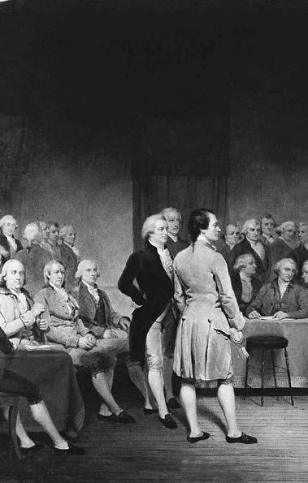

66

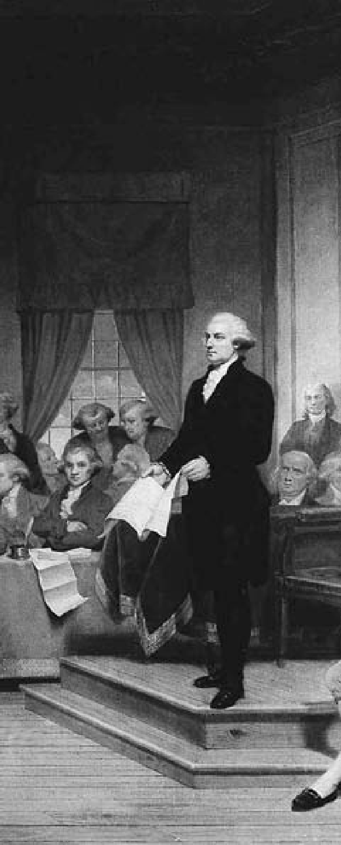

**C H A P T E R**

4

**THE FORMATION OF A NATIONAL GOVERNMENT**

George Washington addressing the Constitutional Convention in Philadelphia, 1787.

“Every man, and every body of men on Earth,

possesses the right of self-government.”

Drafter of the Declaration of Independence

Thomas Jefferson, 1790

**STATE CONSTITUTIONS**

# T

solid foundation of colonial experi- ence and English practice. But each

he success of the Revolution gave Americans the opportunity to give legal form to their ideals as expressed in the Declaration of Independence, and to remedy some of their griev- ances through state constitutions. As early as May 10, 1776, Congress had passed a resolution advising the colonies to form new govern- ments “such as shall best conduce to the happiness and safety of their constituents.” Some of them had al- ready done so, and within a year af- ter the Declaration of Independence, all but three had drawn up constitu- tions.

The new constitutions showed the impact of democratic ideas. None made any drastic break with the past, since all were built on the

was also animated by the spirit of re- publicanism, an ideal that had long been praised by Enlightenment phi- losophers.

Naturally, the first objective of the framers of the state constitu- tions was to secure those “unalien- able rights” whose violation had caused the former colonies to repu- diate their connection with Britain. Thus, each constitution began with a declaration or bill of rights. Virgin- ia’s, which served as a model for all the others, included a declaration of principles: popular sovereignty, rota- tion in office, freedom of elections, and an enumeration of fundamental liberties: moderate bail and humane punishment, speedy trial by jury, freedom of the press and of con-

science, and the right of the majority to reform or alter the government.

Other states enlarged the list of liberties to freedom of speech, of as- sembly, and of petition. Their con- stitutions frequently included such provisions as the right to bear arms, to a writ of habeas corpus, to invio- lability of domicile, and to equal pro- tection under the law. Moreover, all prescribed a three-branch structure of government — executive, legisla- tive, and judiciary — each checked and balanced by the others.

Pennsylvania’s constitution was the most radical. In that state, Phila- delphia artisans, Scots-Irish frontiers- men, and German-speaking farmers had taken control. The provincial congress adopted a constitution that permitted every male taxpayer and his sons to vote, required rotation in office (no one could serve as a rep- resentative more than four years out of every seven), and set up a single- chamber legislature.

The state constitutions had some glaring limitations, particularly by more recent standards. Constitu- tions established to guarantee people their natural rights did not secure for everyone the most fundamental natural right — equality. The colo- nies south of Pennsylvania excluded their slave populations from their inalienable rights as human beings. Women had no political rights. No state went so far as to permit univer- sal male suffrage, and even in those states that permitted all taxpayers to vote (Delaware, North Carolina, and Georgia, in addition to Pennsylva-

nia), office-holders were required to own a certain amount of property.

#### THE ARTICLES OF CONFEDERATION

**T**he struggle with England had done much to change colonial atti- tudes. Local assemblies had rejected

the Albany Plan of Union in 1754, re- fusing to surrender even the smallest part of their autonomy to any other body, even one they themselves had elected. But in the course of the Rev- olution, mutual aid had proved ef- fective, and the fear of relinquishing individual authority had lessened to a large degree.

John Dickinson produced the “Articles of Confederation and Per- petual Union” in 1776. The Conti- nental Congress adopted them in November 1777, and they went into effect in 1781, having been ratified by all the states. Reflecting the fragil- ity of a nascent sense of nationhood, the Articles provided only for a very loose union. The national govern- ment lacked the authority to set up tariffs, to regulate commerce, and to levy taxes. It possessed scant control of international relations: A number of states had begun their own nego- tiations with foreign countries. Nine states had their own armies, several their own navies. In the absence of a sound common currency, the new nation conducted its commerce with a curious hodgepodge of coins and a bewildering variety of state and na- tional paper bills, all fast depreciat- ing in value.

Economic difficulties after the war prompted calls for change. The end of the war had a severe effect on merchants who supplied the armies of both sides and who had lost the advantages deriving from participa- tion in the British mercantile system. The states gave preference to Ameri- can goods in their tariff policies, but these were inconsistent, leading to the demand for a stronger central government to implement a uniform policy.

Farmers probably suffered the most from economic difficulties following the Revolution. The supply of farm produce exceeded demand; unrest centered chiefly among farmer-debtors who wanted strong remedies to avoid foreclosure on their property and imprison- ment for debt. Courts were clogged with suits for payment filed by their creditors. All through the summer of 1786, popular conventions and informal gatherings in several states demanded reform in the state administrations.

That autumn, mobs of farmers in Massachusetts under the leadership of a former army captain, Daniel Shays, began forcibly to prevent the county courts from sitting and passing further judgments for debt, pending the next state election. In January 1787 a ragtag army of 1,200 farmers moved toward the federal arsenal at Springfield. The rebels, armed chiefly with staves and pitchforks, were repulsed by a small state militia force; General Benjamin Lincoln then arrived with

reinforcements from Boston and routed the remaining Shaysites, whose leader escaped to Vermont. The government captured 14 rebels and sentenced them to death, but ul- timately pardoned some and let the others off with short prison terms. After the defeat of the rebellion, a newly elected legislature, whose majority sympathized with the reb- els, met some of their demands for debt relief.

#### THE PROBLEM OF EXPANSION

**W**ith the end of the Revolution, the United States again had to face the old unsolved Western ques-

tion, the problem of expansion, with its complications of land, fur trade, Indians, settlement, and lo- cal government. Lured by the rich- est land yet found in the country, pioneers poured over the Appala- chian Mountains and beyond. By 1775 the far-flung outposts scat- tered along the waterways had tens of thousands of settlers. Separated by mountain ranges and hundreds of kilometers from the centers of political authority in the East, the inhabitants established their own governments. Settlers from all the Tidewater states pressed on into the fertile river valleys, hardwood forests, and rolling prairies of the interior. By 1790 the population of the trans-Appalachian region num- bered well over 120,000.

Before the war, several colonies had laid extensive and often over- lapping claims to land beyond the

Appalachians. To those without such claims this rich territorial prize seemed unfairly apportioned. Mary- land, speaking for the latter group, introduced a resolution that the western lands be considered com- mon property to be parceled by the Congress into free and independent governments. This idea was not re- ceived enthusiastically. Nonethe- less, in 1780 New York led the way by ceding its claims. In 1784 Virgin- ia, which held the grandest claims, relinquished all land north of the Ohio River. Other states ceded their claims, and it became apparent that Congress would come into posses- sion of all the lands north of the Ohio River and west of the Allegh- eny Mountains. This common pos- session of millions of hectares was the most tangible evidence yet of na- tionality and unity, and gave a cer- tain substance to the idea of national sovereignty. At the same time, these vast territories were a problem that required solution.

The Confederation Congress es- tablished a system of limited self- government for this new national Northwest Territory. The Northwest Ordinance of 1787 provided for its organization, initially as a single district, ruled by a governor and judges appointed by the Congress. When this territory had 5,000 free male inhabitants of voting age, it was to be entitled to a legislature of two chambers, itself electing the lower house. In addition, it could at that time send a nonvoting delegate to Congress. Three to five states

would be formed as the territory was settled. Whenever any one of them had 60,000 free inhabitants, it was to be admitted to the Union “on an equal footing with the original states in all respects.” The ordinance guaranteed civil rights and liberties, encouraged education, and prohib- ited slavery or other forms of invol- untary servitude.

The new policy repudiated the time-honored concept that colonies existed for the benefit of the mother country, were politically subordi- nate, and peopled by social inferiors. Instead, it established the principle that colonies (“territories”) were an extension of the nation and entitled, not as a privilege but as a right, to all the benefits of equality.

#### CONSTITUTIONAL CONVENTION

**B**y the time the Northwest Ordi- nance was enacted, American leaders were in the midst of drafting a new

and stronger constitution to replace the Articles of Confederation. Their presiding officer, George Washing- ton, had written accurately that the states were united only by a “rope of sand.” Disputes between Maryland and Virginia over navigation on the Potomac River led to a confer- ence of representatives of five states at Annapolis, Maryland, in 1786. One of the delegates, Alexander Hamilton of New York, convinced his colleagues that commerce was bound up with large political and economic questions. What was re-

quired was a fundamental rethink- ing of the Confederation.

The Annapolis conference issued a call for all the states to appoint representatives to a convention to be held the following spring in Philadel- phia. The Continental Congress was at first indignant over this bold step, but it acquiesced after Washington gave the project his backing and was elected a delegate. During the next fall and winter, elections were held in all states but Rhode Island.

A remarkable gathering of no- tables assembled at the Federal Convention in May 1787. The state legislatures sent leaders with expe- rience in colonial and state govern- ments, in Congress, on the bench, and in the army. Washington, re- garded as the country’s first citizen because of his integrity and his mili- tary leadership during the Revolu- tion, was chosen as presiding officer. Prominent among the more active members were two Pennsylvanians: Gouverneur Morris, who clearly saw the need for national government, and James Wilson, who labored in- defatigably for the national idea. Also elected by Pennsylvania was Benjamin Franklin, nearing the end of an extraordinary career of public service and scientific achievement. From Virginia came James Madison, a practical young statesman, a thor- ough student of politics and history, and, according to a colleague, “from a spirit of industry and application ... the best-informed man on any point in debate.” He would be recognized

as the “Father of the Constitution.”

Massachusetts sent Rufus King and Elbridge Gerry, young men of ability and experience. Roger Sher- man, shoemaker turned judge, was one of the representatives from Connecticut. From New York came Alexander Hamilton, who had pro- posed the meeting. Absent from the Convention were Thomas Jefferson, who was serving as minister repre- senting the United States in France, and John Adams, serving in the same capacity in Great Britain. Youth pre- dominated among the 55 delegates — the average age was 42.

Congress had authorized the Convention merely to draft amend- ments to the Articles of Confedera- tion but, as Madison later wrote, the delegates, “with a manly confidence in their country,” simply threw the Articles aside and went ahead with the building of a wholly new form of government.

They recognized that the para- mount need was to reconcile two different powers — the power of local control, which was already being exercised by the 13 semi-in- dependent states, and the power of a central government. They adopted the principle that the functions and powers of the national government

* being new, general, and inclusive
* had to be carefully defined and stated, while all other functions and powers were to be understood as be- longing to the states. But realizing that the central government had to have real power, the delegates also generally accepted the fact that the government should be authorized,

among other things, to coin money, to regulate commerce, to declare war, and to make peace.

#### DEBATE AND COMPROMISE

**T**he 18th-century statesmen who met in Philadelphia were adherents of Montesquieu’s concept of the

balance of power in politics. This principle was supported by colo- nial experience and strengthened by the writings of John Locke, with which most of the delegates were fa- miliar. These influences led to the conviction that three equal and co- ordinate branches of government should be established. Legislative, executive, and judicial powers were to be so harmoniously balanced that no one could ever gain control. The delegates agreed that the legislative branch, like the colonial legislatures and the British Parliament, should consist of two houses.

On these points there was una- nimity within the assembly. But sharp differences also arose. Repre- sentatives of the small states — New Jersey, for instance — objected to changes that would reduce their in- fluence in the national government by basing representation upon popu- lation rather than upon statehood, as was the case under the Articles of Confederation.

On the other hand, representa- tives of large states, like Virginia, argued for proportionate represen- tation. This debate threatened to go on endlessly until Roger Sherman came forward with arguments for

representation in proportion to the population of the states in one house of Congress, the House of Represen- tatives, and equal representation in the other, the Senate.

The alignment of large against small states then dissolved. But al- most every succeeding question raised new divisions, to be resolved only by new compromises. Northern- ers wanted slaves counted when de- termining each state’s tax share, but not in determining the number of seats a state would have in the House of Representatives. Under a com- promise reached with little dissent, tax levies and House membership would be apportioned according to the number of free inhabitants plus three-fifths of the slaves.

Certain members, such as Sher- man and Elbridge Gerry, still smart- ing from Shays’s Rebellion, feared that the mass of people lacked suf- ficient wisdom to govern themselves and thus wished no branch of the federal government to be elected di- rectly by the people. Others thought the national government should be given as broad a popular base as possible. Some delegates wished to exclude the growing West from the opportunity of statehood; others championed the equality principle established in the Northwest Ordi- nance of 1787.

There was no serious difference on such national economic ques- tions as paper money, laws concern- ing contract obligations, or the role of women, who were excluded from politics. But there was a need for

balancing sectional economic in- terests; for settling arguments as to the powers, term, and selection of the chief executive; and for solving problems involving the tenure of judges and the kind of courts to be established.

Laboring through a hot Philadel- phia summer, the convention finally achieved a draft incorporating in a brief document the organization of the most complex government yet devised, one that would be su- preme within a clearly defined and limited sphere. It would have full power to levy taxes, borrow money, establish uniform duties and ex- cise taxes, coin money, regulate in- terstate commerce, fix weights and measures, grant patents and copy- rights, set up post offices, and build post roads. It also was authorized to raise and maintain an army and navy, manage Native American af- fairs, conduct foreign policy, and wage war. It could pass laws for naturalizing foreigners and control- ling public lands; it could admit new states on a basis of absolute equal- ity with the old. The power to pass all necessary and proper laws for executing these clearly defined pow- ers rendered the federal government able to meet the needs of later gen- erations and of a greatly expanded body politic.

The principle of separation of powers had already been given a fair trial in most state constitutions and had proved sound. Accordingly, the convention set up a governmental

system with separate legislative, ex- ecutive, and judiciary branches, each checked by the others. Thus congressional enactments were not to become law until approved by the president. And the president was to submit the most important of his ap- pointments and all his treaties to the Senate for confirmation. The presi- dent, in turn, could be impeached and removed by Congress. The ju- diciary was to hear all cases arising under federal laws and the Con- stitution; in effect, the courts were empowered to interpret both the fundamental and the statute law. But members of the judiciary, appointed by the president and confirmed by the Senate, could also be impeached by Congress.

To protect the Constitution from hasty alteration, Article V stipulated that amendments to the Constitution be proposed either by two-thirds of both houses of Con- gress or by two-thirds of the states, meeting in convention. The propos- als were to be ratified by one of two methods: either by the legislatures of three-fourths of the states, or by convention in three-fourths of the states, with the Congress proposing the method to be used.

Finally, the convention faced the most important problem of all: How should the powers given to the new government be enforced? Under the Articles of Confedera- tion, the national government had possessed — on paper — signifi- cant powers, which, in practice, had

come to naught, for the states paid no attention to them. What was to save the new government from the same fate?

At the outset, most delegates fur- nished a single answer — the use of force. But it was quickly seen that the application of force upon the states would destroy the Union. The deci- sion was that the government should not act upon the states but upon the people within the states, and should legislate for and upon all the indi- vidual residents of the country. As the keystone of the Constitution, the convention adopted two brief but highly significant statements:

*Congress shall have power ... to make all Laws which shall be necessary and proper for carrying into Execution the ... Powers vested by this Constitution in the Government of the United States.*

*...* (Article I, Section 7)

*This Constitution, and the Laws of the United States which shall be made in Pursuance thereof; and all Treaties made, or which shall be made, under the Authority of the United States, shall be the supreme Law of the Land; and the Judges in every State shall be bound thereby,*

*any Thing in the Constitution or Laws of any State to the Contrary notwithstanding.* (Article VI)

Thus the laws of the United States became enforceable in its own na- tional courts, through its own judges and marshals, as well as in the state courts through the state judges and state law officers.

Debate continues to this day about the motives of those who wrote the Constitution. In 1913 his- torian Charles Beard, in *An Econom- ic Interpretation of the Constitution*, argued that the Founding Fathers represented emerging commercial- capitalist interests that needed a strong national government. He also believed many may have been motivated by personal holdings of large amounts of depreciated gov- ernment securities. However, James Madison, principal drafter of the Constitution, held no bonds and was a Virginia planter. Conversely, some opponents of the Constitu- tion owned large amounts of bonds and securities. Economic interests influenced the course of the debate, but so did state, sectional, and ideo- logical interests. Equally important was the idealism of the framers. Products of the Enlightenment, the Founding Fathers designed a gov- ernment that they believed would promote individual liberty and pub- lic virtue. The ideals embodied in the U.S. Constitution remain an es- sential element of the American na- tional identity.

#### RATIFICATION AND THE BILL OF RIGHTS

**O**n September 17, 1787, after 16 weeks of deliberation, the finished Constitution was signed by 39 of

the 42 delegates present. Franklin, pointing to the half-sun painted in brilliant gold on the back of Wash- ington’s chair, said:

*I have often in the course of the session ... looked at that [chair] behind the president, without being able to tell whether it was rising or setting; but now, at length, I have the happiness to know that it is a rising, and not a setting, sun.*

The convention was over; the members “adjourned to the City Tavern, dined together, and took a cordial leave of each other.” Yet a crucial part of the struggle for a more perfect union remained to be faced. The consent of popularly elected state conventions was still required before the document could become effective.

The convention had decided that the Constitution would take effect upon ratification by conventions in nine of the 13 states. By June 1788 the required nine states had ratified the Constitution, but the large states of Virginia and New York had not. Most people felt that without their support the Constitution would nev- er be honored. To many, the docu- ment seemed full of dangers: Would not the strong central government that it established tyrannize them, oppress them with heavy taxes, and drag them into wars?

Differing views on these ques- tions brought into existence two par- ties, the Federalists, who favored a strong central government, and the Antifederalists, who preferred a loose association of separate states. Impas- sioned arguments on both sides were voiced by the press, the legislatures, and the state conventions.

In Virginia, the Antifederalists attacked the proposed new gov- ernment by challenging the open- ing phrase of the Constitution: “We the People of the United States.” Without using the individual state names in the Constitution, the del- egates argued, the states would not retain their separate rights or pow- ers. Virginia Antifederalists were led by Patrick Henry, who became the chief spokesman for back-coun- try farmers who feared the powers of the new central government. Wa- vering delegates were persuaded by a proposal that the Virginia con- vention recommend a bill of rights, and Antifederalists joined with the Federalists to ratify the Constitution on June 25.

In New York, Alexander Ham- ilton, John Jay, and James Madison pushed for the ratification of the Constitution in a series of essays known as *The Federalist Papers*. The essays, published in New York newspapers, provided a now-classic argument for a central federal gov- ernment, with separate executive, legislative, and judicial branches that checked and balanced one another. With *The Federalist Papers* influenc- ing the New York delegates, the Con- stitution was ratified on July 26.

Antipathy toward a strong cen- tral government was only one con- cern among those opposed to the Constitution; of equal concern to many was the fear that the Constitution did not protect individ- ual rights and freedoms sufficiently. Virginian George Mason, author

of Virginia’s Declaration of Rights of 1776, was one of three delegates to the Constitutional Convention who had refused to sign the final document because it did not enu- merate individual rights. Together with Patrick Henry, he campaigned vigorously against ratification of the Constitution by Virginia. Indeed, five states, including Massachusetts, ratified the Constitution on the con- dition that such amendments be added immediately.

When the first Congress con- vened in New York City in Septem- ber 1789, the calls for amendments protecting individual rights were virtually unanimous. Congress quickly adopted 12 such amend- ments; by December 1791, enough states had ratified 10 amendments to make them part of the Constitu- tion. Collectively, they are known as the Bill of Rights. Among their provisions: freedom of speech, press, religion, and the right to assemble peacefully, protest, and demand changes (First Amendment); protec- tion against unreasonable search- es, seizures of property, and arrest (Fourth Amendment); due process of law in all criminal cases (Fifth Amendment); right to a fair and speedy trial (Sixth Amendment); protection against cruel and unusual punishment (Eighth Amendment); and provision that the people retain additional rights not listed in the Constitution (Ninth Amendment).

Since the adoption of the Bill of Rights, only 17 more amend- ments have been added to the

Constitution. Although a number of the subsequent amendments re- vised the federal government’s struc- ture and operations, most followed the precedent established by the Bill of Rights and expanded individual rights and freedoms.

#### PRESIDENT WASHINGTON

**O**ne of the last acts of the Con- gress of the Confederation was to ar- range for the first presidential elec-

tion, setting March 4, 1789, as the date that the new government would come into being. One name was on everyone’s lips for the new chief of state, George Washington. He was unanimously chosen president and took the oath of office at his inau- guration on April 30, 1789. In words spoken by every president since, Washington pledged to execute the duties of the presidency faithfully and, to the best of his ability, to “pre- serve, protect, and defend the Con- stitution of the United States.”

When Washington took office, the new Constitution enjoyed nei- ther tradition nor the full backing of organized public opinion. The new government had to create its own machinery and legislate a system of taxation that would support it. Until a judiciary could be established, laws could not be enforced. The army was small. The navy had ceased to exist. Congress quickly created the de- partments of State and Treasury, with Thomas Jefferson and Alex- ander Hamilton as their respective secretaries. Departments of War

and Justice were also created. Since Washington preferred to make de- cisions only after consulting those men whose judgment he valued, the American presidential Cabinet came into existence, consisting of the heads of all the departments that Congress might create. Simultane- ously, Congress provided for a fed- eral judiciary — a Supreme Court, with one chief justice and five associ- ate justices, three circuit courts, and 13 district courts.

Meanwhile, the country was growing steadily and immigration from Europe was increasing. Ameri- cans were moving westward: New Englanders and Pennsylvanians into Ohio; Virginians and Carolinians into Kentucky and Tennessee. Good farms were to be had for small sums; labor was in strong demand. The rich valley stretches of upper New York, Pennsylvania, and Virginia soon became great wheat-growing areas.

Although many items were still homemade, the Industrial Revo- lution was dawning in the United States. Massachusetts and Rhode Is- land were laying the foundation of important textile industries; Con- necticut was beginning to turn out tinware and clocks; New York, New Jersey, and Pennsylvania were pro- ducing paper, glass, and iron. Ship- ping had grown to such an extent that on the seas the United States was second only to Britain. Even be- fore 1790, American ships were trav- eling to China to sell furs and bring back tea, spices, and silk.

At this critical juncture in the country’s growth, Washington’s wise leadership was crucial. He organized a national government, developed policies for settlement of territories previously held by Britain and Spain, stabilized the northwestern frontier, and oversaw the admission of three new states: Vermont (1791), Ken- tucky (1792), and Tennessee (1796). Finally, in his Farewell Address, he warned the nation to “steer clear of permanent alliances with any por- tion of the foreign world.” This ad- vice influenced American attitudes toward the rest of the world for gen- erations to come.

#### HAMILTON VS. JEFFERSON

**A** conflict took shape in the 1790s between America’s first political parties. Indeed, the Federalists, led

by Alexander Hamilton, and the Republicans (also called Demo- cratic-Republicans), led by Thomas Jefferson, were the first political parties in the Western world. Un- like loose political groupings in the British House of Commons or in the American colonies before the Revolution, both had reasonably consistent and principled platforms, relatively stable popular followings, and continuing organizations.

The Federalists in the main rep- resented the interests of trade and manufacturing, which they saw as forces of progress in the world. They believed these could be advanced only by a strong central government capable of establishing sound public

credit and a stable currency. Openly distrustful of the latent radicalism of the masses, they could nonetheless credibly appeal to workers and arti- sans. Their political stronghold was in the New England states. Seeing England as in many respects an ex- ample the United States should try to emulate, they favored good relations with their mother country.

Although Alexander Hamilton was never able to muster the popular appeal to stand successfully for elec- tive office, he was far and away the Federalists’ main generator of ideol- ogy and public policy. He brought to public life a love of efficiency, order, and organization. In response to the call of the House of Representatives for a plan for the “adequate support of public credit,” he laid down and supported principles not only of the public economy, but of effective gov- ernment. Hamilton pointed out that the United States must have credit for industrial development, com- mercial activity, and the operations of government, and that its obliga- tions must have the complete faith and support of the people.

There were many who wished to repudiate the Confederation’s na- tional debt or pay only part of it. Hamilton insisted upon full pay- ment and also upon a plan by which the federal government took over the unpaid debts of the states in- curred during the Revolution. He also secured congressional legisla- tion for a Bank of the United States. Modeled after the Bank of England, it acted as the nation’s central fi-

nancial institution and operated branches in different parts of the country. Hamilton sponsored a na- tional mint, and argued in favor of tariffs, saying that temporary pro- tection of new firms could help fos- ter the development of competitive national industries. These measures

* placing the credit of the feder- al government on a firm founda- tion and giving it all the revenues it needed — encouraged commerce and industry, and created a solid phalanx of interests firmly behind the national government.

The Republicans, led by Thomas Jefferson, spoke primarily for agri- cultural interests and values. They distrusted bankers, cared little for commerce and manufacturing, and believed that freedom and democra- cy flourished best in a rural society composed of self-sufficient farm- ers. They felt little need for a strong central government; in fact, they tended to see it as a potential source of oppression. Thus they favored states’ rights. They were strongest in the South.

Hamilton’s great aim was more efficient organization, whereas Jef- ferson once said, “I am not a friend to a very energetic government.” Hamilton feared anarchy and thought in terms of order; Jefferson feared tyranny and thought in terms of freedom. Where Hamilton saw England as an example, Jefferson, who had been minister to France in the early stages of the French Rev- olution, looked to the overthrow of the French monarchy as vindication

of the liberal ideals of the Enlighten- ment. Against Hamilton’s instinctive conservatism, he projected an elo- quent democratic radicalism.

An early clash between them, which occurred shortly after Jeffer- son took office as secretary of state, led to a new and profoundly impor- tant interpretation of the Constitu- tion. When Hamilton introduced his bill to establish a national bank, Jef- ferson, speaking for those who be- lieved in states’ rights, argued that the Constitution expressly enumer- ated all the powers belonging to the federal government and reserved all other powers to the states. Nowhere was the federal government empow- ered to set up a bank.

Hamilton responded that because of the mass of necessary detail, a vast body of powers had to be implied by general clauses, and one of these authorized Congress to “make all laws which shall be nec- essary and proper” for carrying out other powers specifically granted. The Constitution authorized the national government to levy and collect taxes, pay debts, and bor- row money. A national bank would materially help in performing these functions efficiently. Congress, therefore, was entitled, under its im- plied powers, to create such a bank. Washington and the Congress ac- cepted Hamilton’s view — and set an important precedent for an ex- pansive interpretation of the federal government’s authority.

#### CITIZEN GENET AND FOREIGN POLICY

**A**lthough one of the first tasks of the new government was to strengthen the domestic economy

and make the nation financially secure, the United States could not ignore foreign affairs. The corner- stones of Washington’s foreign pol- icy were to preserve peace, to give the country time to recover from its wounds, and to permit the slow work of national integration to continue. Events in Europe threat- ened these goals. Many Americans watched the French Revolution with keen interest and sympathy. In April 1793, news came that France had declared war on Great Britain and Spain, and that a new French envoy, Edmond Charles Genet — Citizen Genet — was coming to the United States.

When the revolution in France led to the execution of King Louis XVI in January 1793, Britain, Spain, and Holland became involved in war with France. According to the Franco-American Treaty of Alliance of 1778, the United States and France were perpetual allies, and the Unit- ed States was obliged to help France defend the West Indies. However, the United States, militarily and economically a very weak country, was in no position to become in- volved in another war with major European powers.

On April 22, 1793, Washington effectively abrogated the terms of the

1778 treaty that had made American independence possible by proclaim- ing the United States to be “friendly and impartial toward the belligerent powers.” When Genet arrived, he was cheered by many citizens, but treated with cool formality by the government. Angered, he violated a promise not to outfit a captured British ship as a privateer (private- ly owned warships commissioned to prey on ships of enemy nations). Genet then threatened to take his cause directly to the American peo- ple, over the head of the government. Shortly afterward, the United States requested his recall by the French government.

The Genet incident strained American relations with France at a time when those with Great Brit- ain were far from satisfactory. Brit- ish troops still occupied forts in the West, property carried off by British soldiers during the Revolution had not been restored or paid for, and the British Navy was seizing American ships bound for French ports. The two countries seemed to be drifting toward war. Washington sent John Jay, first chief justice of the Supreme Court, to London as a special envoy. Jay negotiated a treaty that secured withdrawal of British soldiers from western forts but allowed the British to continue the fur trade with the Indians in the Northwest. London agreed to pay damages for American ships and cargoes seized in 1793 and 1794, but made no commitments on possible future seizures. Moreover, the treaty failed to address the fes-

tering issue of British “impressment” of American sailors into the Royal Navy, placed severe limitations on American trade with the West In- dies, and accepted the British view that food and naval stores, as well as war materiel, were contraband sub- ject to seizure if bound for enemy ports on neutral ships.

American diplomat Charles Pinckney was more successful in dealing with Spain. In 1795, he negotiated an important treaty set- tling the Florida border on Ameri- can terms and giving Americans access to the port of New Orleans. All the same, the Jay Treaty with the British reflected a continu- ing American weakness vis-a-vis a world superpower. Deeply unpopu- lar, it was vocally supported only by Federalists who valued cultural and economic ties with Britain. Wash- ington backed it as the best bargain available, and, after a heated debate, the Senate approved it.

Citizen Genet’s antics and Jay’s Treaty demonstrated both the diffi- culties faced by a small weak nation caught between two great powers and the wide gap in outlook between Federalists and Republicans. To the Federalists, Republican backers of the increasingly violent and radical French Revolution were dangerous radicals (“Jacobins”); to the Repub- licans, advocates of amity with Eng- land were monarchists who would subvert the natural rights of Ameri- cans. The Federalists connected vir- tue and national development with commerce; the Republicans saw

America’s destiny as that of a vast agrarian republic. The politics of their conflicting positions became increasingly vehement.

#### ADAMS AND JEFFERSON

**W**ashington retired in 1797, firm- ly declining to serve for more than eight years as the nation’s head.

Thomas Jefferson of Virginia (Re- publican) and John Adams (Federal- ist) vied to succeed him. Adams won a narrow election victory. From the beginning, however, he was at the head of a party and an administra- tion divided between his backers and those of his rival, Hamilton.

Adams faced serious internation- al difficulties. France, angered by Jay’s treaty with Britain, adopted its definition of contraband and began to seize American ships headed for Britain. By 1797 France had snatched

300 American ships and broken off diplomatic relations with the United States. When Adams sent three commissioners to Paris to ne- gotiate, agents of Foreign Minis- ter Charles Maurice de Talleyrand (whom Adams labeled X, Y, and Z in his report to Congress) informed the Americans that negotiations could only begin if the United States loaned France $12 million and bribed of- ficials of the French government. American hostility to France rose to an excited pitch. The so-called XYZ Affair led to the enlistment of troops and the strengthening of the fledg- ling U.S. Navy.

In 1799, after a series of sea bat-

tles with the French, war seemed inevitable. In this crisis, Adams re- jected the guidance of Hamilton, who wanted war, and reopened ne- gotiations with France. Napoleon, who had just come to power, re- ceived them cordially. The danger of conflict subsided with the nego- tiation of the Convention of 1800, which formally released the United States from its 1778 defense alliance with France. However, reflecting American weakness, France refused to pay $20 million in compensation for American ships taken by the French Navy.

Hostility to France had led Con- gress to pass the Alien and Sedition Acts, which had severe repercus- sions for American civil liberties. The Naturalization Act, which changed the requirement for citi- zenship from five to 14 years, was targeted at Irish and French immi- grants suspected of supporting the Republicans. The Alien Act, oper- ative for two years only, gave the president the power to expel or im- prison aliens in time of war. The Sedition Act proscribed writing, speaking, or publishing anything of “a false, scandalous, and mali- cious” nature against the president or Congress. The few convictions won under it created martyrs to the cause of civil liberties and aroused support for the Republicans.

The acts met with resistance. Jef- ferson and Madison sponsored the passage of the Kentucky and Virgin- ia Resolutions by the legislatures of these two states in November and

December 1798. Extreme declara- tion of states’ rights, the resolutions asserted that states could “interpose” their views on federal actions and “nullify” them. The doctrine of nul- lification would be used later for the Southern states’ resistance to protec- tive tariffs, and, more ominously, slavery.

By 1800 the American people were ready for a change. Under Washington and Adams, the Feder- alists had established a strong gov- ernment, but sometimes failing to honor the principle that the Ameri- can government must be responsive to the will of the people, they had followed policies that alienated large groups. For example, in 1798 they had enacted a tax on houses, land, and slaves, affecting every property owner in the country.

Jefferson had steadily gathered behind him a great mass of small farmers, shopkeepers, and other workers. He won a close victory in a contested election. Jefferson en- joyed extraordinary favor because of his appeal to American idealism. In his inaugural address, the first such speech in the new capital of Wash- ington, D.C., he promised “a wise and frugal government” that would preserve order among the inhabit- ants but leave people “otherwise free to regulate their own pursuits of in- dustry, and improvement.”

Jefferson’s mere presence in the White House encouraged demo- cratic procedures. He preached and practiced democratic simplic- ity, eschewing much of the pomp

and ceremony of the presidency. In line with Republican ideology, he sharply cut military expenditures. Believing America to be a haven for the oppressed, he secured a lib- eral naturalization law. By the end of his second term, his far-sighted secretary of the treasury, Albert Gallatin, had reduced the national debt to less than $560 million. Wide- ly popular, Jefferson won reelection as president easily.

#### LOUISIANA AND BRITAIN

**O**ne of Jefferson’s acts doubled the area of the country. At the end of the Seven Years’ War, France had ceded

its territory west of the Mississippi River to Spain. Access to the port of New Orleans near its mouth was vital for the shipment of American products from the Ohio and Missis- sippi river valleys. Shortly after Jef- ferson became president, Napoleon forced a weak Spanish government to cede this great tract, the Louisiana Territory, back to France. The move filled Americans with apprehension and indignation. French plans for a huge colonial empire just west of the United States seriously threat- ened the future development of the United States. Jefferson asserted that if France took possession of Loui- siana, “from that moment we must marry ourselves to the British fleet and nation.”

Napoleon, however, lost interest after the French were expelled from Haiti by a slave revolt. Knowing that another war with Great Britain was

impending, he resolved to fill his treasury and put Louisiana beyond the reach of Britain by selling it to the United States. His offer present- ed Jefferson with a dilemma: The Constitution conferred no explicit power to purchase territory. At first the president wanted to propose an amendment, but delay might lead Napoleon to change his mind. Ad- vised that the power to purchase territory was inherent in the power to make treaties, Jefferson relented, saying that “the good sense of our country will correct the evil of loose construction when it shall produce ill effects.”

The United States obtained the “Louisiana Purchase” for $15 mil- lion in 1803. It contained more than 2,600,000 square kilometers as well as the port of New Orleans. The nation had gained a sweep of rich plains, mountains, forests, and river systems that within 80 years would become its heartland — and a bread- basket for the world.

As Jefferson began his second term in 1805, he declared American neutrality in the struggle between Great Britain and France. Although both sides sought to restrict neutral shipping to the other, British con- trol of the seas made its interdiction and seizure much more serious than any actions by Napoleonic France. British naval commanders routinely searched American ships, seized ves- sels and cargoes, and took off sailors believed to be British subjects. They also frequently impressed American seamen into their service.

When Jefferson issued a procla- mation ordering British warships to leave U.S. territorial waters, the British reacted by impressing more sailors. Jefferson then decided to rely on economic pressure; in December 1807 Congress passed the Embargo Act, forbidding all foreign com- merce. Ironically, the law required strong police authority that vastly increased the powers of the national government. Economically, it was disastrous. In a single year Ameri- can exports fell to one-fifth of their former volume. Shipping interests were almost ruined by the measure; discontent rose in New England and New York. Agricultural interests suffered heavily also. Prices dropped drastically when the Southern and Western farmers could not export their surplus grain, cotton, meat, and tobacco.

The embargo failed to starve Great Britain into a change of pol- icy. As the grumbling at home in- creased, Jefferson turned to a milder measure, which partially conciliated domestic shipping interests. In early 1809 he signed the Non-Intercourse Act permitting commerce with all countries except Britain or France and their dependencies.

James Madison succeeded Jeffer- son as president in 1809. Relations with Great Britain grew worse, and the two countries moved rapidly to- ward war. The president laid before Congress a detailed report, showing several thousand instances in which the British had impressed American citizens. In addition, northwestern

settlers had suffered from attacks by Indians whom they believed had been incited by British agents in Canada. In turn, many Americans favored conquest of Canada and the elimination of British influence in North America, as well as vengeance for impressment and commercial repression. By 1812, war fervor was dominant. On June 18, the United States declared war on Britain.

#### THE WAR OF 1812

**T**he nation went to war bitterly divided. While the South and West favored the conflict, New York and

New England opposed it because it interfered with their commerce. The U.S. military was weak. The army had fewer than 7,000 regular soldiers, distributed in widely scat- tered posts along the coast, near the Canadian border, and in the re- mote interior. The state militias were poorly trained and undisciplined.

Hostilities began with an inva- sion of Canada, which, if properly timed and executed, would have brought united action against Mon- treal. Instead, the entire campaign miscarried and ended with the Brit- ish occupation of Detroit. The U.S. Navy, however, scored successes. In addition, American privateers, swarming the Atlantic, captured 500 British vessels during the fall and winter months of 1812 and 1813.

The campaign of 1813 centered on Lake Erie. General William Henry Harrison — who would lat- er become president — led an army

of militia, volunteers, and regulars from Kentucky with the object of reconquering Detroit. On September 12, while he was still in upper Ohio, news reached him that Commodore Oliver Hazard Perry had annihilated the British fleet on Lake Erie. Har- rison occupied Detroit and pushed into Canada, defeating the fleeing British and their Indian allies on the Thames River. The entire region now came under American control.

A year later Commodore Thomas Macdonough won a point-blank gun duel with a British flotilla on Lake Champlain in upper New York. De- prived of naval support, a British in- vasion force of 10,000 men retreated to Canada. Nevertheless, the Brit- ish fleet harassed the Eastern sea- board with orders to “destroy and lay waste.” On the night of August 24, 1814, an expeditionary force routed American militia, marched to Washington, D.C., and left the city in flames. President James Madison fled to Virginia.

British and American negotia- tors conducted talks in Europe. The British envoys decided to concede, however, when they learned of Mac- donough’s victory on Lake Champ- lain. Faced with the depletion of the British treasury due in large part to the heavy costs of the Napoleonic Wars, the negotiators for Great Brit- ain accepted the Treaty of Ghent in December 1814. It provided for the cessation of hostilities, the restora- tion of conquests, and a commission to settle boundary disputes. Unaware that a peace treaty had been signed,

the two sides continued fighting into 1815 near New Orleans, Louisiana. Led by General Andrew Jackson, the United States scored the great- est land victory of the war, ending once and for all any British hopes of reestablishing continental influence south of the Canadian border.

While the British and Americans were negotiating a settlement, Fed- eralist delegates selected by the leg- islatures of Massachusetts, Rhode Island, Connecticut, Vermont, and New Hampshire gathered in Hart- ford, Connecticut, to express oppo- sition to “Mr. Madison’s war.” New England had managed to trade with

the enemy throughout the conflict, and some areas actually prospered from this commerce. Nevertheless, the Federalists claimed that the war was ruining the economy. With a possibility of secession from the Union in the background, the con- vention proposed a series of consti- tutional amendments that would protect New England interests. In- stead, the end of the war, punctuated by the smashing victory at New Or- leans, stamped the Federalists with a stigma of disloyalty from which they never recovered. 9

OUTLINE OF U.S. HISTORY

**THE SECOND GREAT AWAKENING**

**B**y the end of the 18th century, many educated Americans no longer

professed traditional Christian beliefs. In reaction to the secularism of the age, a religious revival spread westward in the first half of the 19th century.

This “Second Great Awakening” consisted of several kinds of activity, distinguished by locale and expression of religious commitment. In New England, the renewed interest in religion inspired a wave of social activism. In western New York, the spirit of revival encouraged the emergence of new denominations. In the Appalachian region of Kentucky and Tennessee, the

revival strengthened the Methodists and the Baptists, and spawned a new form of religious expression — the camp meeting.

In contrast to the Great Awakening of the 1730s, the revivals in the East were notable for the absence of hysteria and open emotion. Rather, unbelievers were awed by the “respectful silence” of those bearing witness to their faith. The evangelical enthusiasm in New England gave rise to interdenominational missionary societies, formed to evangelize the West.

Members of these societies not only acted as apostles for the faith, but as educators, civic leaders, and exponents of Eastern, urban culture. Publication and education societies promoted Christian education. Most notable among them was the American Bible Society, founded in 1816. Social activism inspired by the revival gave rise to abolition of slavery groups and the Society for the Promotion of Temperance, as well as to efforts to reform prisons and care for the handicapped and mentally ill.

Western New York, from Lake Ontario to the Adirondack Mountains, had been the scene of so many religious revivals in the past that it was known as the “Burned-Over District.” Here, the dominant figure was Charles Grandison Finney, a lawyer who had experienced a religious epiphany and set out to preach the Gospel. His revivals were characterized by careful planning, showmanship, and advertising. Finney preached in the Burned-Over District throughout the 1820s and the early 1830s, before moving to Ohio in 1835

to take a chair in theology at Oberlin College, of which he subsequently became president.

Two other important religious denominations in America — the Mormons and the Seventh Day Adventists — also got their start in the Burned-

Over District.

87

CHAPTER 4: THE FORMATION OF A NATIONAL GOVERNMENT

In the Appalachian region, the revival took on characteristics similar to the Great Awakening of the previous century. But here, the center of the revival was the camp meeting, a religious service of several days’ length, for a group that was obliged to take shelter on the spot because of the distance from home. Pioneers in thinly populated areas looked to the camp meeting as a refuge from the lonely life on the frontier. The sheer exhilaration of participating in a religious revival with hundreds and perhaps thousands

of people inspired the dancing, shouting, and singing associated with these events. Probably the largest camp meeting was at Cane Ridge, Kentucky, in August 1801; between 10,000 and 25,000 people attended.

The great revival quickly spread throughout Kentucky, Tennessee, and southern Ohio, with the Methodists and the Baptists its prime beneficiaries. Each denomination had assets that allowed it to thrive on the frontier. The Methodists had a very efficient organization that depended on ministers — known as circuit riders — who sought out people in remote frontier locations. The circuit riders came from among the common people and possessed a rapport with the frontier families they hoped to convert. The Baptists had

no formal church organization. Their farmer-preachers were people who received “the call” from God, studied the Bible, and founded a church, which then ordained them. Other candidates for the ministry emerged from these churches, and established a presence farther into the wilderness. Using such methods, the Baptists became dominant throughout the border states and most of the South.

The Second Great Awakening exercised a profound impact on American history. The numerical strength of the Baptists and Methodists rose relative to that of the denominations dominant in the colonial period — Anglicans,

Presbyterians, and Congregationalists. The growing differences

within American Protestantism reflected the growth and diversity of an expanding nation. ◆

88

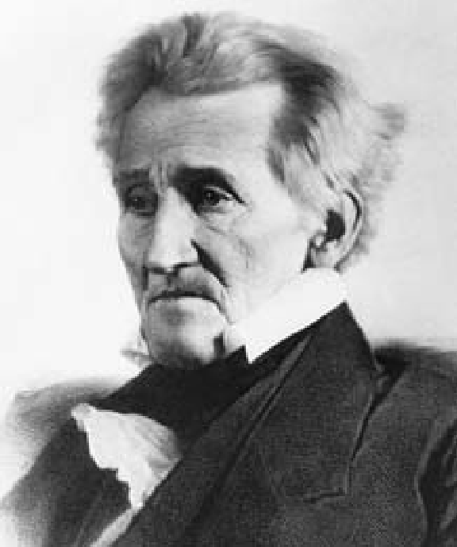Andrew Jackson, president from 1829 to 1837. Charismatic, forceful, and passionate, Jackson forged an effective political coalition within the Democratic Party with Westerners, farmers, and working people.

TRANSFORMING

A N A T I O N

A PICTURE PROFILE

**The United States transformed itself again in the 19th and early 20th centuries. A rural, agricultural nation became an industrial power whose backbone was steel and coal, railroads,**

**and steam power. A young country once bound by the Mississippi River expanded across the North American continent, and on to overseas territories. A nation divided by the issue of slavery and tested by the trauma of civil war became a world power whose global influence was first felt in World War I.**

89

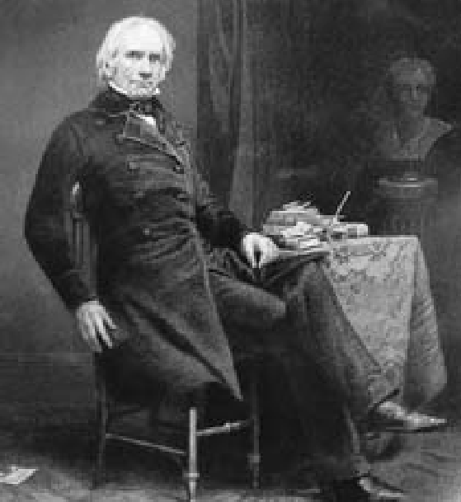Henry Clay of Kentucky, although never president, was one of the most influential American politicians of the first half of the 19th century. Clay became indispensable for his role in preserving the Union with the Missouri Compromise of 1820 and the Compromise of 1850. Both pieces of legislation resolved, for a time, disputes over slavery in

the territories.

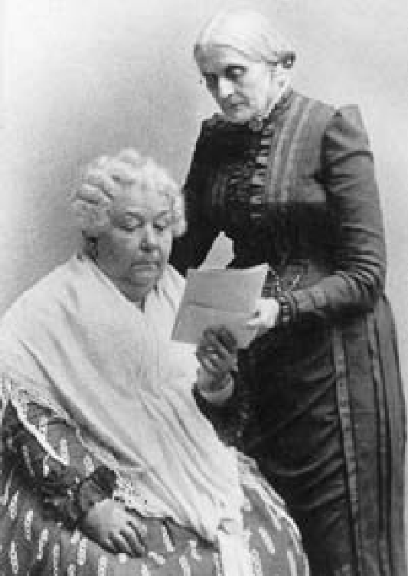The great champions of women’s rights in the 19th century: Elizabeth Cady Stanton (seated) and Susan

B. Anthony. Stanton helped organize the first women’s rights convention in 1848

in Seneca Falls, New York. In later years, she joined Anthony in founding the National Woman Suffrage Association. “I forged the thunderbolts,” Stanton said

of their partnership, “and she fired them.”

90

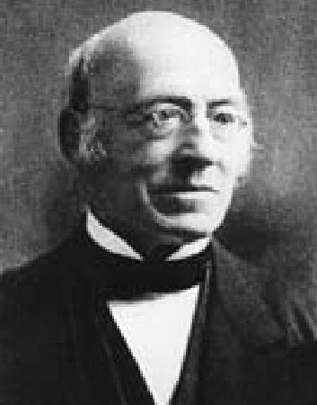

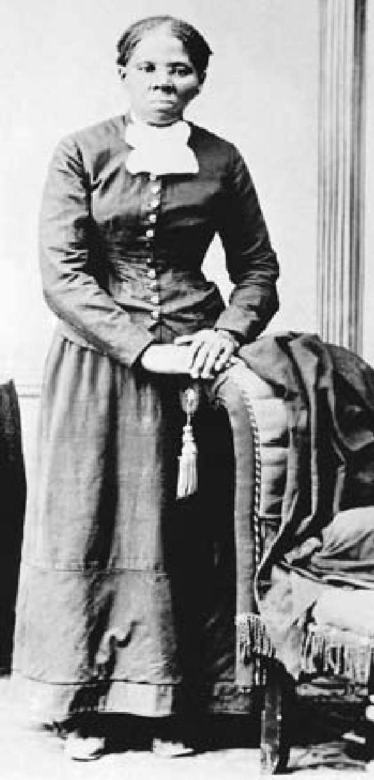William Lloyd Garrison, whose passionate denunciations of slavery and eloquent defense of the rights of enslaved African Americans appeared in his weekly paper, the

*Liberator*, from its first issue in 1831 to 1865, when the last issue appeared at the close of the Civil War.

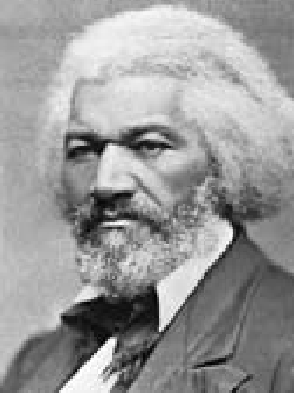

Frederick Douglass, the nation’s leading African-American abolitionist of the 19th century, escaped from slavery in 1838. His speech about his sufferings as a slave at the Massachusetts Anti-

Slavery Society’s annual convention in Nantucket launched his career as an outspoken lecturer, writer, and publisher on the abolition of slavery and racial equality.

Harriet Tubman, a former slave who rescued hundreds from slavery through the Underground Railroad. The Underground Railroad was a vast network of people who helped fugitive slaves escape to the North and to Canada in the first half of the 19th century.

91

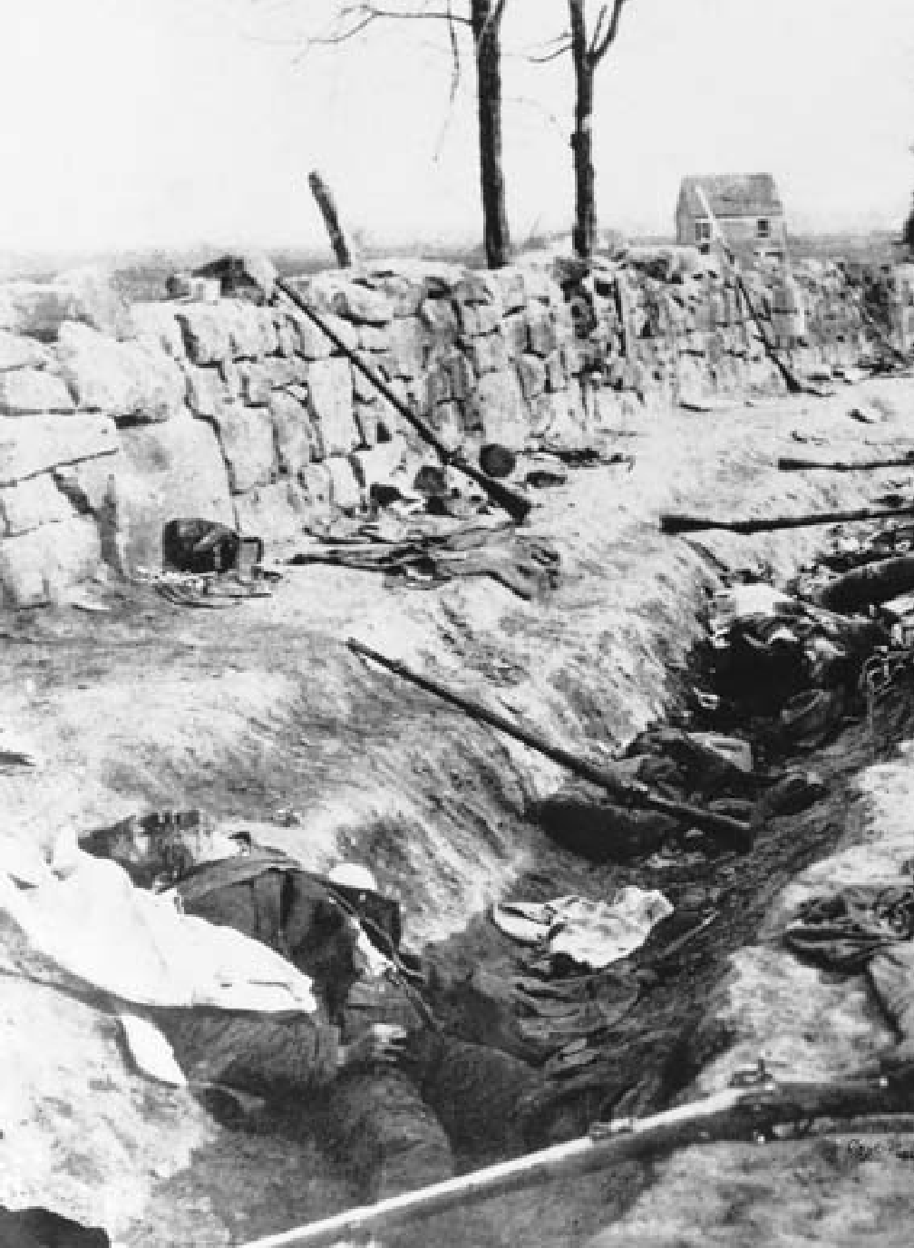

Confederate dead along a stone wall during the Chancellorsville campaign, May 1863. Victorious at Chancellorsville, Southern forces advanced north into Pennsylvania, but were defeated at the three-day battle of Gettysburg, the turning point of the Civil War and the largest battle ever fought in North America. More Americans died in the Civil War (1861-65) than in any other conflict in U.S. history.

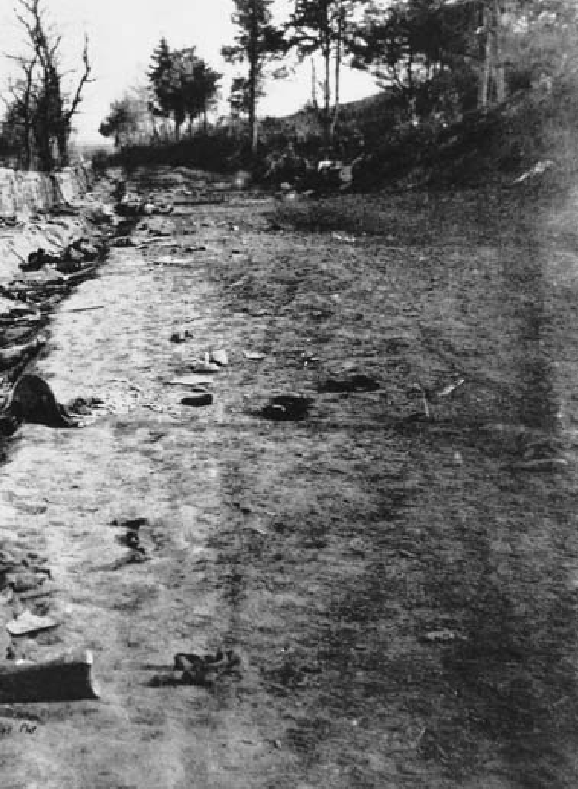

93

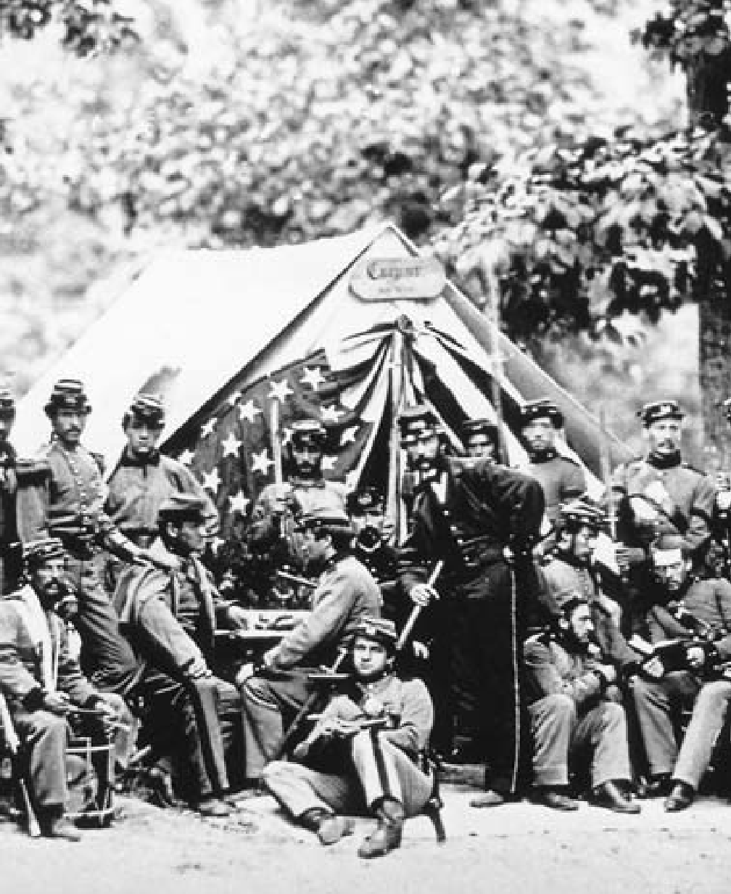

Encampment of Union troops from New York in Alexandria, Virginia, just across the Potomac River from the capital of Washington.

94

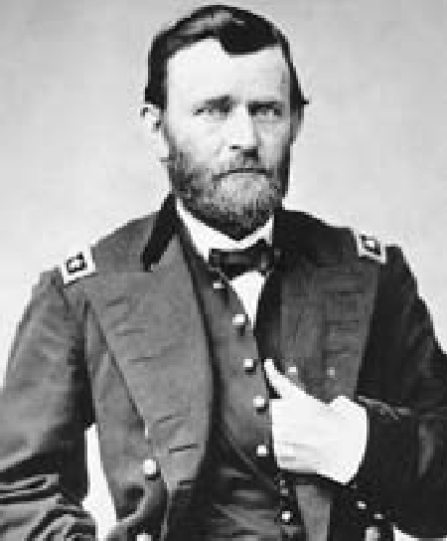

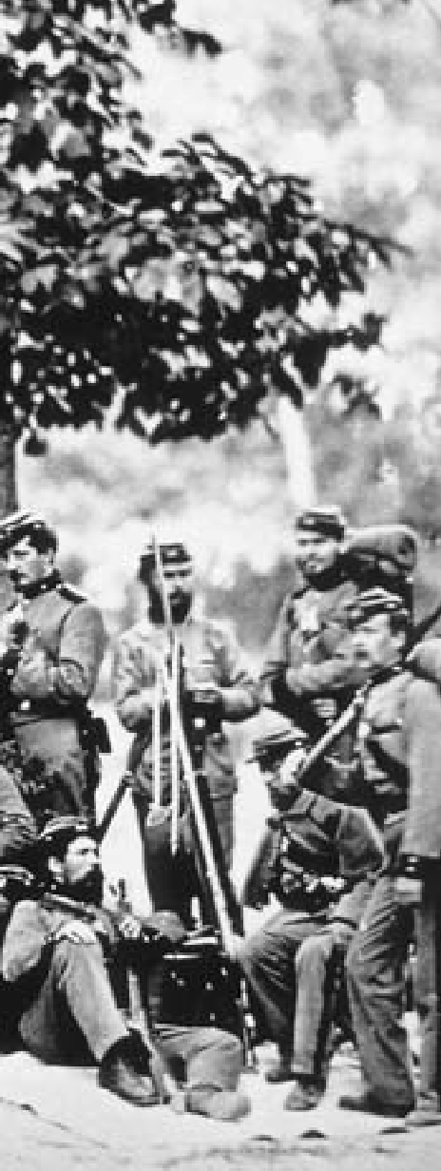Union General Ulysses S. Grant, who led Union forces to victory in the Civil War and became the 18th president of the United States. Despite heavy losses in several battles against his opponent, General Lee (below), Grant refused to retreat, leading President Lincoln to say to critics calling for his removal, “I can’t spare this general. He fights.”

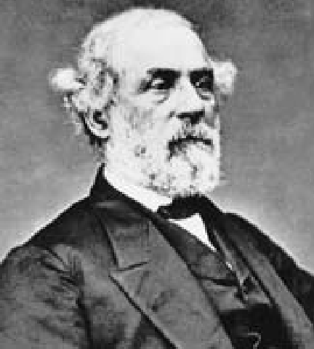

Confederate General Robert E. Lee. Military historians to this day study his tactics

and Grant’s in battles such as Vicksburg, Chancellorsville, and the Wilderness.

95

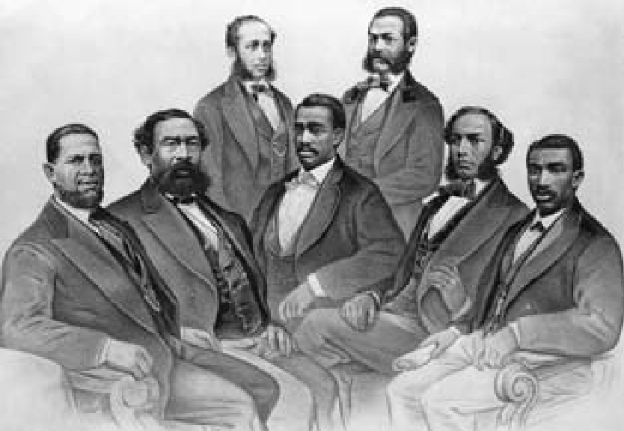

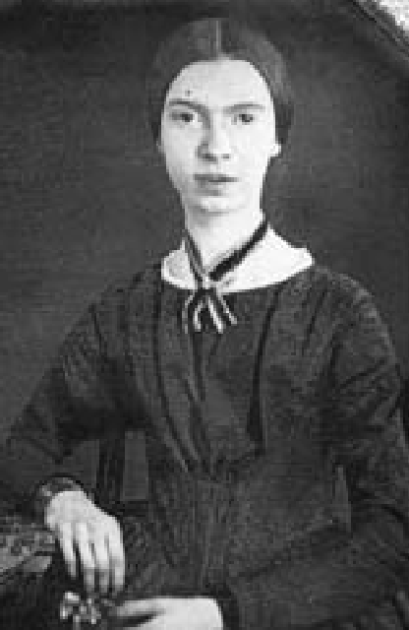Engraving of the first African-American members elected to the U.S. Congress during the Reconstruction Era, following the Civil War. Seated at left is H.R. Revels, senator from Mississippi. The others were members of the House of Representatives, from the states of Alabama, Florida, South Carolina, and Georgia.

Although practically unknown during her lifetime, Emily Dickinson (1830-1886) is now seen as one of the most brilliant and original poets America has ever produced.

96

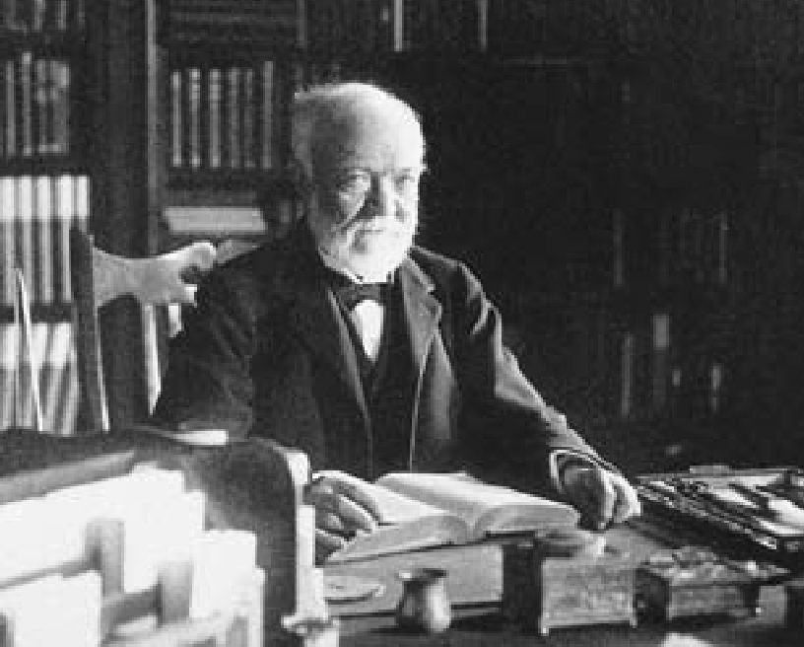

Andrew Carnegie, business tycoon and philanthropist. Born in Scotland of a poor family, Carnegie immigrated to the United States and made his fortune by building the country’s largest iron and steel manufacturing corporation. Believing that the wealthy had an obligation to give back to society, he endowed public libraries across the United States.

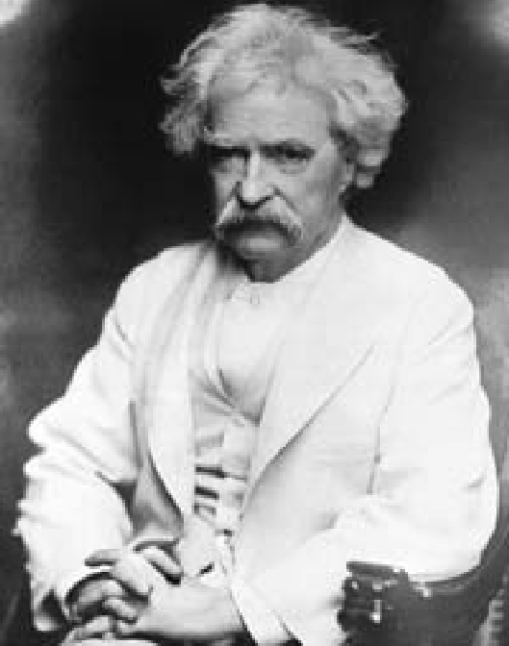Samuel Langhorne Clemens (1835-1910), better known by his pen name of Mark Twain, is perhaps the most widely read and enjoyed American writer and humorist. In his *Adventures of Huckleberry Finn* and other works, Twain developed a style based on vigorous, realistic, colloquial

American speech.

97

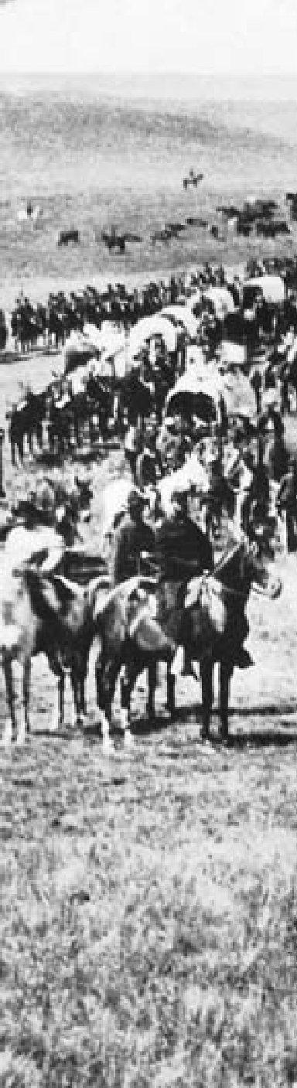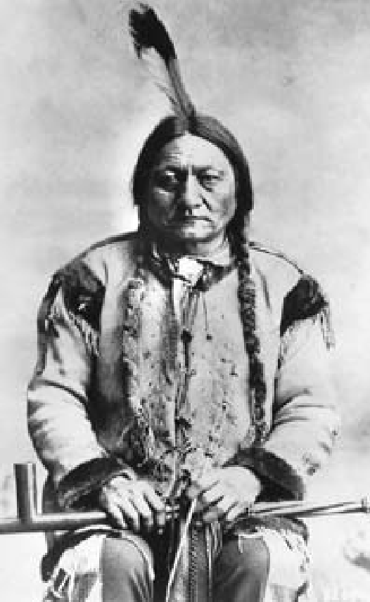

Sitting Bull, Sioux chief who led the last great battle of the Plains Indians against the U.S. Army, when his warriors defeated forces under the command of General George Custer at the Battle of

Little Bighorn in 1876.

Custer’s army on the march prior to Little Bighorn. The Plains Indians who defeated his army were resisting white intrusions into their sacred lands and

U.S. government attempts to force them back onto South Dakota’s Great Sioux Reservation.

98

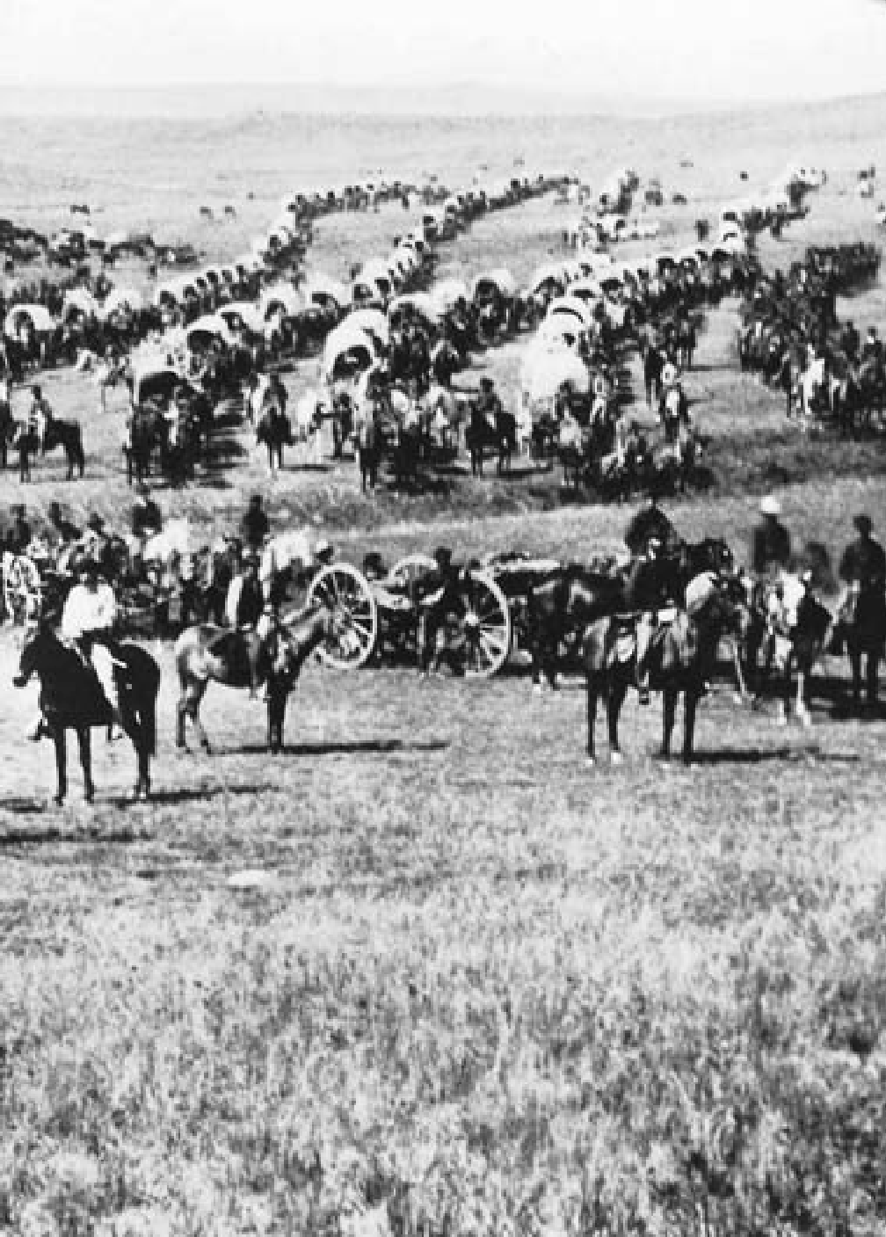

99

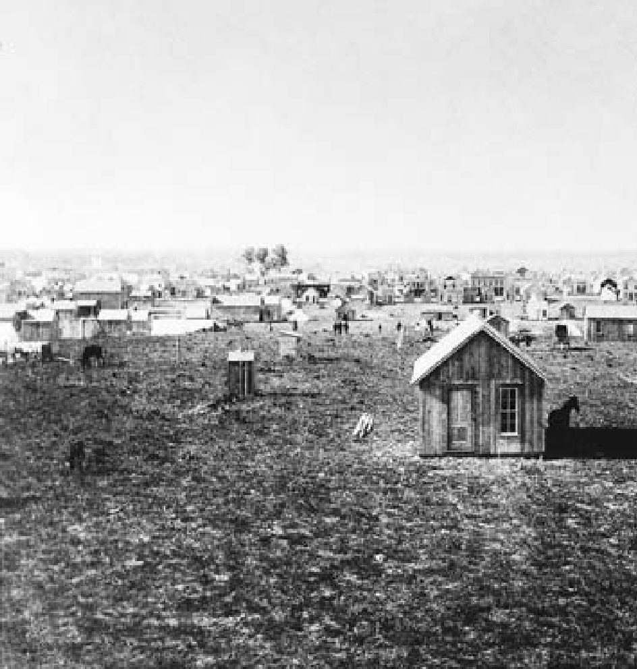

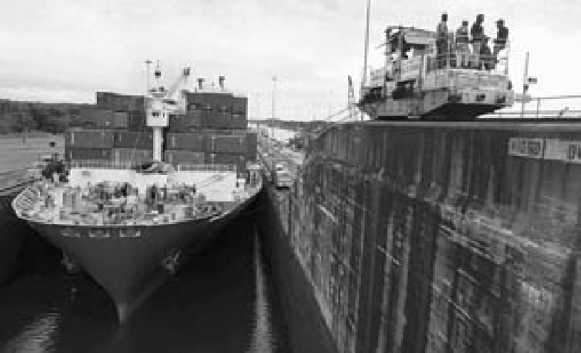

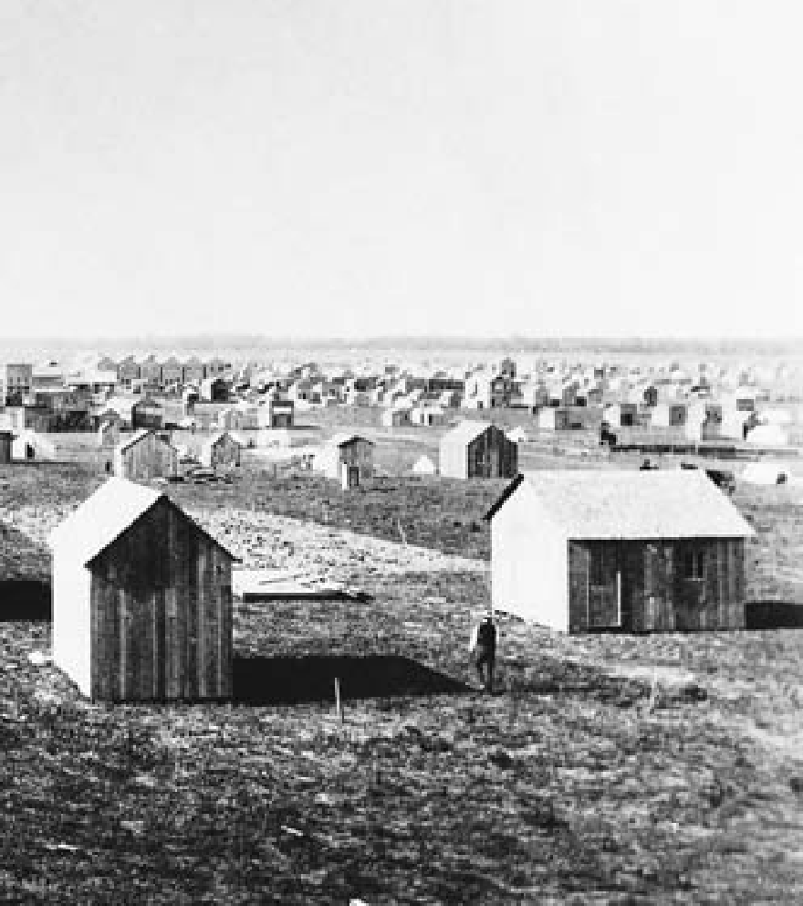

Above, Oklahoma City in 1889, four weeks after the Oklahoma Territory was opened up for settlement. Settlers staked their claim, put up tents, and then swiftly began erecting board shacks and houses — a pattern repeated throughout the West.

Left, a vessel at the Gatun locks of the Panama Canal. The United States acquired the rights to build the canal in 1903 in a treaty with Panama, which had just rebelled and broken away from Colombia. Under the terms of the 1977 treaty, the canal reverted to Panamanian control on December 31, 1999.

101

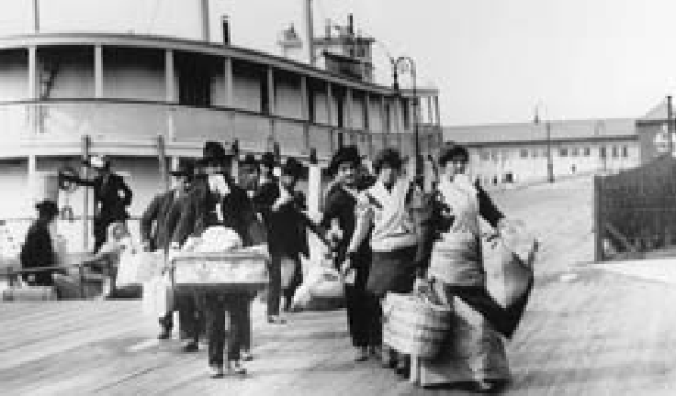

102

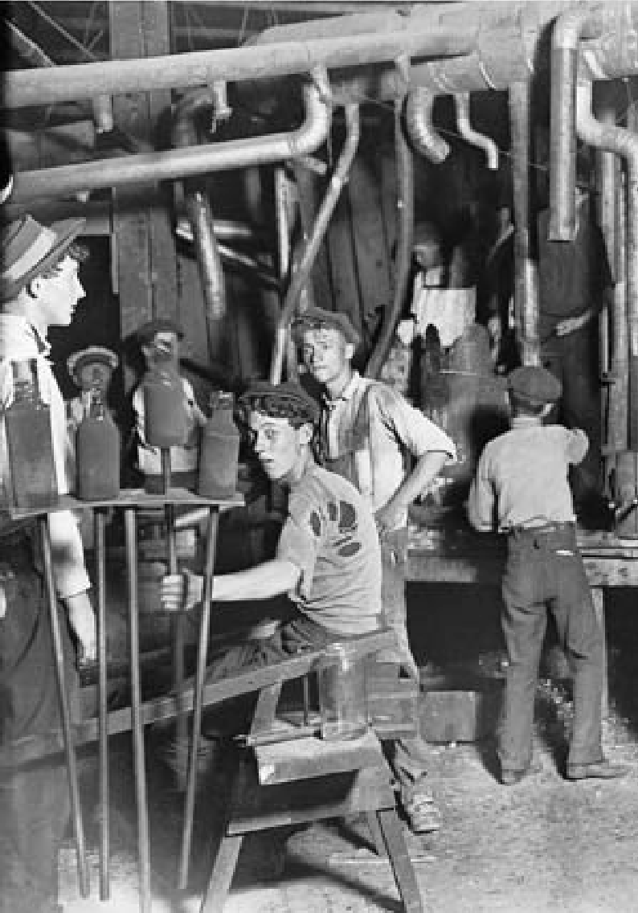

Left, opposite page, immigrants arriving at Ellis Island in New York City, principal gateway to the United States in the late 19th and early 20th centuries. From 1890 to 1921, almost 19 million people entered the United States as immigrants.

Below, children working at the Indiana Glass Works in 1908. Enacting child labor laws was one of the principal goals of the Progressive movement in this era.

103

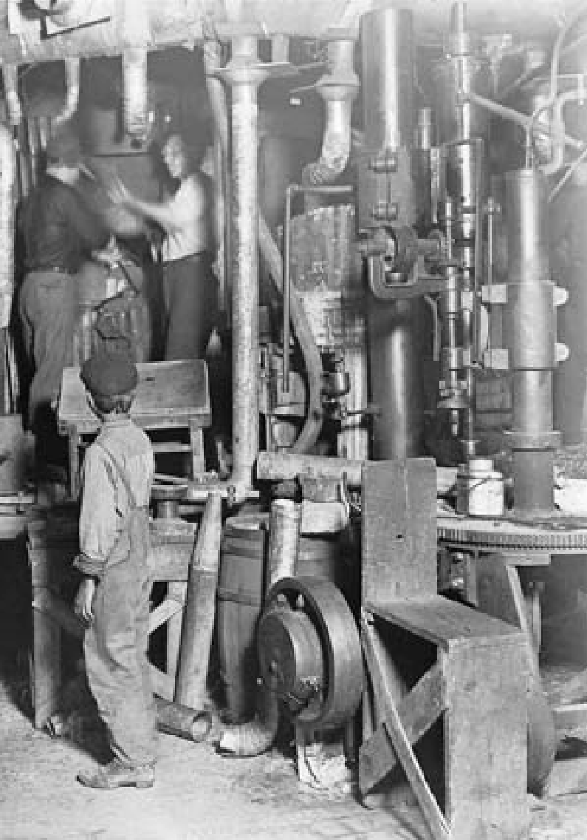

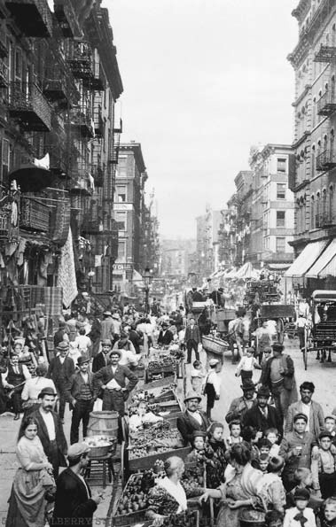Mulberry Street in New York City, also known as “Little Italy,” in the early years of the 20th century. Newly arrived immigrant families, largely from Eastern and southern Europe in this period,

often settled in densely populated urban enclaves. Typically, their children,

or grandchildren, would disperse, moving to other cities or other parts of the country.

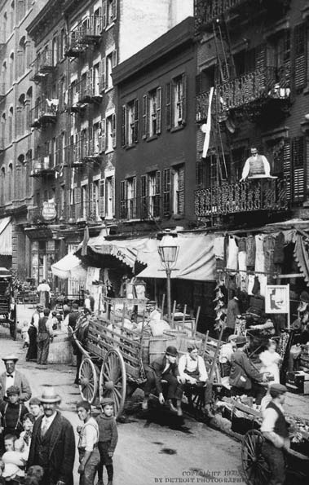

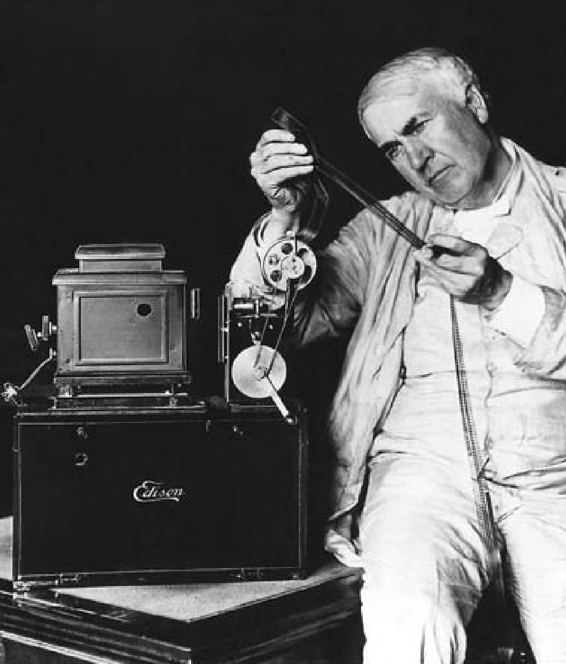Thomas Edison examines film used in the motion picture projector that he invented with George Eastman. The most celebrated of Edison’s hundreds of inventions was the incandescent light bulb.

106

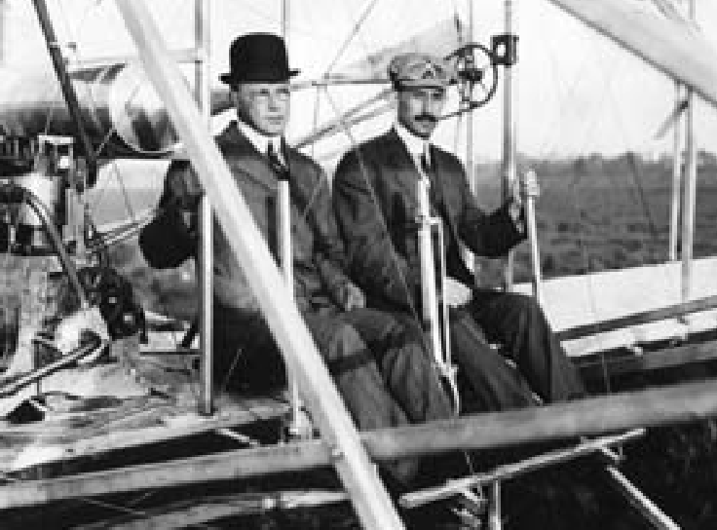Orville Wright, who built and flew the first heavier-than-air airplane at Kitty Hawk, North Carolina, in 1903, with his brother Wilbur. Orville is shown here at the controls of a later model plane in 1909.

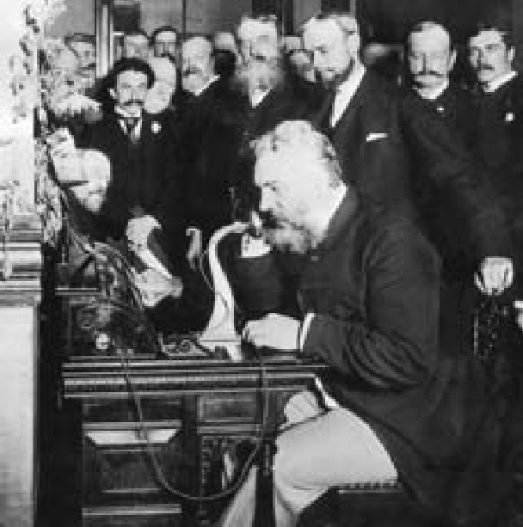

Alexander Graham Bell makes the first telephone call from New York City to Chicago in 1892. Bell, an immigrant from

Scotland who settled in Boston, invented the telephone 16 years earlier, in 1876.

107

American infantry forces in 1918, firing a 37 mm. gun, advance against German positions in World War I.

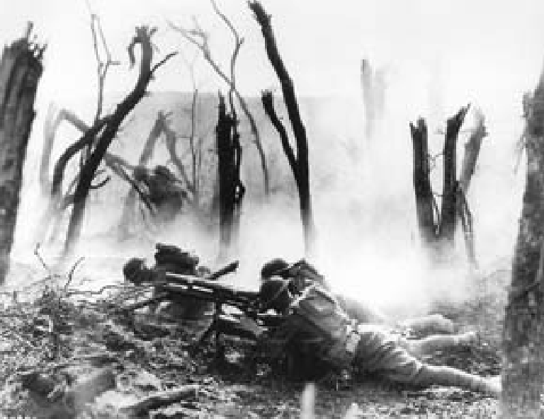

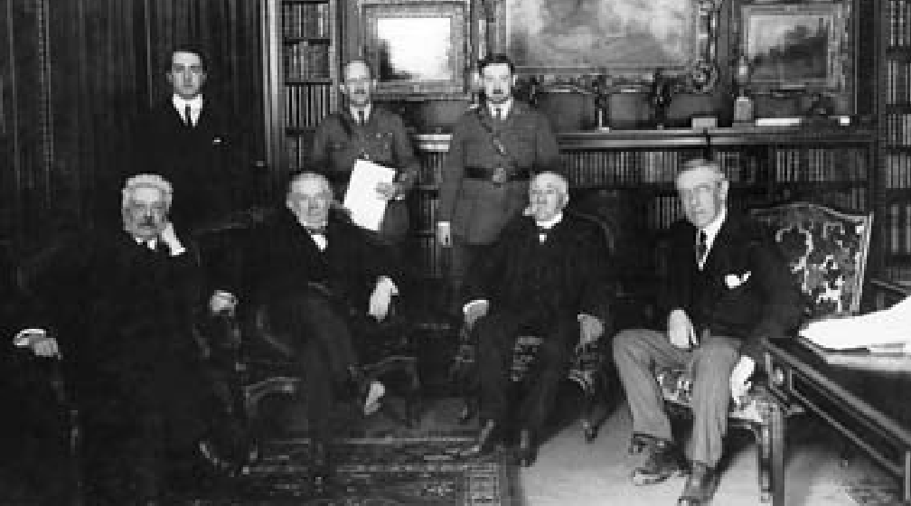The “Big Four” at the Paris Peace Conference in 1919, following the end of World War

1. They are, seated from left, Prime Minister Vittorio Orlando of Italy, Prime Minister David Lloyd George of Great Britain, Premier Georges Clemenceau of France, and President Woodrow Wilson of the United States. Despite strenuous efforts, Wilson was unable to persuade the U.S. Senate to agree to American participation in the new League of Nations established in the aftermath of the war.

108

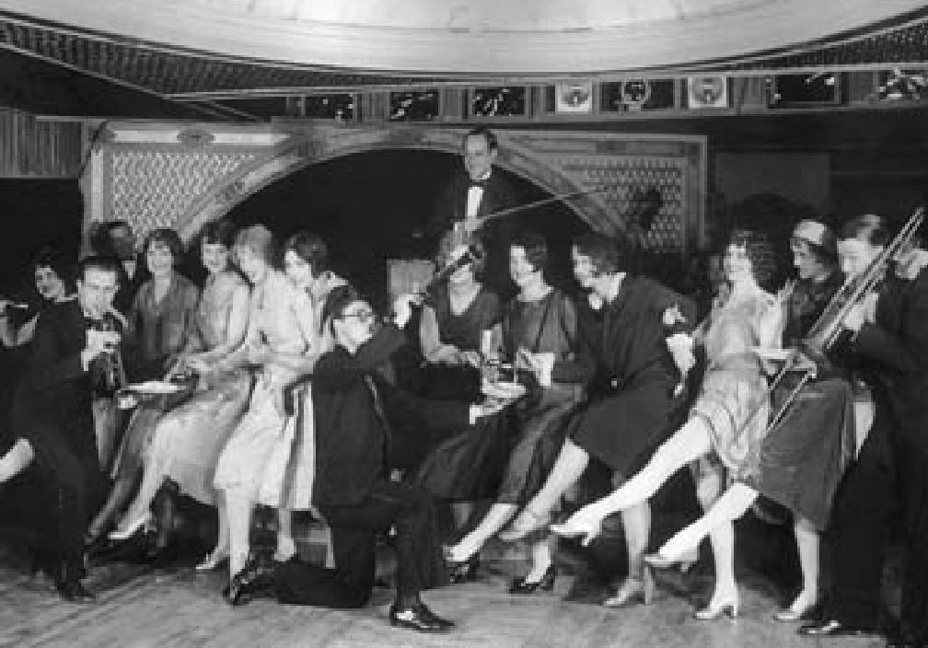

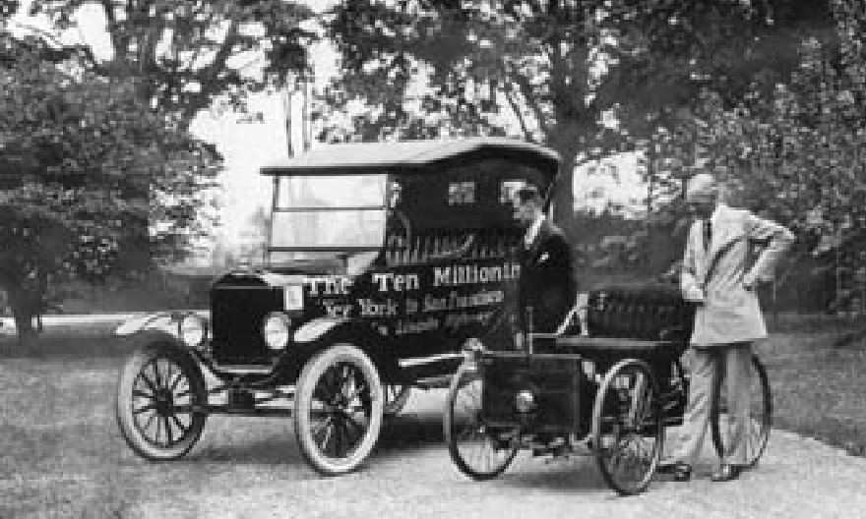

For the educated and well-to-do, the 1920s was the era of the “Lost Generation,” symbolized by writers like Ernest Hemingway, who left the United States for voluntary exile in Paris. It was also the “flapper era” of frivolity and excess in which young people could reject the constraints and traditions of their elders. Top, flappers posing for the camera at a 1920s-era party. Above, Henry Ford and his son stand with one of his early automobiles, and the 10-millionth Ford Model-T. The Model-T was the first car whose price and availability made car ownership possible for large numbers of people.

109

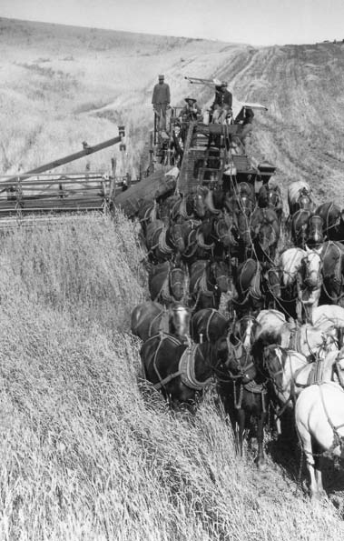

110

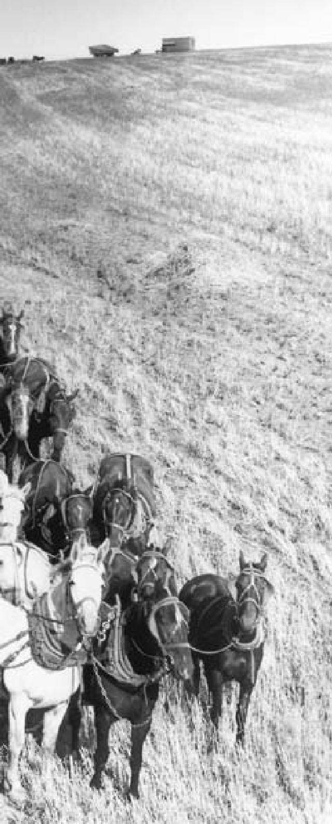

**C H A P T E R**

5

**WESTWARD EXPANSION AND REGIONAL DIFFERENCES**

Horse-drawn combine harvesting wheat in the Midwest, 19th century.

“Go West, young man, and grow up with

the country.”

Newspaper editor Horace Greeley, 1851

**BUILDING UNITY**

# T

was as essential as political inde- pendence. To foster self-sufficiency,

he War of 1812 was, in a sense, a second war of independence that confirmed once and for all the American break with England. With its conclusion, many of the serious difficulties that the young republic had faced since the Revolution dis- appeared. National union under the Constitution brought a balance between liberty and order. With a low national debt and a continent awaiting exploration, the prospect of peace, prosperity, and social prog- ress opened before the nation.

Commerce cemented national unity. The privations of war con- vinced many of the importance of protecting the manufacturers of America until they could stand alone against foreign competition. Eco- nomic independence, many argued,

congressional leaders Henry Clay of Kentucky and John C. Calhoun of South Carolina urged a policy of pro- tectionism — imposition of restric- tions on imported goods to foster the development of American industry.

The time was propitious for rais- ing the customs tariff. The shepherds of Vermont and Ohio wanted pro- tection against an influx of English wool. In Kentucky, a new industry of weaving local hemp into cotton bagging was threatened by the Scot- tish bagging industry. Pittsburgh, Pennsylvania, already a flourishing center of iron smelting, was eager to challenge British and Swedish iron suppliers. The tariff enacted in 1816 imposed duties high enough to give manufacturers real protection.

In addition, Westerners advocat-

ed a national system of roads and canals to link them with Eastern cit- ies and ports, and to open frontier lands for settlement. However, they were unsuccessful in pressing their demands for a federal role in inter- nal improvement because of oppo- sition from New England and the South. Roads and canals remained the province of the states until the passage of the Federal Aid Road Act of 1916.

The position of the federal gov- ernment at this time was greatly strengthened by several Supreme Court decisions. A committed Fed- eralist, John Marshall of Virginia be- came chief justice in 1801 and held office until his death in 1835. The court — weak before his adminis- tration — was transformed into a powerful tribunal, occupying a po- sition co-equal to the Congress and the president. In a succession of his- toric decisions, Marshall established the power of the Supreme Court and strengthened the national govern- ment.

Marshall was the first in a long line of Supreme Court justices whose decisions have molded the meaning and application of the Constitu- tion. When he finished his long ser- vice, the court had decided nearly 50 cases clearly involving constitu- tional issues. In one of Marshall’s most famous opinions — *Marbury*

*v. Madison* (1803) — he decisively established the right of the Supreme Court to review the constitution- ality of any law of Congress or of a state legislature. In *McCulloch v.*

*Maryland* (1819), he boldly upheld the Hamiltonian theory that the Constitution by implication gives the government powers beyond those expressly stated.

#### EXTENSION OF SLAVERY

**S**lavery, which up to now had re- ceived little public attention, began to assume much greater importance

as a national issue. In the early years of the republic, when the Northern states were providing for immedi- ate or gradual emancipation of the slaves, many leaders had supposed that slavery would die out. In 1786 George Washington wrote that he devoutly wished some plan might be adopted “by which slavery may be abolished by slow, sure, and im- perceptible degrees.” Virginians Jef- ferson, Madison, and Monroe and other leading Southern statesmen made similar statements.

The Northwest Ordinance of 1787 had banned slavery in the Northwest Territory. As late as 1808, when the international slave trade was abol- ished, there were many Southern- ers who thought that slavery would soon end. The expectation proved false, for during the next generation, the South became solidly united behind the institution of slavery as new economic factors made slavery far more profitable than it had been before 1790.

Chief among these was the rise of a great cotton-growing industry in the South, stimulated by the intro- duction of new types of cotton and

by Eli Whitney’s invention in 1793 of the cotton gin, which separated the seeds from cotton. At the same time, the Industrial Revolution, which made textile manufacturing a large- scale operation, vastly increased the demand for raw cotton. And the opening of new lands in the West after 1812 greatly extended the area available for cotton cultivation. Cot- ton culture moved rapidly from the Tidewater states on the East Coast through much of the lower South to the delta region of the Mississippi and eventually to Texas.

Sugar cane, another labor-inten- sive crop, also contributed to slav- ery’s extension in the South. The rich, hot lands of southeastern Loui- siana proved ideal for growing sug- ar cane profitably. By 1830 the state was supplying the nation with about half its sugar supply. Finally, tobac- co growers moved westward, taking slavery with them.

As the free society of the North and the slave society of the South spread westward, it seemed politi- cally expedient to maintain a rough equality among the new states carved out of western territories. In 1818, when Illinois was admitted to the Union, 10 states permitted slav- ery and 11 states prohibited it; but balance was restored after Alabama was admitted as a slave state. Popula- tion was growing faster in the North, which permitted Northern states to have a clear majority in the House of Representatives. However, equal- ity between the North and the South was maintained in the Senate.

In 1819 Missouri, which had 10,000 slaves, applied to enter the Union. Northerners rallied to op- pose Missouri’s entry except as a free state, and a storm of protest swept the country. For a time Congress was deadlocked, but Henry Clay ar- ranged the so-called Missouri Com- promise: Missouri was admitted as a slave state at the same time Maine came in as a free state. In addition, Congress banned slavery from the territory acquired by the Louisiana Purchase north of Missouri’s south- ern boundary. At the time, this pro- vision appeared to be a victory for the Southern states because it was thought unlikely that this “Great American Desert” would ever be settled. The controversy was tempo- rarily resolved, but Thomas Jefferson wrote to a friend that “this momen- tous question, like a fire bell in the night, awakened and filled me with terror. I considered it at once as the knell of the Union.”

#### LATIN AMERICA AND THE MONROE DOCTRINE

**D**uring the opening decades of the 19th century, Central and South America turned to revolution. The

idea of liberty had stirred the people of Latin America from the time the English colonies gained their free- dom. Napoleon’s conquest of Spain and Portugal in 1808 provided the signal for Latin Americans to rise in revolt. By 1822, ably led by Simón Bolívar, Francisco Miranda, José de San Martín and Miguel de Hidalgo,

most of Hispanic America — from Argentina and Chile in the south to Mexico in the north — had won in- dependence.

The people of the United States took a deep interest in what seemed a repetition of their own experience in breaking away from European rule. The Latin American independence movements confirmed their own be- lief in self-government. In 1822 Pres- ident James Monroe, under powerful public pressure, received authority to recognize the new countries of Latin America and soon exchanged ministers with them. He thereby confirmed their status as genuinely independent countries, entirely sep- arated from their former European connections.

At just this point, Russia, Prussia, and Austria formed an association, the Holy Alliance, to protect them- selves against revolution. By inter- vening in countries where popular movements threatened monarchies, the alliance — joined by post-Napo- leonic France — hoped to prevent the spread of revolution. This policy was the antithesis of the American principle of self-determination.

As long as the Holy Alliance con- fined its activities to the Old World, it aroused no anxiety in the United States. But when the alliance an- nounced its intention of restoring to Spain its former colonies, Americans became very concerned. Britain, to which Latin American trade had be- come of great importance, resolved to block any such action. London urged joint Anglo-American guarantees

to Latin America, but Secretary of State John Quincy Adams convinced Monroe to act unilaterally: “It would be more candid, as well as more dig- nified, to avow our principles explic- itly to Russia and France, than to come in as a cock-boat in the wake of the British man-of-war.”

In December 1823, with the knowledge that the British navy would defend Latin America from the Holy Alliance and France, Presi- dent Monroe took the occasion of his annual message to Congress to pronounce what would become known as the Monroe Doctrine — the refusal to tolerate any further extension of European domination in the Americas:

*The American continents ... are henceforth not to be considered as subjects for future colonization by any European powers.*

*We should consider any attempt on their part to extend their [political] system to any portion of this hemisphere, as dangerous to our peace and safety.*

*With the existing colonies or dependencies of any European power we have not interfered, and shall not interfere. But with the governments who have declared their independence, and maintained it, and whose independence we have ...*

*acknowledged, we could not view any interposition for the purpose of oppressing them, or controlling, in any other manner, their destiny, by any European power in any other light than as the manifestation of*

*an unfriendly disposition towards the United States.*

The Monroe Doctrine expressed a spirit of solidarity with the new- ly independent republics of Latin America. These nations in turn rec- ognized their political affinity with the United States by basing their new constitutions, in many instances, on the North American model.

#### FACTIONALISM AND POLITICAL PARTIES

**D**omestically, the presidency of Monroe (1817-1825) was termed the “era of good feelings.” The phrase ac-

knowledged the political triumph of the Republican Party over the Feder- alist Party, which had collapsed as a national force. All the same, this was a period of vigorous factional and re- gional conflict.

The end of the Federalists led to a brief period of factional politics and brought disarray to the practice of choosing presidential nominees by congressional party caucuses. For a time, state legislatures nominated candidates. In 1824 Tennessee and Pennsylvania chose Andrew Jack- son, with South Carolina Senator John C. Calhoun as his running mate. Kentucky selected Speaker of the House Henry Clay; Massachu- setts, Secretary of State John Quincy Adams, son of the second president, John Adams. A congressional cau- cus, widely derided as undemocrat- ic, picked Secretary of the Treasury William Crawford.

Personality and sectional al- legiance played important roles in determining the outcome of the election. Adams won the electoral votes from New England and most of New York; Clay won Kentucky, Ohio, and Missouri; Jackson won the Southeast, Illinois, Indiana, the Carolinas, Pennsylvania, Maryland, and New Jersey; and Crawford won Virginia, Georgia, and Delaware. No candidate gained a majority in the Electoral College, so, accord- ing to the provisions of the Con- stitution, the election was thrown into the House of Representatives, where Clay was the most influential figure. He supported Adams, who gained the presidency.

During Adams’s administration, new party alignments appeared. Adams’s followers, some of whom were former Federalists, took the name of “National Republicans” as emblematic of their support of a federal government that would take a strong role in developing an expanding nation. Though he governed honestly and efficiently, Adams was not a popular president. He failed in his effort to institute a national system of roads and canals. His coldly intellectual temperament did not win friends. Jackson, by con- trast, had enormous popular appeal and a strong political organization. His followers coalesced to establish the Democratic Party, claimed di- rect lineage from the Democratic- Republican Party of Jefferson, and in general advocated the principles of small, decentralized government.

Mounting a strong anti-Adams cam- paign, they accused the president of a “corrupt bargain” for naming Clay secretary of state. In the election of 1828, Jackson defeated Adams by an overwhelming electoral majority.

Jackson — Tennessee politi- cian, fighter in wars against Native Americans on the Southern fron- tier, and hero of the Battle of New Orleans during the War of 1812 — drew his support from the “common people.” He came to the presidency on a rising tide of enthusiasm for popular democracy. The election of 1828 was a significant benchmark in the trend toward broader voter participation. By then most states had either enacted universal white male suffrage or minimized prop- erty requirements. In 1824 members of the Electoral College in six states were still selected by the state leg- islatures. By 1828 presidential elec- tors were chosen by popular vote in every state but Delaware and South Carolina. These developments were the products of a widespread sense that the people should rule and that government by traditional elites had come to an end.

#### NULLIFICATION CRISIS

**T**oward the end of his first term in office, Jackson was forced to con- front the state of South Carolina,

the most important of the emerg- ing Deep South cotton states, on the issue of the protective tariff. Busi- ness and farming interests in the state had hoped that the president

would use his power to modify the 1828 act that they called the Tar- iff of Abominations. In their view, all its benefits of protection went to Northern manufacturers, leaving agricultural South Carolina poorer. In 1828, the state’s leading politician

* and Jackson’s vice president until his resignation in 1832 — John C. Calhoun had declared in his *South Carolina Exposition and Protest* that states had the right to nullify op- pressive national legislation.

In 1832, Congress passed and Jackson signed a bill that revised the 1828 tariff downward, but it was not enough to satisfy most South Carolinians. The state adopted an Ordinance of Nullification, which declared both the tariffs of 1828 and 1832 null and void within state bor- ders. Its legislature also passed laws to enforce the ordinance, including authorization for raising a military force and appropriations for arms. Nullification was a long-established theme of protest against perceived excesses by the federal government. Jefferson and Madison had proposed it in the Kentucky and Virginia Res- olutions of 1798, to protest the Alien and Sedition Acts. The Hartford Convention of 1814 had invoked it to protest the War of 1812. Never before, however, had a state actually attempted nullification. The young nation faced its most dangerous crisis yet.

In response to South Carolina’s threat, Jackson sent seven small naval vessels and a man-of-war to Charleston in November 1832. On

December 10, he issued a resound- ing proclamation against the nulli- fiers. South Carolina, the president declared, stood on “the brink of insurrection and treason,” and he appealed to the people of the state to reassert their allegiance to the Union. He also let it be known that, if necessary, he personally would lead the U.S. Army to enforce the law.

When the question of tariff duties again came before Congress, Jack- son’s political rival, Senator Henry Clay, a great advocate of protection but also a devoted Unionist, spon- sored a compromise measure. Clay’s tariff bill, quickly passed in 1833, specified that all duties in excess of 20 percent of the value of the goods imported were to be reduced year by year, so that by 1842 the duties on all articles would reach the level of the moderate tariff of 1816. At the same time, Congress passed a Force Act, authorizing the president to use military power to enforce the laws.

South Carolina had expected the support of other Southern states, but instead found itself isolated. (Its most likely ally, the state govern- ment of Georgia, wanted, and got,

U.S. military force to remove Native American tribes from the state.) Eventually, South Carolina rescind- ed its action. Both sides, neverthe- less, claimed victory. Jackson had strongly defended the Union. But South Carolina, by its show of re- sistance, had obtained many of its demands and had demonstrated that a single state could force its will on Congress.

#### THE BANK FIGHT

**A**lthough the nullification crisis possessed the seeds of civil war, it was not as critical a political issue

as a bitter struggle over the contin- ued existence of the nation’s central bank, the second Bank of the United States. The first bank, established in 1791 under Alexander Hamilton’s guidance, had been chartered for a 20-year period. Though the gov- ernment held some of its stock, the bank, like the Bank of England and other central banks of the time, was a private corporation with profits passing to its stockholders. Its public functions were to act as a deposito- ry for government receipts, to make short-term loans to the government, and above all to establish a sound currency by refusing to accept at face value notes (paper money) issued by state-chartered banks in excess of their ability to redeem.

To the Northeastern financial and commercial establishment, the central bank was a needed enforc- er of prudent monetary policy, but from the beginning it was resent- ed by Southerners and Westerners who believed their prosperity and regional development depended upon ample money and credit. The Republican Party of Jefferson and Madison doubted its constitutional- ity. When its charter expired in 1811, it was not renewed.

For the next few years, the bank- ing business was in the hands of state-chartered banks, which issued currency in excessive amounts, cre-

ating great confusion and fueling in- flation. It became increasingly clear that state banks could not provide the country with a reliable currency. In 1816 a second Bank of the United States, similar to the first, was again chartered for 20 years. From its inception, the second bank was unpopular in the newer states and territories, especially with state and local bankers who resented its vir- tual monopoly over the country’s credit and currency, but also with less prosperous people everywhere, who believed that it represented the interests of the wealthy few.

On the whole, the bank was well managed and rendered a valu- able service; but Jackson had long shared the Republican distrust of the financial establishment. Elected as a tribune of the people, he sensed that the bank’s aristocratic man- ager, Nicholas Biddle, was an easy target. When the bank’s support- ers in Congress pushed through an early renewal of its charter, Jackson responded with a stinging veto that denounced monopoly and special privilege. The effort to override the veto failed.

In the presidential campaign that followed, the bank question re- vealed a fundamental division. Es- tablished merchant, manufacturing, and financial interests favored sound money. Regional bankers and entre- preneurs on the make wanted an increased money supply and lower interest rates. Other debtor classes, especially farmers, shared those sen- timents. Jackson and his supporters

called the central bank a “monster” and coasted to an easy election vic- tory over Henry Clay.

The president interpreted his tri- umph as a popular mandate to crush the central bank irrevocably. In Sep- tember 1833 he ordered an end to deposits of government money in the bank, and gradual withdrawals of the money already in its custody. The government deposited its funds in selected state banks, characterized as “pet banks” by the opposition.

For the next generation the Unit- ed States would get by on a relatively unregulated state banking system, which helped fuel westward expan- sion through cheap credit but kept the nation vulnerable to periodic panics. During the Civil War, the United States initiated a system of national charters for local and re- gional banks, but the nation re- turned to a central bank only with the establishment of the Federal Re- serve system in 1913.

#### WHIGS, DEMOCRATS, AND KNOW-NOTHINGS

**J**ackson’s political opponents, unit- ed by little more than a common opposition to him, eventually co-

alesced into a common party called the Whigs, a British term signify- ing opposition to Jackson’s “monar- chial rule.” Although they organized soon after the election campaign of 1832, it was more than a decade be- fore they reconciled their differences and were able to draw up a platform. Largely through the magnetism of

Henry Clay and Daniel Webster, the Whigs’ most brilliant statesmen, the party solidified its membership. But in the 1836 election, the Whigs were still too divided to unite behind a single man. New York’s Martin Van Buren, Jackson’s vice president, won the contest.

An economic depression and the larger-than-life personality of his predecessor obscured Van Buren’s merits. His public acts aroused no enthusiasm, for he lacked the com- pelling qualities of leadership and the dramatic flair that had attended Jackson’s every move. The election of 1840 found the country afflicted with hard times and low wages — and the Democrats on the defensive. The Whig candidate for presi- dent was William Henry Harrison of Ohio, vastly popular as a hero of conflicts with Native Americans and the War of 1812. He was promoted, like Jackson, as a representative of the democratic West. His vice presi- dential candidate was John Tyler — a Virginian whose views on states’ rights and a low tariff were popular in the South. Harrison won a sweep-

ing victory.

Within a month of his inaugu- ration, however, the 68-year-old Harrison died, and Tyler became president. Tyler’s beliefs differed sharply from those of Clay and Web- ster, still the most influential men in Congress. The result was an open break between the new president and the party that had elected him. The Tyler presidency would accomplish little other than to establish defini-

tively that, if a president died, the vice president would assume the of- fice with full powers for the balance of his term.

Americans found themselves di- vided in other, more complex ways. The large number of Catholic im- migrants in the first half of the 19th century, primarily Irish and Ger- man, triggered a backlash among native-born Protestant Americans. Immigrants brought strange new customs and religious practices to American shores. They competed with the native-born for jobs in cit- ies along the Eastern seaboard. The coming of universal white male suffrage in the 1820s and 1830s in- creased their political clout. Dis- placed patrician politicians blamed the immigrants for their fall from power. The Catholic Church’s failure to support the temperance move- ment gave rise to charges that Rome was trying to subvert the United States through alcohol.

The most important of the nativ- ist organizations that sprang up in this period was a secret society, the Order of the Star-Spangled Banner, founded in 1849. When its mem- bers refused to identify themselves, they were swiftly labeled the “Know- Nothings.” In a few years, they be- came a national organization with considerable political power.

The Know-Nothings advocated an extension in the period required for naturalized citizenship from five to 21 years. They sought to exclude the foreign-born and Catholics from public office. In 1855 they won con-

trol of legislatures in New York and Massachusetts; by then, about 90

U.S. congressmen were linked to the party. That was its high point. Soon after, the gathering crisis between North and South over the extension of slavery fatally divided the party, consuming it along with the old de- bates between Whigs and Demo- crats that had dominated American politics in the second quarter of the 19th century.

#### STIRRINGS OF REFORM

**T**he democratic upheaval in poli- tics exemplified by Jackson’s election was merely one phase of the long

American quest for greater rights and opportunities for all citizens. Another was the beginning of la- bor organization, primarily among skilled and semiskilled workers. In 1835 labor forces in Philadelphia, Pennsylvania, succeeded in reducing the old “dark-to-dark” workday to a 10-hour day. By 1860, the new work day had become law in sever- al of the states and was a generally accepted standard.

The spread of suffrage had al- ready led to a new concept of education. Clear-sighted statesmen everywhere understood that uni- versal suffrage required a tutored, literate electorate. Workingmen’s organizations demanded free, tax- supported schools open to all chil- dren. Gradually, in one state after another, legislation was enacted to provide for such free instruction. The leadership of Horace Mann in

Massachusetts was especially ef- fective. The public school system became common throughout the North. In other parts of the coun- try, however, the battle for public education continued for years.

Another influential social move- ment that emerged during this period was the opposition to the sale and use of alcohol, or the temper- ance movement. It stemmed from a variety of concerns and motives: religious beliefs, the effect of alco- hol on the work force, the violence and suffering women and children experienced at the hands of heavy drinkers. In 1826 Boston ministers organized the Society for the Pro- motion of Temperance. Seven years later, in Philadelphia, the society convened a national convention, which formed the American Tem- perance Union. The union called for the prohibition of all alcoholic bev- erages, and pressed state legislatures to ban their production and sale. Thirteen states had done so by 1855, although the laws were subsequently challenged in court. They survived only in northern New England, but between 1830 and 1860 the temper- ance movement reduced Americans’ per capita consumption of alcohol.

Other reformers addressed the problems of prisons and care for the insane. Efforts were made to turn prisons, which stressed punishment, into penitentiaries where the guilty would undergo rehabilitation. In Massachusetts, Dorothea Dix led a struggle to improve conditions for insane persons, who were kept con-

fined in wretched almshouses and prisons. After winning improve- ments in Massachusetts, she took her campaign to the South, where nine states established hospitals for the insane between 1845 and 1852.

#### WOMEN’S RIGHTS

**S**uch social reforms brought many women to a realization of their own unequal position in society. From

colonial times, unmarried women had enjoyed many of the same legal rights as men, although custom re- quired that they marry early. With matrimony, women virtually lost their separate identities in the eyes of the law. Women were not permit- ted to vote. Their education in the 17th and 18th centuries was limited largely to reading, writing, music, dancing, and needlework.

The awakening of women began with the visit to America of Fran- ces Wright, a Scottish lecturer and journalist, who publicly promoted women’s rights throughout the Unit- ed States during the 1820s. At a time when women were often forbidden to speak in public places, Wright not only spoke out, but shocked audi- ences by her views advocating the rights of women to seek information on birth control and divorce. By the 1840s an American women’s rights movement emerged. Its foremost leader was Elizabeth Cady Stanton.

In 1848 Cady Stanton and her colleague Lucretia Mott organized a women’s rights convention — the first in the history of the world —

at Seneca Falls, New York. Delegates drew up a “Declaration of Senti- ments,” demanding equality with men before the law, the right to vote, and equal opportunities in educa- tion and employment. The resolu- tions passed unanimously with the exception of the one for women’s suffrage, which won a majority only after an impassioned speech in fa- vor by Frederick Douglass, the black abolitionist.

At Seneca Falls, Cady Stan- ton gained national prominence as an eloquent writer and speaker for women’s rights. She had realized ear- ly on that without the right to vote, women would never be equal with men. Taking the abolitionist Wil- liam Lloyd Garrison as her model, she saw that the key to success lay in changing public opinion, and not in party action. Seneca Falls became the catalyst for future change. Soon other women’s rights conventions were held, and other women would come to the forefront of the move- ment for their political and social equality.

In 1848 also, Ernestine Rose, a Polish immigrant, was instrumental in getting a law passed in the state of New York that allowed married women to keep their property in their own name. Among the first laws in the nation of this kind, the Married Women’s Property Act en- couraged other state legislatures to enact similar laws.

In 1869 Elizabeth Cady Stanton and another leading women’s rights activist, Susan B. Anthony, founded

the National Woman Suffrage Asso- ciation (NWSA) to promote a con- stitutional amendment for women’s right to the vote. These two would become the women’s movement’s most outspoken advocates. Describ- ing their partnership, Cady Stanton would say, “I forged the thunderbolts and she fired them.”

#### WESTWARD

**T**he frontier did much to shape American life. Conditions along the entire Atlantic seaboard stimulat-

ed migration to the newer regions. From New England, where the soil was incapable of producing high yields of grain, came a steady stream of men and women who left their coastal farms and villages to take advantage of the rich interior land of the continent. In the backcoun- try settlements of the Carolinas and Virginia, people handicapped by the lack of roads and canals giving ac- cess to coastal markets and resent- ful of the political dominance of the Tidewater planters also moved west- ward. By 1800 the Mississippi and Ohio River valleys were becoming a great frontier region. “Hi-o, away we go, floating down the river on the O- hi-o,” became the song of thousands of migrants.

The westward flow of population in the early 19th century led to the division of old territories and the drawing of new boundaries. As new states were admitted, the political map stabilized east of the Mississippi River. From 1816 to 1821, six states

were created — Indiana, Illinois, and Maine (which were free states), and Mississippi, Alabama, and Missouri (slave states). The first frontier had been tied closely to Europe, the sec- ond to the coastal settlements, but the Mississippi Valley was indepen- dent and its people looked west rath- er than east.

Frontier settlers were a varied group. One English traveler de- scribed them as “a daring, hardy race of men, who live in miserable cabins They are unpolished but

hospitable, kind to strangers, hon- est, and trustworthy. They raise a little Indian corn, pumpkins, hogs, and sometimes have a cow or two.

... But the rifle is their principal means of support.” Dexterous with the ax, snare, and fishing line, these men blazed the trails, built the first log cabins, and confronted Native American tribes, whose land they occupied.

As more and more settlers pene- trated the wilderness, many became farmers as well as hunters. A com- fortable log house with glass win- dows, a chimney, and partitioned rooms replaced the cabin; the well replaced the spring. Industrious set- tlers would rapidly clear their land of timber, burning the wood for potash and letting the stumps de- cay. They grew their own grain, veg- etables, and fruit; ranged the woods for deer, wild turkeys, and honey; fished the nearby streams; looked after cattle and hogs. Land specu- lators bought large tracts of the cheap land and, if land values rose,

sold their holdings and moved still farther west, making way for others. Doctors, lawyers, storekeepers, editors, preachers, mechanics, and politicians soon followed the farm- ers. The farmers were the sturdy base, however. Where they settled, they intended to stay and hoped their children would remain after them. They built large barns and brick or frame houses. They brought improved livestock, plowed the land skillfully, and sowed productive seed. Some erected flour mills, saw- mills, and distilleries. They laid out good highways, and built churches and schools. Incredible transforma- tions were accomplished in a few years. In 1830, for example, Chicago, Illinois, was merely an unpromis- ing trading village with a fort; but long before some of its original set- tlers had died, it had become one of the largest and richest cities in

the nation.

Farms were easy to acquire. Gov- ernment land after 1820 could be bought for $1.25 for about half a hectare, and after the 1862 Home- stead Act, could be claimed by merely occupying and improving it. In addition, tools for working the land were easily available. It was a time when, in a phrase coined by Indiana newspaperman John Soule and popularized by *New York Tri- bune* editor Horace Greeley, young men could “go west and grow with the country.”

Except for a migration into Mex- ican-owned Texas, the westward march of the agricultural frontier

did not pass Missouri into the vast Western territory acquired in the Louisiana Purchase until after 1840. In 1819, in return for assuming the claims of American citizens to the amount of $5 million, the United States obtained from Spain both Florida and Spain’s rights to the Oregon country in the Far West. In the meantime, the Far West had become a field of great activity in the fur trade, which was to have significance far beyond the value of the skins. As in the first days of French explorationinthe Mississippi Valley, the trader was a pathfinder for the settlers beyond the Missis- sippi. The French and Scots-Irish trappers, exploring the great rivers and their tributaries and discover- ing the passes through the Rocky and Sierra Mountains, made pos- sible the overland migration of the 1840s and the later occupation of the interior of the nation.

Overall, the growth of the na- tion was enormous: Population grew from 7.25 million to more than 23 million from 1812 to 1852, and the land available for settlement in- creased by almost the size of West- ern Europe — from 4.4 million to

7.8 million square kilometers. Still unresolved, however, were the ba- sic conflicts rooted in sectional dif- ferences that, by the decade of the 1860s, would explode into civil war. Inevitably, too, this westward expan- sion brought settlers into conflict with the original inhabitants of the land: the Native Americans.

In the first part of the 19th centu-

ry, the most prominent figure asso- ciated with these conflicts was An- drew Jackson, the first “Westerner” to occupy the White House. In the midst of the War of 1812, Jackson, then in charge of the Tennessee mili- tia, was sent into southern Alabama, where he ruthlessly put down an up- rising of Creek Indians. The Creeks soon ceded two-thirds of their land to the United States. Jackson later routed bands of Seminoles from their sanctuaries in Spanish-owned Florida.

In the 1820s, President Monroe’s secretary of war, John C. Calhoun, pursued a policy of removing the re- maining tribes from the old South- west and resettling them beyond the Mississippi. Jackson continued this policy as president. In 1830 Congress passed the Indian Removal Act, pro- viding funds to transport the east- ern tribes beyond the Mississippi.

In 1834 a special Native American territory was set up in what is now Oklahoma. In all, the tribes signed

94 treaties during Jackson’s two terms, ceding millions of hectares to the federal government and remov- ing dozens of tribes from their an- cestral homelands.

The most terrible chapter in this unhappy history concerned the Cherokees, whose lands in western North Carolina and Georgia had been guaranteed by treaty since 1791. Among the most progressive of the eastern tribes, the Cherokees nevertheless were sure to be dis- placed when gold was discovered on their land in 1829. Forced to make a long and cruel trek to Oklahoma in 1838, the tribe lost many of its numbers from disease and priva- tion on what became known as the “Trail of Tears.” 9

CHAPTER 5: WESTWARD EXPANSION AND REGIONAL DIFFERENCES

**THE FRONTIER, “THE WEST,” AND THE AMERICAN EXPERIENCE**

**T**he frontier — the point at which settled territory met unoccupied land — began at Jamestown and Plymouth Rock. It moved in a westward direction for

nearly 300 years through densely forested wilderness and barren plains until the decennial census of 1890 revealed that at last the United States no longer possessed a discernible line of settlement.

At the time it seemed to many that a long period had come to an end — one in which the country had grown from a few struggling outposts of English civilization to a huge independent nation with an identity of its own.

It was easy to believe that the experience of settlement and post-settlement development, constantly repeated as a people conquered a continent, had been the defining factor in the nation’s development.

In 1893, the historian Frederick Jackson Turner, expressing a widely held sentiment, declared that the frontier had made the United States more than an extension of Europe. It had created a nation with a culture that was perhaps coarser than Europe’s, but also more pragmatic, energetic, individualistic, and democratic. The existence of large areas of “free land” had created a nation of property holders and had provided a “safety valve” for discontent in cities and more settled areas. His analysis implied that an America without a frontier would trend ominously toward what were seen as the European ills of strati- fied social systems, class conflict, and diminished opportunity.

After more than a hundred years scholars still debate the significance of the frontier in American history. Few believe it was quite as all-important as Turner suggested; its absence does not appear to have led to dire consequenc- es. Some have gone farther, rejecting the Turner argument as a romantic glo- rification of a bloody, brutal process — marked by a war of conquest against Mexico, near-genocidal treatment of Native American tribes, and environmen- tal despoliation. The common experience of the frontier, they argue, was one of hardship and failure.

Yet it remains hard to believe that three centuries of westward movement had no impact on the national character and suggestive that intelligent foreign observers, such as the French intellectual Alexis de Tocqueville, were fasci- nated by the American West. Indeed, the last area of frontier settlement, the vast area stretching north from Texas to the Canadian border, which Ameri- cans today commonly call “the West,” still seems characterized by ideals of individualism, democracy, and opportunity that are more palpable than in the rest of the nation. It is perhaps also revealing that many people in other lands, when hearing the word “American,” so often identify it with a symbol of that final frontier — the “cowboy.” ◆

126

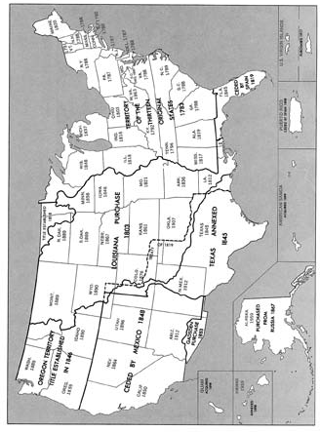**Major Acquisitions of Territory by the United States and Dates of Admission of States**

U.S. Department of Commerce

United States of America, showing territorial expansion from 1803 to 1898.

**1–6 UNITED STATES SUMMARY**

Bureau of Census

NUMBER OF INHABITANTS

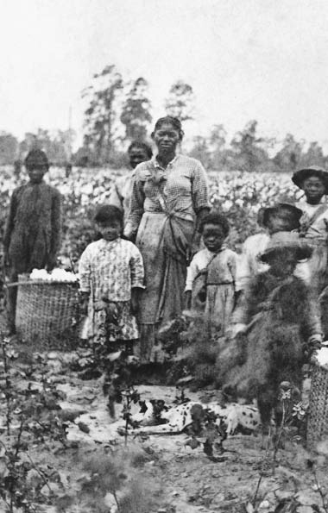

128

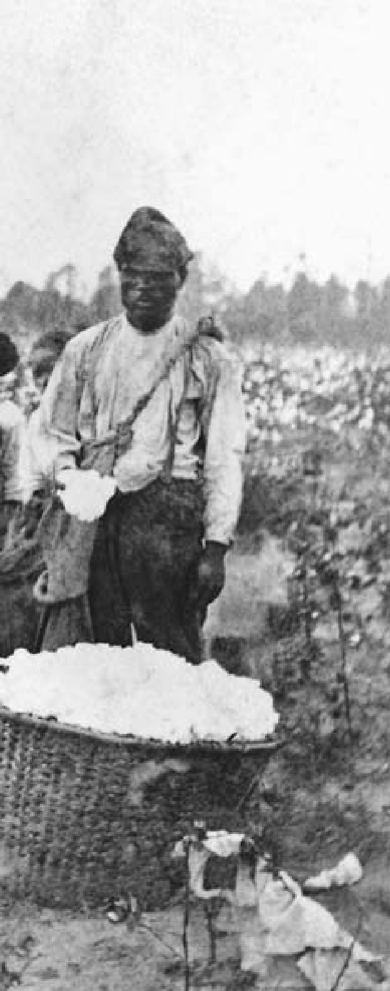

**C H A P T E R**

6

**SECTIONAL CONFLICT**

Slave family picking cotton near Savannah, Georgia,

in the early 1860s.

“A house divided against itself cannot stand. I believe this government cannot endure permanently

half-slave and half-free.”

Senatorial candidate Abraham Lincoln, 1858

**TWO AMERICAS**

# N

whether such rough equality could survive in the face of a growing fac-

o visitor to the United States left a more enduring record of his trav- els and observations than the French writer and political theorist Alexis de Tocqueville, whose *Democracy in America*, first published in 1835, remains one of the most trenchant and insightful analyses of Ameri- can social and political practices. Tocqueville was far too shrewd an observer to be uncritical about the United States, but his verdict was fundamentally positive. “The gov- ernment of a democracy brings the notion of political rights to the level of the humblest citizens,” he wrote, “just as the dissemination of wealth brings the notion of property within the reach of all men.” Nonetheless, Tocqueville was only one in the first of a long line of thinkers to worry

tory system that threatened to create divisions between industrial workers and a new business elite.

Other travelers marveled at the growth and vitality of the country, where they could see “everywhere the most unequivocal proofs of prosperity and rapid progress in ag- riculture, commerce, and great pub- lic works.” But such optimistic views of the American experiment were by no means universal. One skep- tic was the English novelist Charles Dickens, who first visited the United States in 1841-42. “This is not the Republic I came to see,” he wrote in a letter. “This is not the Republic of my imagination. ... The more I think of its youth and strength, the poorer and more trifling in a thou- sand respects, it appears in my eyes.

In everything of which it has made a boast — excepting its education of the people, and its care for poor chil- dren — it sinks immeasurably below the level I had placed it upon.”

Dickens was not alone. America in the 19th century, as throughout its history, generated expectations and passions that often conflicted with a reality at once more mundane and more complex. The young nation’s size and diversity defied easy gener- alization and invited contradiction: America was both a freedom-loving and slave-holding society, a nation of expansive and primitive frontiers, a society with cities built on growing commerce and industrialization.

#### LANDS OF PROMISE

**B**y 1850 the national territory stretched over forest, plain, and mountain. Within its far-flung lim-

its dwelt 23 million people in a Union comprising 31 states. In the East, in- dustry boomed. In the Midwest and the South, agriculture flourished. After 1849 the gold mines of Cali- fornia poured their precious ore into the channels of trade.

New England and the Middle At- lantic states were the main centers of manufacturing, commerce, and finance. Principal products of these areas were textiles, lumber, cloth- ing, machinery, leather, and wool- en goods. The maritime trade had reached the height of its prosper- ity; vessels flying the American flag plied the oceans, distributing wares of all nations.

The South, from the Atlantic to the Mississippi River and beyond, featured an economy centered on agriculture. Tobacco was important in Virginia, Maryland, and North Carolina. In South Carolina, rice was an abundant crop. The climate and soil of Louisiana encouraged the cultivation of sugar. But cotton eventually became the dominant commodity and the one with which the South was identified. By 1850 the American South grew more than 80 percent of the world’s cotton. Slaves cultivated all these crops.

The Midwest, with its bound- less prairies and swiftly growing population, flourished. Europe and the older settled parts of America demanded its wheat and meat products. The introduction of la- bor-saving implements — notably the McCormick reaper (a machine to cut and harvest grain) — made possible an unparalleled increase in grain production. The nation’s wheat crops swelled from some 35 million hectoliters in 1850 to nearly 61 million in 1860, more than half grown in the Midwest.

An important stimulus to the country’s prosperity was the great improvement in transportation fa- cilities; from 1850 to 1857 the Ap- palachian Mountain barrier was pierced by five railway trunk lines linking the Midwest and the North- east. These links established the economic interests that would un- dergird the political alliance of the Union from 1861 to 1865. The South lagged behind. It was not until the

late 1850s that a continuous line ran through the mountains connecting the lower Mississippi River area with the southern Atlantic seaboard.

#### SLAVERY AND SECTIONALISM

**O**ne overriding issue exacerbat- ed the regional and economic dif- ferences between North and South:

slavery. Resenting the large profits amassed by Northern businessmen from marketing the cotton crop, many Southerners attributed the backwardness of their own section to Northern aggrandizement. Many Northerners, on the other hand, de- clared that slavery — the “peculiar institution” that the South regarded as essential to its economy — was largely responsible for the region’s relative financial and industrial backwardness.

As far back as the Missouri Compromise in 1819, sectional lines had been steadily hardening on the slavery question. In the North, sen- timent for outright abolition grew increasingly powerful. Southern- ers in general felt little guilt about slavery and defended it vehemently. In some seaboard areas, slavery by 1850 was well over 200 years old; it was an integral part of the basic economy of the region.

Although the 1860 census showed that there were nearly four million slaves out of a total population of

12.3 million in the 15 slave states, only a minority of Southern whites owned slaves. There were some 385,000 slave owners out of about

1.5 million white families. Fifty per- cent of these slave owners owned no more than five slaves. Twelve percent owned 20 or more slaves, the num- ber defined as turning a farmer into a planter. Three-quarters of South- ern white families, including the “poor whites,” those on the lowest rung of Southern society, owned no slaves.

It is easy to understand the in- terest of the planters in slave hold- ing. But the yeomen and poor whites supported the institution of slavery as well. They feared that, if freed, blacks would compete with them economically and challenge their higher social status. Southern whites defended slavery not simply on the basis of economic necessity but out of a visceral dedication to white supremacy.

As they fought the weight of Northern opinion, political lead- ers of the South, the professional classes, and most of the clergy now no longer apologized for slavery but championed it. Southern publicists insisted, for example, that the rela- tionship between capital and labor was more humane under the slavery system than under the wage system of the North.

Before 1830 the old patriarchal system of plantation government, with its personal supervision of the slaves by their owners or masters, was still characteristic. Gradually, however, with the introduction of large-scale cotton production in the lower South, the master gradu- ally ceased to exercise close personal

supervision over his slaves, and employed professional overseers charged with exacting from slaves a maximum amount of work. In such circumstances, slavery could become a system of brutality and coercion in which beatings and the breakup of families through the sale of individuals were commonplace. In other settings, however, it could be much milder.

In the end, however, the most trenchant criticism of slavery was not the behavior of individual mas- ters and overseers. Systematically treating African-American laborers as if they were domestic animals, slavery, the abolitionists pointed out, violated every human being’s in- alienable right to be free.

#### THE ABOLITIONISTS

**I**n national politics, Southerners chiefly sought protection and en- largement of the interests represent-

ed by the cotton/slavery system. They sought territorial expansion because the wastefulness of cultivating a sin- gle crop, cotton, rapidly exhausted the soil, increasing the need for new fertile lands. Moreover, new territory would establish a basis for additional slave states to offset the admission of new free states. Antislavery North- erners saw in the Southern view a conspiracy for proslavery aggran- dizement. In the 1830s their opposi- tion became fierce.

An earlier antislavery movement, an offshoot of the American Revo- lution, had won its last victory in

1808 when Congress abolished the slave trade with Africa. Thereafter, opposition came largely from the Quakers, who kept up a mild but ineffectual protest. Meanwhile, the cotton gin and westward expansion into the Mississippi delta region cre- ated an increasing demand for slaves. The abolitionist movement that emerged in the early 1830s was combative, uncompromising, and insistent upon an immediate end to slavery. This approach found a leader in William Lloyd Garrison, a young man from Massachusetts, who com- bined the heroism of a martyr with the crusading zeal of a demagogue. On January 1, 1831, Garrison pro- duced the first issue of his newspa- per, *The Liberator*, which bore the announcement: “I shall strenuously contend for the immediate enfran- chisement of our slave population.

... On this subject, I do not wish to think, or speak, or write, with mod- eration I am in earnest — I will

not equivocate — I will not excuse

— I will not retreat a single inch — AND I WILL BE HEARD.”

Garrison’s sensational methods awakened Northerners to the evil in an institution many had long come to regard as unchangeable. He sought to hold up to public gaze the most repulsive aspects of slav- ery and to castigate slave holders as torturers and traffickers in human life. He recognized no rights of the masters, acknowledged no compro- mise, tolerated no delay. Other aboli- tionists, unwilling to subscribe to his law-defying tactics, held that reform

should be accomplished by legal and peaceful means. Garrison was joined by another powerful voice, that of Frederick Douglass, an escaped slave who galvanized Northern audiences. Theodore Dwight Weld and many other abolitionists crusaded against slavery in the states of the old North- west Territory with evangelical zeal. One activity of the movement in- volved helping slaves escape to safe refuges in the North or over the bor- der into Canada. The “Underground Railroad,” an elaborate network of secret routes, was firmly established in the 1830s in all parts of the North. In Ohio alone, from 1830 to 1860, as many as 40,000 fugitive slaves were helped to freedom. The number of local antislavery societies increased at such a rate that by 1838 there were about 1,350 with a membership of

perhaps 250,000.

Most Northerners nonetheless ei- ther held themselves aloof from the abolitionist movement or actively opposed it. In 1837, for example, a mob attacked and killed the an- tislavery editor Elijah P. Lovejoy in Alton, Illinois. Still, Southern re- pression of free speech allowed the abolitionists to link the slavery issue with the cause of civil liberties for whites. In 1835 an angry mob de- stroyed abolitionist literature in the Charleston, South Carolina, post of- fice. When the postmaster-general stated he would not enforce delivery of abolitionist material, bitter de- bates ensued in Congress. Abolition- ists flooded Congress with petitions calling for action against slavery. In

1836 the House voted to table such petitions automatically, thus effec- tively killing them. Former President John Quincy Adams, elected to the House of Representatives in 1830, fought this so-called gag rule as a violation of the First Amendment, finally winning its repeal in 1844.

#### TEXAS AND WAR WITH MEXICO

**T**hroughout the 1820s, Ameri- cans settled in the vast territory of Texas, often with land grants from

the Mexican government. However, their numbers soon alarmed the au- thorities, who prohibited further im- migration in 1830. In 1834 General Antonio López de Santa Anna estab- lished a dictatorship in Mexico, and the following year Texans revolted. Santa Anna defeated the American rebels at the celebrated siege of the Alamo in early 1836, but Texans under Sam Houston destroyed the Mexican Army and captured Santa Anna a month later at the Battle of San Jacinto, ensuring Texan inde- pendence.

For almost a decade, Texas re- mained an independent republic, largely because its annexation as a huge new slave state would disrupt the increasingly precarious balance of political power in the United States. In 1845, President James K. Polk, narrowly elected on a platform of westward expansion, brought the Republic of Texas into the Union. Polk’s move was the first gambit in a larger design. Texas claimed that

its border with Mexico was the Rio Grande; Mexico argued that the border stood far to the north along the Nueces River. Meanwhile, set- tlers were flooding into the territo- ries of New Mexico and California. Many Americans claimed that the United States had a “manifest des- tiny” to expand westward to the Pa- cific Ocean.

U.S. attempts to purchase from Mexico the New Mexico and Cali- fornia territories failed. In 1846, after a clash of Mexican and U.S. troops along the Rio Grande, the United States declared war. Ameri- can troops occupied the lightly populated territory of New Mexico, then supported a revolt of settlers in California. A U.S. force under Zachary Taylor invaded Mexico, winning victories at Monterrey and Buena Vista, but failing to bring the Mexicans to the negotiating table. In March 1847, a U.S. Army command- ed by Winfield Scott landed near Veracruz on Mexico’s east coast, and fought its way to Mexico City. The United States dictated the Trea- ty of Guadalupe Hidalgo in which Mexico ceded what would become the American Southwest region and California for $15 million.

The war was a training ground for American officers who would later fight on both sides in the Civil War. It was also politically divisive. Polk, in a simultaneous facedown with Great Britain, had achieved British recognition of American sov- ereignty in the Pacific Northwest to the 49th parallel. Still, antislavery

forces, mainly among the Whigs, at- tacked Polk’s expansion as a proslav- ery plot.

With the conclusion of the Mexi- can War, the United States gained a vast new territory of 1.36 million square kilometers encompassing the present-day states of New Mexico, Nevada, California, Utah, most of Arizona, and portions of Colorado and Wyoming. The nation also faced a revival of the most explosive ques- tion in American politics of the time: Would the new territories be slave or free?

#### THE COMPROMISE OF 1850

**U**ntil 1845, it had seemed likely that slavery would be confined to the areas where it already existed. It had

been given limits by the Missouri Compromise in 1820 and had no op- portunity to overstep them. The new territories made renewed expansion of slavery a real likelihood.

Many Northerners believed that if not allowed to spread, slavery would ultimately decline and die. To jus- tify their opposition to adding new slave states, they pointed to the state- ments of Washington and Jefferson, and to the Ordinance of 1787, which forbade the extension of slavery into the Northwest. Texas, which already permitted slavery, naturally entered the Union as a slave state. But the California, New Mexico, and Utah territories did not have slavery. From the beginning, there were strongly conflicting opinions on whether they should.

Southerners urged that all the lands acquired from Mexico should be thrown open to slave holders. Antislavery Northerners demanded that all the new regions be closed to slavery. One group of moderates suggested that the Missouri Com- promise line be extended to the Pa- cific with free states north of it and slave states to the south. Another group proposed that the question be left to “popular sovereignty.” The government should permit settlers to enter the new territory with or with- out slaves as they pleased. When the time came to organize the region into states, the people themselves could decide.

Despite the vitality of the aboli- tionist movement, most Northerners were unwilling to challenge the exis- tence of slavery in the South. Many, however, were against its expansion. In 1848 nearly 300,000 men voted for the candidates of a new Free Soil Party, which declared that the best policy was “to limit, localize, and discourage slavery.” In the immedi- ate aftermath of the war with Mex- ico, however, popular sovereignty had considerable appeal.

In January 1848 the discovery of gold in California precipitated a headlong rush of settlers, more than 80,000 in the single year of 1849. Congress had to determine the sta- tus of this new region quickly in order to establish an organized gov- ernment. The venerable Kentucky Senator Henry Clay, who twice before in times of crisis had come forward with compromise arrange-

ments, advanced a complicated and carefully balanced plan. His old Massachusetts rival, Daniel Web- ster, supported it. Illinois Demo- cratic Senator Stephen A. Douglas, the leading advocate of popular sovereignty, did much of the work in guiding it through Congress.

The Compromise of 1850 con- tained the following provisions: (1) California was admitted to the Union as a free state; (2) the remainder of the Mexican cession was divided into the two territories of New Mexico and Utah and organized without mention of slavery; (3) the claim of Texas to a portion of New Mexico was satisfied by a payment of $10 million; (4) new legislation (the Fugitive Slave Act) was passed to apprehend runaway slaves and return them to their mas- ters; and (5) the buying and selling of slaves (but not slavery) was abolished in the District of Columbia.

The country breathed a sigh of relief. For the next three years, the compromise seemed to settle near- ly all differences. The new Fugitive Slave Law, however, was an imme- diate source of tension. It deeply offended many Northerners, who refused to have any part in catch- ing slaves. Some actively and vio- lently obstructed its enforcement. The Underground Railroad became more efficient and daring than ever.

#### A DIVIDED NATION

**D**uring the 1850s, the issue of slav- ery severed the political bonds that had held the United States together.

It ate away at the country’s two great political parties, the Whigs and the Democrats, destroying the first and irrevocably dividing the second. It produced weak presidents whose irresolution mirrored that of their parties. It eventually discredited even the Supreme Court.

The moral fervor of abolition- ist feeling grew steadily. In 1852, Harriet Beecher Stowe published *Uncle Tom’s Cabin*, a novel pro- voked by the passage of the Fugitive Slave Law. More than 300,000 cop- ies were sold the first year. Presses ran day and night to keep up with the demand. Although sentimental and full of stereotypes, *Uncle Tom’s Cabin* portrayed with undeniable force the cruelty of slavery and pos- ited a fundamental conflict between free and slave societies. It inspired widespread enthusiasm for the an- tislavery cause, appealing as it did to basic human emotions — in- dignation at injustice and pity for the helpless individuals exposed to ruthless exploitation.

In 1854 the issue of slavery in the territories was renewed and the quarrel became more bitter. The re- gion that now comprises Kansas and Nebraska was being rapidly settled, increasing pressure for the establish- ment of territorial, and eventually, state governments.

Under terms of the Missouri Compromise of 1820, the entire re- gion was closed to slavery. Dominant slave-holding elements in Missouri objected to letting Kansas become a free territory, for their state would

then have three free-soil neighbors (Illinois, Iowa, and Kansas) and might be forced to become a free state as well. Their congressional delegation, backed by Southerners, blocked all efforts to organize the region.

At this point, Stephen A. Doug- las enraged all free-soil supporters. Douglas argued that the Compro- mise of 1850, having left Utah and New Mexico free to resolve the slav- ery issue for themselves, superseded the Missouri Compromise. His plan called for two territories, Kansas and Nebraska. It permitted settlers to carry slaves into them and even- tually to determine whether they should enter the Union as free or slave states.

Douglas’s opponents accused him of currying favor with the South in order to gain the presidency in 1856. The free-soil movement, which had seemed to be in decline, reemerged with greater momentum than ever. Yet in May 1854, Douglas’s plan in the form of the Kansas-Nebraska Act passed Congress to be signed by President Franklin Pierce. Southern enthusiasts celebrated with cannon fire. But when Douglas subsequently visited Chicago to speak in his own defense, the ships in the harbor low- ered their flags to half-mast, the church bells tolled for an hour, and a crowd of 10,000 hooted so loudly that he could not make himself heard.

The immediate results of Douglas’s ill-starred measure were momen- tous. The Whig Party, which had straddled the question of slavery ex-

pansion, sank to its death, and in its stead a powerful new organization arose, the Republican Party, whose primary demand was that slavery be excluded from all the territories. In 1856, it nominated John Fremont, whose expeditions into the Far West had won him renown. Fremont lost the election, but the new party swept a great part of the North. Such free- soil leaders as Salmon P. Chase and William Seward exerted greater in- fluence than ever. Along with them appeared a tall, lanky Illinois attor- ney, Abraham Lincoln.

Meanwhile, the flow of both Southern slave holders and antislav- ery families into Kansas resulted in armed conflict. Soon the territory was being called “bleeding Kansas.” The Supreme Court made things worse with its infamous 1857 Dred Scott decision.

Scott was a Missouri slave who, some 20 years earlier, had been tak- en by his master to live in Illinois and the Wisconsin Territory; in both places, slavery was banned. Return- ing to Missouri and becoming dis- contented with his life there, Scott sued for liberation on the ground of his residence on free soil. A majority of the Supreme Court — dominated by Southerners — decided that Scott lacked standing in court because he was not a citizen; that the laws of a free state (Illinois) had no effect on his status because he was the resi- dent of a slave state (Missouri); and that slave holders had the right to take their “property” anywhere in the federal territories. Thus, Con-

gress could not restrict the expan- sion of slavery. This last assertion invalidated former compromises on slavery and made new ones impos- sible to craft.

The Dred Scott decision stirred fierce resentment throughout the North. Never before had the Court been so bitterly condemned. For Southern Democrats, the decision was a great victory, since it gave ju- dicial sanction to their justification of slavery throughout the territories.

#### LINCOLN, DOUGLAS, AND BROWN

**A**braham Lincoln had long re- garded slavery as an evil. As ear- ly as 1854 in a widely publicized

speech, he declared that all national legislation should be framed on the principle that slavery was to be re- stricted and eventually abolished. He contended also that the princi- ple of popular sovereignty was false, for slavery in the western territo- ries was the concern not only of the local inhabitants but of the United States as a whole.

In 1858 Lincoln opposed Ste- phen A. Douglas for election to the

U.S. Senate from Illinois. In the first paragraph of his opening campaign speech, on June 17, Lincoln struck the keynote of American history for the seven years to follow:

*A house divided against itself cannot stand. I believe this government cannot endure permanently half-slave and half- free. I do not expect the Union to*

*be dissolved — I do not expect the house to fall — but I do expect it will cease to be divided.*

Lincoln and Douglas engaged in a series of seven debates in the ensuing months of 1858. Senator Douglas, known as the “Little Gi- ant,” had an enviable reputation as an orator, but he met his match in Lincoln, who eloquently challenged Douglas’s concept of popular sov- ereignty. In the end, Douglas won the election by a small margin, but Lincoln had achieved stature as a national figure.

By then events were spinning out of control. On the night of October 16, 1859, John Brown, an antislavery fanatic who had captured and killed five proslavery settlers in Kansas three years before, led a band of fol- lowers in an attack on the federal arsenal at Harper’s Ferry (in what is now West Virginia). Brown’s goal was to use the weapons seized to lead a slave uprising. After two days of fighting, Brown and his surviving men were taken prisoner by a force of U.S. Marines commanded by Colonel Robert E. Lee.

Brown’s attempt confirmed the worst fears of many Southerners. Antislavery activists, on the other hand, generally hailed Brown as a martyr to a great cause. Virginia put Brown on trial for conspiracy, treason, and murder. On December 2, 1859, he was hanged. Although most Northerners had initially con- demned him, increasing numbers

were coming to accept his view that he had been an instrument in the hand of God.

#### THE 1860 ELECTION

**I**n 1860 the Republican Party nominated Abraham Lincoln as its candidate for president. The Repub-

lican platform declared that slavery could spread no farther, promised a tariff for the protection of indus- try, and pledged the enactment of a law granting free homesteads to settlers who would help in the open- ing of the West. Southern Demo- crats, unwilling in the wake of the Dred Scott case to accept Douglas’s popular sovereignty, split from the party and nominated Vice President John C. Breckenridge of Kentucky for president. Stephen A. Douglas was the nominee of northern Dem- ocrats. Diehard Whigs from the border states, formed into the Con- stitutional Union Party, nominated John C. Bell of Tennessee.

Lincoln and Douglas compet- ed in the North, Breckenridge and Bell in the South. Lincoln won only 39 percent of the popular vote, but had a clear majority of 180 elector- al votes, carrying all 18 free states. Bell won Tennessee, Kentucky, and Virginia; Breckenridge took the oth- er slave states except for Missouri, which was won by Douglas. Despite his poor showing, Douglas trailed only Lincoln in the popular vote. 9

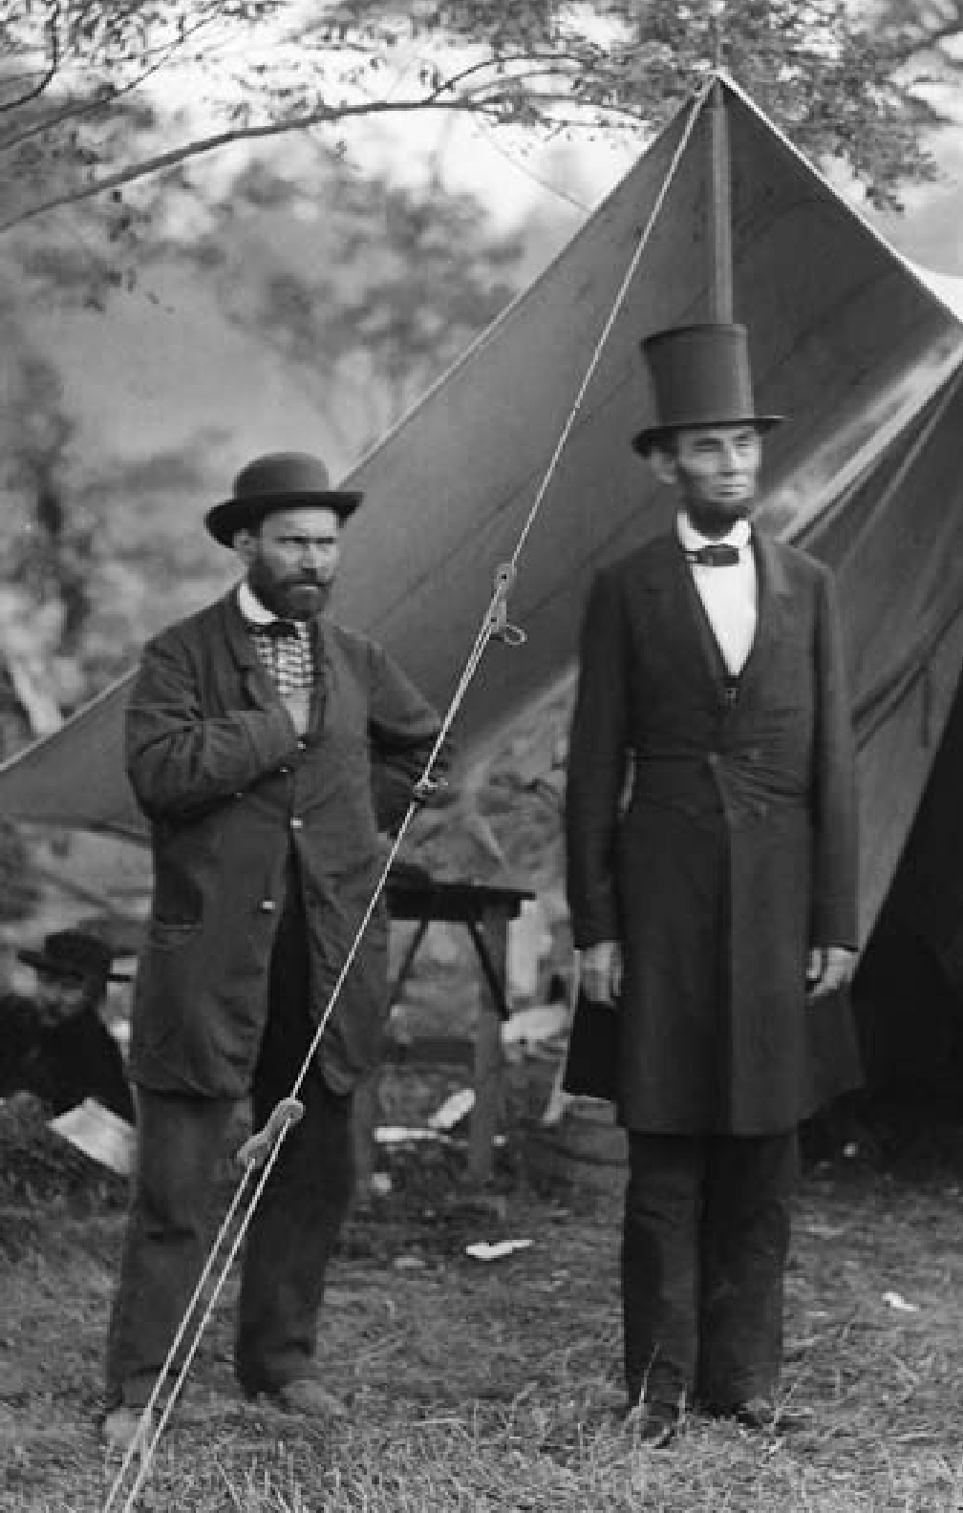

140

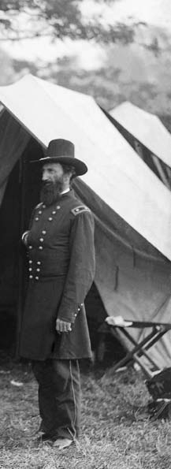

**C H A P T E R**

7

**THE CIVIL WAR**

**AND**

## RECONSTRUCTION

President Abraham Lincoln (center) at a Union Army encampment in October 1862, following the battle of Antietam.

“That this nation under God shall have a

new birth of freedom.”

President Abraham Lincoln, November 19, 1863

#### SECESSION AND CIVIL WAR

**L**incoln’s victory in the presi- dential election of November 1860 made South Carolina’s secession

from the Union December 20 a foregone conclusion. The state had long been waiting for an event that would unite the South against the antislavery forces. By February 1, 1861, five more Southern states had seceded. On February 8, the six states signed a provisional constitu- tion for the Confederate States of America. The remaining Southern states as yet remained in the Union, although Texas had begun to move on its secession.

Less than a month later, March 4, 1861, Abraham Lincoln was sworn in as president of the United States. In his inaugural address, he declared the Confederacy “legally void.” His speech closed with a plea for restora-

tion of the bonds of union, but the South turned a deaf ear. On April 12, Confederate guns opened fire on the federal garrison at Fort Sumter in the Charleston, South Carolina, harbor. A war had begun in which more Americans would die than in any other conflict before or since.

In the seven states that had se- ceded, the people responded posi- tively to the Confederate action and the leadership of Confeder- ate President Jefferson Davis. Both sides now tensely awaited the action of the slave states that thus far had remained loyal. Virginia seceded on April 17; Arkansas, Tennessee, and North Carolina followed quickly.

No state left the Union with greater reluctance than Virginia. Her statesmen had a leading part in the winning of the Revolution and the framing of the Constitution, and she had provided the nation with

five presidents. With Virginia went Colonel Robert E. Lee, who declined the command of the Union Army out of loyalty to his native state.

Between the enlarged Confed- eracy and the free-soil North lay the border slave states of Delaware, Maryland, Kentucky, and Missouri, which, despite some sympathy with the South, would remain loyal to the Union.

Each side entered the war with high hopes for an early victory. In material resources the North enjoyed a decided advantage. Twenty-three states with a population of 22 mil- lion were arrayed against 11 states inhabited by nine million, including slaves. The industrial superiority of the North exceeded even its prepon- derance in population, providing it with abundant facilities for manu- facturing arms and ammunition, clothing, and other supplies. It had a greatly superior railway network.

The South nonetheless had cer- tain advantages. The most impor- tant was geography; the South was fighting a defensive war on its own territory. It could establish its inde- pendence simply by beating off the Northern armies. The South also had a stronger military tradition, and possessed the more experienced military leaders.

#### WESTERN ADVANCE, EASTERN STALEMATE

**T**he first large battle of the war, at Bull Run, Virginia (also known as First Manassas) near Washington,

stripped away any illusions that vic- tory would be quick or easy. It also established a pattern, at least in the Eastern United States, of bloody Southern victories that never trans- lated into a decisive military advan- tage for the Confederacy.

In contrast to its military failures in the East, the Union was able to se- cure battlefield victories in the West and slow strategic success at sea. Most of the Navy, at the war’s begin- ning, was in Union hands, but it was scattered and weak. Secretary of the Navy Gideon Welles took prompt measures to strengthen it. Lincoln then proclaimed a blockade of the Southern coasts. Although the ef- fect of the blockade was negligible at first, by 1863 it almost completely prevented shipments of cotton to Europe and blocked the importa- tion of sorely needed munitions, clothing, and medical supplies to the South.

A brilliant Union naval com- mander, David Farragut, conducted two remarkable operations. In April 1862, he took a fleet into the mouth of the Mississippi River and forced the surrender of the largest city in the South, New Orleans, Louisiana. In August 1864, with the cry, “Damn the torpedoes! Full speed ahead,” he led a force past the fortified entrance of Mobile Bay, Alabama, captured a Confederate ironclad vessel, and sealed off the port.

In the Mississippi Valley, the Union forces won an almost unin- terrupted series of victories. They began by breaking a long Confeder-

ate line in Tennessee, thus making it possible to occupy almost all the western part of the state. When the important Mississippi River port of Memphis was taken, Union troops advanced some 320 kilometers into the heart of the Confederacy. With the tenacious General Ulysses S. Grant in command, they withstood a sudden Confederate counterattack at Shiloh, on the bluffs overlooking the Tennessee River. Those killed and wounded at Shiloh numbered more than 10,000 on each side, a ca- sualty rate that Americans had never before experienced. But it was only the beginning of the carnage.

In Virginia, by contrast, Union troops continued to meet one de- feat after another in a succession of bloody attempts to capture Rich- mond, the Confederate capital. The Confederates enjoyed strong defense positions afforded by numerous streams cutting the road between Washington and Richmond. Their two best generals, Robert E. Lee and Thomas J. (“Stonewall”) Jackson, both far surpassed in ability their early Union counterparts. In 1862 Union commander George McClel- lan made a slow, excessively cautious attempt to seize Richmond. But in the Seven Days’ Battles between June 25 and July 1, the Union troops were driven steadily backward, both sides suffering terrible losses.

After another Confederate vic- tory at the Second Battle of Bull Run (or Second Manassas), Lee crossed the Potomac River and in- vaded Maryland. McClellan again

responded tentatively, despite learn- ing that Lee had split his army and was heavily outnumbered. The Union and Confederate Armies met at Antietam Creek, near Sharpsburg, Maryland, on September 17, 1862, in the bloodiest single day of the war: More than 4,000 died on both sides and 18,000 were wounded. Despite his numerical advantage, however, McClellan failed to break Lee’s lines or press the attack, and Lee was able to retreat across the Potomac with his army intact. As a result, Lincoln fired McClellan.

Although Antietam was in- conclusive in military terms, its consequences were nonetheless momentous. Great Britain and France, both on the verge of rec- ognizing the Confederacy, delayed their decision, and the South never received the diplomatic recognition and the economic aid from Europe that it desperately sought.

Antietam also gave Lincoln the opening he needed to issue the preliminary Emancipation Procla- mation, which declared that as of January 1, 1863, all slaves in states re- belling against the Union were free. In practical terms, the proclamation had little immediate impact; it freed slaves only in the Confederate states, while leaving slavery intact in the border states. Politically, however, it meant that in addition to preserving the Union, the abolition of slavery was now a declared objective of the Union war effort.

The final Emancipation Proc- lamation, issued January 1, 1863,

also authorized the recruitment of African Americans into the Union Army, a move abolitionist lead- ers such as Frederick Douglass had been urging since the beginning of armed conflict. Union forces already had been sheltering escaped slaves as “contraband of war,” but following the Emancipation Proclamation, the Union Army recruited and trained regiments of African-American soldiers that fought with distinc- tion in battles from Virginia to the Mississippi. About 178,000 African Americans served in the U.S. Col- ored Troops, and 29,500 served in the Union Navy.

Despite the political gains represented by the Emancipation Proclamation, however, the North’s military prospects in the East re- mained bleak as Lee’s Army of Northern Virginia continued to maul the Union Army of the Po- tomac, first at Fredericksburg, Vir- ginia, in December 1862 and then at Chancellorsville in May 1863. But Chancellorsville, although one of Lee’s most brilliant military victo- ries, was also one of his most costly. His most valued lieutenant, General “Stonewall” Jackson, was mistaken- ly shot and killed by his own men.

#### GETTYSBURG TO APPOMATTOX

**Y**et none of the Confederate vic- tories was decisive. The Union sim- ply mustered new armies and tried

again. Believing that the North’s crushing defeat at Chancellorsville

gave him his chance, Lee struck northward into Pennsylvania at the beginning of July 1863, almost reach- ing the state capital at Harrisburg. A strong Union force intercepted him at Gettysburg, where, in a titanic three-day battle — the largest of the Civil War — the Confederates made a valiant effort to break the Union lines. They failed, and on July 4 Lee’s army, after crippling losses, retreated behind the Potomac.

More than 3,000 Union soldiers and almost 4,000 Confederates died at Gettysburg; wounded and missing totaled more than 20,000 on each side. On November 19, 1863, Lincoln dedicated a new national cemetery there with perhaps the most famous address in U.S. history. He concluded his brief remarks with these words:

*... we here highly resolve that these dead shall not have died in vain — that this nation, under God, shall have a new birth of freedom — and that government*

*of the people, by the people, for the people, shall not perish from the earth.*

On the Mississippi, Union con- trol had been blocked at Vicksburg, where the Confederates had strong- ly fortified themselves on bluffs too high for naval attack. In early 1863 Grant began to move below and around Vicksburg, subjecting it to a six-week siege. On July 4, he cap- tured the town, together with the strongest Confederate Army in the West. The river was now entirely in Union hands. The Confederacy was broken in two, and it became almost

impossible to bring supplies from Texas and Arkansas.

The Northern victories at Vicks- burg and Gettysburg in July 1863 marked the turning point of the war, although the bloodshed continued unabated for more than a year-and- a-half.

Lincoln brought Grant east and made him commander-in-chief of all Union forces. In May 1864 Grant advanced deep into Virginia and met Lee’s Confederate Army in the three-day Battle of the Wilderness. Losses on both sides were heavy, but unlike other Union command- ers, Grant refused to retreat. In- stead, he attempted to outflank Lee, stretching the Confederate lines and pounding away with artillery and infantry attacks. “I propose to fight it out along this line if it takes all sum- mer,” the Union commander said at Spotsylvania, during five days of bloody trench warfare that charac- terized fighting on the eastern front for almost a year.

In the West, Union forces gained control of Tennessee in the fall of 1863 with victories at Chattanoo- ga and nearby Lookout Mountain, opening the way for General Wil- liam T. Sherman to invade Georgia. Sherman outmaneuvered several smaller Confederate armies, occu- pied the state capital of Atlanta, then marched to the Atlantic coast, sys- tematically destroying railroads, factories, warehouses, and other facilities in his path. His men, cut off from their normal supply lines, ravaged the countryside for food.

From the coast, Sherman marched northward; by February 1865, he had taken Charleston, South Caro- lina, where the first shots of the Civil War had been fired. Sherman, more than any other Union general, un- derstood that destroying the will and morale of the South was as impor- tant as defeating its armies.

Grant, meanwhile, lay siege to Pe- tersburg, Virginia, for nine months, before Lee, in March 1865, knew that he had to abandon both Petersburg and the Confederate capital of Rich- mond in an attempt to retreat south. But it was too late. On April 9, 1865, surrounded by huge Union armies, Lee surrendered to Grant at Appo- mattox Courthouse. Although scat- tered fighting continued elsewhere for several months, the Civil War was over.

The terms of surrender at Ap- pomattox were magnanimous, and on his return from his meeting with Lee, Grant quieted the noisy dem- onstrations of his soldiers by re- minding them: “The rebels are our countrymen again.” The war for Southern independence had become the “lost cause,” whose hero, Rob- ert E. Lee, had won wide admiration through the brilliance of his leader- ship and his greatness in defeat.

#### WITH MALICE TOWARD NONE

**F**or the North, the war produced a still greater hero in Abraham Lin- coln — a man eager, above all else,

to weld the Union together again, not by force and repression but by

warmth and generosity. In 1864 he had been elected for a second term as president, defeating his Demo- cratic opponent, George McClellan, the general he had dismissed after Antietam. Lincoln’s second inaugu- ral address closed with these words: *With malice toward none; with charity for all; with firmness in*

*the right, as God gives us to see the right, let us strive on to finish the work we are in; to bind up the nation’s wounds; to care for him who shall have borne the battle,*

*and for his widow, and his orphan*

*— to do all which may achieve and cherish a just, and a lasting peace, among ourselves, and with all nations.*

Three weeks later, two days after Lee’s surrender, Lincoln delivered his last public address, in which he unfolded a generous reconstruction policy. On April 14, 1865, the presi- dent held what was to be his last Cabinet meeting. That evening — with his wife and a young couple who were his guests — he attended a performance at Ford’s Theater. There, as he sat in the presidential box, he was assassinated by John Wilkes Booth, a Virginia actor em- bittered by the South’s defeat. Booth was killed in a shootout some days later in a barn in the Virginia coun- tryside. His accomplices were cap- tured and later executed.

Lincoln died in a downstairs bed- room of a house across the street from Ford’s Theater on the morn- ing of April 15. Poet James Russell Lowell wrote:

*Never before that startled April morning did such multitudes of men shed tears for the death of one they had never seen, as if with him a friendly presence had been taken from their lives, leaving them colder and darker. Never was funeral panegyric so eloquent as the silent look of sympathy which strangers exchanged when they met that day. Their common manhood had lost a kinsman.*

The first great task confronting the victorious North — now under the leadership of Lincoln’s vice presi- dent, Andrew Johnson, a Southerner who remained loyal to the Union — was to determine the status of the states that had seceded. Lincoln had already set the stage. In his view, the people of the Southern states had never legally seceded; they had been misled by some disloyal citi- zens into a defiance of federal au- thority. And since the war was the act of individuals, the federal gov- ernment would have to deal with these individuals and not with the states. Thus, in 1863 Lincoln proclaimed that if in any state 10 percent of the voters of record in 1860 would form a government loyal to the U.S. Constitution and would acknowledge obedience to the laws of the Congress and the proclama- tions of the president, he would rec- ognize the government so created as the state’s legal government.

Congress rejected this plan. Many Republicans feared it would simply entrench former rebels in power; they challenged Lincoln’s right

to deal with the rebel states with- out consultation. Some members of Congress advocated severe punish- ment for all the seceded states; oth- ers simply felt the war would have been in vain if the old Southern es- tablishment was restored to power. Yet even before the war was wholly over, new governments had been set up in Virginia, Tennessee, Arkansas, and Louisiana.

To deal with one of its major concerns — the condition of for- mer slaves — Congress established the Freedmen’s Bureau in March 1865 to act as guardian over African Americans and guide them toward self-support. And in December of that year, Congress ratified the 13th Amendment to the U.S. Constitu- tion, which abolished slavery.

Throughout the summer of 1865 Johnson proceeded to carry out Lin- coln’s reconstruction program, with minor modifications. By presidential proclamation he appointed a gover- nor for each of the former Confeder- ate states and freely restored political rights to many Southerners through use of presidential pardons.

In due time conventions were held in each of the former Confed- erate states to repeal the ordinances of secession, repudiate the war debt, and draft new state constitutions. Eventually a native Unionist became governor in each state with authority to convoke a convention of loyal vot- ers. Johnson called upon each con- vention to invalidate the secession, abolish slavery, repudiate all debts that went to aid the Confederacy,

and ratify the 13th Amendment. By the end of 1865, this process was completed, with a few exceptions.

#### RADICAL RECONSTRUCTION

**B**oth Lincoln and Johnson had foreseen that the Congress would have the right to deny Southern leg-

islators seats in the U.S. Senate or House of Representatives, under the clause of the Constitution that says, “Each house shall be the judge of the ... qualifications of its own mem- bers.” This came to pass when, under the leadership of Thaddeus Stevens, those congressmen called “Radical Republicans,” who were wary of a quick and easy “reconstruction,” re- fused to seat newly elected Southern senators and representatives. Within the next few months, Congress pro- ceeded to work out a plan for the reconstruction of the South quite different from the one Lincoln had started and Johnson had continued. Wide public support gradual-

ly developed for those members of Congress who believed that African Americans should be given full citi- zenship. By July 1866, Congress had passed a civil rights bill and set up a new Freedmen’s Bureau — both designed to prevent racial discrimi- nation by Southern legislatures. Fol- lowing this, the Congress passed a 14th Amendment to the Constitu- tion, stating that “all persons born or naturalized in the United States, and subject to the jurisdiction there- of, are citizens of the United States and of the State wherein they reside.”

This repudiated the Dred Scott rul- ing, which had denied slaves their right of citizenship.

All the Southern state legisla- tures, with the exception of Tennes- see, refused to ratify the amendment, some voting against it unanimously. In addition, Southern state legisla- tures passed “codes” to regulate the African-American freedmen. The codes differed from state to state, but some provisions were common. African Americans were required to enter into annual labor contracts, with penalties imposed in case of violation; dependent children were subject to compulsory apprentice- ship and corporal punishments by masters; vagrants could be sold into private service if they could not pay severe fines.

Many Northerners interpreted the Southern response as an attempt to reestablish slavery and repudi- ate the hard-won Union victory in the Civil War. It did not help that Johnson, although a Unionist, was a Southern Democrat with an ad- diction to intemperate rhetoric and an aversion to political compromise. Republicans swept the congressional elections of 1866. Firmly in power, the Radicals imposed their own vi- sion of Reconstruction.

In the Reconstruction Act of March 1867, Congress, ignoring the governments that had been estab- lished in the Southern states, divided the South into five military districts, each administered by a Union gener- al. Escape from permanent military government was open to those states

that established civil governments, ratified the 14th Amendment, and adopted African-American suffrage. Supporters of the Confederacy who had not taken oaths of loyalty to the United States generally could not vote. The 14th Amendment was rati- fied in 1868. The 15th Amendment, passed by Congress the following year and ratified in 1870 by state leg- islatures, provided that “The right of citizens of the United States to vote shall not be denied or abridged by the United States or any state on ac- count of race, color, or previous con- dition of servitude.”

The Radical Republicans in Congress were infuriated by Presi- dent Johnson’s vetoes (even though they were overridden) of legisla- tion protecting newly freed African Americans and punishing former Confederate leaders by depriving them of the right to hold office. Congressional antipathy to Johnson was so great that, for the first time in American history, impeachment proceedings were instituted to re- move the president from office.

Johnson’s main offense was his opposition to punitive congressional policies and the violent language he used in criticizing them. The most serious legal charge his enemies could level against him was that, despite the Tenure of Office Act (which required Senate approval for the removal of any officeholder the Senate had previously confirmed), he had removed from his Cabinet the secretary of war, a staunch sup- porter of the Congress. When the

impeachment trial was held in the Senate, it was proved that Johnson was technically within his rights in removing the Cabinet member. Even more important, it was pointed out that a dangerous precedent would be set if the Congress were to remove a president because he disagreed with the majority of its members. The fi- nal vote was one short of the two- thirds required for conviction.

Johnson continued in office until his term expired in 1869, but Con- gress had established an ascendancy that would endure for the rest of the century. The Republican victor in the presidential election of 1868, for- mer Union general Ulysses S. Grant, would enforce the reconstruction policies the Radicals had initiated.

By June 1868, Congress had re- admitted the majority of the for- mer Confederate states back into the Union. In many of these re- constructed states, the majority of the governors, representatives, and senators were Northern men — so- called carpetbaggers — who had gone South after the war to make their political fortunes, often in alliance with newly freed African Americans. In the legislatures of Louisiana and South Carolina, Af- rican Americans actually gained a majority of the seats.

Many Southern whites, their po- litical and social dominance threat- ened, turned to illegal means to prevent African Americans from gaining equality. Violence against African Americans by such extra- legal organizations as the Ku Klux

Klan became more and more fre- quent. Increasing disorder led to the passage of Enforcement Acts in 1870 and 1871, severely punishing those who attempted to deprive the African-American freedmen of their civil rights.

#### THE END OF RECONSTRUCTION

**A**s time passed, it became more and more obvious that the problems of the South were not being solved

by harsh laws and continuing rancor against former Confederates. More- over, some Southern Radical state governments with prominent Af- rican-American officials appeared corrupt and inefficient. The nation was quickly tiring of the attempt to impose racial democracy and liberal values on the South with Union bay- onets. In May 1872, Congress passed a general Amnesty Act, restoring full political rights to all but about 500 former rebels.

Gradually Southern states began electing members of the Democratic Party into office, ousting carpet- bagger governments and intimidat- ing African Americans from voting or attempting to hold public office. By 1876 the Republicans remained in power in only three Southern states. As part of the bargaining that resolved the disputed presidential elections that year in favor of Ruth- erford B. Hayes, the Republicans promised to withdraw federal troops that had propped up the remaining Republican governments. In 1877

Hayes kept his promise, tacitly aban- doning federal responsibility for en- forcing blacks’ civil rights.

The South was still a region dev- astated by war, burdened by debt caused by misgovernment, and de- moralized by a decade of racial war- fare. Unfortunately, the pendulum of national racial policy swung from one extreme to the other. A feder- al government that had supported harsh penalties against Southern white leaders now tolerated new and humiliating kinds of discrimina- tion against African Americans. The last quarter of the 19th century saw a profusion of “Jim Crow” laws in Southern states that segregated pub- lic schools, forbade or limited Afri- can-American access to many public facilities such as parks, restaurants, and hotels, and denied most blacks the right to vote by imposing poll taxes and arbitrary literacy tests. “Jim Crow” is a term derived from a song in an 1828 minstrel show where a white man first performed in “blackface.”

Historians have tended to judge Reconstruction harshly, as a murky period of political conflict, corrup- tion, and regression that failed to achieve its original high-minded goals and collapsed into a sinkhole of virulent racism. Slaves were grant- ed freedom, but the North complete-

ly failed to address their economic needs. The Freedmen’s Bureau was unable to provide former slaves with political and economic oppor- tunity. Union military occupiers often could not even protect them from violence and intimidation. Indeed, federal army officers and agents of the Freedmen’s Bureau were often racists themselves. With- out economic resources of their own, many Southern African Americans were forced to become tenant farm- ers on land owned by their former masters, caught in a cycle of poverty that would continue well into the 20th century.

Reconstruction-era governments did make genuine gains in rebuild- ing Southern states devastated by the war, and in expanding public services, notably in establishing tax-supported, free public schools for African Americans and whites. However, recalcitrant Southerners seized upon instances of corruption (hardly unique to the South in this era) and exploited them to bring down radical regimes. The failure of Reconstruction meant that the struggle of African Americans for equality and freedom was deferred until the 20th century — when it would become a national, not just a Southern issue. 9

CHAPTER 7: THE CIVIL WAR AND RECONSTRUCTION

**THE CIVIL WAR AND NEW PATTERNS OF AMERICAN POLITICS**

**T**he controversies of the 1850s had destroyed the Whig Party, created the Republican Party, and divided the Democratic Party along regional lines. The Civil War demonstrated that the Whigs were gone beyond recall and

the Republicans on the scene to stay. It also laid the basis for a reunited Democratic Party.

The Republicans could seamlessly replace the Whigs throughout the North and West because they were far more than a free-soil/antislavery force. Most of their leaders had started as Whigs and continued the Whig interest in federally assisted national development. The need to manage a war did not deter them from also enacting a protective tariff (1861) to foster American manufacturing, the Homestead Act (1862) to encourage Western settlement, the Morrill Act (1862) to establish “land grant” agricultural and techni-

cal colleges, and a series of Pacific Railway Acts (1862-64) to underwrite a transcontinental railway line. These measures rallied support throughout the Union from groups to whom slavery was a secondary issue and ensured the party’s continuance as the latest manifestation of a political creed that had been advanced by Alexander Hamilton and Henry Clay.

The war also laid the basis for Democratic reunification because Northern opposition to it centered in the Democratic Party. As might be expected from the party of “popular sovereignty,” some Democrats believed that full-scale war to reinstate the Union was unjustified. This group came to be known as the Peace Democrats. Their more extreme elements were called “Copperheads.”

Moreover, few Democrats, whether of the “war” or “peace” faction, believed the emancipation of the slaves was worth Northern blood. Opposition to emancipation had long been party policy. In 1862, for example, virtually every Democrat in Congress voted against eliminating slavery in the District of Columbia and prohibiting it in the territories.

Much of this opposition came from the working poor, particularly Irish and German Catholic immigrants, who feared a massive migration of newly freed African Americans to the North. They also resented the establish- ment of a military draft (March 1863) that disproportionately affected them. Race riots erupted in several Northern cities. The worst of these occurred in New York, July 13-16, 1863, precipitated by Democratic Governor Horatio Seymour’s condemnation of military conscription. Federal troops, who just days earlier had been engaged at Gettysburg, were sent to restore order.

152

OUTLINE OF U.S. HISTORY

The Republicans prosecuted the war with little regard for civil liberties. In September 1862, Lincoln suspended the writ of habeas corpus and imposed martial law on those who interfered with recruitment or gave aid and comfort to the rebels. This breech of civil law, although constitution- ally justified during times of crisis, gave the Democrats another opportunity to criticize Lincoln. Secretary of War Edwin Stanton enforced martial law vigorously, and many thousands — most of them Southern sympathizers or Democrats — were arrested.

Despite the Union victories at Vicksburg and Gettysburg in 1863, Democratic “peace” candidates continued to play on the nation’s misfortunes and racial sensitivities. Indeed, the mood of the North was such that Lincoln was convinced he would lose his re-election bid in November 1864. Largely for that reason, the Republican Party renamed itself the Union Party and drafted the Tennessee Democrat Andrew Johnson to be Lincoln’s running mate. Sherman’s victories in the South sealed the election for them.

Lincoln’s assassination, the rise of Radical Republicanism, and Johnson’s blundering leadership all played into a postwar pattern of politics in which

the Republican Party suffered from overreaching in its efforts to remake the South, while the Democrats, through their criticism of Reconstruction, al- lied themselves with the neo-Confederate Southern white majority. Ulysses S. Grant’s status as a national hero carried the Republicans through two presi- dential elections, but as the South emerged from Reconstruction, it became apparent that the country was nearly evenly divided between the two parties.

The Republicans would be dominant in the industrial Northeast until the 1930s and strong in most of the rest of the country outside the South.

However, their appeal as the party of strong government and national develop- ment increasingly would be perceived as one of allegiance to big business

and finance.

When President Hayes ended Reconstruction, he hoped it would be pos- sible to build the Republican Party in the South, using the old Whigs as a base and the appeal of regional development as a primary issue. By then, how- ever, Republicanism as the South’s white majority perceived it was

identified with a hated African-American supremacy. For the next three- quarters of a century, the South would be solidly Democratic. For much of that time, the national Democratic Party would pay solemn deference to states’ rights while ignoring civil rights. The group that would suffer the most as a

legacy of Reconstruction was the African Americans. ◆

153

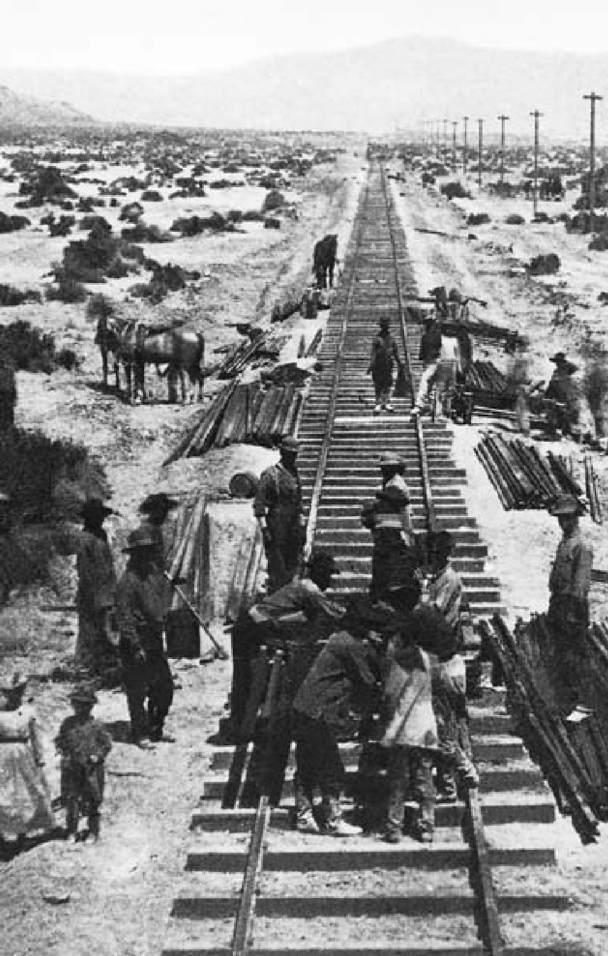

154

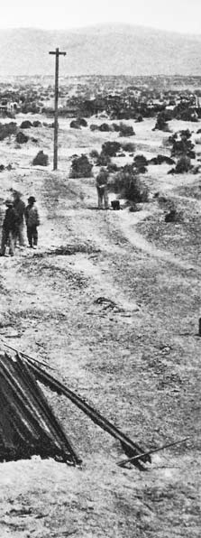

**C H A P T E R**

8

**GROWTH AND**

**TRANSFORMATION**

Building the transcontinental railroad, 1868.

“Upon the sacredness of property,

civilization itself depends.”

Industrialist and philanthropist Andrew Carnegie, 1889

Between two great wars — the Civil War and the First World War — the United States of America came of age. In a period of less than 50 years it was transformed from a rural re- public to an urban nation. The fron- tier vanished. Great factories and steel mills, transcontinental railroad lines, flourishing cities, and vast agricultural holdings marked the land. With this economic growth and affluence came corresponding problems. Nationwide, a few busi- nesses came to dominate whole in- dustries, either independently or in combination with others. Work- ing conditions were often poor. Cities grew so quickly they could not properly house or govern their growing populations.

#### TECHNOLOGY AND CHANGE

“**T**he Civil War,” says one writer, “cut a wide gash through the history

of the country; it dramatized in a stroke the changes that had begun to take place during the preceding 20 or 30 years ” War needs had enor-

mously stimulated manufacturing, speeding an economic process based on the exploitation of iron, steam, and electric power, as well as the for- ward march of science and inven- tion. In the years before 1860, 36,000 patents were granted; in the next 30 years, 440,000 patents were issued, and in the first quarter of the 20th century, the number reached nearly a million.

As early as 1844, Samuel F.B. Morse had perfected electrical te- legraphy; soon afterward distant parts of the continent were linked by a network of poles and wires. In 1876 Alexander Graham Bell exhib- ited a telephone instrument; within half a century, 16 million telephones would quicken the social and eco- nomic life of the nation. The growth

of business was hastened by the in- vention of the typewriter in 1867, the adding machine in 1888, and the cash register in 1897. The lino- type composing machine, invented in 1886, and rotary press and paper- folding machinery made it possible to print 240,000 eight-page newspa- pers in an hour. Thomas Edison’s incandescent lamp eventually lit millions of homes. The talking ma- chine, or phonograph, was perfected by Edison, who, in conjunction with George Eastman, also helped devel- op the motion picture. These and many other applications of science and ingenuity resulted in a new level of productivity in almost every field. Concurrently, the nation’s basic industry — iron and steel — forged ahead, protected by a high tariff. The iron industry moved westward as ge- ologists discovered new ore depos- its, notably the great Mesabi range at the head of Lake Superior, which became one of the largest produc- ers in the world. Easy and cheap to mine, remarkably free of chemical impurities, Mesabi ore could be pro- cessed into steel of superior quality at about one-tenth the previously

prevailing cost.

#### CARNEGIE AND THE ERA OF STEEL

**A**ndrew Carnegie was largely re- sponsible for the great advances in steel production. Carnegie, who

came to America from Scotland as a child of 12, progressed from bob- bin boy in a cotton factory to a job

in a telegraph office, then to one on the Pennsylvania Railroad. Before he was 30 years old he had made shrewd and farsighted investments, which by 1865 were concentrated in iron. Within a few years, he had or- ganized or had stock in companies making iron bridges, rails, and lo- comotives. Ten years later, he built the nation’s largest steel mill on the Monongahela River in Pennsylvania. He acquired control not only of new mills, but also of coke and coal prop- erties, iron ore from Lake Superior, a fleet of steamers on the Great Lakes, a port town on Lake Erie, and a con- necting railroad. His business, allied with a dozen others, commanded favorable terms from railroads and shipping lines. Nothing comparable in industrial growth had ever been seen in America before.

Though Carnegie long dominat- ed the industry, he never achieved a complete monopoly over the nat- ural resources, transportation, and industrial plants involved in the making of steel. In the 1890s, new companies challenged his preemi- nence. He would be persuaded to merge his holdings into a new cor- poration that would embrace most of the important iron and steel proper- ties in the nation.

#### CORPORATIONS AND CITIES

**T**he United States Steel Corpora- tion, which resulted from this merg- er in 1901, illustrated a process under

way for 30 years: the combination of independent industrial enterprises

into federated or centralized compa- nies. Started during the Civil War, the trend gathered momentum after the 1870s, as businessmen began to fear that overproduction would lead to declining prices and falling prof- its. They realized that if they could control both production and mar- kets, they could bring competing firms into a single organization. The “corporation” and the “trust” were developed to achieve these ends.

Corporations, making available a deep reservoir of capital and giving business enterprises permanent life and continuity of control, attracted investors both by their anticipated profits and by their limited liability in case of business failure. The trusts were in effect combinations of cor- porations whereby the stockholders of each placed stocks in the hands of trustees. (The “trust” as a method of corporate consolidation soon gave way to the holding company, but the term stuck.) Trusts made possible large-scale combinations, central- ized control and administration, and the pooling of patents. Their larger capital resources provided power to expand, to compete with foreign business organizations, and to drive hard bargains with labor, which was beginning to organize effective- ly. They could also exact favorable terms from railroads and exercise influence in politics.

The Standard Oil Company, founded by John D. Rockefeller, was one of the earliest and stron- gest corporations, and was followed rapidly by other combinations — in

cottonseed oil, lead, sugar, tobacco, and rubber. Soon aggressive indi- vidual businessmen began to mark out industrial domains for them- selves. Four great meat packers, chief among them Philip Armour and Gustavus Swift, established a beef trust. Cyrus McCormick achieved preeminence in the reaper business. A 1904 survey showed that more than 5,000 previously independent concerns had been consolidated into some 300 industrial trusts.

The trend toward amalgamation extended to other fields, particular- ly transportation and communica- tions. Western Union, dominant in telegraphy, was followed by the Bell Telephone System and eventually by the American Telephone and Tele- graph Company. In the 1860s, Cor- nelius Vanderbilt had consolidated 13 separate railroads into a single 800-kilometer line connecting New York City and Buffalo. During the next decade he acquired lines to Chi- cago, Illinois, and Detroit, Michigan, establishing the New York Central Railroad. Soon the major railroads of the nation were organized into trunk lines and systems directed by a handful of men.

In this new industrial order, the city was the nerve center, bringing to a focus all the nation’s dynamic economic forces: vast accumulations of capital, business, and financial in- stitutions, spreading railroad yards, smoky factories, armies of manual and clerical workers. Villages, at- tracting people from the countryside and from lands across the sea, grew

into towns and towns into cities al- most overnight. In 1830 only one of every 15 Americans lived in commu- nities of 8,000 or more; in 1860 the ratio was nearly one in every six; and in 1890 three in every 10. No single city had as many as a million in- habitants in 1860; but 30 years later New York had a million and a half; Chicago, Illinois, and Philadelphia, Pennsylvania, each had over a mil- lion. In these three decades, Phila- delphia and Baltimore, Maryland, doubled in population; Kansas City, Missouri, and Detroit, Michigan, grew fourfold; Cleveland, Ohio, six- fold; Chicago, tenfold. Minneapolis, Minnesota, and Omaha, Nebraska, and many communities like them

— hamlets when the Civil War be- gan — increased 50 times or more in population.

#### RAILROADS, REGULATIONS, AND THE TARIFF

**R**ailroads were especially impor- tant to the expanding nation, and their practices were often criticized.

Rail lines extended cheaper freight rates to large shippers by rebating a portion of the charge, thus disadvan- taging small shippers. Freight rates also frequently were not proportion- ate to distance traveled; competition usually held down charges between cities with several rail connections. Rates tended to be high between points served by only one line. Thus it cost less to ship goods 1,280 kilo- meters from Chicago to New York than to places a few hundred kilo-

meters from Chicago. Moreover, to avoid competition rival companies sometimes divided (“pooled”) the freight business according to a pre- arranged scheme that placed the to- tal earnings in a common fund for distribution.

Popular resentment at these prac- tices stimulated state efforts at regu- lation, but the problem was national in character. Shippers demanded congressional action. In 1887 Presi- dent Grover Cleveland signed the Interstate Commerce Act, which forbade excessive charges, pools, rebates, and rate discrimination. It created an Interstate Commerce Commission (ICC) to oversee the act, but gave it little enforcement power. In the first decades of its ex- istence, virtually all the ICC’s efforts at regulation and rate reductions failed to pass judicial review.

President Cleveland also opposed the protective tariff on foreign goods, which had come to be accepted as permanent national policy under the Republican presidents who dominat- ed the politics of the era. Cleveland, a conservative Democrat, regarded tariff protection as an unwarranted subsidy to big business, giving the trusts pricing power to the disadvan- tage of ordinary Americans. Reflect- ing the interests of their Southern base, the Democrats had reverted to their pre-Civil War opposition to protection and advocacy of a “tariff for revenue only.”

Cleveland, narrowly elected in 1884, was unsuccessful in achieving tariff reform during his first term.

He made the issue the keynote of his campaign for reelection, but Repub- lican candidate Benjamin Harrison, a defender of protectionism, won in a close race. In 1890, the Harrison administration, fulfilling its cam- paign promises, achieved passage of the McKinley tariff, which increased the already high rates. Blamed for high retail prices, the McKinley du- ties triggered widespread dissatisfac- tion, led to Republican losses in the 1890 elections, and paved the way for Cleveland’s return to the presidency in the 1892 election.

During this period, public an- tipathy toward the trusts increased. The nation’s gigantic corpora- tions were subjected to bitter attack through the 1880s by reformers such as Henry George and Edward Bel- lamy. The Sherman Antitrust Act, passed in 1890, forbade all combina- tions in restraint of interstate trade and provided several methods of enforcement with severe penalties. Couched in vague generalities, the law accomplished little immediately after its passage. But a decade later, President Theodore Roosevelt would use it vigorously.

#### REVOLUTION IN AGRICULTURE

**D**espite the great gains in industry, agriculture remained the nation’s basic occupation. The revolution

in agriculture — paralleling that in manufacturing after the Civil War

— involved a shift from hand labor to machine farming, and from sub-

sistence to commercial agriculture. Between 1860 and 1910, the number of farms in the United States tripled, increasing from two million to six million, while the area farmed more than doubled from 160 million to 352 million hectares.

Between 1860 and 1890, the pro- duction of such basic commodities as wheat, corn, and cotton out- stripped all previous figures in the United States. In the same period, the nation’s population more than doubled, with the largest growth in the cities. But the American farmer grew enough grain and cotton, raised enough beef and pork, and clipped enough wool not only to supply American workers and their families but also to create ever-in- creasing surpluses.

Several factors accounted for this extraordinary achievement. One was the expansion into the West. Anoth- er was a technological revolution. The farmer of 1800, using a hand sickle, could hope to cut a fifth of a hectare of wheat a day. With the cradle, 30 years later, he might cut four-fifths. In 1840 Cyrus McCor- mick performed a miracle by cutting from two to two-and-a-half hectares a day with the reaper, a machine he had been developing for nearly 10 years. He headed west to the young prairie town of Chicago, where he set up a factory — and by 1860 sold a quarter of a million reapers.

Other farm machines were de- veloped in rapid succession: the automatic wire binder, the threshing

*(Continued on page 177.)*

The silhouette of one of the United States’ most revered Founding Fathers, Thomas Jefferson, stands in the shrine dedicated to his memory.

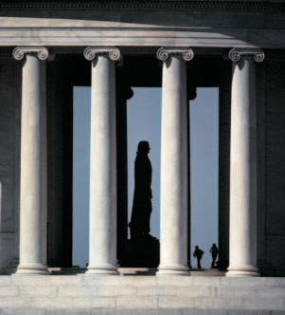“I have sworn upon the altar of God, eternal hostility against every form of tyranny over the mind of man.”

M O N U M E N T S A N D

A PICTURE PROFILE

**The monuments of American history span a continent in distance and centuries in time. They range from a massive serpent-shaped mound created by a long-gone Native-American culture to memorials in contemporary Washington, D.C., and New York City.**

MEMORIALS

161



The snow-covered Old Granary cemetery in Boston, Massachusetts, is burial ground for, among other leading American patriots, victims of the Boston Massacre, three signers of the Declaration of Independence, and six governors of Massachusetts. Originally founded by religious dissidents from England known as Puritans, Massachusetts was a leader in the struggle for independence against England. It was the setting for the Boston Tea Party and the first battles of the American Revolution — in Lexington and Concord.

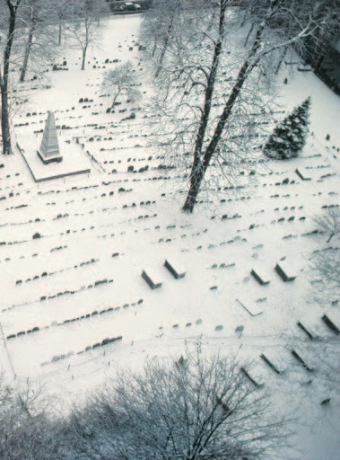

163

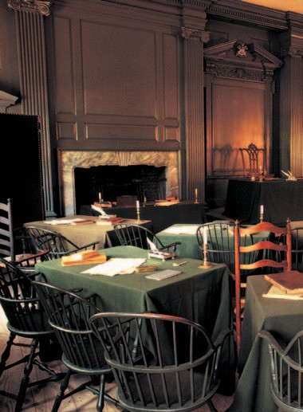

The historic room in Independence Hall, Philadelphia, where delegates drafted the Constitution of the United States in the summer of 1787. The Constitution is the supreme law of the land. It prescribes the form and authority of the federal

government, and ensures the fundamental freedoms and rights of the citizens of the country through the Bill of Rights.

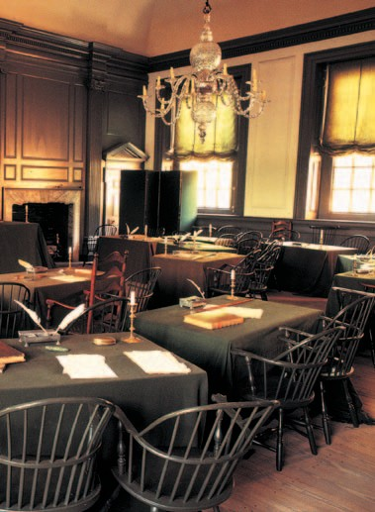

165

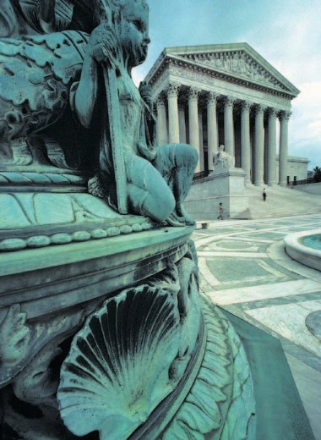

Statues guard the majestic façade of the U.S. Supreme Court, the highest court in the land. The words engraved on the lintel over the Greek pillars embody one of America’s founding principles: “Equal Justice Under Law.”

166

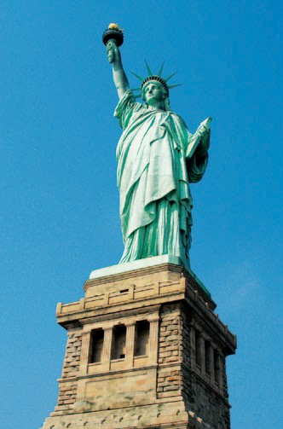

The Statue of Liberty, one of the United States’ most beloved monuments, stands 151 feet high at the entrance to New York harbor. A gift of friendship from the people of France to the United States, it was intended to be an impressive symbol of human liberty. It was certainly that for the millions of immigrants who came to the United States in the 19th and early 20th centuries, seeking freedom and a better life.

167

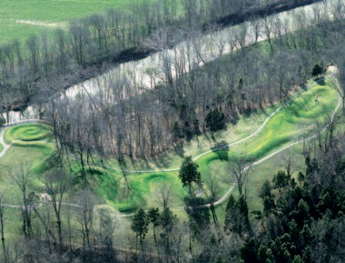

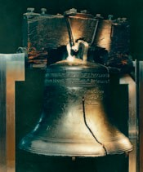Aerial view of the Great Serpent Mound in Adams County, Ohio. Carbon tests of the effigy revealed that the creators of this 1,330-foot monument were members of the Native-American Fort Ancient Culture (A.D. 1000-1550).

The Liberty Bell in Philadelphia, Pennsylvania, an enduring symbol of American freedom. First rung on July

8, 1776, to celebrate the adoption of the Declaration of Independence, it cracked in 1836 during the funeral of John Marshall, Chief Justice of the U.S. Supreme Court.

168

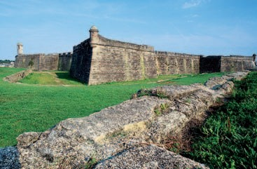

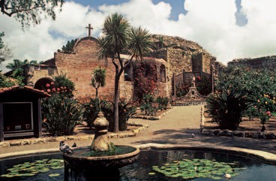Two monuments to the central role Spain played in the exploration of what is now the United States. Top, the Castillo de San Marcos, built 1672-1695 to guard

St. Augustine, Florida, the first permanent European settlement in the continental United States. Above, fountain and mission remains of the San Juan Capistrano Mission, California, one of nine missions founded by Spanish Franciscan missionaries led by Fray Junípero Serra in the 1770s. Serra led the Spanish colonization of what is today the state of California.

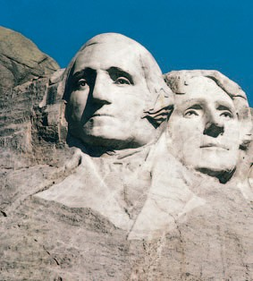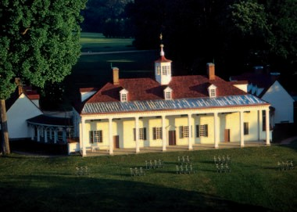

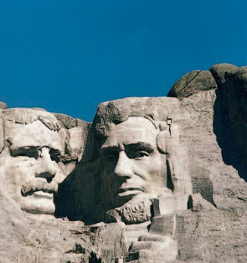

The faces of four of the most admired American presidents were carved by Gutzon Borglum into the southeast face of Mount Rushmore in South Dakota, beginning in 1927. From left to right, they are: George Washington, commander of the Revolutionary Army and first president of the young nation; Thomas Jefferson, author of the Declaration of Independence; Theodore Roosevelt, who led the country toward progressive reforms and a strong foreign policy; and Abraham Lincoln, who led the country through the Civil War and freed the slaves.

George Washington’s beloved home, Mount Vernon, by the Potomac River in Virginia, where he died on December 14, 1799, and is buried along with his wife Martha. Among other treasured items owned by the first president on display there, visitors can see one of the keys to the Bastille, a gift to Washington from the Marquis de Lafayette.

171

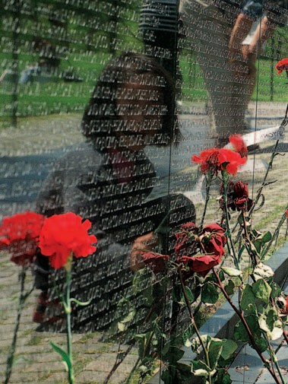

Six-year-old Mary Zheng straightens a flower placed at the Vietnam Veterans Memorial in Washington, D.C., April 30, 2000. The names of more than 58,000 servicemen who died in the war or remain missing are etched on the “wall” part of the memorial, pictured here. This portion of the monument was designed by Maya Lin, then a student at Yale University.

172

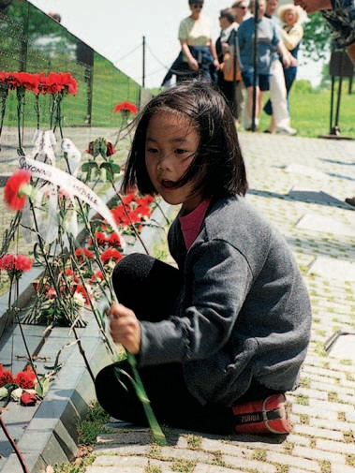

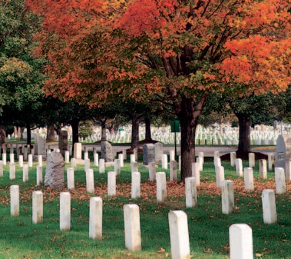

An autumnal view of Arlington Cemetery, Virginia, America’s largest and best-known national burial grounds. More than 260,000 people are buried at Arlington Cemetery, including veterans from all the nation’s wars.

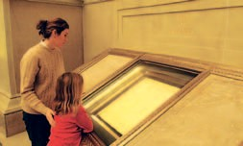

A mother and daughter viewing documents in the Exhibition Hall of the National Archives. The U.S. Constitution, the Declaration of

Independence, and the Bill of Rights are on display in this Washington, D.C., building.

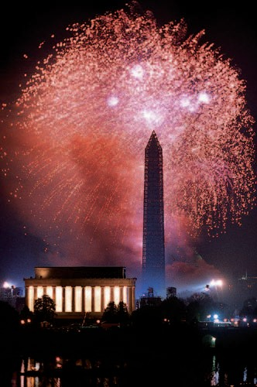

Fireworks celebrating the arrival of the Millennium illuminate two major monuments in Washington, D.C., the Lincoln Memorial on the left and the

obelisk-shaped Washington Monument, center. The Lincoln Memorial’s north and south side chambers contain carved inscriptions of his Second Inaugural Address and his Gettysburg Address. The tallest structure in the nation’s capital,

the Washington Monument was dedicated on February 21, 1885.

175

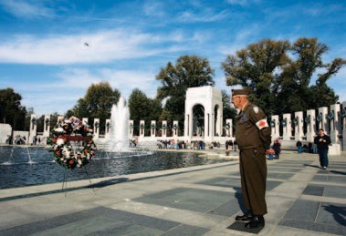



Top, the World War II Memorial, opened in 2004, is the most recent addition to the many national monuments in Washington, D.C. It honors the 16 million who served in the armed forces of the United States, the more than 400,000 who died, and all who supported the war effort from home. Above, the planned design for the World Trade Center Memorial in New York City is depicted in this photograph of a model unveiled in late 2004. “Reflecting Absence” will preserve not only the memory of those who died in the terrorist attack of September 11, 2001, but the visible remnants of the buildings destroyed that morning, too.

176

machine, and the reaper-thresher or combine. Mechanical planters, cut- ters, huskers, and shellers appeared, as did cream separators, manure spreaders, potato planters, hay dri- ers, poultry incubators, and a hun- dred other inventions.

Scarcely less important than machinery in the agricultural rev- olution was science. In 1862 the Morrill Land Grant College Act al- lotted public land to each state for the establishment of agricultural and industrial colleges. These were to serve both as educational institu- tions and as centers for research in scientific farming. Congress subse- quently appropriated funds for the creation of agricultural experiment stations throughout the country and granted funds directly to the De- partment of Agriculture for research purposes. By the beginning of the new century, scientists throughout the United States were at work on a wide variety of agricultural projects. One of these scientists, Mark Carleton, traveled for the Depart- ment of Agriculture to Russia. There he found and exported to his home- land the rust- and drought-resistant winter wheat that now accounts for more than half the U.S. wheat crop. Another scientist, Marion Dorset, conquered the dreaded hog cholera, while still another, George Mohler, helped prevent hoof-and- mouth disease. From North Africa, one researcher brought back Kaf- fir corn; from Turkestan, another imported the yellow-flowering al- falfa. Luther Burbank in California

produced scores of new fruits and vegetables; in Wisconsin, Stephen Babcock devised a test for determin- ing the butterfat content of milk; at Tuskegee Institute in Alabama, the African-American scientist George Washington Carver found hundreds of new uses for the peanut, sweet po- tato, and soybean.

In varying degrees, the explosion in agricultural science and technol- ogy affected farmers all over the world, raising yields, squeezing out small producers, and driving migra- tion to industrial cities. Railroads and steamships, moreover, began to pull regional markets into one large world market with prices instantly communicated by trans-Atlantic ca- ble as well as ground wires. Good news for urban consumers, falling agricultural prices threatened the livelihood of many American farm- ers and touched off a wave of agrar- ian discontent.

**THE DIVIDED SOUTH**

**A**fter Reconstruction, Southern leaders pushed hard to attract indus- try. States offered large inducements

and cheap labor to investors to de- velop the steel, lumber, tobacco, and textile industries. Yet in 1900 the re- gion’s percentage of the nation’s in- dustrial base remained about what it had been in 1860. Moreover, the price of this drive for industrializa- tion was high: Disease and child labor proliferated in Southern mill towns. Thirty years after the Civil War, the South was still poor, over-

whelmingly agrarian, and economi- cally dependent. Moreover, its race relations reflected not just the legacy of slavery, but what was emerging as the central theme of its history — a determination to enforce white su- premacy at any cost.

Intransigent white Southerners found ways to assert state control to maintain white dominance. Sev- eral Supreme Court decisions also bolstered their efforts by upholding traditional Southern views of the ap- propriate balance between national and state power.

In 1873 the Supreme Court found that the 14th Amendment (citi- zenship rights not to be abridged) conferred no new privileges or im- munities to protect African Amer- icans from state power. In 1883, furthermore, it ruled that the 14th Amendment did not prevent indi- viduals, as opposed to states, from practicing discrimination. And in *Plessy v. Ferguson* (1896), the Court found that “separate but equal” public accommodations for Afri- can Americans, such as trains and restaurants, did not violate their rights. Soon the principle of segre- gation by race extended into every area of Southern life, from railroads to restaurants, hotels, hospitals, and schools. Moreover, any area of life that was not segregated by law was segregated by custom and practice. Further curtailment of the right to vote followed. Periodic lynchings by mobs underscored the region’s determination to subjugate its Afri- can-American population.

Faced with pervasive discrimina- tion, many African Americans fol- lowed Booker T. Washington, who counseled them to focus on modest economic goals and to accept tem- porary social discrimination. Oth- ers, led by the African-American intellectual W.E.B. DuBois, wanted to challenge segregation through political action. But with both ma- jor parties uninterested in the is- sue and scientific theory of the time generally accepting black inferior- ity, calls for racial justice attracted little support.

#### THE LAST FRONTIER

**I**n 1865 the frontier line generally followed the western limits of the states bordering the Mississippi Riv-

er, but bulged outward beyond the eastern sections of Texas, Kansas, and Nebraska. Then, running north and south for nearly 1,600 kilome- ters, loomed huge mountain ranges, many rich in silver, gold, and other metals. To their west, plains and des- erts stretched to the wooded coastal ranges and the Pacific Ocean. Apart from the settled districts in Cali- fornia and scattered outposts, the vast inland region was populated by Native Americans: among them the Great Plains tribes — Sioux and Blackfoot, Pawnee and Cheyenne — and the Indian cultures of the South- west, including Apache, Navajo, and Hopi.

A mere quarter-century later, virtually all this country had been carved into states and territories.

Miners had ranged over the whole of the mountain country, tunnel- ing into the earth, establishing little communities in Nevada, Montana, and Colorado. Cattle ranchers, tak- ing advantage of the enormous grasslands, had laid claim to the huge expanse stretching from Texas to the upper Missouri River. Sheep herders had found their way to the valleys and mountain slopes. Farm- ers sank their plows into the plains and closed the gap between the East and West. By 1890 the frontier line had disappeared.

Settlement was spurred by the Homestead Act of 1862, which granted free farms of 64 hectares to citizens who would occupy and improve the land. Unfortunately for the would-be farmers, much of the Great Plains was suited more for cattle ranching than farming, and by 1880 nearly 22,400,000 hectares of “free” land were in the hands of cattlemen or the railroads.

In 1862 Congress also voted a charter to the Union Pacific Rail- road, which pushed westward from Council Bluffs, Iowa, using mostly the labor of ex-soldiers and Irish im- migrants. At the same time, the Cen- tral Pacific Railroad began to build eastward from Sacramento, Cali- fornia, relying heavily on Chinese immigrant labor. The whole country was stirred as the two lines steadily approached each other, finally meet- ing on May 10, 1869, at Promontory Point in Utah. The months of labo- rious travel hitherto separating the two oceans was now cut to about six

days. The continental rail network grew steadily; by 1884 four great lines linked the central Mississippi Valley area with the Pacific.

The first great rush of population to the Far West was drawn to the mountainous regions, where gold was found in California in 1848, in Colorado and Nevada 10 years lat- er, in Montana and Wyoming in the 1860s, and in the Black Hills of the Dakota country in the 1870s. Miners opened up the country, established communities, and laid the founda- tions for more permanent settle- ments. Eventually, however, though a few communities continued to be devoted almost exclusively to min- ing, the real wealth of Montana, Colorado, Wyoming, Idaho, and California proved to be in the grass and soil. Cattle-raising, long an important industry in Texas, flour- ished after the Civil War, when enterprising men began to drive their Texas longhorn cattle north across the open public land. Feed- ing as they went, the cattle arrived at railway shipping points in Kan- sas, larger and fatter than when they started. The annual cattle drive became a regular event; for hundreds of kilometers, trails were dotted with herds moving northward.

Next, immense cattle ranches appeared in Colorado, Wyoming, Kansas, Nebraska, and the Dakota territory. Western cities flourished as centers for the slaughter of cat- tle and dressing of meat. The cat- tle boom peaked in the mid-1880s. By then, not far behind the rancher

creaked the covered wagons of the farmers bringing their families, their draft horses, cows, and pigs. Under the Homestead Act they staked their claims and fenced them with a new invention, barbed wire. Ranchers were ousted from lands they had roamed without legal title.

Ranching and the cattle drives gave American mythology its last icon of frontier culture — the cow- boy. The reality of cowboy life was one of grueling hardship. As de- picted by writers like Zane Grey and movie actors such as John Wayne, the cowboy was a powerful mytho- logical figure, a bold, virtuous man of action. Not until the late 20th cen- tury did a reaction set in. Histori- ans and filmmakers alike began to depict “the Wild West” as a sordid place, peopled by characters more apt to reflect the worst, rather than the best, in human nature.

#### THE PLIGHT OF

**THE NATIVE AMERICANS**

**A**s in the East, expansion into the plains and mountains by miners, ranchers, and settlers led to increas-

ing conflicts with the Native Amer- icans of the West. Many tribes of Native Americans — from the Utes of the Great Basin to the Nez Perces of Idaho — fought the whites at one time or another. But the Sioux of the Northern Plains and the Apache of the Southwest provided the most significant opposition to frontier ad- vance. Led by such resourceful lead- ers as Red Cloud and Crazy Horse,

the Sioux were particularly skilled at high-speed mounted warfare. The Apaches were equally adept and highly elusive, fighting in their envi- rons of desert and canyons.

Conflicts with the Plains Indians worsened after an incident where the Dakota (part of the Sioux nation), declaring war against the U.S. gov- ernment because of long-standing grievances, killed five white settlers. Rebellions and attacks continued through the Civil War. In 1876 the last serious Sioux war erupted, when the Dakota gold rush penetrated the Black Hills. The Army was sup- posed to keep miners off Sioux hunt- ing grounds, but did little to protect the Sioux lands. When ordered to take action against bands of Sioux hunting on the range according to their treaty rights, however, it moved quickly and vigorously.

In 1876, after several indecisive encounters, Colonel George Custer, leading a small detachment of cav- alry encountered a vastly superior force of Sioux and their allies on the Little Bighorn River. Custer and his men were completely annihilated. Nonetheless the Native-American insurgency was soon suppressed. Later, in 1890, a ghost dance ritual on the Northern Sioux reservation at Wounded Knee, South Dakota, led to an uprising and a last, tragic encounter that ended in the death of nearly 300 Sioux men, women, and children.

Long before this, however, the way of life of the Plains Indians had been destroyed by an expand-

ing white population, the coming of the railroads, and the slaughter of the buffalo, almost exterminated in the decade after 1870 by the settlers’ indiscriminate hunting.

The Apache wars in the South- west dragged on until Geronimo, the last important chief, was captured in 1886.

Government policy ever since the Monroe administration had been to move the Native Americans be- yond the reach of the white frontier. But inevitably the reservations had become smaller and more crowd- ed. Some Americans began to pro- test the government’s treatment of Native Americans. Helen Hunt Jack- son, for example, an Easterner liv- ing in the West, wrote *A Century of Dishonor* (1881), which dramatized their plight and struck a chord in the nation’s conscience. Most re- formers believed the Native Ameri- can should be assimilated into the dominant culture. The federal gov- ernment even set up a school in Car- lisle, Pennsylvania, in an attempt to impose white values and beliefs on Native-American youths. (It was at this school that Jim Thorpe, often considered the best athlete the Unit- ed States has produced, gained fame in the early 20th century.)

In 1887 the Dawes (General Al- lotment) Act reversed U.S. Native- American policy, permitting the president to divide up tribal land and parcel out 65 hectares of land to each head of a family. Such al- lotments were to be held in trust by the government for 25 years, after

which time the owner won full title and citizenship. Lands not thus dis- tributed, however, were offered for sale to settlers. This policy, however well-intentioned, proved disastrous, since it allowed more plundering of Native-American lands. Moreover, its assault on the communal orga- nization of tribes caused further disruption of traditional culture. In 1934 U.S. policy was reversed yet again by the Indian Reorganiza- tion Act, which attempted to pro- tect tribal and communal life on the reservations.

#### AMBIVALENT EMPIRE

**T**he last decades of the 19th century were a period of imperial expansion for the United States. The American

story took a different course from that of its European rivals, however, because of the U.S. history of strug- gle against European empires and its unique democratic development.

The sources of American ex- pansionism in the late 19th century were varied. Internationally, the pe- riod was one of imperialist frenzy, as European powers raced to carve up Africa and competed, along with Japan, for influence and trade in Asia. Many Americans, including influential figures such as Theodore Roosevelt, Henry Cabot Lodge, and Elihu Root, felt that to safeguard its own interests, the United States had to stake out spheres of economic in- fluence as well. That view was sec- onded by a powerful naval lobby, which called for an expanded fleet

and network of overseas ports as es- sential to the economic and political security of the nation. More general- ly, the doctrine of “manifest destiny,” first used to justify America’s conti- nental expansion, was now revived to assert that the United States had a right and duty to extend its influ- ence and civilization in the Western Hemisphere and the Caribbean, as well as across the Pacific.

At the same time, voices of anti- imperialism from diverse coalitions of Northern Democrats and reform- minded Republicans remained loud and constant. As a result, the acqui- sition of a U.S. empire was piecemeal and ambivalent. Colonial-minded administrations were often more concerned with trade and economic issues than political control.

The United States’ first venture beyond its continental borders was the purchase of Alaska — sparsely populated by Inuit and other native peoples — from Russia in 1867. Most Americans were either indifferent to or indignant at this action by Secre- tary of State William Seward, whose critics called Alaska “Seward’s Folly” and “Seward’s Icebox.” But 30 years later, when gold was discovered on Alaska’s Klondike River, thousands of Americans headed north, and many of them settled in Alaska per- manently. When Alaska became the 49th state in 1959, it replaced Texas as geographically the largest state in the Union.

The Spanish-American War, fought in 1898, marked a turn- ing point in U.S. history. It left the

United States exercising control or influence over islands in the Carib- bean Sea and the Pacific.

By the 1890s, Cuba and Puer- to Rico were the only remnants of Spain’s once vast empire in the New World, and the Philippine Islands comprised the core of Spanish power in the Pacific. The outbreak of war had three principal sources: popular hostility to autocratic Spanish rule in Cuba; U.S. sympathy with the Cu- ban fight for independence; and a new spirit of national assertiveness, stimulated in part by a nationalistic and sensationalist press.

By 1895 Cuba’s growing restive- ness had become a guerrilla war of independence. Most Americans were sympathetic with the Cubans, but President Cleveland was deter- mined to preserve neutrality. Three years later, however, during the ad- ministration of William McKinley, the U.S. warship *Maine*, sent to Ha- vana on a “courtesy visit” designed to remind the Spanish of American concern over the rough handling of the insurrection, blew up in the har- bor. More than 250 men were killed. The *Maine* was probably destroyed by an accidental internal explosion, but most Americans believed the Spanish were responsible. Indigna- tion, intensified by sensationalized press coverage, swept across the country. McKinley tried to preserve the peace, but within a few months, believing delay futile, he recom- mended armed intervention.

The war with Spain was swift and decisive. During the four months it

lasted, not a single American reverse of any importance occurred. A week after the declaration of war, Com- modore George Dewey, commander of the six-warship Asiatic Squad- ron then at Hong Kong, steamed to the Philippines. Catching the entire Spanish fleet at anchor in Manila Bay, he destroyed it without losing an American life.

Meanwhile, in Cuba, troops land- ed near Santiago, where, after win- ning a rapid series of engagements, they fired on the port. Four armored Spanish cruisers steamed out of San- tiago Bay to engage the American navy and were reduced to ruined hulks.

From Boston to San Francisco, whistles blew and flags waved when word came that Santiago had fallen. Newspapers dispatched correspon- dents to Cuba and the Philippines, who trumpeted the renown of the nation’s new heroes. Chief among them were Commodore Dewey and Colonel Theodore Roosevelt, who had resigned as assistant secretary of the navy to lead his volunteer regi- ment, the “Rough Riders,” to service in Cuba. Spain soon sued for an end to the war. The peace treaty signed on December 10, 1898, transferred Cuba to the United States for tem- porary occupation preliminary to the island’s independence. In addi- tion, Spain ceded Puerto Rico and Guam in lieu of war indemnity, and the Philippines for a U.S. payment of

$20 million.

Officially, U.S. policy encouraged the new territories to move toward

democratic self-government, a po- litical system with which none of them had any previous experience. In fact, the United States found itself in a colonial role. It maintained for- mal administrative control in Puer- to Rico and Guam, gave Cuba only nominal independence, and harshly suppressed an armed independence movement in the Philippines. (The Philippines gained the right to elect both houses of its legislature in 1916. In 1936 a largely autonomous Philippine Commonwealth was es- tablished. In 1946, after World War II, the islands finally attained full independence.)

U.S. involvement in the Pacific area was not limited to the Philip- pines. The year of the Spanish-Amer- ican War also saw the beginning of a new relationship with the Hawaiian Islands. Earlier contact with Hawaii had been mainly through missionar- ies and traders. After 1865, however, American investors began to devel- op the islands’ resources — chiefly sugarcane and pineapples.

When the government of Queen Liliuokalani announced its inten- tion to end foreign influence in 1893, American businessmen joined with influential Hawaiians to depose her. Backed by the American ambassa- dor to Hawaii and U.S. troops sta- tioned there, the new government then asked to be annexed to the United States. President Cleveland, just beginning his second term, re- jected annexation, leaving Hawaii nominally independent until the Spanish-American War, when, with

the backing of President McKinley, Congress ratified an annexation treaty. In 1959 Hawaii would be- come the 50th state.

To some extent, in Hawaii espe- cially, economic interests had a role in American expansion, but to influ- ential policy makers such as Roos- evelt, Senator Henry Cabot Lodge, and Secretary of State John Hay, and to influential strategists such as Admiral Alfred Thayer Mahan, the main impetus was geostrategic. For these people, the major dividend of acquiring Hawaii was Pearl Har- bor, which would become the major

U.S. naval base in the central Pacific. The Philippines and Guam comple- mented other Pacific bases — Wake Island, Midway, and American Sa- moa. Puerto Rico was an important foothold in a Caribbean area that was becoming increasingly impor- tant as the United States contemplat- ed a Central American canal.

U.S. colonial policy tended to- ward democratic self-government. As it had done with the Philippines, in 1917 the U.S. Congress granted Puerto Ricans the right to elect all of their legislators. The same law also made the island officially a U.S. territory and gave its people Ameri- can citizenship. In 1950 Congress granted Puerto Rico complete free- dom to decide its future. In 1952, the citizens voted to reject either statehood or total independence, and chose instead a commonwealth status that has endured despite the efforts of a vocal separatist move- ment. Large numbers of Puerto Ri-

cans have settled on the mainland, to which they have free access and where they enjoy all the political and civil rights of any other citizen of the United States.

#### THE CANAL AND THE AMERICAS

**T**he war with Spain revived U.S. interest in building a canal across the isthmus of Panama, uniting the

two great oceans. The usefulness of such a canal for sea trade had long been recognized by the major com- mercial nations of the world; the French had begun digging one in the late 19th century but had been unable to overcome the engineering difficulties. Having become a power in both the Caribbean Sea and the Pacific Ocean, the United States saw a canal as both economically benefi- cial and a way of providing speedier transfer of warships from one ocean to the other.

At the turn of the century, what is now Panama was the rebellious northern province of Colombia. When the Colombian legislature in 1903 refused to ratify a treaty giv- ing the United States the right to build and manage a canal, a group of impatient Panamanians, with the support of U.S. Marines, rose in re- bellion and declared Panamanian independence. The breakaway coun- try was immediately recognized by President Theodore Roosevelt. Un- der the terms of a treaty signed that November, Panama granted the United States a perpetual lease to a

16-kilometer-wide strip of land (the Panama Canal Zone) between the Atlantic and the Pacific, in return for $10 million and a yearly fee of

$250,000. Colombia later received

$25 million as partial compensation. Seventy-five years later, Panama and the United States negotiated a new treaty. It provided for Panamanian sovereignty in the Canal Zone and transfer of the canal to Panama on December 31, 1999.

The completion of the Panama Canal in 1914, directed by Colonel George W. Goethals, was a major triumph of engineering. The simul- taneous conquest of malaria and yel- low fever made it possible and was one of the 20th century’s great feats in preventive medicine.

Elsewhere in Latin America, the United States fell into a pattern of fitful intervention. Between 1900 and 1920, the United States carried out sustained interventions in six Western Hemispheric nations — most notably Haiti, the Dominican Republic, and Nicaragua. Washing- ton offered a variety of justifications for these interventions: to establish political stability and democratic government, to provide a favorable environment for U.S. investment (often called dollar diplomacy), to secure the sea lanes leading to the Panama Canal, and even to prevent European countries from forcibly collecting debts. The United States had pressured the French into re- moving troops from Mexico in 1867. Half a century later, however, as part of an ill-starred campaign to influ-

ence the Mexican revolution and stop raids into American territory, President Woodrow Wilson sent 11,000 troops into the northern part of the country in a futile effort to capture the elusive rebel and outlaw Francisco “Pancho” Villa.

Exercising its role as the most powerful — and most liberal — of Western Hemisphere nations, the United States also worked to estab- lish an institutional basis for coop- eration among the nations of the Americas. In 1889 Secretary of State James G. Blaine proposed that the 21 independent nations of the Western Hemisphere join in an organization dedicated to the peaceful settlement of disputes and to closer econom- ic bonds. The result was the Pan- American Union, founded in 1890 and known today as the Organiza- tion of American States (OAS).

The later administrations of Herbert Hoover (1929-33) and Franklin D. Roosevelt (1933-45) re- pudiated the right of U.S. interven- tion in Latin America. In particular, Roosevelt’s Good Neighbor Policy of the 1930s, while not ending all tensions between the United States and Latin America, helped dissipate much of the ill-will engendered by earlier U.S. intervention and unilat- eral actions.

#### UNITED STATES AND ASIA

**N**ewly established in the Philip- pines and firmly entrenched in Ha- waii at the turn of the century, the

United States had high hopes for a

vigorous trade with China. However, Japan and various European nations had acquired established spheres of influence there in the form of naval bases, leased territories, monopolis- tic trade rights, and exclusive con- cessions for investing in railway construction and mining.

Idealism in American foreign policy existed alongside the desire to compete with Europe’s imperi- al powers in the Far East. The U.S. government thus insisted as a matter of principle upon equality of com- mercial privileges for all nations. In September 1899, Secretary of State John Hay advocated an “Open Door” for all nations in China — that is, equality of trading opportu- nities (including equal tariffs, har- bor duties, and railway rates) in the areas Europeans controlled. Despite its idealistic component, the Open Door, in essence, was a diplomatic maneuver that sought the advantag- es of colonialism while avoiding the stigma of its frank practice. It had limited success.

With the Boxer Rebellion of 1900, the Chinese struck out against for- eigners. In June, insurgents seized Beijing and attacked the foreign legations there. Hay promptly an- nounced to the European powers and Japan that the United States would oppose any disturbance of Chinese

territorial or administrative rights and restated the Open Door policy. Once the rebellion was quelled, Hay protected China from crushing in- demnities. Primarily for the sake of American goodwill, Great Britain, Germany, and lesser colonial powers formally affirmed the Open Door policy and Chinese independence. In practice, they consolidated their privileged positions in the country.

A few years later, President Theodore Roosevelt mediated the deadlocked Russo-Japanese War of 1904-05, in many respects a strug- gle for power and influence in the northern Chinese province of Man- churia. Roosevelt hoped the settle- ment would provide open-door opportunities for American busi- ness, but the former enemies and other imperial powers succeeded in shutting the Americans out. Here as elsewhere, the United States was unwilling to deploy military force in the service of economic imperi- alism. The president could at least content himself with the award of the Nobel Peace Prize (1906). De- spite gains for Japan, moreover, U.S. relations with the proud and new- ly assertive island nation would be intermittently difficult through the early decades of the 20th century. 9

OUTLINE OF U.S. HISTORY

**J.P. MORGAN AND FINANCE CAPITALISM**

**T**he rise of American industry required more than great industrialists. Big industry required big amounts of capital; headlong economic growth required

foreign investors. John Pierpont (J.P.) Morgan was the most important of the American financiers who underwrote both requirements.

During the late 19th and early 20th centuries, Morgan headed the nation’s largest investment banking firm. It brokered American securities to wealthy elites at home and abroad. Since foreigners needed assurance that their investments were in a stable currency, Morgan had a strong interest in keeping the dollar tied to its legal value in gold. In the absence of an official

U.S. central bank, he became the de facto manager of the task.

From the 1880s through the early 20th century, Morgan and Company not only managed the securities that underwrote many important corporate consolidations, it actually originated some of them. The most stunning of these was the U.S. Steel Corporation, which combined Carnegie Steel with several other companies. Its corporate stock and bonds were sold to investors at the then-unprecedented sum of $1.4 billion.

Morgan originated, and made large profits from, numerous other merg- ers. Acting as primary banker to numerous railroads, moreover, he effectively muted competition among them. His organizational efforts brought stability to American industry by ending price wars to the disadvantage of farmers and small manufacturers, who saw him as an oppressor. In 1901, when he estab- lished the Northern Securities Company to control a group of major railroads, President Theodore Roosevelt authorized a successful Sherman Antitrust Act suit to break up the merger.

Acting as an unofficial central banker, Morgan took the lead in support- ing the dollar during the economic depression of the mid-1890s by marketing a large government bond issue that raised funds to replenish Treasury gold supplies. At the same time, his firm undertook a short-term guarantee of the nation’s gold reserves. In 1907, he took the lead in organizing the New York financial community to prevent a potentially ruinous string of bankruptcies. In the process, his own firm acquired a large independent steel company, which it amalgamated with U.S. Steel. President Roosevelt personally approved the action in order to avert a serious depression.

By then, Morgan’s power was so great that most Americans instinctively distrusted and disliked him. With some exaggeration, reformers depicted him as the director of a “money trust” that controlled America. By the time of his death in 1913, the country was in the final stages of at last reestablishing a central bank, the Federal Reserve System, that would assume much of the re- sponsibility he had exercised unofficially. ◆

187

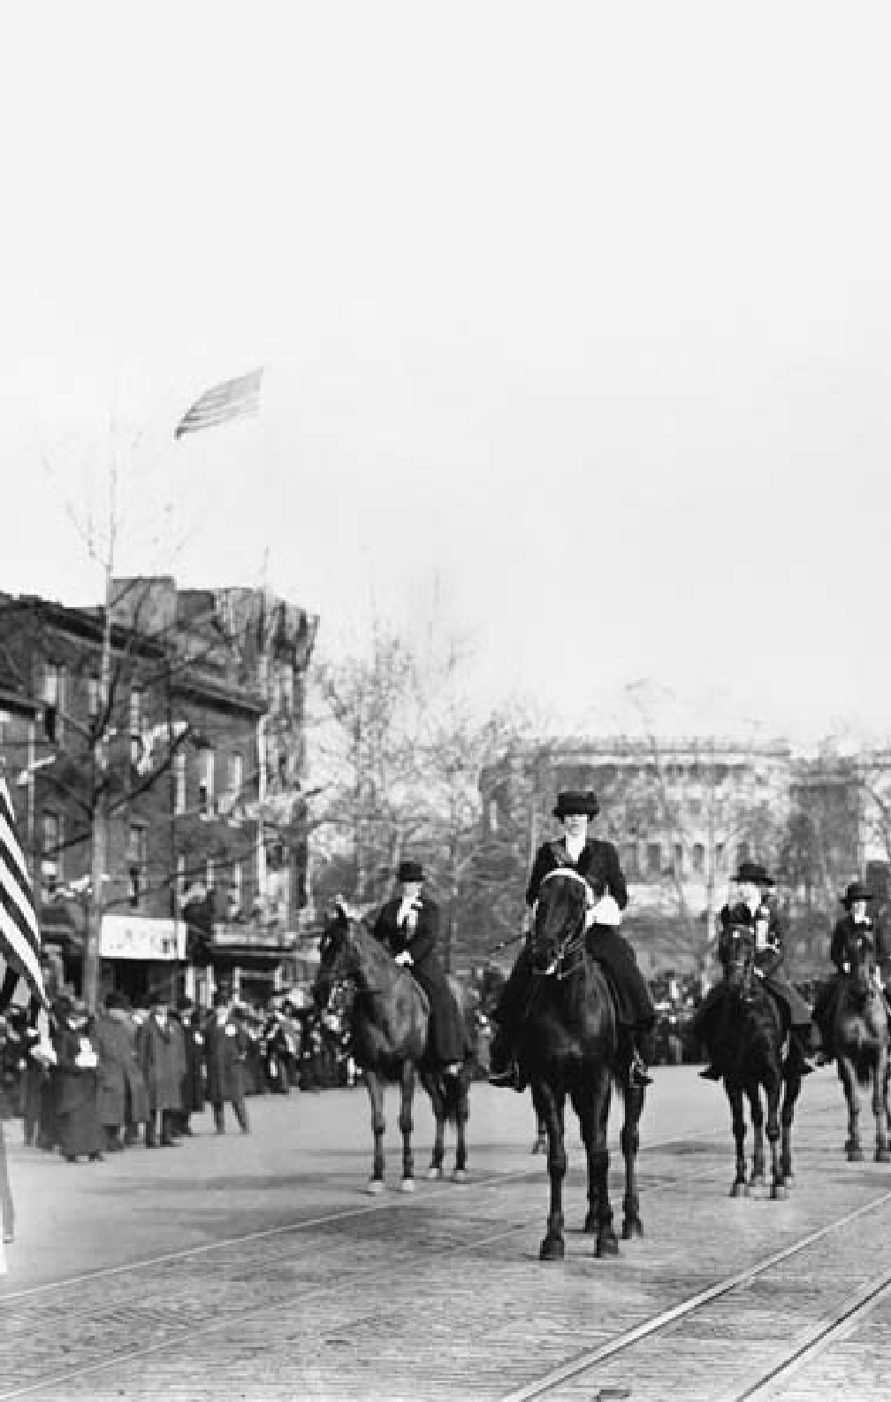

188

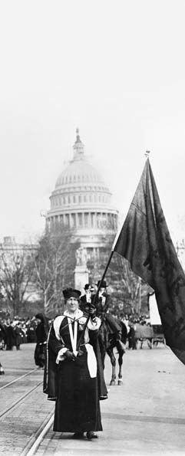

**C H A P T E R**

9

**DISCONTENT AND REFORM**

Suffragists march on Pennsylvania Avenue, Washington, D.C., March 3, 1913.

“A great democracy will be neither great nor a democracy if it is not progressive.”

Former President Theodore Roosevelt, circa 1910

**AGRARIAN DISTRESS AND THE RISE OF POPULISM**

# I

Midwestern farmers were in- creasingly restive over what they considered excessive railroad

n spite of their remarkable prog- ress, late-19th century American farmers experienced recurring pe- riods of hardship. Mechanical im- provements greatly increased yield per hectare. The amount of land un- der cultivation grew rapidly through- out the second half of the century, as the railroads and the gradual displacement of the Plains Indians opened up new areas for western settlement. A similar expansion of agricultural lands in countries such as Canada, Argentina, and Australia compounded these problems in the international market, where much of U.S. agricultural production was now sold. Everywhere, heavy sup- ply pushed the price of agricultural commodities downward.

freight rates to move their goods to market. They believed that the protective tariff, a subsidy to big business, drove up the price of their increasingly expensive equipment. Squeezed by low market prices and high costs, they resented ever- heavier debt loads and the banks that held their mortgages. Even the weather was hostile. During the late 1880s droughts devastated the west- ern Great Plains and bankrupted thousands of settlers.

In the South, the end of slavery brought major changes. Much ag- ricultural land was now worked by sharecroppers, tenants who gave up to half of their crop to a land- owner for rent, seed, and essential supplies. An estimated 80 percent

of the South’s African-American farmers and 40 percent of its white ones lived under this debilitating system. Most were locked in a cycle of debt, from which the only hope of escape was increased planting. This led to the over-production of cotton and tobacco, and thus to declining prices and the further exhaustion of the soil.

The first organized effort to ad- dress general agricultural problems was by the Patrons of Husbandry, a farmer’s group popularly known as the Grange Movement. Launched in 1867 by employees of the U.S. Department of Agriculture, the Granges focused initially on social activities to counter the isolation most farm families encountered. Women’s participation was actively encouraged. Spurred by the Panic of 1873, the Grange soon grew to 20,000 chapters and one-and-a-half million members.

The Granges set up their own marketing systems, stores, process- ing plants, factories, and coopera- tives, but most ultimately failed. The movement also enjoyed some politi- cal success. During the 1870s, a few states passed “Granger laws,” limit- ing railroad and warehouse fees.

By 1880 the Grange was in decline and being replaced by the Farmers’ Alliances, which were similar in many respects but more overtly po- litical. By 1890 the alliances, initially autonomous state organizations, had about 1.5 million members from New York to California. A par- allel African-American group, the

Colored Farmers National Alliance, claimed over a million members. Federating into two large North- ern and Southern blocs, the alli- ances promoted elaborate economic programs to “unite the farmers of America for their protection against class legislation and the encroach- ments of concentrated capital.”

By 1890 the level of agrarian dis- tress, fueled by years of hardship and hostility toward the McKinley tar- iff, was at an all-time high. Working with sympathetic Democrats in the South or small third parties in the West, the Farmers’ Alliances made a push for political power. A third political party, the People’s (or Pop- ulist) Party, emerged. Never before in American politics had there been anything like the Populist fervor that swept the prairies and cotton lands. The elections of 1890 brought the new party into power in a dozen Southern and Western states, and sent a score of Populist senators and representatives to Congress.

The first Populist convention was in 1892. Delegates from farm, labor, and reform organizations met in Omaha, Nebraska, determined to overturn a U.S. political system they viewed as hopelessly corrupted by the industrial and financial trusts. Their platform stated:

*We are met, in the midst of a nation brought to the verge of moral, political, and material ruin. Corruption dominates the ballot- box, the legislatures, the Congress, and touches even the ermine of the bench [courts]. From the same*

*prolific womb of governmental injustice we breed the two great classes — tramps and millionaires.*

The pragmatic portion of their platform called for the national- ization of the railroads; a low tar- iff; loans secured by non-perishable crops stored in government-owned warehouses; and, most explosively, currency inflation through Treasury purchase and the unlimited coin- age of silver at the “traditional” ratio of 16 ounces of silver to one ounce of gold.

The Populists showed impres- sive strength in the West and South, and their candidate for president polled more than a million votes. But the currency question soon over- shadowed all other issues. Agrar- ian spokesmen, convinced that their troubles stemmed from a shortage of money in circulation, argued that increasing the volume of mon- ey would indirectly raise prices for farm products and drive up indus- trial wages, thus allowing debts to be paid with inflated currency. Con- servative groups and the financial classes, on the other hand, respond- ed that the 16:1 price ratio was nearly twice the market price for silver. A policy of unlimited purchase would denude the U.S. Treasury of all its gold holdings, sharply devalue the dollar, and destroy the purchasing power of the working and middle classes. Only the gold standard, they said, offered stability.

The financial panic of 1893 heightened the tension of this de- bate. Bank failures abounded in the South and Midwest; unemployment soared and crop prices fell badly. The crisis and President Grover Cleveland’s defense of the gold stan- dard sharply divided the Democrat- ic Party. Democrats who were silver supporters went over to the Popu- lists as the presidential elections of 1896 neared.

The Democratic convention that year was swayed by one of the most famous speeches in U.S. political history. Pleading with the conven- tion not to “crucify mankind on a cross of gold,” William Jennings Bryan, the young Nebraskan cham- pion of silver, won the Democrats’ presidential nomination. The Popu- lists also endorsed Bryan.

In the epic contest that followed, Bryan carried almost all the South- ern and Western states. But he lost the more populated, industrial North and East — and the election

* to Republican candidate William McKinley.

The following year the country’s finances began to improve, in part owing to the discovery of gold in Alaska and the Yukon. This pro- vided a basis for a conservative expansion of the money supply. In 1898 the Spanish-American War drew the nation’s attention further from Populist issues. Populism and the silver issue were dead. Many of the movement’s other reform ideas, however, lived on.

#### THE STRUGGLES OF LABOR

**T**he life of a 19th-century Ameri- can industrial worker was hard. Even in good times wages were low,

hours long, and working conditions hazardous. Little of the wealth that the growth of the nation had gener- ated went to its workers. Moreover, women and children made up a high percentage of the work force in some industries and often received but a fraction of the wages a man could earn. Periodic economic crises swept the nation, further eroding industri- al wages and producing high levels of unemployment.

At the same time, technologi- cal improvements, which added so much to the nation’s productivity, continually reduced the demand for skilled labor. Yet the unskilled labor pool was constantly growing, as un- precedented numbers of immigrants

* + 18 million between 1880 and 1910
  + entered the country, eager for work.

Before 1874, when Massachusetts passed the nation’s first legislation limiting the number of hours wom- en and child factory workers could perform to 10 hours a day, virtually no labor legislation existed in the country. It was not until the 1930s that the federal government would become actively involved. Until then, the field was left to the state and local authorities, few of whom were as responsive to the workers as they were to wealthy industrialists.

The laissez-faire capitalism that dominated the second half of the

19th century and fostered huge con- centrations of wealth and power was backed by a judiciary that time and again ruled against those who chal- lenged the system. In this, they were merely following the prevailing phi- losophy of the times. Drawing on a simplified understanding of Dar- winian science, many social think- ers believed that both the growth of large business at the expense of small enterprise and the wealth of a few alongside the poverty of many was “survival of the fittest,” and an un- avoidable by-product of progress.

American workers, especially the skilled among them, appear to have lived at least as well as their coun- terparts in industrial Europe. Still, the social costs were high. As late as the year 1900, the United States had the highest job-related fatality rate of any industrialized nation in the world. Most industrial workers still worked a 10-hour day (12 hours in the steel industry), yet earned less than the minimum deemed neces- sary for a decent life. The number of children in the work force doubled between 1870 and 1900.

The first major effort to orga- nize workers’ groups on a nation- wide basis appeared with the Noble Order of the Knights of Labor in 1869. Originally a secret, ritualistic society organized by Philadelphia garment workers and advocating a cooperative program, it was open to all workers, including African Americans, women, and farmers. The Knights grew slowly until its railway workers’ unit won a strike

against the great railroad baron, Jay Gould, in 1885. Within a year they added 500,000 workers to their rolls, but, not attuned to pragmatic trade unionism and unable to repeat this success, the Knights soon fell into a decline.

Their place in the labor move- ment was gradually taken by the American Federation of Labor (AFL). Rather than open member- ship to all, the AFL, under former ci- gar union official Samuel Gompers, was a group of unions focused on skilled workers. Its objectives were “pure and simple” and apolitical: in- creasing wages, reducing hours, and improving working conditions. It did much to turn the labor move- ment away from the socialist views of most European labor movements. Nonetheless, both before the founding of the AFL and after, American labor history was violent. In the Great Rail Strike of 1877, rail workers across the nation went out in response to a 10-percent pay cut. Attempts to break the strike led to ri- oting and wide-scale destruction in several cities: Baltimore, Maryland; Chicago, Illinois; Pittsburgh, Penn- sylvania; Buffalo, New York; and San Francisco, California. Federal troops had to be sent to several locations

before the strike was ended.

Nine years later, in Chicago’s Haymarket Square incident, some- one threw a bomb at police about to break up an anarchist rally in support of an ongoing strike at the McCormick Harvester Company in Chicago. In the ensuing melee, seven

policemen and at least four workers were reported killed. Some 60 police officers were injured.

In 1892, at Carnegie’s steel works in Homestead, Pennsylvania, a group of 300 Pinkerton detectives the company had hired to break a bitter strike by the Amalgamated Association of Iron, Steel, and Tin Workers fought a fierce and losing gun battle with strikers. The Na- tional Guard was called in to protect non-union workers and the strike was broken. Unions were not let back into the plant until 1937.

In 1894, wage cuts at the Pullman Company just outside Chicago led to a strike, which, with the support of the American Railway Union, soon tied up much of the country’s rail system. As the situation deteriorat- ed, U.S. Attorney General Richard Olney, himself a former railroad lawyer, deputized over 3,000 men in an attempt to keep the rails open. This was followed by a federal court injunction against union interfer- ence with the trains. When rioting ensued, President Cleveland sent in federal troops, and the strike was eventually broken.

The most militant of the strike- favoring unions was the Industri- al Workers of the World (IWW). Formed from an amalgam of unions fighting for better conditions in the West’s mining industry, the IWW, or “Wobblies” as they were com- monly known, gained particular prominence from the Colorado mine clashes of 1903 and the singularly brutal fashion in which they were

put down. Influenced by militant anarchism and openly calling for class warfare, the Wobblies gained many adherents after they won a dif- ficult strike battle in the textile mills of Lawrence, Massachusetts, in 1912. Their call for work stoppages in the midst of World War I, however, led to a government crackdown in 1917 that virtually destroyed them.

#### THE REFORM IMPULSE

**T**he presidential election of 1900 gave the American people a chance to pass judgment on the Republican

administration of President McKin- ley, especially its foreign policy. Meeting at Philadelphia, the Repub- licans expressed jubilation over the successful outcome of the war with Spain, the restoration of prosperity, and the effort to obtain new mar- kets through the Open Door policy. McKinley easily defeated his oppo- nent, once again William Jennings Bryan. But the president did not live to enjoy his victory. In Septem- ber 1901, while attending an expo- sition in Buffalo, New York, he was shot down by an assassin, the third president to be assassinated since the Civil War.

Theodore Roosevelt, McKinley’s vice president, assumed the presi- dency. Roosevelt’s accession coin- cided with a new epoch in American political life and international rela- tions. The continent was peopled; the frontier was disappearing. A small, formerly struggling repub- lic had become a world power. The

country’s political foundations had endured the vicissitudes of foreign and civil war, the tides of prosper- ity and depression. Immense strides had been made in agriculture and industry. Free public education had been largely realized and a free press maintained. The ideal of religious freedom had been sustained. The influence of big business was now more firmly entrenched than ever, however, and local and municipal government often was in the hands of corrupt politicians.

In response to the excesses of 19th-century capitalism and politi- cal corruption, a reform movement called “progressivism” arose, which gave American politics and thought its special character from approxi- mately 1890 until the American en- try into World War I in 1917. The Progressives had diverse objec- tives. In general, however, they saw themselves as engaged in a demo- cratic crusade against the abuses of urban political bosses and the cor- rupt “robber barons” of big business. Their goals were greater democracy and social justice, honest govern- ment, more effective regulation of business, and a revived commitment to public service. They believed that expanding the scope of government would ensure the progress of U.S. so- ciety and the welfare of its citizens.

The years 1902 to 1908 marked the era of greatest reform activity, as writers and journalists strongly protested practices and principles inherited from the 18th-century rural republic that were proving

inadequate for a 20th-century ur- ban state. Years before, in 1873, the celebrated author Mark Twain had exposed American society to criti- cal scrutiny in *The Gilded Age*. Now, trenchant articles dealing with trusts, high finance, impure foods, and abusive railroad practices be- gan to appear in the daily newspa- pers and in such popular magazines as *McClure’s* and *Collier’s*. Their au- thors, such as the journalist Ida M. Tarbell, who crusaded against the Standard Oil Trust, became known as “muckrakers.”

In his sensational novel, *The Jungle*, Upton Sinclair exposed un- sanitary conditions in the great Chicago meat-packing houses and condemned the grip of the beef trust on the nation’s meat supply. Theodore Dreiser, in his novels *The Financier* and *The Titan,* made it easy for laymen to understand the machinations of big business. Frank Norris’s *The Octopus* assailed amor- al railroad management; his *The Pit* depicted secret manipulations on the Chicago grain market. Lincoln Steffens’s *The Shame of the Cities* bared local political corruption. This “literature of exposure” roused people to action.

The hammering impact of un- compromising writers and an in- creasingly aroused public spurred political leaders to take practical measures. Many states enacted laws to improve the conditions under which people lived and worked. At the urging of such prominent so- cial critics as Jane Addams, child

labor laws were strengthened and new ones adopted, raising age limits, shortening work hours, re- stricting night work, and requiring school attendance.

#### ROOSEVELT’S REFORMS

**B**y the early 20th century, most of the larger cities and more than half the states had established an

eight-hour day on public works. Equally important were the work- man’s compensation laws, which made employers legally responsible for injuries sustained by employees at work. New revenue laws were also enacted, which, by taxing inheri- tances, incomes, and the property or earnings of corporations, sought to place the burden of government on those best able to pay.

It was clear to many people

* notably President Theodore Roosevelt and Progressive leaders in the Congress (foremost among them Wisconsin Senator Robert La Fol- lette) — that most of the problems reformers were concerned about could be solved only if dealt with on a national scale. Roosevelt declared his determination to give all the American people a “Square Deal.”

During his first term, he initiated a policy of increased government su- pervision through the enforcement of antitrust laws. With his back- ing, Congress passed the Elkins Act (1903), which greatly restricted the railroad practice of giving rebates to favored shippers. The act made published rates the lawful standard,

and shippers equally liable with railroads for rebates. Meanwhile, Congress had created a new Cabi- net Department of Commerce and Labor, which included a Bureau of Corporations empowered to investi- gate the affairs of large business ag- gregations.

Roosevelt won acclaim as a “trust-buster,” but his actual atti- tude toward big business was com- plex. Economic concentration, he believed, was inevitable. Some trusts were “good,” some “bad.” The task of government was to make reasonable distinctions. When, for example, the Bureau of Corporations discovered in 1907 that the American Sugar Re- fining Company had evaded import duties, subsequent legal actions re- covered more than $4 million and convicted several company officials. The Standard Oil Company was in- dicted for receiving secret rebates from the Chicago and Alton Rail- road, convicted, and fined a stagger- ing $29 million.

Roosevelt’s striking personality and his trust-busting activities cap- tured the imagination of the ordinary individual; approval of his progres- sive measures cut across party lines. In addition, the abounding prosper- ity of the country at this time led people to feel satisfied with the party in office. He won an easy victory in the 1904 presidential election.

Emboldened by a sweeping elec- toral triumph, Roosevelt called for stronger railroad regulation. In June 1906 Congress passed the Hepburn Act. It gave the Interstate Commerce

Commission real authority in regu- lating rates, extended the commis- sion’s jurisdiction, and forced the railroads to surrender their inter- locking interests in steamship lines and coal companies.

Other congressional measures carried the principle of federal con- trol still further. The Pure Food and Drug Act of 1906 prohibited the use of any “deleterious drug, chemical, or preservative” in prepared medi- cines and foods. The Meat Inspec- tion Act of the same year mandated federal inspection of all meat-pack- ing establishments engaged in inter- state commerce.

Conservation of the nation’s nat- ural resources, managed develop- ment of the public domain, and the reclamation of wide stretches of ne- glected land were among the other major achievements of the Roosevelt era. Roosevelt and his aides were more than conservationists, but giv- en the helter-skelter exploitation of public resources that had preceded them, conservation loomed large on their agenda. Whereas his predeces- sors had set aside 18,800,000 hect- ares of timberland for preservation and parks, Roosevelt increased the area to 59,200,000 hectares. They also began systematic efforts to pre- vent forest fires and to re-timber de- nuded tracts.

#### TAFT AND WILSON

**R**oosevelt’s popularity was at its peak as the campaign of 1908 neared, but he was unwilling to break the

tradition by which no president had held office for more than two terms. Instead, he supported William How- ard Taft, who had served under him as governor of the Philippines and secretary of war. Taft, pledging to continue Roosevelt’s programs, de- feated Bryan, who was running for the third and last time.

The new president continued the prosecution of trusts with less dis- crimination than Roosevelt, further strengthened the Interstate Com- merce Commission, established a postal savings bank and a parcel post system, expanded the civil service, and sponsored the enactment of two amendments to the Constitution, both adopted in 1913.

The 16th Amendment, rati- fied just before Taft left office, au- thorized a federal income tax; the 17th Amendment, approved a few months later, mandated the direct election of senators by the people, instead of state legislatures. Yet bal- anced against these progressive mea- sures was Taft’s acceptance of a new tariff with higher protective sched- ules; his opposition to the entry of the state of Arizona into the Union because of its liberal constitution; and his growing reliance on the con- servative wing of his party.

By 1910 Taft’s party was bitterly divided. Democrats gained control of Congress in the midterm elec- tions. Two years later, Woodrow Wilson, the Democratic, progressive governor of the state of New Jersey, campaigned against Taft, the Repub- lican candidate — and also against

Roosevelt who ran as the candidate of a new Progressive Party. Wilson, in a spirited campaign, defeated both rivals.

During his first term, Wilson secured one of the most notable leg- islative programs in American histo- ry. The first task was tariff revision. “The tariff duties must be altered,” Wilson said. “We must abolish ev- erything that bears any semblance of privilege.” The Underwood Tariff, signed on October 3, 1913, provided substantial rate reductions on im- ported raw materials and foodstuffs, cotton and woolen goods, iron and steel; it removed the duties from more than a hundred other items. Although the act retained many pro- tective features, it was a genuine at- tempt to lower the cost of living. To compensate for lost revenues, it es- tablished a modest income tax.

The second item on the Demo- cratic program was a long overdue, thorough reorganization of the ram- shackle banking and currency sys- tem. “Control,” said Wilson, “must be public, not private, must be vested in the government itself, so that the banks may be the instruments, not the masters, of business and of indi- vidual enterprise and initiative.”

The Federal Reserve Act of De- cember 23, 1913, was Wilson’s most enduring legislative accomplish- ment. Conservatives had favored establishment of one powerful cen- tral bank. The new act, in line with the Democratic Party’s Jeffersonian sentiments, divided the country into 12 districts, with a Federal Reserve

Bank in each, all supervised by a na- tional Federal Reserve Board with limited authority to set interest rates. The act assured greater flexibility in the money supply and made provi- sion for issuing federal-reserve notes to meet business demands. Greater centralization of the system would come in the 1930s.

The next important task was trust regulation and investigation of corporate abuses. Congress autho- rized a Federal Trade Commission to issue orders prohibiting “unfair methods of competition” by busi- ness concerns in interstate trade. The Clayton Antitrust Act forbade many corporate practices that had thus far escaped specific condem- nation: interlocking directorates, price discrimination among pur- chasers, use of the injunction in labor disputes, and ownership by one corporation of stock in similar enterprises.

Farmers and other workers were not forgotten. The Smith-Lever Act

of 1914 established an “extension system” of county agents to assist farming throughout the country. Subsequent acts made credit avail- able to farmers at low rates of in- terest. The Seamen’s Act of 1915 improved living and working con- ditions on board ships. The Fed- eral Workingman’s Compensation Act in 1916 authorized allowances to civil service employees for dis- abilities incurred at work and estab- lished a model for private enterprise. The Adamson Act of the same year established an eight-hour day for railroad labor.

This record of achievement won Wilson a firm place in American history as one of the nation’s fore- most progressive reformers. How- ever, his domestic reputation would soon be overshadowed by his record as a wartime president who led his country to victory but could not hold the support of his people for the peace that followed. 9

CHAPTER 9: DISCONTENT AND REFORM

**A NATION OF NATIONS**

**N**o country’s history has been more closely bound to immigration than that of the United States. During the first 15 years of the 20th century alone, over

13 million people came to the United States, many passing through Ellis Island, the federal immigration center that opened in New York harbor in 1892. (Though no longer in service, Ellis Island reopened in 1992 as a monument to the millions who crossed the nation’s threshold there.)

The first official census in 1790 had numbered Americans at 3,929,214. Approximately half of the population of the original 13 states was of English origin; the rest were Scots-Irish, German, Dutch, French, Swedish, Welsh, and Finnish. These white Europeans were mostly Protestants. A fifth of the population was enslaved Africans.

From early on, Americans viewed immigrants as a necessary resource for an expanding country. As a result, few official restrictions were placed upon immigration into the United States until the 1920s. As more and more im- migrants arrived, however, some Americans became fearful that their culture was threatened.

The Founding Fathers, especially Thomas Jefferson, had been ambivalent over whether or not the United States ought to welcome arrivals from every corner of the globe. Jefferson wondered whether democracy could ever rest safely in the hands of men from countries that revered monarchs or replaced royalty with mob rule. However, few supported closing the gates to newcomers in a country desperate for labor.

Immigration lagged in the late 18th and early 19th centuries as wars dis- rupted trans-Atlantic travel and European governments restricted movement to retain young men of military age. Still, as European populations increased, more people on the same land constricted the size of farming lots to a point where families could barely survive. Moreover, cottage industries were falling victim to an Industrial Revolution that was mechanizing production. Thou- sands of artisans unwilling or unable to find jobs in factories were out of work in Europe.

In the mid-1840s millions more made their way to the United States as a result of a potato blight in Ireland and continual revolution in the German homelands. Meanwhile, a trickle of Chinese immigrants, most from impov- erished Southeastern China, began to make their way to the American West Coast.

Almost 19 million people arrived in the United States between 1890 and 1921, the year Congress first passed severe restrictions. Most of these immi-

200

OUTLINE OF U.S. HISTORY

grants were from Italy, Russia, Poland, Greece, and the Balkans. Non-Euro- peans came, too: east from Japan, south from Canada, and north from Mexico.

By the early 1920s, an alliance was forged between wage-conscious organized labor and those who called for restricted immigration on racial or religious grounds, such as the Ku Klux Klan and the Immigration Restriction League. The Johnson-Reed Immigration Act of 1924 permanently curtailed the influx of newcomers with quotas calculated on nation of origin.

The Great Depression of the 1930s dramatically slowed immigration still further. With public opinion generally opposed to immigration, even for per- secuted European minorities, relatively few refugees found sanctuary in the United States after Adolf Hitler’s ascent to power in 1933.

Throughout the postwar decades, the United States continued to cling to nationally based quotas. Supporters of the McCarran-Walter Act of 1952 argued that quota relaxation might inundate the United States with Marxist subversives from Eastern Europe.

In 1965 Congress replaced national quotas with hemispheric ones. Rela- tives of U.S. citizens received preference, as did immigrants with job skills

in short supply in the United States. In 1978 the hemispheric quotas were replaced by a worldwide ceiling of 290,000, a limit reduced to 270,000 after passage of the Refugee Act of 1980.

Since the mid-1970s, the United States has experienced a fresh wave of immigration, with arrivals from Asia, Africa, and Latin America transforming communities throughout the country. Current estimates suggest a total annual arrival of approximately 600,000 legal newcomers to the United States.

Because immigrant and refugee quotas remain well under demand, how- ever, illegal immigration is still a major problem. Mexicans and other Latin Americans daily cross the Southwestern U.S. borders to find work, higher wages, and improved education and health care for their families. Likewise, there is a substantial illegal migration from countries like China and other Asian nations. Estimates vary, but some suggest that as many as 600,000 illegals per year arrive in the United States.

Large surges of immigration have historically created social strains along with economic and cultural dividends. Deeply ingrained in most Americans, however, is the conviction that the Statue of Liberty does, indeed, stand as a symbol for the United States as she lifts her lamp before the “golden door,” welcoming those “yearning to breathe free.” This belief, and the sure knowl- edge that their forebears were once immigrants, has kept the United States a nation of nations. ◆

201

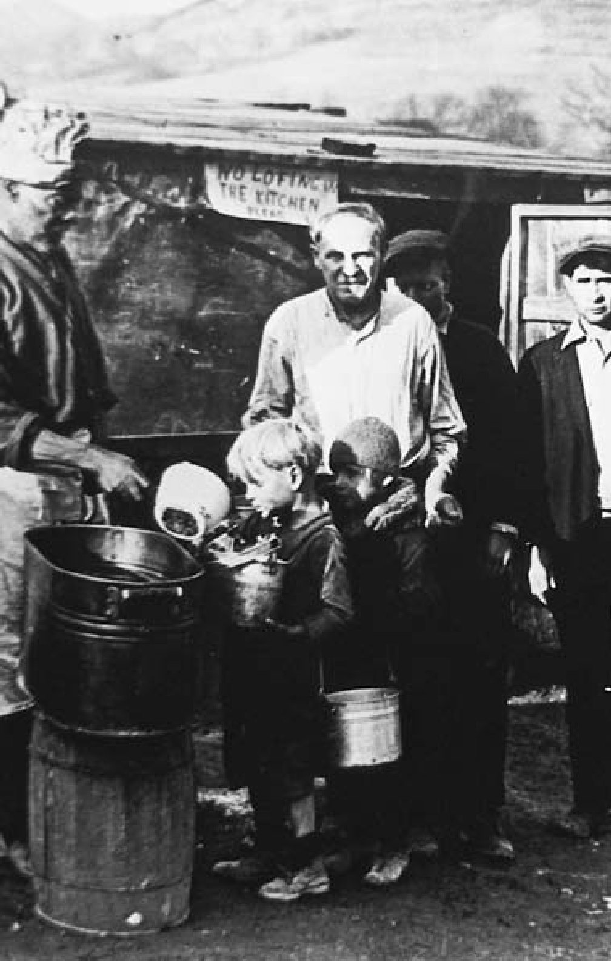

202

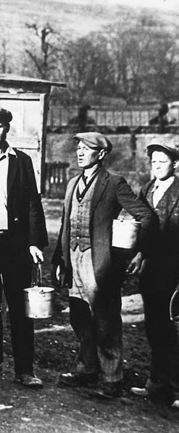

**C H A P T E R**

10

**WAR, PROSPERITY, AND DEPRESSION**

Depression era soup line, 1930s.

“The chief business of the American people

is business.”

President Calvin Coolidge, 1925

#### WAR AND NEUTRAL RIGHTS

**T**o the American public of 1914, the outbreak of war in Europe — with Germany and Austria-Hun-

gary fighting Britain, France, and Russia — came as a shock. At first the encounter seemed remote, but its economic and political effects were swift and deep. By 1915 U.S. industry, which had been mildly de- pressed, was prospering again with munitions orders from the West- ern Allies. Both sides used propa- ganda to arouse the public passions of Americans — a third of whom were either foreign-born or had one or two foreign-born parents. More- over, Britain and Germany both act- ed against U.S. shipping on the high seas, bringing sharp protests from President Woodrow Wilson.

Britain, which controlled the seas, stopped and searched Ameri-

can carriers, confiscating “contra- band” bound for Germany. Germa- ny employed its major naval weapon, the submarine, to sink shipping bound for Britain or France. Presi- dent Wilson warned that the United States would not forsake its tradi- tional right as a neutral to trade with belligerent nations. He also declared that the nation would hold Germa- ny to “strict accountability” for the loss of American vessels or lives. On May 7, 1915, a German submarine sunk the British liner *Lusitania*, kill- ing 1,198 people, 128 of them Amer- icans. Wilson, reflecting American outrage, demanded an immediate halt to attacks on liners and mer- chant ships.

Anxious to avoid war with the United States, Germany agreed to give warning to commercial ves- sels — even if they flew the enemy flag — before firing on them. But

after two more attacks — the sink- ing of the British steamer *Arabic* in August 1915, and the torpedoing of the French liner *Sussex* in March 1916 — Wilson issued an ultimatum threatening to break diplomatic re- lations unless Germany abandoned submarine warfare. Germany agreed and refrained from further attacks through the end of the year.

Wilson won reelection in 1916, partly on the slogan: “He kept us out of war.” Feeling he had a mandate to act as a peacemaker, he delivered a speech to the Senate, January 22, 1917, urging the warring nations to accept a “peace without victory.”

#### UNITED STATES ENTERS WORLD WAR I

**O**n January 31, 1917, however, the German government resumed un- restricted submarine warfare. After

five U.S. vessels were sunk, Wilson on April 2, 1917, asked for a decla- ration of war. Congress quickly ap- proved. The government rapidly mobilized military resources, indus- try, labor, and agriculture. By Octo- ber 1918, on the eve of Allied victory, a U.S. army of over 1,750,000 had been deployed in France.

In the summer of 1918, fresh American troops under the com- mand of General John J. Pershing played a decisive role in stopping a last-ditch German offensive. That fall, Americans were key partici- pants in the Meuse-Argonne of- fensive, which cracked Germany’s vaunted Hindenburg Line.

President Wilson contributed greatly to an early end to the war by defining American war aims that characterized the struggle as be- ing waged not against the German people but against their autocratic government. His Fourteen Points, submitted to the Senate in January 1918, called for: abandonment of se- cret international agreements; free- dom of the seas; free trade between nations; reductions in national ar- maments; an adjustment of colonial claims in the interests of the inhabit- ants affected; self-rule for subjugated European nationalities; and, most importantly, the establishment of an association of nations to afford “mutual guarantees of political inde- pendence and territorial integrity to great and small states alike.”

In October 1918, the German gov- ernment, facing certain defeat, ap- pealed to Wilson to negotiate on the basis of the Fourteen Points. After a month of secret negotiations that gave Germany no firm guarantees, an armistice (technically a truce, but actually a surrender) was concluded on November 11.

#### THE LEAGUE OF NATIONS

**I**t was Wilson’s hope that the final treaty, drafted by the victors, would be even-handed, but the passion and

material sacrifice of more than four years of war caused the European Allies to make severe demands. Per- suaded that his greatest hope for peace, a League of Nations, would never be realized unless he made

concessions, Wilson compromised somewhat on the issues of self-de- termination, open diplomacy, and other specifics. He successfully re- sisted French demands for the entire Rhineland, and somewhat moder- ated that country’s insistence upon charging Germany the whole cost of the war. The final agreement (the Treaty of Versailles), however, pro- vided for French occupation of the coal- and iron-rich Saar Basin, and a very heavy burden of reparations upon Germany.

In the end, there was little left of Wilson’s proposals for a generous and lasting peace but the League of Nations itself, which he had made an integral part of the treaty. Dis- playing poor judgment, however, the president had failed to involve lead- ing Republicans in the treaty nego- tiations. Returning with a partisan document, he then refused to make concessions necessary to satisfy Re- publican concerns about protecting American sovereignty.

With the treaty stalled in a Senate committee, Wilson began a national tour to appeal for support. On Sep- tember 25, 1919, physically ravaged by the rigors of peacemaking and the pressures of the wartime presi- dency, he suffered a crippling stroke. Critically ill for weeks, he never fully recovered. In two separate votes — November 1919 and March 1920 — the Senate once again rejected the Versailles Treaty and with it the League of Nations.

The League of Nations would never be capable of maintaining

world order. Wilson’s defeat showed that the American people were not yet ready to play a commanding role in world affairs. His utopian vision had briefly inspired the nation, but its collision with reality quickly led to widespread disillusion with world affairs. America reverted to its in- stinctive isolationism.

#### POSTWAR UNREST

**T**he transition from war to peace was tumultuous. A postwar eco- nomic boom coexisted with rapid

increases in consumer prices. La- bor unions that had refrained from striking during the war engaged in several major job actions. During the summer of 1919, several race riots oc- curred, reflecting apprehension over the emergence of a “New Negro” who had seen military service or gone north to work in the war industry.

Reaction to these events merged with a widespread national fear of a new international revolutionary movement. In 1917, the Bolsheviks had seized power in Russia; after the war, they attempted revolutions in Germany and Hungary. By 1919, it seemed they had come to America. Excited by the Bolshevik example, large numbers of militants split from the Socialist Party to found what would become the Commu- nist Party of the United States. In April 1919, the postal service inter- cepted nearly 40 bombs addressed to prominent citizens. Attorney Gen- eral A. Mitchell Palmer’s residence in Washington was bombed. Palmer,

in turn, authorized federal roundups of radicals and deported many who were not citizens. Strikes were often blamed on radicals and depicted as the opening shots of a revolution.

Palmer’s dire warnings fueled a “Red Scare” that subsided by mid- 1920. Even a murderous bombing in Wall Street in September failed to re- awaken it. From 1919 on, however, a current of militant hostility toward revolutionary communism would simmer not far beneath the surface of American life.

#### THE BOOMING 1920s

**W**ilson, distracted by the war, then laid low by his stroke, had mis- handled almost every postwar is-

sue. The booming economy began to collapse in mid-1920. The Repub- lican candidates for president and vice president, Warren G. Harding and Calvin Coolidge, easily defeated their Democratic opponents, James

M. Cox and Franklin D. Roosevelt. Following ratification of the 19th

Amendment to the Constitution, women voted in a presidential elec- tion for the first time.

The first two years of Harding’s administration saw a continuance of the economic recession that had begun under Wilson. By 1923, how- ever, prosperity was back. For the next six years the country enjoyed the strongest economy in its history, at least in urban areas. Governmen- tal economic policy during the 1920s was eminently conservative. It was based upon the belief that if govern-

ment fostered private business, ben- efits would radiate out to most of the rest of the population.

Accordingly, the Republicans tried to create the most favorable conditions for U.S. industry. The Fordney-McCumber Tariff of 1922 and the Hawley-Smoot Tariff of 1930 brought American trade barri- ers to new heights, guaranteeing U.S. manufacturers in one field after another a monopoly of the domes- tic market, but blocking a healthy trade with Europe that would have reinvigorated the international economy. Occurring at the begin- ning of the Great Depression, Haw- ley-Smoot triggered retaliation from other manufacturing nations and contributed greatly to a collapsing cycle of world trade that intensified world economic misery.

The federal government also start- ed a program of tax cuts, reflecting Treasury Secretary Andrew Mellon’s belief that high taxes on individual incomes and corporations discour- aged investment in new industrial enterprises. Congress, in laws passed between 1921 and 1929, responded favorably to his proposals.

“The chief business of the Amer- ican people is business,” declared Calvin Coolidge, the Vermont-born vice president who succeeded to the presidency in 1923 after Harding’s death, and was elected in his own right in 1924. Coolidge hewed to the conservative economic policies of the Republican Party, but he was a much abler administrator than the hapless Harding, whose administra-

tion was mired in charges of corrup- tion in the months before his death. Throughout the 1920s, private business received substantial en- couragement, including construc- tion loans, profitable mail-carrying contracts, and other indirect subsi- dies. The Transportation Act of 1920, for example, had already restored to private management the nation’s railways, which had been under gov- ernment control during the war. The Merchant Marine, which had been owned and largely operated by the government, was sold to private op-

erators.

Republican policies in agri- culture, however, faced mounting criticism, for farmers shared least in the prosperity of the 1920s. The period since 1900 had been one of rising farm prices. The unprece- dented wartime demand for U.S. farm products had provided a strong stimulus to expansion. But by the close of 1920, with the abrupt end of wartime demand, the commercial agriculture of staple crops such as wheat and corn fell into sharp de- cline. Many factors accounted for the depression in American agri- culture, but foremost was the loss of foreign markets. This was partly in reaction to American tariff policy, but also because excess farm produc- tion was a worldwide phenomenon. When the Great Depression struck in the 1930s, it devastated an already fragile farm economy.

The distress of agriculture aside, the Twenties brought the best life ever to most Americans. It was the

decade in which the ordinary fam- ily purchased its first automobile, obtained refrigerators and vacuum cleaners, listened to the radio for en- tertainment, and went regularly to motion pictures. Prosperity was real and broadly distributed. The Repub- licans profited politically, as a result, by claiming credit for it.

#### TENSIONS OVER IMMIGRATION

**D**uring the 1920s, the United States sharply restricted foreign im- migration for the first time in its

history. Large inflows of foreigners long had created a certain amount of social tension, but most had been of Northern European stock and, if not quickly assimilated, at least pos- sessed a certain commonality with most Americans. By the end of the 19th century, however, the flow was predominantly from southern and Eastern Europe. According to the census of 1900, the population of the United States was just over 76 mil- lion. Over the next 15 years, more than 15 million immigrants entered the country.

Around two-thirds of the inflow consisted of “newer” nationalities and ethnic groups — Russian Jews, Poles, Slavic peoples, Greeks, south- ern Italians. They were non-Prot- estant, non-“Nordic,” and, many Americans feared, nonassimilable. They did hard, often dangerous, low-pay work — but were accused of driving down the wages of native- born Americans. Settling in squalid

urban ethnic enclaves, the new im- migrants were seen as maintaining Old World customs, getting along with very little English, and sup- porting unsavory political machines that catered to their needs. Nativists wanted to send them back to Europe; social workers wanted to American- ize them. Both agreed that they were a threat to American identity.

Halted by World War I, mass immigration resumed in 1919, but quickly ran into determined oppo- sition from groups as varied as the American Federation of Labor and the reorganized Ku Klux Klan. Mil- lions of old-stock Americans who belonged to neither organization ac- cepted commonly held assumptions about the inferiority of non-Nordics and backed restrictions. Of course, there were also practical arguments in favor of a maturing nation putting some limits on new arrivals.

In 1921, Congress passed a sharp- ly restrictive emergency immigra- tion act. It was supplanted in 1924 by the Johnson-Reed National Origins Act, which established an immigra- tion quota for each nationality. Those quotas were pointedly based on the census of 1890, a year in which the newer immigration had not yet left its mark. Bitterly resented by south- ern and Eastern European ethnic groups, the new law reduced immi- gration to a trickle. After 1929, the economic impact of the Great De- pression would reduce the trickle to a reverse flow — until refugees from European fascism began to press for admission to the country.

#### CLASH OF CULTURES

**S**ome Americans expressed their discontent with the character of modern life in the 1920s by focus-

ing on family and religion, as an increasingly urban, secular society came into conflict with older rural traditions. Fundamentalist preach- ers such as Billy Sunday provided an outlet for many who yearned for a return to a simpler past.

Perhaps the most dramatic dem- onstration of this yearning was the religious fundamentalist crusade that pitted Biblical texts against the Darwinian theory of biological evo- lution. In the 1920s, bills to prohibit the teaching of evolution began ap- pearing in Midwestern and South- ern state legislatures. Leading this crusade was the aging William Jen- nings Bryan, long a spokesman for the values of the countryside as well as a progressive politician. Bryan skillfully reconciled his anti-evo- lutionary activism with his earlier economic radicalism, declaring that evolution “by denying the need or possibility of spiritual regeneration, discourages all reforms.”

The issue came to a head in 1925, when a young high school teacher, John Scopes, was prosecuted for vio- lating a Tennessee law that forbade the teaching of evolution in the pub- lic schools. The case became a nation- al spectacle, drawing intense news coverage. The American Civil Lib- erties Union retained the renowned attorney Clarence Darrow to defend Scopes. Bryan wrangled an appoint-

ment as special prosecutor, then fool- ishly allowed Darrow to call him as a hostile witness. Bryan’s confused defense of Biblical passages as literal rather than metaphorical truth drew widespread criticism. Scopes, nearly forgotten in the fuss, was convicted, but his fine was reversed on a tech- nicality. Bryan died shortly after the trial ended. The state wisely declined to retry Scopes. Urban sophisticates ridiculed fundamentalism, but it continued to be a powerful force in rural, small-town America.

Another example of a power- ful clash of cultures — one with far greater national consequences

* + was Prohibition. In 1919, after almost a century of agitation, the 18th Amendment to the Constitu- tion was enacted, prohibiting the manufacture, sale, or transportation of alcoholic beverages. Intended to eliminate the saloon and the drunk- ard from American society, Prohi- bition created thousands of illegal drinking places called “speakeasies,” made intoxication fashionable, and created a new form of criminal ac- tivity — the transportation of ille- gal liquor, or “bootlegging.” Widely observed in rural America, openly evaded in urban America, Prohibi- tion was an emotional issue in the prosperous Twenties. When the De- pression hit, it seemed increasingly irrelevant. The 18th Amendment would be repealed in 1933.

Fundamentalism and Prohibition were aspects of a larger reaction to a modernist social and intellectual revolution most visible in changing

manners and morals that caused the decade to be called the Jazz Age, the Roaring Twenties, or the era of “flaming youth.” World War I had overturned the Victorian social and moral order. Mass prosperity en- abled an open and hedonistic life style for the young middle classes.

The leading intellectuals were supportive. H.L. Mencken, the de- cade’s most important social critic, was unsparing in denouncing sham and venality in American life. He usually found these qualities in ru- ral areas and among businessmen. His counterparts of the progressive movement had believed in “the peo- ple” and sought to extend democra- cy. Mencken, an elitist and admirer of Nietzsche, bluntly called demo- cratic man a boob and characterized the American middle class as the “booboisie.”

Novelist F. Scott Fitzgerald cap- tured the energy, turmoil, and disil- lusion of the decade in such works as *The Beautiful and the Damned* (1922) and *The Great Gatsby* (1925). Sinclair Lewis, the first American to win a Nobel Prize for literature, sati- rized mainstream America in *Main Street* (1920) and *Babbitt* (1922). Er- nest Hemingway vividly portrayed the malaise wrought by the war in *The Sun Also Rises* (1926) and *A Farewell to Arms* (1929). Fitzgerald, Hemingway, and many other writ- ers dramatized their alienation from America by spending much of the decade in Paris.

African-American culture flow- ered. Between 1910 and 1930, huge

numbers of African Americans moved from the South to the North in search of jobs and personal free- dom. Most settled in urban areas, especially New York City’s Har- lem, Detroit, and Chicago. In 1910

W.E.B. DuBois and other intel- lectuals had founded the National Association for the Advancement of Colored People (NAACP), which helped African Americans gain a na- tional voice that would grow in im- portance with the passing years.

An African-American literary and artistic movement, called the “Harlem Renaissance,” emerged. Like the “Lost Generation,” its writers, such as the poets Langs- ton Hughes and Countee Cullen, rejected middle-class values and conventional literary forms, even as they addressed the realities of African-American experience. Af- rican-American musicians — Duke Ellington, King Oliver, Louis Arm- strong — first made jazz a staple of American culture in the 1920s.

#### THE GREAT DEPRESSION

**I**n October 1929 the booming stock market crashed, wiping out many investors. The collapse did not in

itself cause the Great Depression, although it reflected excessively easy credit policies that had allowed the market to get out of hand. It also ag- gravated fragile economies in Europe that had relied heavily on American loans. Over the next three years, an

initial American recession became part of a worldwide depression. Business houses closed their doors, factories shut down, banks failed with the loss of depositors’ savings. Farm income fell some 50 percent. By November 1932, approximately one of every five American workers was unemployed.

The presidential campaign of 1932 was chiefly a debate over the causes and possible remedies of the Great Depression. President Her- bert Hoover, unlucky in entering the White House only eight months before the stock market crash, had tried harder than any other president before him to deal with economic hard times. He had attempted to or- ganize business, had sped up public works schedules, established the Re- construction Finance Corporation to support businesses and financial institutions, and had secured from a reluctant Congress an agency to un- derwrite home mortgages. Nonethe- less, his efforts had little impact, and he was a picture of defeat.

His Democratic opponent, Frank- lin D. Roosevelt, already popular as the governor of New York during the developing crisis, radiated infec- tious optimism. Prepared to use the federal government’s authority for even bolder experimental remedies, he scored a smashing victory — re- ceiving 22,800,000 popular votes to Hoover’s 15,700,000. The United States was about to enter a new era of economic and political change. 9

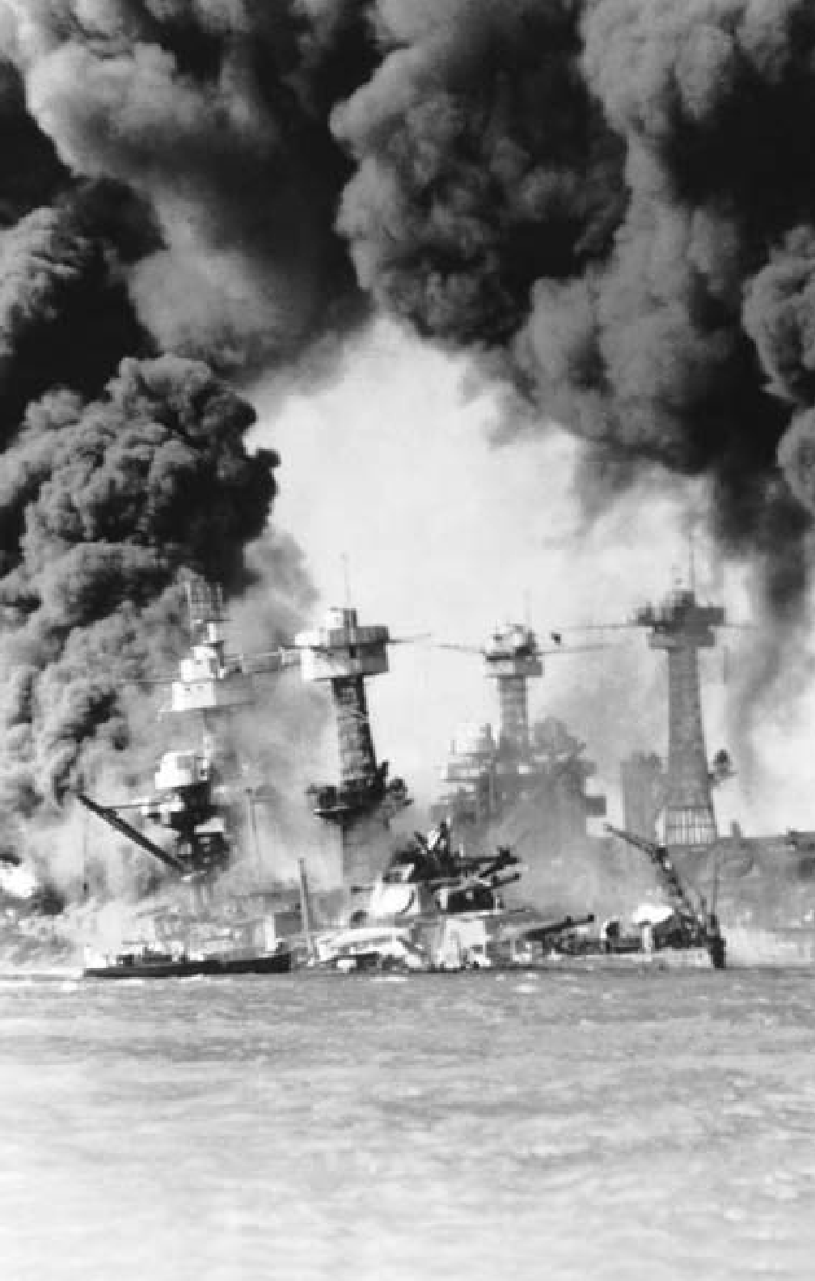

212

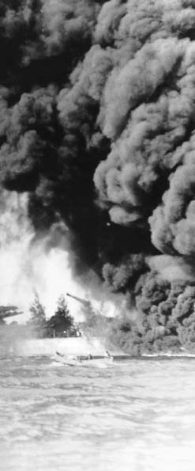

**C H A P T E R**

11

**THE NEW DEAL**

**AND WORLD WAR II**

U.S. battleships *West Virginia* and *Tennessee*, following the Japanese attack on Pearl Harbor, December 7, 1941.

“We must be the great arsenal of democracy.”

President Franklin D. Roosevelt, 1941

**ROOSEVELT AND THE NEW DEAL**

# I

gressive era of Theodore Roosevelt and Woodrow Wilson.

What was truly novel about the

n 1933 the new president, Franklin

D. Roosevelt, brought an air of con- fidence and optimism that quickly rallied the people to the banner of his program, known as the New Deal. “The only thing we have to fear is fear itself,” the president de- clared in his inaugural address to the nation.

In one sense, the New Deal merely introduced social and eco- nomic reforms familiar to many Europeans for more than a gen- eration. Moreover, the New Deal represented the culmination of a long-range trend toward abandon- ment of “laissez-faire” capitalism, going back to the regulation of the railroads in the 1880s, and the flood of state and national reform legislation introduced in the Pro-

New Deal, however, was the speed with which it accomplished what previously had taken generations. Many of its reforms were hastily drawn and weakly administered; some actually contradicted others. Moreover, it never succeeded in re- storing prosperity. Yet its actions provided tangible help for millions of Americans, laid the basis for a powerful new political coalition, and brought to the individual cit- izen a sharp revival of interest in government.

#### THE FIRST NEW DEAL

**Banking and Finance.** When Roose- velt took the presidential oath, the banking and credit system of the na- tion was in a state of paralysis. With

astonishing rapidity the nation’s banks were first closed — and then reopened only if they were solvent. The administration adopted a policy of moderate currency inflation to start an upward movement in com- modity prices and to afford some relief to debtors. New governmen- tal agencies brought generous credit facilities to industry and agricul- ture. The Federal Deposit Insurance Corporation (FDIC) insured sav- ings-bank deposits up to $5,000. Federal regulations were imposed upon the sale of securities on the stock exchange.

**Unemployment.** Roosevelt faced unprecedented mass unemployment. By the time he took office, as many as 13 million Americans — more than a quarter of the labor force

— were out of work. Bread lines were a common sight in most cit- ies. Hundreds of thousands roamed the country in search of food, work, and shelter. “Brother, can you spare a dime?” was the refrain of a popu- lar song.

An early step for the unemployed came in the form of the Civilian Conservation Corps (CCC), a pro- gram that brought relief to young men between 18 and 25 years of age. CCC enrollees worked in camps ad- ministered by the army. About two million took part during the decade. They participated in a variety of conservation projects: planting trees to combat soil erosion and maintain national forests; eliminating stream pollution; creating fish, game, and

bird sanctuaries; and conserving coal, petroleum, shale, gas, sodium, and helium deposits.

A Public Works Administra- tion (PWA) provided employment for skilled construction workers on a wide variety of mostly medium- to large-sized projects. Among the most memorable of its many accom- plishments were the Bonneville and Grand Coulee Dams in the Pacific Northwest, a new Chicago sewer sys- tem, the Triborough Bridge in New York City, and two aircraft carriers (*Yorktown* and *Enterprise*) for the

U.S. Navy.

The Tennessee Valley Authority (TVA), both a work relief program and an exercise in public planning, developed the impoverished Tennes- see River valley area through a se- ries of dams built for flood control and hydroelectric power generation. Its provision of cheap electricity for the area stimulated some economic progress, but won it the enmity of private electric companies. New Dealers hailed it as an example of “grassroots democracy.”

The Federal Emergency Relief Administration (FERA), in opera- tion from 1933 to 1935, distributed direct relief to hundreds of thou- sands of people, usually in the form of direct payments. Sometimes, it assumed the salaries of schoolteach- ers and other local public service workers. It also developed numerous small-scale public works projects, as did the Civil Works Administra- tion (CWA) from late 1933 into the spring of 1934. Criticized as “make

work,” the jobs funded ranged from ditch digging to highway repairs to teaching. Roosevelt and his key officials worried about costs but continued to favor unemployment programs based on work relief rath- er than welfare.

**Agriculture.** In the spring of 1933, the agricultural sector of the econo- my was in a state of collapse. It there- by provided a laboratory for the New Dealers’ belief that greater regulation would solve many of the country’s problems. In 1933, Congress passed the Agricultural Adjustment Act (AAA) to provide economic relief to farmers. The AAA proposed to raise crop prices by paying farmers a subsidy to compensate for volun- tary cutbacks in production. Funds for the payments would be generat- ed by a tax levied on industries that processed crops. By the time the act had become law, however, the grow- ing season was well under way, and the AAA paid farmers to plow under their abundant crops. Crop reduc- tion and further subsidies through the Commodity Credit Corporation, which purchased commodities to be kept in storage, drove output down and farm prices up.

Between 1932 and 1935, farm income increased by more than 50 percent, but only partly because of federal programs. During the same years that farmers were being en- couraged to take land out of pro- duction — displacing tenants and sharecroppers — a severe drought hit the Plains states. Violent wind

and dust storms during the 1930s created what became known as the “Dust Bowl.” Crops were destroyed and farms ruined.

By 1940, 2.5 million people had moved out of the Plains states, the largest migration in American histo- ry. Of those, 200,000 moved to Cali- fornia. The migrants were not only farmers, but also professionals, re- tailers, and others whose livelihoods were connected to the health of the farm communities. Many ended up competing for seasonal jobs picking crops at extremely low wages.

The government provided aid in the form of the Soil Conserva- tion Service, established in 1935. Farm practices that damaged the soil had intensified the impact of the drought. The service taught farmers measures to reduce erosion. In ad- dition, almost 30,000 kilometers of trees were planted to break the force of winds.

Although the AAA had been mostly successful, it was abandoned in 1936, when its tax on food pro- cessors was ruled unconstitutional by the Supreme Court. Congress quickly passed a farm-relief act, which authorized the government to make payments to farmers who took land out of production for the pur- pose of soil conservation. In 1938, with a pro-New Deal majority on the Supreme Court, Congress reinstated the AAA.

By 1940 nearly six million farm- ers were receiving federal subsidies. New Deal programs also provided loans on surplus crops, insurance for

wheat, and a system of planned stor- age to ensure a stable food supply. Economic stability for the farmer was substantially achieved, albeit at great expense and with extraordi- nary government oversight.

**Industry and Labor.** The National Recovery Administration (NRA), established in 1933 with the Nation- al Industrial Recovery Act (NIRA), attempted to end cutthroat competi- tion by setting codes of fair competi- tive practice to generate more jobs and thus more buying. Although welcomed initially, the NRA was soon criticized for over-regulation and was unable to achieve industrial recovery. It was declared unconstitu- tional in 1935.

The NIRA had guaranteed to labor the right of collective bargain- ing through labor unions repre- senting individual workers, but the NRA had failed to overcome strong business opposition to independent unionism. After its demise in 1935, Congress passed the National Labor Relations Act, which restated that guarantee and prohibited employers from unfairly interfering with union activities. It also created the Nation- al Labor Relations Board (NLRB) to supervise collective bargaining, administer elections, and ensure workers the right to choose the orga- nization that should represent them in dealing with employers.

The great progress made in labor organization brought working peo- ple a growing sense of common in- terests, and labor’s power increased

not only in industry but also in poli- tics. Roosevelt’s Democratic Party benefited enormously from these developments.

#### THE SECOND NEW DEAL

**I**n its early years, the New Deal sponsored a remarkable series of legislative initiatives and achieved

significant increases in production and prices — but it did not bring an end to the Depression. As the sense of immediate crisis eased, new demands emerged. Businessmen mourned the end of “laissez-faire” and chafed under the regulations of the NIRA. Vocal attacks also mounted from the political left and right as dreamers, schemers, and politicians alike emerged with economic panaceas that drew wide audiences. Dr. Francis E. Townsend advocated generous old-age pensions. Father Charles Coughlin, the “radio priest,” called for inflationary policies and blamed international bankers in speeches increasingly peppered with anti-Semitic imagery. Most formidably, Senator Huey P. Long of Louisiana, an eloquent and ruth- less spokesman for the displaced, advocated a radical redistribution of wealth. (If he had not been assassinated in September 1935, Long very likely would have launched a presidential challenge to Franklin Roosevelt in 1936.)

In the face of these pressures, President Roosevelt backed a new set of economic and social mea- sures. Prominent among them were

measures to fight poverty, create more work for the unemployed, and provide a social safety net.

The Works Progress Adminis- tration (WPA), the principal relief agency of the so-called second New Deal, was the biggest public works agency yet. It pursued small-scale projects throughout the country, constructing buildings, roads, air- ports, and schools. Actors, painters, musicians, and writers were em- ployed through the Federal Theater Project, the Federal Art Project, and the Federal Writers Project. The National Youth Administra- tion gave part-time employment to students, established training programs, and provided aid to un- employed youth. The WPA only in- cluded about three million jobless at a time; when it was abandoned in 1943, it had helped a total of nine million people.

The New Deal’s cornerstone, ac- cording to Roosevelt, was the Social Security Act of 1935. Social Security created a system of state-adminis- tered welfare payments for the poor, unemployed, and disabled based on matching state and federal contribu- tions. It also established a national system of retirement benefits draw- ing on a “trust fund” created by em- ployer and employee contributions. Many other industrialized nations had already enacted such programs, but calls for such an initiative in the United States had gone unheeded. Social Security today is the largest domestic program administered by the U.S. government.

To these, Roosevelt added the National Labor Relations Act, the “Wealth Tax Act” that increased taxes on the wealthy, the Public Util- ity Holding Company Act to break up large electrical utility conglomer- ates, and a Banking Act that greatly expanded the power of the Federal Reserve Board over the large pri- vate banks. Also notable was the establishment of the Rural Electri- fication Administration, which ex- tended electricity into farming areas throughout the country.

#### A NEW COALITION

**I**n the 1936 election, Roosevelt won a decisive victory over his Re- publican opponent, Alf Landon of

Kansas. He was personally popular, and the economy seemed near re- covery. He took 60 percent of the vote and carried all but two states. A broad new coalition aligned with the Democratic Party emerged, con- sisting of labor, most farmers, most urban ethnic groups, African Amer- icans, and the traditionally Demo- cratic South. The Republican Party received the support of business as well as middle-class members of small towns and suburbs. This po- litical alliance, with some variation and shifting, remained intact for several decades.

Roosevelt’s second term was a time of consolidation. The presi- dent made two serious political missteps: an ill-advised, unsuccess- ful attempt to enlarge the Supreme Court and a failed effort to “purge”

increasingly recalcitrant Southern conservatives from the Democratic Party. When he cut high govern- ment spending, moreover, the econ- omy collapsed. These events led to the rise of a conservative coalition in Congress that was unreceptive to new initiatives.

From 1932 to 1938 there was widespread public debate on the meaning of New Deal policies to the nation’s political and economic life. Americans clearly wanted the government to take greater respon- sibility for the welfare of ordinary people, however uneasy they might be about big government in general. The New Deal established the foun- dations of the modern welfare state in the United States. Roosevelt, per- haps the most imposing of the 20th- century presidents, had established a new standard of mass leadership.

No American leader, then or since, used the radio so effectively. In a radio address in 1938, Roose- velt declared: “Democracy has disappeared in several other great nations, not because the people of those nations disliked democracy, but because they had grown tired of unemployment and insecurity, of seeing their children hungry while they sat helpless in the face of gov- ernment confusion and government weakness through lack of leader- ship.” Americans, he concluded, wanted to defend their liberties at any cost and understood that “the first line of the defense lies in the protection of economic security.”

#### WAR AND UNEASY NEUTRALITY

**B**efore Roosevelt’s second term was well under way, his domestic program was overshadowed by the

expansionist designs of totalitarian regimes in Japan, Italy, and Ger- many. In 1931 Japan had invaded Manchuria, crushed Chinese resis- tance, and set up the puppet state of Manchukuo. Italy, under Benito Mussolini, enlarged its boundar- ies in Libya and in 1935 conquered Ethiopia. Germany, under Nazi leader Adolf Hitler, militarized its economy and reoccupied the Rhine- land (demilitarized by the Treaty of Versailles) in 1936. In 1938, Hitler incorporated Austria into the Ger- man Reich and demanded cession of the German-speaking Sudetenland from Czechoslovakia. By then, war seemed imminent.

The United States, disillusioned by the failure of the crusade for democracy in World War I, an- nounced that in no circumstances could any country involved in the conflict look to it for aid. Neutral- ity legislation, enacted piecemeal from 1935 to 1937, prohibited trade in arms with any warring nations, required cash for all other com- modities, and forbade American flag merchant ships from carrying those goods. The objective was to prevent, at almost any cost, the in- volvement of the United States in a foreign war.

With the Nazi conquest of Po- land in 1939 and the outbreak of

World War II, isolationist sentiment increased, even though Americans clearly favored the victims of Hitler’s aggression and supported the Allied democracies, Britain and France. Roosevelt could only wait until pub- lic opinion regarding U.S. involve- ment was altered by events.

After the fall of France and the beginning of the German air war against Britain in mid-1940, the de- bate intensified between those in the United States who favored aiding the democracies and the antiwar faction known as the isolationists. Roos- evelt did what he could to nudge public opinion toward intervention. The United States joined Canada in a Mutual Board of Defense, and aligned with the Latin American re- publics in extending collective pro- tection to the nations in the Western Hemisphere.

Congress, confronted with the mounting crisis, voted immense sums for rearmament, and in Sep- tember 1940 passed the first peace- time conscription bill ever enacted in the United States. In that month also, Roosevelt concluded a daring executive agreement with British Prime Minister Winston Churchill. The United States gave the British Navy 50 “overage” destroyers in re- turn for British air and naval bases in Newfoundland and the North Atlantic.

The 1940 presidential election campaign demonstrated that the isolationists, while vocal, were a minority. Roosevelt’s Republican opponent, Wendell Wilkie, leaned

toward intervention. Thus the No- vember election yielded another majority for the president, making Roosevelt the first, and last, U.S. chief executive to be elected to a third term.

In early 1941, Roosevelt got Con- gress to approve the Lend-Lease Program, which enabled him to transfer arms and equipment to any nation (notably Great Britain, later the Soviet Union and China) deemed vital to the defense of the United States. Total Lend-Lease aid by war’s end would amount to more than $50,000 million.

Most remarkably, in August, he met with Prime Minister Churchill off the coast of Newfoundland. The two leaders issued a “joint state- ment of war aims,” which they called the Atlantic Charter. Bearing a remarkable resemblance to Wood- row Wilson’s Fourteen Points, it called for these objectives: no ter- ritorial aggrandizement; no territo- rial changes without the consent of the people concerned; the right of all people to choose their own form of government; the restoration of self-government to those deprived of it; economic collaboration be- tween all nations; freedom from war, from fear, and from want for all peoples; freedom of the seas; and the abandonment of the use of force as an instrument of inter- national policy.

America was now neutral in name only.

#### JAPAN, PEARL HARBOR, AND WAR

**W**hile most Americans anxiously watched the course of the European war, tension mounted in Asia. Tak-

ing advantage of an opportunity to improve its strategic position, Japan boldly announced a “new order” in which it would exercise hegemony over all of the Pacific. Battling for survival against Nazi Germany, Brit- ain was unable to resist, abandon- ing its concession in Shanghai and temporarily closing the Chinese sup- ply route from Burma. In the sum- mer of 1940, Japan won permission from the weak Vichy government in France to use airfields in north- ern Indochina (North Vietnam). That September the Japanese for- mally joined the Rome-Berlin Axis. The United States countered with an embargo on the export of scrap iron to Japan.

In July 1941 the Japanese occu- pied southern Indochina (South Vietnam), signaling a probable move southward toward the oil, tin, and rubber of British Malaya and the Dutch East Indies. The United States, in response, froze Japanese assets and initiated an embargo on the one commodity Japan needed above all others — oil.

General Hideki Tojo became prime minister of Japan that Oc- tober. In mid-November, he sent a special envoy to the United States to meet with Secretary of State Cordell Hull. Among other things, Japan demanded that the United

States release Japanese assets and stop U.S. naval expansion in the Pacific. Hull countered with a pro- posal for Japanese withdrawal from all its conquests. The swift Japanese rejection on December 1 left the talks stalemated.

On the morning of December 7, Japanese carrier-based planes ex- ecuted a devastating surprise attack against the U.S. Pacific Fleet at Pearl Harbor, Hawaii.

Twenty-one ships were destroyed or temporarily disabled; 323 aircraft were destroyed or damaged; 2,388 soldiers, sailors, and civilians were killed. However, the U.S. aircraft carriers that would play such a criti- cal role in the ensuing naval war in the Pacific were at sea and not an- chored at Pearl Harbor.

American opinion, still divid- ed about the war in Europe, was unified overnight by what Presi- dent Roosevelt called “a day that will live in infamy.” On December 8, Congress declared a state of war with Japan; three days later Ger- many and Italy declared war on the United States.

#### MOBILIZATION FOR TOTAL WAR

**T**he nation rapidly geared itself for mobilization of its people and its entire industrial capacity. Over the

next three-and-a-half years, war in- dustry achieved staggering produc- tion goals — 300,000 aircraft, 5,000 cargo ships, 60,000 landing craft, 86,000 tanks. Women workers, ex-

emplified by “Rosie the Riveter,” played a bigger part in industrial production than ever before. Total strength of the U.S. armed forces at the end of the war was more than 12 million. All the nation’s activi- ties — farming, manufacturing, mining, trade, labor, investment, communications, even education and cultural undertakings — were in some fashion brought under new and enlarged controls.

As a result of Pearl Harbor and the fear of Asian espionage, Ameri- cans also committed what was later recognized as an act of intolerance: the internment of Japanese Ameri- cans. In February 1942, nearly 120,000 Japanese Americans resid- ing in California were removed from their homes and interned behind barbed wire in 10 wretched tem- porary camps, later to be moved to “relocation centers” outside isolated Southwestern towns.

Nearly 63 percent of these Japa- nese Americans were American-born

U.S. citizens. A few were Japanese sympathizers, but no evidence of es- pionage ever surfaced. Others volun- teered for the U.S. Army and fought with distinction and valor in two in- fantry units on the Italian front. Some served as interpreters and translators in the Pacific.

In 1983 the U.S. government ac- knowledged the injustice of intern- ment with limited payments to those Japanese-Americans of that era who were still living.

#### THE WAR IN NORTH AFRICA AND EUROPE

**S**oon after the United States en- tered the war, the United States, Britain, and the Soviet Union (at

war with Germany since June 22, 1941) decided that their primary military effort was to be concen- trated in Europe.

Throughout 1942, British and German forces fought inconclusive back-and-forth battles across Libya and Egypt for control of the Suez Canal. But on October 23, Brit- ish forces commanded by General Sir Bernard Montgomery struck at the Germans from El Alamein. Equipped with a thousand tanks, many made in America, they defeat- ed General Erwin Rommel’s army in a grinding two-week campaign. On November 7, American and Brit- ish armed forces landed in French North Africa. Squeezed between forces advancing from east and west, the Germans were pushed back and, after fierce resistance, surrendered in May 1943.

The year 1942 was also the turn- ing point on the Eastern Front. The Soviet Union, suffering immense losses, stopped the Nazi invasion at the gates of Leningrad and Moscow. In the winter of 1942-43, the Red Army defeated the Germans at Stal- ingrad (Volgograd) and began the long offensive that would take them to Berlin in 1945.

In July 1943 British and Ameri- can forces invaded Sicily and won control of the island in a month.

During that time, Benito Mussolini fell from power in Italy. His suc- cessors began negotiations with the Allies and surrendered im- mediately after the invasion of the Italian mainland in September. However, the German Army had by then taken control of the peninsula. The fight against Nazi forces in Ita- ly was bitter and protracted. Rome was not liberated until June 4, 1944. As the Allies slowly moved north, they built airfields from which they made devastating air raids against railroads, factories, and weapon em- placements in southern Germany and central Europe, including the oil installations at Ploesti, Romania.

Late in 1943 the Allies, after much debate over strategy, decided to open a front in France to compel the Ger- mans to divert far larger forces from the Soviet Union.

U.S. General Dwight D. Eisen- hower was appointed Supreme Commander of the Allied Forces in Europe. After immense prepara- tions, on June 6, 1944, a U.S., British, and Canadian invasion army, pro- tected by a greatly superior air force, landed on five beaches in Norman- dy. With the beachheads established after heavy fighting, more troops poured in, and pushed the Germans back in one bloody engagement af- ter another. On August 25 Paris was liberated.

The Allied offensive stalled that fall, then suffered a setback in east- ern Belgium during the winter, but in March, the Americans and British were across the Rhine and the Rus-

sians advancing irresistibly from the East. On May 7, Germany surren- dered unconditionally.

#### THE WAR IN THE PACIFIC

**U**.S. troops were forced to surren- der in the Philippines in early 1942, but the Americans rallied in the

following months. General James “Jimmy” Doolittle led U.S. Army bombers on a raid over Tokyo in April; it had little actual military significance, but gave Americans an immense psychological boost.

In May, at the Battle of the Coral Sea — the first naval engagement in history in which all the fighting was done by carrier-based planes — a Japanese naval invasion fleet sent to strike at southern New Guinea and Australia was turned back by a

U.S. task force in a close battle. A few weeks later, the naval Battle of Mid- way in the central Pacific resulted in the first major defeat of the Japanese Navy, which lost four aircraft car- riers. Ending the Japanese advance across the central Pacific, Midway was the turning point.

Other battles also contributed to Allied success. The six-month land and sea battle for the island of Guadalcanal (August 1942-Feb- ruary 1943) was the first major U.S. ground victory in the Pacific. For most of the next two years, Ameri- can and Australian troops fought their way northward from the South Pacific and westward from the Central Pacific, capturing the Solomons, the Gilberts, the Mar-

shalls, and the Marianas in a series of amphibious assaults.

#### THE POLITICS OF WAR

**A**llied military efforts were ac- companied by a series of important international meetings on the politi-

cal objectives of the war. In Janu- ary 1943 at Casablanca, Morocco, an Anglo-American conference de- cided that no peace would be con- cluded with the Axis and its Balkan satellites except on the basis of “un- conditional surrender.” This term, insisted upon by Roosevelt, sought to assure the people of all the fight- ing nations that no separate peace negotiations would be carried on with representatives of Fascism and Nazism and there would be no com- promise of the war’s idealistic objec- tives. Axis propagandists, of course, used it to assert that the Allies were engaged in a war of extermination.

At Cairo, in November 1943, Roosevelt and Churchill met with Nationalist Chinese leader Chiang Kai-shek to agree on terms for Ja- pan, including the relinquishment of gains from past aggression. At Tehran, shortly afterward, Roose- velt, Churchill, and Soviet leader Joseph Stalin made basic agree- ments on the postwar occupation of Germany and the establishment of a new international organization, the United Nations.

In February 1945, the three Al- lied leaders met again at Yalta (now in Ukraine), with victory seemingly secure. There, the Soviet Union se-

cretly agreed to enter the war against Japan three months after the surren- der of Germany. In return, the USSR would gain effective control of Man- churia and receive the Japanese Ku- rile Islands as well as the southern half of Sakhalin Island. The eastern boundary of Poland was set roughly at the Curzon line of 1919, thus giv- ing the USSR half its prewar terri- tory. Discussion of reparations to be collected from Germany — payment demanded by Stalin and opposed by Roosevelt and Churchill — was inconclusive. Specific arrangements were made concerning Allied occu- pation in Germany and the trial and punishment of war criminals. Also at Yalta it was agreed that the great powers in the Security Council of the proposed United Nations should have the right of veto in matters af- fecting their security.

Two months after his return from Yalta, Franklin Roosevelt died of a cerebral hemorrhage while va- cationing in Georgia. Few figures in U.S. history have been so deeply mourned, and for a time the Ameri- can people suffered from a numbing sense of irreparable loss. Vice Presi- dent Harry Truman, former senator from Missouri, succeeded him.

#### WAR, VICTORY, AND THE BOMB

**T**he final battles in the Pacific were among the war’s bloodiest. In June 1944, the Battle of the Philippine Sea

effectively destroyed Japanese naval air power, forcing the resignation of

Japanese Prime Minister Tojo. Gen- eral Douglas MacArthur — who had reluctantly left the Philippines two years before to escape Japanese capture — returned to the islands in October. The accompanying Battle of Leyte Gulf, the largest naval en- gagement ever fought, was the final decisive defeat of the Japanese Navy. By February 1945, U.S. forces had taken Manila.

Next, the United States set its sight on the strategic island of Iwo Jima in the Bonin Islands, about halfway between the Marianas and Japan. The Japanese, trained to die fighting for the Emperor, made suicidal use of natural caves and rocky terrain. U.S. forces took the island by mid-March, but not before losing the lives of some 6,000 U.S. Marines. Nearly all the Japanese de- fenders perished. By now the United States was undertaking extensive air attacks on Japanese shipping and airfields and wave after wave of in- cendiary bombing attacks against Japanese cities.

At Okinawa (April 1-June 21, 1945), the Americans met even fierc- er resistance. With few of the de- fenders surrendering, the U.S. Army and Marines were forced to wage a war of annihilation. Waves of Ka- mikaze suicide planes pounded the offshore Allied fleet, inflicting more damage than at Leyte Gulf. Japan lost 90-100,000 troops and probably as many Okinawan civilians. U.S. losses were more than 11,000 killed and nearly 34,000 wounded. Most Americans saw the fighting as a pre-

view of what they would face in a planned invasion of Japan.

The heads of the U.S., British, and Soviet governments met at Pots- dam, a suburb outside Berlin, from July 17 to August 2, 1945, to discuss operations against Japan, the peace settlement in Europe, and a policy for the future of Germany. Perhaps presaging the coming end of the al- liance, they had no trouble on vague matters of principle or the practi- cal issues of military occupation, but reached no agreement on many tan- gible issues, including reparations.

The day before the Potsdam Conference began, U.S. nuclear sci- entists engaged in the secret Man- hattan Project exploded an atomic bomb near Alamogordo, New Mex- ico. The test was the culmination of three years of intensive research in laboratories across the United States. It lay behind the Potsdam Declara- tion, issued on July 26 by the United States and Britain, promising that Japan would neither be destroyed nor enslaved if it surrendered. If Japan continued the war, howev- er, it would meet “prompt and ut- ter destruction.” President Truman, calculating that an atomic bomb might be used to gain Japan’s sur- render more quickly and with fewer casualties than an invasion of the mainland, ordered that the bomb be used if the Japanese did not surren- der by August 3.

A committee of U.S. military and political officials and scientists had considered the question of targets for the new weapon. Secretary of

War Henry L. Stimson argued suc- cessfully that Kyoto, Japan’s ancient capital and a repository of many national and religious treasures, be taken out of consideration. Hiroshi- ma, a center of war industries and military operations, became the first objective.

On August 6, a U.S. plane, the *Enola Gay*, dropped an atomic bomb on the city of Hiroshima. On Au- gust 9, a second atomic bomb was dropped, this time on Nagasaki. The bombs destroyed large sections of both cities, with massive loss of life. On August 8, the USSR declared war on Japan and attacked Japanese forces in Manchuria. On August 14, Japan agreed to the terms set at Pots- dam. On September 2, 1945, Japan formally surrendered. Americans were relieved that the bomb has- tened the end of the war. The re- alization of the full implications of nuclear weapons’ awesome destruc- tiveness would come later.

Within a month, on October 24, the United Nations came into exis- tence following the meeting of rep- resentatives of 50 nations in San Francisco, California. The constitu-

tion they drafted outlined a world organization in which internation- al differences could be discussed peacefully and common cause made against hunger and disease. In con- trast to its rejection of U.S. mem- bership in the League of Nations after World War I, the U.S. Senate promptly ratified the U.N. Charter by an 89 to 2 vote. This action con- firmed the end of the spirit of isola- tionism as a dominating element in American foreign policy.

In November 1945 at Nurem- berg, Germany, the criminal trials of 22 Nazi leaders, provided for at Potsdam, took place. Before a group of distinguished jurists from Brit- ain, France, the Soviet Union, and the United States, the Nazis were accused not only of plotting and waging aggressive war but also of violating the laws of war and of hu- manity in the systematic genocide, known as the Holocaust, of Europe- an Jews and other peoples. The trials lasted more than 10 months. Twenty- two defendants were convicted, 12 of them sentenced to death. Similar proceedings would be held against Japanese war leaders. 9

OUTLINE OF U.S. HISTORY

**THE RISE OF INDUSTRIAL UNIONS**

**W**hile the 1920s were years of relative prosperity in the United States, the workers in industries such as steel, automobiles, rubber, and textiles benefited

less than they would later in the years after World War II. Working conditions in many of these industries did improve. Some companies in the 1920s began to institute “welfare capitalism” by offering workers various pension, profit- sharing, stock option, and health plans to ensure their loyalty. Still, shop floor environments were often hard and authoritarian.

The 1920s saw the mass production industries redouble their efforts to prevent the growth of unions, which under the American Federation of Labor (AFL) had enjoyed some success during World War I. They did so by using spies and armed strikebreakers and by firing those suspected of union sym- pathies. Independent unions were often accused of being Communist. At the same time, many companies formed their own compliant employee organiza- tions, often called “company unions.”

Traditionally, state legislatures, reflecting the views of the American mid- dle class, supported the concept of the “open shop,” which prevented a union from being the exclusive representative of all workers. This made it easier for companies to deny unions the right to collective bargaining and block union- ization through court enforcement.

Between 1920 and 1929, union membership in the United States dropped from about five million to three-and-a-half million. The large un- skilled or semi-skilled industries remained unorganized.

The onset of the Great Depression led to widespread unemployment. By 1933 there were over 12 million Americans out of work. In the automobile in- dustry, for example, the work force was cut in half between 1929 and 1933. At the same time, wages dropped by two-thirds.

The election of Franklin Roosevelt, however, was to change the status of the American industrial worker forever. The first indication that Roosevelt was interested in the well-being of workers came with the appointment of Frances Perkins, a prominent social welfare advocate, to be his secretary of labor. (Perkins was also the first woman to hold a Cabinet-level position.) The far- reaching National Industrial Recovery Act sought to raise industrial wages, limit the hours in a work week, and eliminate child labor. Most importantly, the law recognized the right of employees “to organize and bargain collectively through representatives of their own choosing.”

John L. Lewis, the feisty and articulate head of the United Mine Workers (UMW), understood more than any other labor leader what the New Deal meant for workers. Stressing Roosevelt’s support, Lewis engineered a major

227

CHAPTER 11: THE NEW DEAL AND WORLD WAR II

unionizing campaign, rebuilding the UMW’s declining membership from 150,000 to over 500,000 within a year.

Lewis was eager to get the AFL, where he was a member of the Execu- tive Council, to launch a similar drive in the mass production industries. But the AFL, with its historic focus on the skilled trade worker, was unwilling to do so. After a bitter internal feud, Lewis and a few others broke with the AFL to set up the Committee for Industrial Organization (CIO), later the Congress of Industrial Organizations. The passage of the National Labor Relations Act (NLRA) in 1935 and the friendly attitude of the National Labor Relations Board put the power and authority of the federal government behind the CIO.

Its first targets were the notoriously anti-union auto and steel industries. In late 1936 a series of sit-down strikes, orchestrated by the fledgling United Auto Workers union under Walter Reuther, erupted at General Motors plants in Cleveland, Ohio, and Flint, Michigan. Soon 135,000 workers were involved and GM production ground to a halt.

With the sympathetic governor of Michigan refusing to evict the strikers, a settlement was reached in early 1937. By September of that year, the United Auto Workers had contracts with 400 companies involved in the automobile industry, assuring workers a minimum wage of 75 cents per hour and a 40- hour work week.

In the first six months of its existence, the Steel Workers Organizing Committee (SWOC), headed by Lewis lieutenant Philip Murray, picked up 125,000 members. The major American steel company, U.S. Steel, realizing that times had changed, also came to terms in 1937. That same year the Su- preme Court upheld the constitutionality of the NLRA. Subsequently, smaller companies, traditionally even more anti-union than the large corporations, gave in. One by one, other industries — rubber, oil, electronics, and textiles

— also followed suit.

The rise of big labor had two major long-term impacts. It became the organizational core of the national Democratic Party, and it gained material benefits for its members that all but erased the economic distinction between working-class and middle-class America. ◆

228

In the depths of the Great Depression, March 1933, anxious depositors line up outside of a New York bank. The new president, Franklin D. Roosevelt, had just temporarily closed the nation’s banks to end the drain on the banks’ reserves. Only those banks that were still solvent were permitted

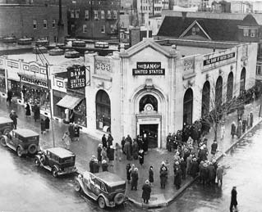to reopen after a four-day “bank holiday.”

T U R M O I L A N D

CHANGE

A PICTURE PROFILE

**For the United States, the 20th century was a period of extraordinary turmoil and change. In these decades, the nation endured the worst economic depression in its history; emerged triumphant, with the Allies, in World War II; assumed a role of global leadership in the century’s twilight conflict known as the Cold War; and underwent a remarkable social, economic, and political transition at home. Where once the United States transformed itself over the slow march of centuries, it now seemed to reinvent itself almost by decades.**

229

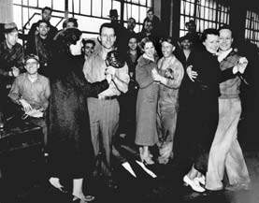

Men and women strikers dance the time away on March 11, 1937, during a strike at the Chevrolet Fisher Body Plants in St. Louis, Missouri. Strikes such as these succeeded in winning union recognition for industrial workers throughout

the country in the 1930s.

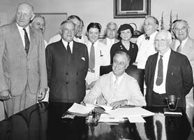

President Franklin D. Roosevelt signs perhaps the most far-reaching legislation of the New Deal: the Social Security Act of 1935. Today, Social Security, one of the largest government programs in the United States, provides retirement and disability income to millions of Americans.

230

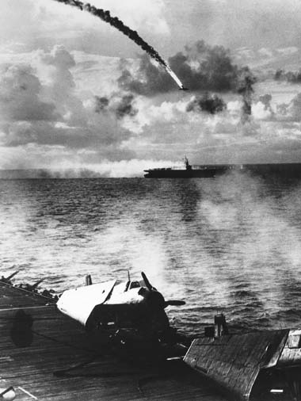

World War II in the Pacific was characterized by large-scale naval and air battles. Here, a Japanese plane plunges in flames during an attack on a U.S. carrier fleet in the Mariana Islands, June 1944. U.S. Army and Marine forces’ “island hopping” campaign began at Guadalcanal in August 1942 and ended with the assault on

Okinawa in April 1945.

231



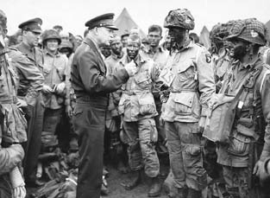

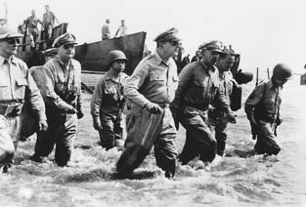

Top, General Dwight Eisenhower, Supreme Commander in Europe, talks with paratroopers shortly before the Normandy invasion, June 6, 1944.

Above, General Douglas MacArthur (center) had declared, “I shall return,” when he escaped from advancing Japanese forces in the Philippines in 1942. Two years later, he made good on his promise and waded ashore at Leyte as American forces began the liberation of the Philippines.

232

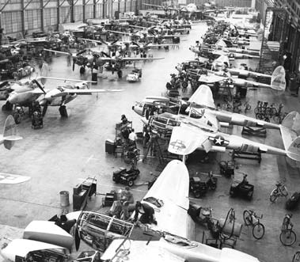

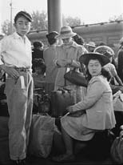Assembly line of P-38 *Lightning* fighter planes during World War II. With its massive output of war materiel, the United States became, in the words of President Roosevelt, “the arsenal of democracy.”

Japanese Americans await relocation to internment camps in the worst violation of human rights that occurred inside the United States during World War II.

233

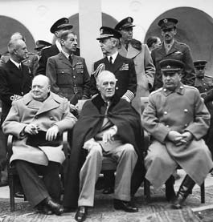

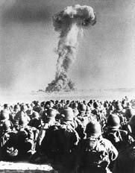Meeting of British Prime Minister Winston Churchill, President Roosevelt, and Soviet leader Josef Stalin at Yalta in February 1945.

Disagreements over the future of Europe anticipated the division of the European continent that remained a fixture of the Cold War.

U.S. troops witness a nuclear test in the Nevada desert in 1951. The threat of nuclear weapons remained a constant and ominous fact of life throughout the

Cold War era.

234

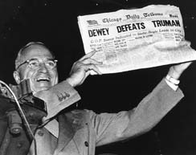In perhaps the most famous photograph in American political

history, President Harry Truman holds aloft a newspaper wrongly announcing his defeat by Republican nominee Thomas Dewey in

the 1948 presidential election. Truman’s come-from-behind victory surprised all political experts

that day.

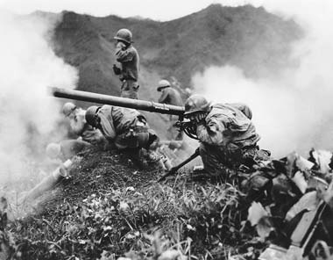U.S. infantry fire against North Korean forces invading South Korea in 1951, in a conflict that lasted three painful years.

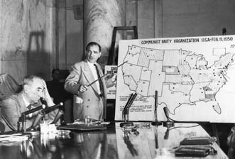

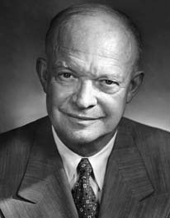At a congressional hearing in 1954, Senator Joseph McCarthy points to a map purportedly showing Communist Party influence in the United States in 1950. His chief antagonist at the hearing, lawyer Joseph Welch, sits at left. Welch successfully discredited McCarthy at these hearings, which were among the first to be televised across the country.

Portrait of President Dwight Eisenhower, whose genial, reassuring personality dominated the decade of the 1950s.

236

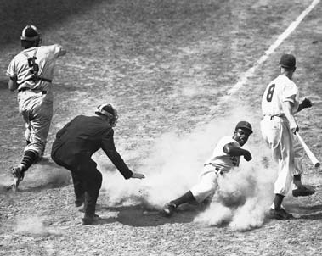Jackie Robinson, sliding home in a 1948 baseball game. Robinson broke the color barrier against black professional baseball players when he joined the Brooklyn Dodgers and became one of the stars of the game.

237

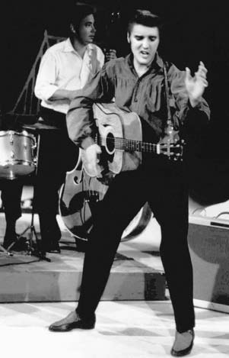

America’s first star of rock and roll, Elvis Presley, performing on television’s “Ed Sullivan Show,” September 9, 1956. Today, years after his death, he is still revered by legions of his fans as “The King.”

238

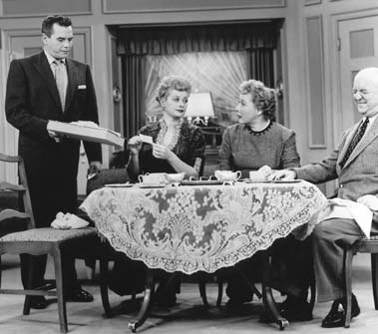Lucille Ball (second from left) with her supporting cast, including husband

Desi Arnaz (standing), on one of the most popular television comedy shows of the 1950s, *I Love Lucy*. The show established many of the techniques and conventions shared by hundreds of the televised “situation comedies” that followed.

239

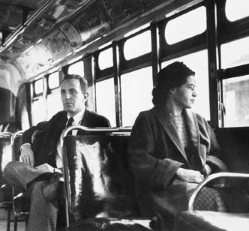

Above, Rosa Parks sits in one of the front seats of a city bus following the successful boycott of the bus system in 1955-56 by African- American citizens of Montgomery, Alabama. The boycott was organized to protest the practice of segregation in which African Americans were forced to sit in the back of the bus. The Supreme Court agreed that this practice was a constitutional violation a

year after the boycott began. The great leader of the civil rights movement in America, Martin Luther King Jr., gained national prominence through the Montgomery bus boycott.

Opposite page, right, Martin Luther King Jr. escorts children to a previously all-white public school in Grenada, Mississippi, in 1966. Although school segregation was outlawed in the landmark *Brown*

*v. Board of Education* decision of the Supreme Court in 1954, it took decades of protest, political pressure, and additional court decisions to enforce school desegregation across the country.

240

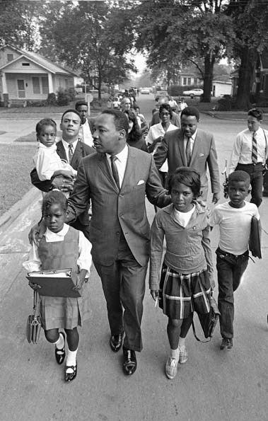

241

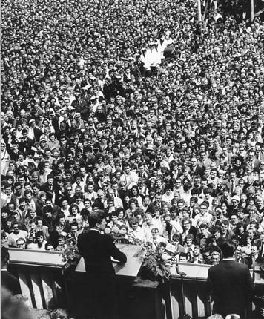

President John F. Kennedy addresses nearly a quarter of a million Germans in West Berlin in June 1963. Honoring the courage of those living in one of the flash points of the Cold War, he said, “All free men, wherever they may live, are

citizens of Berlin, and therefore, as a free man, I take pride in the words, ‘Ich bin ein Berliner’ (I am a Berliner).”

242

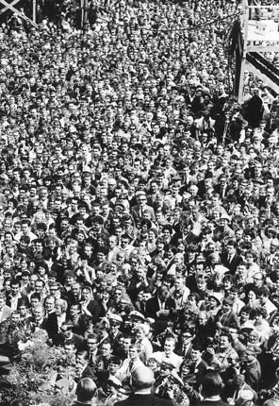

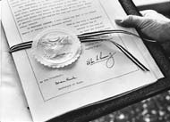Ratification document for the 1963 Limited Nuclear Test Ban Treaty, one of the first arms control agreements between the West and the Soviet bloc, which ended atmospheric nuclear testing.

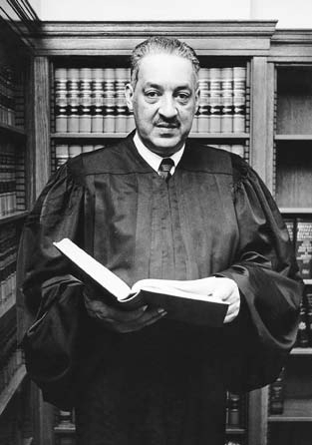

Thurgood Marshall, one of the champions of equal rights for all Americans. As a counsel for the National Association for the Advancement of Colored People (NAACP), Marshall successfully argued the landmark 1954 *Brown v. Board of*

*Education* case before the Supreme Court, which outlawed segregation in public schools. He later served a distinguished career as a justice of the Supreme Court.

244

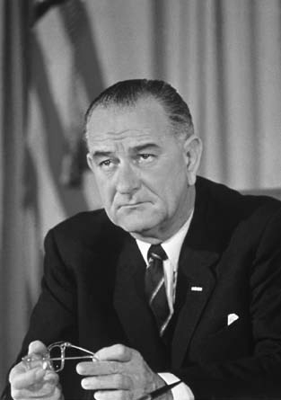

President Lyndon B. Johnson, born in Texas, was Senate majority leader in the Eisenhower years and vice president under John F. Kennedy before becoming president. One of the most powerful political personalities to serve in Washington, Johnson engineered the most ambitious domestic legislative agenda through Congress since Roosevelt’s New Deal. The Vietnam War ended his presidency, however, since it divided the nation.

245

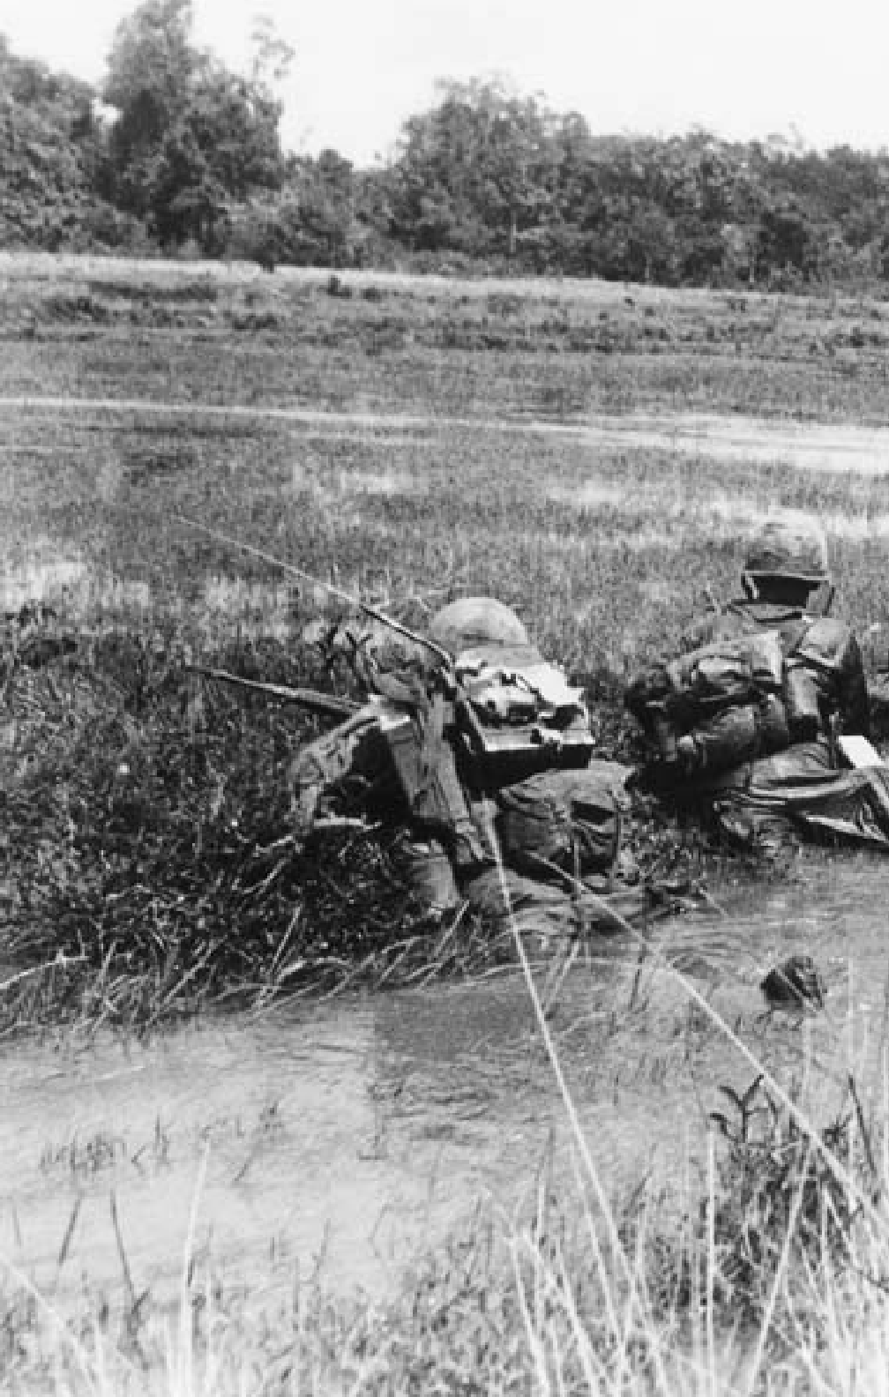

A U.S. Army unit searches for snipers while on patrol in South Vietnam in 1965. From 60,000 troops in 1965, U.S. forces grew to more than 540,000 by 1969, in a conflict that divided

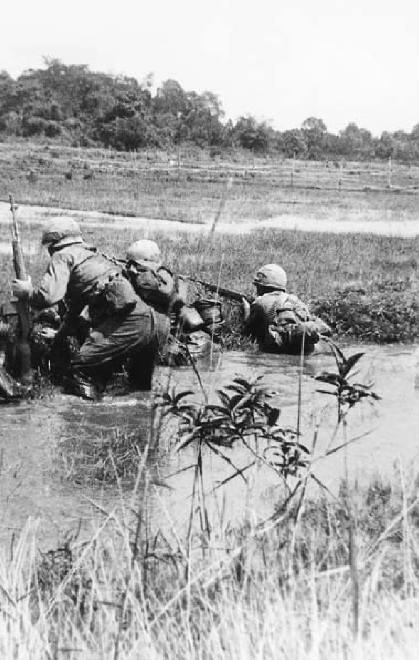

the nation more bitterly than any other in the 20th century. The last U.S. combat forces left

Vietnam in 1973.

247

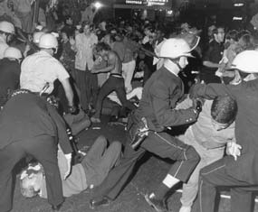

Antiwar demonstrators and police clash during violent protests at the 1968 Democratic National Convention in Chicago, Illinois. Antiwar candidates at the convention lost the presidential nomination to Lyndon Johnson’s vice president, Hubert Humphrey.

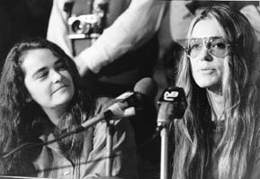

Two of the leaders of the women’s movement in the 1960s: Kate Millett (left), author of a controversial book of the time, *Sexual Politics*, and journalist and activist Gloria Steinem.

248

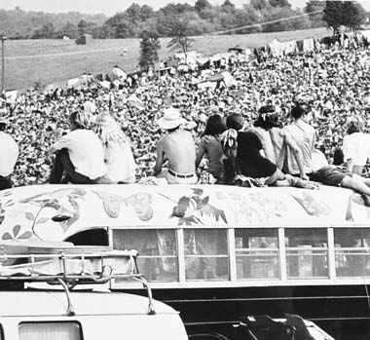The crest of the counterculture wave in the United States: the three-day 1969 outdoor rock concert and gathering known as Woodstock.

249

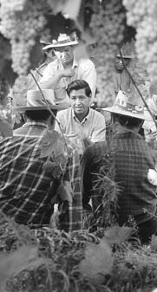

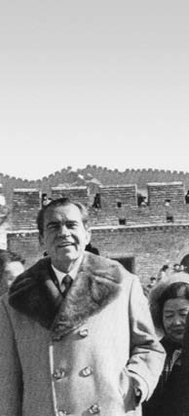Mexican-American labor activist César Chávez (center) talking with grape pickers in the field in 1968. Head of the United Farm Workers Union in California,

Chávez was a leading voice for the rights of migrant farm workers, focusing national attention on their terrible working conditions.

250

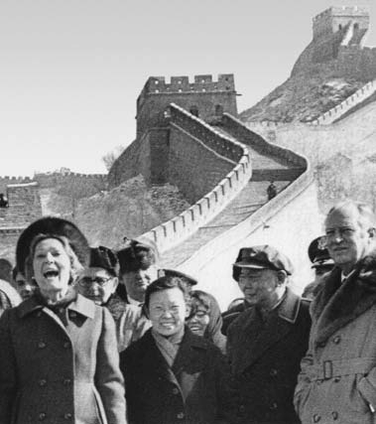

President Richard M. Nixon, with his wife Pat Nixon and Secretary of State William Rogers (far right), walks along a portion of the Great Wall of China. Nixon’s 1972 opening to the People’s Republic of China was a major diplomatic triumph at a time when U.S. forces were slowly withdrawing from South Vietnam.

251

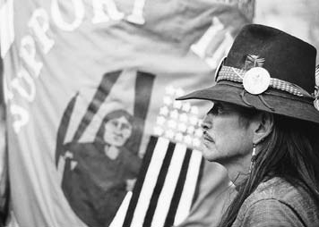

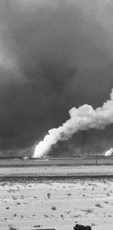Participant in a demonstration by Native Americans in Washington, D.C., in 1978. They also have sought to assert their rights and identity in recent decades.

Oil fires burn behind a destroyed Iraqi tank at the conclusion of the Gulf War in February 1991. The United States led a coalition of more than 30 nations in an air and ground campaign called Desert Storm that ended Iraq’s

occupation of Kuwait.

252

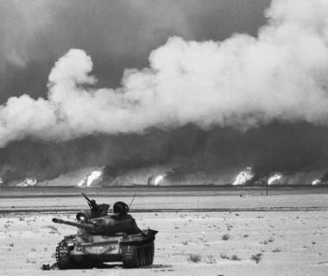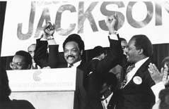

Civil rights leader and political activist Jesse Jackson at a political rally in 1984. For more than four decades, Jackson has remained among the most prominent, politically active, and eloquent representatives of what he has termed a “Rainbow Coalition”

of the poor, African Americans, and other minorities.

253

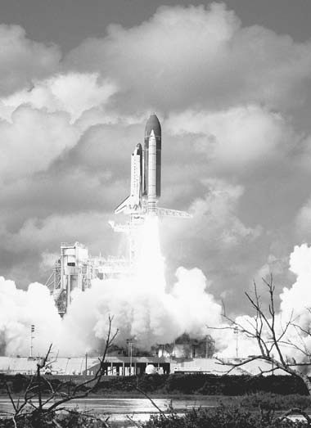

A launch of a space shuttle, the first reusable space vehicle. The versatile shuttle, which has been used to place satellites in orbit and conduct wide-ranging experiments, is indispensable in the assemblage (beginning June 1998) and running of the International Space Station.

254

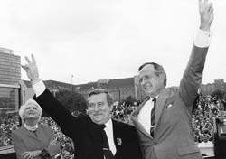President George

H.W. Bush with Poland’s Lech Walesa (center) and First Lady Barbara Bush

in Warsaw, July 1989. That remarkable year saw the end of the Cold War, as well

as the end to the 40-year division of Europe into hostile

East and West blocs.

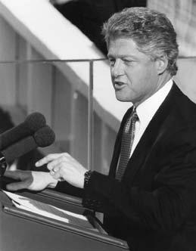President William (Bill)

J. Clinton, delivering his inaugural address to the nation, January 21, 1993. During his administration, the United States enjoyed more peace and economic well-being than at any time in its history. He was the second U.S. president to be impeached and found not guilty.

255

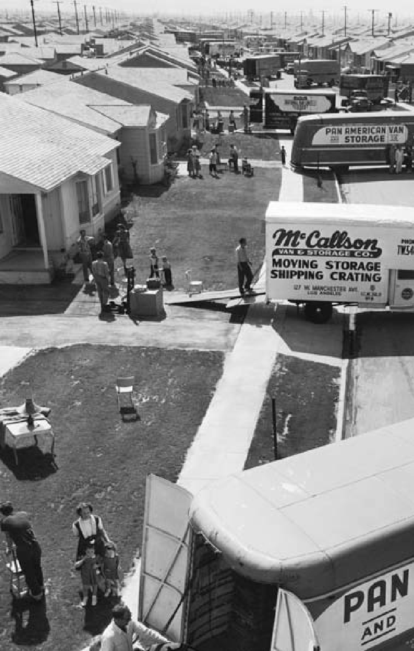

256

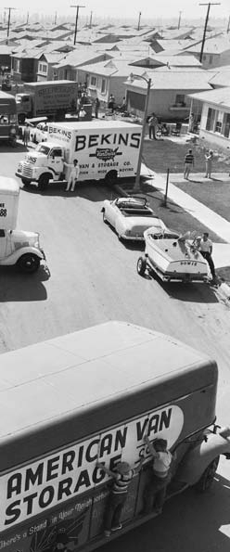

**C H A P T E R**

12

**POSTWAR AMERICA**

Moving day in a newly opened suburban community, 1953.

“We must build a new world, a far better world —

one in which the eternal dignity of man is respected.”

President Harry S. Truman, 1945

#### CONSENSUS AND CHANGE

**T**he United States dominated glob- al affairs in the years immediately after World War II. Victorious in

that great struggle, its homeland undamaged from the ravages of war, the nation was confident of its mission at home and abroad. U.S. leaders wanted to maintain the dem- ocratic structure they had defended at tremendous cost and to share the benefits of prosperity as widely as possible. For them, as for publisher Henry Luce of *Time* magazine, this was the “American Century.”

For 20 years most Americans re- mained sure of this confident ap- proach. They accepted the need for a strong stance against the So- viet Union in the Cold War that unfolded after 1945. They endorsed

the growth of government author- ity and accepted the outlines of the rudimentary welfare state first for- mulated during the New Deal. They enjoyed a postwar prosperity that created new levels of affluence.

But gradually some began to question dominant assumptions. Challenges on a variety of fronts shattered the consensus. In the 1950s, African Americans launched a crusade, joined later by other mi- nority groups and women, for a larg- er share of the American dream. In the 1960s, politically active students protested the nation’s role abroad, particularly in the corrosive war in Vietnam. A youth counterculture emerged to challenge the status quo. Americans from many walks of life sought to establish a new social and political equilibrium.

**COLD WAR AIMS**

# T

(1929-40), America now advocated open trade for two reasons: to cre-

he Cold War was the most im- portant political and diplomatic is- sue of the early postwar period. It grew out of longstanding disagree- ments between the Soviet Union and the United States that developed af- ter the Russian Revolution of 1917. The Soviet Communist Party un- der V.I. Lenin considered itself the spearhead of an international move- ment that would replace the exist- ing political orders in the West, and indeed throughout the world. In 1918 American troops participated in the Allied intervention in Russia on behalf of anti-Bolshevik forces. American diplomatic recognition of the Soviet Union did not come until 1933. Even then, suspicions persist- ed. During World War II, however, the two countries found themselves allied and downplayed their differ- ences to counter the Nazi threat.

At the war’s end, antagonisms surfaced again. The United States hoped to share with other countries its conception of liberty, equality, and democracy. It sought also to learn from the perceived mistakes of the post-WWI era, when American political disengagement and eco- nomic protectionism were thought to have contributed to the rise of dic- tatorships in Europe and elsewhere. Faced again with a postwar world of civil wars and disintegrating empires, the nation hoped to pro- vide the stability to make peaceful reconstruction possible. Recalling the specter of the Great Depression

ate markets for American agricul- tural and industrial products, and to ensure the ability of Western Eu- ropean nations to export as a means of rebuilding their economies. Re- duced trade barriers, American policy makers believed, would pro- mote economic growth at home and abroad, bolstering U.S. friends and allies in the process.

The Soviet Union had its own agenda. The Russian historical tra- dition of centralized, autocratic government contrasted with the American emphasis on democracy. Marxist-Leninist ideology had been downplayed during the war but still guided Soviet policy. Devastated by the struggle in which 20 million Soviet citizens had died, the Soviet Union was intent on rebuilding and on protecting itself from another such terrible conflict. The Soviets were particularly concerned about another invasion of their territo- ry from the west. Having repelled Hitler’s thrust, they were determined to preclude another such attack. They demanded “defensible” bor- ders and “friendly” regimes in East- ern Europe and seemingly equated both with the spread of Commu- nism, regardless of the wishes of native populations. However, the United States had declared that one of its war aims was the restoration of independence and self-govern- ment to Poland, Czechoslovakia, and the other countries of Central and Eastern Europe.

**HARRY TRUMAN’S LEADERSHIP**

# T

ment following the Western model. The Yalta Conference of February 1945 had produced an agreement on

he nation’s new chief executive, Harry S. Truman, succeeded Frank- lin D. Roosevelt as president before the end of the war. An unpretentious man who had previously served as Democratic senator from Missouri, then as vice president, Truman ini- tially felt ill-prepared to govern. Roosevelt had not discussed com- plex postwar issues with him, and he had little experience in international affairs. “I’m not big enough for this job,” he told a former colleague.

Still, Truman responded quickly to new challenges. Sometimes im- pulsive on small matters, he proved willing to make hard and carefully considered decisions on large ones. A small sign on his White House desk declared, “The Buck Stops Here.” His judgments about how to respond to the Soviet Union ulti- mately determined the shape of the early Cold War.

#### ORIGINS OF THE COLD WAR

**T**he Cold War developed as dif- ferences about the shape of the postwar world created suspicion and

distrust between the United States and the Soviet Union. The first — and most difficult — test case was Poland, the eastern half of which had been invaded and occupied by the USSR in 1939. Moscow demanded a government subject to Soviet in- fluence; Washington wanted a more independent, representative govern-

Eastern Europe open to different in- terpretations. It included a promise of “free and unfettered” elections.

Meeting with Soviet Minister of Foreign Affairs Vyacheslav Mo- lotov less than two weeks after be- coming president, Truman stood firm on Polish self-determination, lecturing the Soviet diplomat about the need to implement the Yalta ac- cords. When Molotov protested, “I have never been talked to like that in my life,” Truman retorted, “Carry out your agreements and you won’t get talked to like that.” Relations de- teriorated from that point onward.

During the closing months of World War II, Soviet military forces occupied all of Central and Eastern Europe. Moscow used its military power to support the efforts of the Communist parties in Eastern Eu- rope and crush the democratic par- ties. Communists took over one nation after another. The process concluded with a shocking coup d’etat in Czechoslovakia in 1948.

Public statements defined the be- ginning of the Cold War. In 1946 Stalin declared that international peace was impossible “under the present capitalist development of the world economy.” Former British Prime Minister Winston Churchill delivered a dramatic speech in Ful- ton, Missouri, with Truman sitting on the platform. “From Stettin in the Baltic to Trieste in the Adriatic,” Churchill said, “an iron curtain has

descended across the Continent.” Britain and the United States, he de- clared, had to work together to coun- ter the Soviet threat.

#### CONTAINMENT

**C**ontainment of the Soviet Union became American policy in the postwar years. George Kennan, a

top official at the U.S. embassy in Moscow, defined the new approach in the Long Telegram he sent to the State Department in 1946. He extended his analysis in an arti- cle under the signature “X” in the prestigious journal *Foreign Affairs*. Pointing to Russia’s traditional sense of insecurity, Kennan argued that the Soviet Union would not soften its stance under any circumstances. Moscow, he wrote, was “committed fanatically to the belief that with the United States there can be no perma- nent *modus vivendi*, that it is desir- able and necessary that the internal harmony of our society be disrupt- ed.” Moscow’s pressure to expand its power had to be stopped through “firm and vigilant containment of Russian expansive tendencies ”

The first significant application of the containment doctrine came in the Middle East and eastern Medi- terranean. In early 1946, the Unit- ed States demanded, and obtained, a full Soviet withdrawal from Iran, the northern half of which it had oc- cupied during the war. That sum- mer, the United States pointedly supported Turkey against Soviet demands for control of the Turkish

straits between the Black Sea and the Mediterranean. In early 1947, Amer- ican policy crystallized when Britain told the United States that it could no longer afford to support the gov- ernment of Greece against a strong Communist insurgency.

In a strongly worded speech to Congress, Truman declared, “I be- lieve that it must be the policy of the United States to support free peoples who are resisting attempted subjuga- tion by armed minorities or by out- side pressures.” Journalists quickly dubbed this statement the “Truman Doctrine.” The president asked Congress to provide $400 million for economic and military aid, mostly to Greece but also to Turkey. After an emotional debate that resembled the one between interventionists and isolationists before World War II, the money was appropriated.

Critics from the left later charged that to whip up American support for the policy of containment, Tru- man overstated the Soviet threat to the United States. In turn, his state- ments inspired a wave of hysterical anti-Communism throughout the country. Perhaps so. Others, how- ever, would counter that this argu- ment ignores the backlash that likely would have occurred if Greece, Tur- key, and other countries had fallen within the Soviet orbit with no op- position from the United States.

Containment also called for ex- tensive economic aid to assist the re- covery of war-torn Western Europe. With many of the region’s nations economically and politically unsta-

ble, the United States feared that lo- cal Communist parties, directed by Moscow, would capitalize on their wartime record of resistance to the Nazis and come to power. “The pa- tient is sinking while the doctors de- liberate,” declared Secretary of State George C. Marshall. In mid-1947 Marshall asked troubled European nations to draw up a program “di- rected not against any country or doctrine but against hunger, poverty, desperation, and chaos.”

The Soviets participated in the first planning meeting, then depart- ed rather than share economic data and submit to Western controls on the expenditure of the aid. The re- maining 16 nations hammered out a request that finally came to $17,000 million for a four-year period. In early 1948 Congress voted to fund the “Marshall Plan,” which helped underwrite the economic resur- gence of Western Europe. It is gen- erally regarded as one of the most successful foreign policy initiatives in U.S. history.

Postwar Germany was a special problem. It had been divided into U.S., Soviet, British, and French zones of occupation, with the for- mer German capital of Berlin (it- self divided into four zones), near the center of the Soviet zone. When the Western powers announced their intention to create a consoli- dated federal state from their zones, Stalin responded. On June 24, 1948, Soviet forces blockaded Berlin, cut- ting off all road and rail access from the West.

American leaders feared that losing Berlin would be a prelude to losing Germany and subsequently all of Europe. Therefore, in a successful demonstration of Western resolve known as the Berlin Airlift, Allied air forces took to the sky, flying supplies into Berlin. U.S., French, and British planes delivered nearly 2,250,000 tons of goods, including food and coal. Stalin lifted the blockade after 231 days and 277,264 flights.

By then, Soviet domination of Eastern Europe, and especially the Czech coup, had alarmed the West- ern Europeans. The result, initiated by the Europeans, was a military al- liance to complement economic ef- forts at containment. The Norwegian historian Geir Lundestad has called it “empire by invitation.” In 1949 the United States and 11 other countries established the North Atlantic Trea- ty Organization (NATO). An attack against one was to be considered an attack against all, to be met by ap- propriate force. NATO was the first peacetime “entangling alliance” with powers outside the Western hemi- sphere in American history.

The next year, the United States defined its defense aims clearly. The National Security Council (NSC)

— the forum where the President, Cabinet officers, and other execu- tive branch members consider na- tional security and foreign affairs issues — undertook a full-fledged review of American foreign and defense policy. The resulting docu- ment, known as NSC-68, signaled a new direction in American security

policy. Based on the assumption that “the Soviet Union was engaged in a fanatical effort to seize control of all governments wherever possible,” the document committed America to assist allied nations anywhere in the world that seemed threatened by Soviet aggression. After the start of the Korean War, a reluctant Truman approved the document. The United States proceeded to increase defense spending dramatically.

#### THE COLD WAR IN ASIA AND THE MIDDLE EAST

**W**hile seeking to prevent Com- munist ideology from gaining fur- ther adherents in Europe, the United

States also responded to challenges elsewhere. In China, Americans worried about the advances of Mao Zedong and his Communist Party. During World War II, the National- ist government under Chiang Kai- shek and the Communist forces waged a civil war even as they fought the Japanese. Chiang had been a war-time ally, but his government was hopelessly inefficient and cor- rupt. American policy makers had little hope of saving his regime and considered Europe vastly more im- portant. With most American aid moving across the Atlantic, Mao’s forces seized power in 1949. Chiang’s government fled to the island of Tai- wan. When China’s new ruler an- nounced that he would support the Soviet Union against the “imperial- ist” United States, it appeared that Communism was spreading out of

control, at least in Asia.

The Korean War brought armed conflict between the United States and China. The United States and the Soviet Union had divided Ko- rea along the 38th parallel after lib- erating it from Japan at the end of World War II. Originally a matter of military convenience, the divid- ing line became more rigid as both major powers set up governments in their respective occupation zones and continued to support them even after departing.

In June 1950, after consultations with and having obtained the assent of the Soviet Union, North Korean leader Kim Il-sung dispatched his Soviet-supplied army across the 38th parallel and attacked southward, overrunning Seoul. Truman, per- ceiving the North Koreans as Soviet pawns in the global struggle, read- ied American forces and ordered World War II hero General Douglas MacArthur to Korea. Meanwhile, the United States was able to secure a U.N. resolution branding North Korea as an aggressor. (The Soviet Union, which could have vetoed any action had it been occupying its seat on the Security Council, was boycot- ting the United Nations to protest a decision not to admit Mao’s new Chinese regime.)

The war seesawed back and forth.

U.S. and Korean forces were initial- ly pushed into an enclave far to the south around the city of Pusan. A daring amphibious landing at In- chon, the port for the city of Seoul, drove the North Koreans back and

threatened to occupy the entire peninsula. In November, China entered the war, sending massive forces across the Yalu River. U.N. forces, largely American, retreated once again in bitter fighting. Com- manded by General Matthew B. Ridgway, they stopped the overex- tended Chinese, and slowly fought their way back to the 38th parallel. MacArthur meanwhile challenged Truman’s authority by attempting to orchestrate public support for bombing China and assisting an invasion of the mainland by Chi- ang Kai-shek’s forces. In April 1951, Truman relieved him of his duties and replaced him with Ridgway.

The Cold War stakes were high. Mindful of the European prior- ity, the U.S. government decided against sending more troops to Ko- rea and was ready to settle for the prewar status quo. The result was frustration among many Americans who could not understand the need for restraint. Truman’s popular- ity plunged to a 24-percent approval rating, the lowest to that time of any president since pollsters had begun to measure presidential popularity. Truce talks began in July 1951. The two sides finally reached an agree- ment in July 1953, during the first term of Truman’s successor, Dwight Eisenhower.

Cold War struggles also occurred in the Middle East. The region’s stra- tegic importance as a supplier of oil had provided much of the impetus for pushing the Soviets out of Iran in 1946. But two years later, the United

States officially recognized the new state of Israel 15 minutes after it was proclaimed — a decision Truman made over strong resistance from Marshall and the State Department. The result was an enduring dilemma

— how to maintain ties with Israel while keeping good relations with bitterly anti-Israeli (and oil-rich) Arab states.

#### EISENHOWER AND THE COLD WAR

**I**n 1953, Dwight D. Eisenhower be- came the first Republican president in 20 years. A war hero rather than

a career politician, he had a natu- ral, common touch that made him widely popular. “I like Ike” was the campaign slogan of the time. After serving as Supreme Commander of Allied Forces in Western Europe during World War II, Eisenhower had been army chief of staff, presi- dent of Columbia University, and military head of NATO before seek- ing the Republican presidential nomination. Skillful at getting peo- ple to work together, he functioned as a strong public spokesman and an executive manager somewhat re- moved from detailed policy making. Despite disagreements on detail,

he shared Truman’s basic view of American foreign policy. He, too, perceived Communism as a mono- lithic force struggling for world supremacy. In his first inaugural ad- dress, he declared, “Forces of good and evil are massed and armed and opposed as rarely before in history.

Freedom is pitted against slavery, lightness against dark.”

The new president and his secre- tary of state, John Foster Dulles, had argued that containment did not go far enough to stop Soviet expansion. Rather, a more aggressive policy of liberation was necessary, to free those subjugated by Communism. But when a democratic rebellion broke out in Hungary in 1956, the United States stood back as Soviet forces suppressed it.

Eisenhower’s basic commitment to contain Communism remained, and to that end he increased Ameri- can reliance on a nuclear shield. The United States had created the first atomic bombs. In 1950 Truman had authorized the development of a new and more powerful hydrogen bomb. Eisenhower, fearful that defense spending was out of control, re- versed Truman’s NSC-68 policy of a large conventional military buildup. Relying on what Dulles called “mas- sive retaliation,” the administration signaled it would use nuclear weap- ons if the nation or its vital interests were attacked.

In practice, however, the nuclear option could be used only against extremely critical attacks. Real Communist threats were generally peripheral. Eisenhower rejected the use of nuclear weapons in Indochi- na, when the French were ousted by Vietnamese Communist forces in 1954. In 1956, British and French forces attacked Egypt following Egyptian nationalization of the Suez Canal and Israel invaded the Egyp-

tian Sinai. The president exerted heavy pressure on all three countries to withdraw. Still, the nuclear threat may have been taken seriously by Communist China, which refrained not only from attacking Taiwan, but from occupying small islands held by Nationalist Chinese just off the mainland. It may also have deterred Soviet occupation of Berlin, which reemerged as a festering problem during Eisenhower’s last two years in office.

#### THE COLD WAR AT HOME

**N**ot only did the Cold War shape

U.S. foreign policy, it also had a pro-

found effect on domestic affairs. Americans had long feared radi- cal subversion. These fears could at times be overdrawn, and used to jus- tify otherwise unacceptable politi- cal restrictions, but it also was true that individuals under Communist Party discipline and many “fellow traveler” hangers-on gave their po- litical allegiance not to the United States, but to the international Com- munist movement, or, practically speaking, to Moscow. During the Red Scare of 1919-1920, the govern- ment had attempted to remove per- ceived threats to American society. After World War II, it made strong efforts against Communism within the United States. Foreign events, espionage scandals, and politics cre- ated an anti-Communist hysteria.

When Republicans were victo- rious in the midterm congressio- nal elections of 1946 and appeared

ready to investigate subversive activ- ity, President Truman established a Federal Employee Loyalty Program. It had little impact on the lives of most civil servants, but a few hun- dred were dismissed, some unfairly. In 1947 the House Committee on Un-American Activities investi- gated the motion-picture industry to determine whether Communist sentiments were being reflected in popular films. When some writers (who happened to be secret mem- bers of the Communist Party) re- fused to testify, they were cited for contempt and sent to prison. After that, the film companies refused to hire anyone with a marginally ques-

tionable past.

In 1948, Alger Hiss, who had been an assistant secretary of state and an adviser to Roosevelt at Yal- ta, was publicly accused of being a Communist spy by Whittaker Chambers, a former Soviet agent. Hiss denied the accusation, but in 1950 he was convicted of perjury. Subsequent evidence indicates that he was indeed guilty.

In 1949 the Soviet Union shocked Americans by testing its own atomic bomb. In 1950, the government un- covered a British-American spy net- work that transferred to the Soviet Union materials about the develop- ment of the atomic bomb. Two of its operatives, Julius Rosenberg and his wife Ethel, were sentenced to death. Attorney General J. Howard McGrath declared there were many American Communists, each bear- ing “the germ of death for society.”

The most vigorous anti-Commu- nist warrior was Senator Joseph R. McCarthy, a Republican from Wis- consin. He gained national attention in 1950 by claiming that he had a list of 205 known Communists in the State Department. Though McCar- thy subsequently changed this figure several times and failed to substan- tiate any of his charges, he struck a responsive public chord.

McCarthy gained power when the Republican Party won control of the Senate in 1952. As a commit- tee chairman, he now had a forum for his crusade. Relying on exten- sive press and television coverage, he continued to search for treachery among second-level officials in the Eisenhower administration. Enjoy- ing the role of a tough guy doing dirty but necessary work, he pursued presumed Communists with vigor.

McCarthy overstepped himself by challenging the U.S. Army when one of his assistants was drafted. Television brought the hearings into millions of homes. Many Ameri- cans saw McCarthy’s savage tactics for the first time, and public sup- port began to wane. The Republican Party, which had found McCarthy useful in challenging a Democratic administration when Truman was president, began to see him as an embarrassment. The Senate finally condemned him for his conduct.

McCarthy in many ways repre- sented the worst domestic excesses of the Cold War. As Americans re- pudiated him, it became natural for many to assume that the Com-

munist threat at home and abroad had been grossly overblown. As the country moved into the 1960s, anti- Communism became increasingly suspect, especially among intellectu- als and opinion-shapers.

#### THE POSTWAR ECONOMY: 1945-1960

**I**n the decade and a half after World War II, the United States ex- perienced phenomenal economic

growth and consolidated its position as the world’s richest country. Gross national product (GNP), a measure of all goods and services produced in the United States, jumped from about $200,000-million in 1940 to

$300,000-million in 1950 to more than $500,000-million in 1960. More and more Americans now considered themselves part of the middle class.

The growth had different sourc- es. The economic stimulus provided by large-scale public spending for World War II helped get it started. Two basic middle-class needs did much to keep it going. The number of automobiles produced annually quadrupled between 1946 and 1955. A housing boom, stimulated in part by easily affordable mortgages for returning servicemen, fueled the expansion. The rise in defense spending as the Cold War escalated also played a part.

After 1945 the major corporations in America grew even larger. There had been earlier waves of mergers in the 1890s and in the 1920s; in the

1950s another wave occurred. Fran- chise operations like McDonald’s fast-food restaurants allowed small entrepreneurs to make themselves part of large, efficient enterprises. Big American corporations also de- veloped holdings overseas, where la- bor costs were often lower.

Workers found their own lives changing as industrial America changed. Fewer workers produced goods; more provided services. As early as 1956 a majority of employ- ees held white-collar jobs, working as managers, teachers, salesper- sons, and office operatives. Some firms granted a guaranteed annual wage, long-term employment con- tracts, and other benefits. With such changes, labor militancy was under- mined and some class distinctions began to fade.

Farmers — at least those with small operations — faced tough times. Gains in productivity led to agricultural consolidation, and farming became a big business. More and more family farmers left the land.

Other Americans moved too. The West and the Southwest grew with increasing rapidity, a trend that would continue through the end of the century. Sun Belt cities like Houston, Texas; Miami, Florida; Al- buquerque, New Mexico; and Phoe- nix, Arizona, expanded rapidly. Los Angeles, California, moved ahead of Philadelphia, Pennsylvania, as the third largest U.S. city and then sur- passed Chicago, metropolis of the Midwest. The 1970 census showed

that California had displaced New York as the nation’s largest state. By 2000, Texas had moved ahead of New York into second place.

An even more important form of movement led Americans out of in- ner cities into new suburbs, where they hoped to find affordable hous- ing for the larger families spawned by the postwar baby boom. Develop- ers like William J. Levitt built new communities — with homes that all looked alike — using the tech- niques of mass production. Levitt’s houses were prefabricated — partly assembled in a factory rather than on the final location — and modest, but Levitt’s methods cut costs and allowed new owners to possess a part of the American dream.

As suburbs grew, businesses moved into the new areas. Large shopping centers containing a great variety of stores changed consumer patterns. The number of these cen- ters rose from eight at the end of World War II to 3,840 in 1960. With easy parking and convenient eve- ning hours, customers could avoid city shopping entirely. An unfortu- nate by-product was the “hollowing- out” of formerly busy urban cores.

New highways created better ac- cess to the suburbs and its shops. The Highway Act of 1956 provided

$26,000-million, the largest public works expenditure in U.S. history, to build more than 64,000 kilometers of limited access interstate highways to link the country together.

Television, too, had a powerful impact on social and economic pat-

terns. Developed in the 1930s, it was not widely marketed until after the war. In 1946 the country had fewer than 17,000 television sets. Three years later consumers were buying 250,000 sets a month, and by 1960 three-quarters of all families owned at least one set. In the middle of the decade, the average family watched television four to five hours a day. Popular shows for children included *Howdy Doody Time* and *The Mickey Mouse Club*; older viewers preferred situation comedies like *I Love Lucy* and *Father Knows Best*. Ameri- cans of all ages became exposed to increasingly sophisticated advertise- ments for products said to be neces- sary for the good life.

#### THE FAIR DEAL

**T**he Fair Deal was the name given to President Harry Truman’s domes- tic program. Building on Roosevelt’s

New Deal, Truman believed that the federal government should guaran- tee economic opportunity and social stability. He struggled to achieve those ends in the face of fierce political op- position from legislators determined to reduce the role of government.

Truman’s first priority in the immediate postwar period was to make the transition to a peacetime economy. Servicemen wanted to come home quickly, but once they arrived they faced competition for housing and employment. The G.I. Bill, passed before the end of the war, helped ease servicemen back into ci- vilian life by providing benefits such

as guaranteed loans for home-buy- ing and financial aid for industrial training and university education.

More troubling was labor unrest. As war production ceased, many workers found themselves without jobs. Others wanted pay increases they felt were long overdue. In 1946,

4.6 million workers went on strike, more than ever before in American history. They challenged the automo- bile, steel, and electrical industries. When they took on the railroads and soft-coal mines, Truman intervened to stop union excesses, but in so do- ing he alienated many workers.

While dealing with immediately pressing issues, Truman also provid- ed a broader agenda for action. Less than a week after the war ended, he presented Congress with a 21-point program, which provided for pro- tection against unfair employment practices, a higher minimum wage, greater unemployment compen- sation, and housing assistance. In the next several months, he added proposals for health insurance and atomic energy legislation. But this scattershot approach often left Tru- man’s priorities unclear.

Republicans were quick to attack. In the 1946 congressional elections they asked, “Had enough?” and vot- ers responded that they had. Re- publicans, with majorities in both houses of Congress for the first time since 1928, were determined to re- verse the liberal direction of the Roosevelt years.

Truman fought with the Congress as it cut spending and reduced taxes.

In 1948 he sought reelection, despite polls indicating that he had little chance. After a vigorous campaign, Truman scored one of the great up- sets in American politics, defeating the Republican nominee, Thomas Dewey, governor of New York. Re- viving the old New Deal coalition, Truman held on to labor, farmers, and African-American voters.

When Truman finally left of- fice in 1953, his Fair Deal was but a mixed success. In July 1948 he banned racial discrimination in fed- eral government hiring practices and ordered an end to segregation in the military. The minimum wage had risen, and social security programs had expanded. A housing program brought some gains but left many needs unmet. National health in- surance, aid-to-education measures, reformed agricultural subsidies, and his legislative civil rights agenda never made it through Congress. The president’s pursuit of the Cold War, ultimately his most important objective, made it especially difficult to develop support for social reform in the face of intense opposition.

#### EISENHOWER’S APPROACH

**W**hen Dwight Eisenhower suc- ceeded Truman as president, he accepted the basic framework of gov-

ernment responsibility established by the New Deal, but sought to hold the line on programs and expendi- tures. He termed his approach “dy- namic conservatism” or “modern Republicanism,” which meant, he ex-

plained, “conservative when it comes to money, liberal when it comes to human beings.” A critic countered that Eisenhower appeared to argue that he would “strongly recommend the building of a great many schools

... but not provide the money.”

Eisenhower’s first priority was to balance the budget after years of deficits. He wanted to cut spending and taxes and maintain the value of the dollar. Republicans were willing to risk unemployment to keep infla- tion in check. Reluctant to stimulate the economy too much, they saw the country suffer three economic recessions in the eight years of the Eisenhower presidency, but none was very severe.

In other areas, the administra- tion transferred control of offshore oil lands from the federal govern- ment to the states. It also favored pri- vate development of electrical power rather than the public approach the Democrats had initiated. In general, its orientation was sympathetic to business.

Compared to Truman, Eisen- hower had only a modest domes- tic program. When he was active in promoting a bill, it likely was to trim the New Deal legacy a bit — as in reducing agricultural subsidies or placing mild restrictions on la- bor unions. His disinclination to push fundamental change in either direction was in keeping with the spirit of the generally prosperous Fifties. He was one of the few presi- dents who left office as popular as when he entered it.

#### THE CULTURE OF THE 1950s

**D**uring the 1950s, many cul- tural commentators pointed out that a sense of uniformity pervaded

American society. Conformity, they asserted, was numbingly common. Though men and women had been forced into new employment pat- terns during World War II, once the war was over, traditional roles were reaffirmed. Men expected to be the breadwinners in each family; wom- en, even when they worked, assumed their proper place was at home. In his influential book, *The Lonely Crowd*, sociologist David Riesman called this new society “other-directed,” characterized by conformity, but also by stability. Television, still very limited in the choices it gave its view- ers, contributed to the homogenizing cultural trend by providing young and old with a shared experience re- flecting accepted social patterns.

Yet beneath this seemingly bland surface, important segments of American society seethed with rebellion. A number of writers, collectively known as the “Beat Gen- eration,” went out of their way to challenge the patterns of respect- ability and shock the rest of the culture. Stressing spontaneity and spirituality, they preferred intuition over reason, Eastern mysticism over Western institutionalized religion.

The literary work of the beats displayed their sense of alienation and quest for self-realization. Jack Kerouac typed his best-selling novel *On the Road* on a 75-meter roll of

paper. Lacking traditional punctua- tion and paragraph structure, the book glorified the possibilities of the free life. Poet Allen Ginsberg gained similar notoriety for his poem “Howl,” a scathing critique of mod- ern, mechanized civilization. When police charged that it was obscene and seized the published version, Ginsberg successfully challenged the ruling in court.

Musicians and artists rebelled as well. Tennessee singer Elvis Presley was the most successful of several white performers who popularized a sensual and pulsating style of Af- rican-American music, which began to be called “rock and roll.” At first, he outraged middle-class Ameri- cans with his ducktail haircut and undulating hips. But in a few years his performances would seem rela- tively tame alongside the antics of later performers such as the British Rolling Stones. Similarly, it was in the 1950s that painters like Jackson Pollock discarded easels and laid out gigantic canvases on the floor, then applied paint, sand, and other mate- rials in wild splashes of color. All of these artists and authors, whatever the medium, provided models for the wider and more deeply felt social revolution of the 1960s.

#### ORIGINS OF THE CIVIL RIGHTS MOVEMENT

**A**frican Americans became in- creasingly restive in the postwar years. During the war they had chal-

lenged discrimination in the mili-

tary services and in the work force, and they had made limited gains. Millions of African Americans had left Southern farms for Northern cit- ies, where they hoped to find better jobs. They found instead crowded conditions in urban slums. Now, African-American servicemen re- turned home, many intent on reject- ing second-class citizenship.

Jackie Robinson dramatized the racial question in 1947 when he broke baseball’s color line and be- gan playing in the major leagues. A member of the Brooklyn Dodgers, he often faced trouble with oppo- nents and teammates as well. But an outstanding first season led to his acceptance and eased the way for other African-American players, who now left the Negro leagues to which they had been confined.

Government officials, and many other Americans, discovered the connection between racial problems and Cold War politics. As the leader of the free world, the United States sought support in Africa and Asia. Discrimination at home impeded the effort to win friends in other parts of the world.

Harry Truman supported the early civil rights movement. He per- sonally believed in political equality, though not in social equality, and recognized the growing importance of the African-American urban vote. When apprised in 1946 of a spate of lynchings and anti-black violence in the South, he appointed a com- mittee on civil rights to investigate discrimination. Its report, *To Secure*

*These Rights*, issued the next year, documented African Americans’ second-class status in American life and recommended numerous fed- eral measures to secure the rights guaranteed to all citizens.

Truman responded by sending a 10-point civil rights program to Congress. Southern Democrats in Congress were able to block its en- actment. A number of the angriest, led by Governor Strom Thurmond of South Carolina, formed a States Rights Party to oppose the president in 1948. Truman thereupon issued an executive order barring discrim- ination in federal employment, or- dered equal treatment in the armed forces, and appointed a committee to work toward an end to military segregation, which was largely ended during the Korean War.

African Americans in the South in the 1950s still enjoyed few, if any, civil and political rights. In gener- al, they could not vote. Those who tried to register faced the likelihood of beatings, loss of job, loss of credit, or eviction from their land. Occa- sional lynchings still occurred. Jim Crow laws enforced segregation of the races in streetcars, trains, hotels, restaurants, hospitals, recreational facilities, and employment.

#### DESEGREGATION

**T**he National Association for the Advancement of Colored People (NAACP) took the lead in efforts to

overturn the judicial doctrine, es- tablished in the Supreme Court case

*Plessy v. Ferguson* in 1896, that seg- regation of African-American and white students was constitutional if facilities were “separate but equal.” That decree had been used for de- cades to sanction rigid segregation in all aspects of Southern life, where facilities were seldom, if ever, equal.

African Americans achieved their goal of overturning *Plessy* in 1954 when the Supreme Court — pre- sided over by an Eisenhower ap- pointee, Chief Justice Earl Warren

— handed down its *Brown v. Board of Education* ruling. The Court de- clared unanimously that “separate facilities are inherently unequal,” and decreed that the “separate but equal” doctrine could no longer be used in public schools. A year later, the Supreme Court demanded that local school boards move “with all deliberate speed” to implement the decision.

Eisenhower, although sympathet- ic to the needs of the South as it faced a major transition, nonetheless act- ed to see that the law was upheld in the face of massive resistance from much of the South. He faced a ma- jor crisis in Little Rock, Arkansas, in 1957, when Governor Orval Faubus attempted to block a desegregation plan calling for the admission of nine black students to the city’s previ- ously all-white Central High School. After futile efforts at negotiation, the president sent federal troops to Little Rock to enforce the plan.

Governor Faubus responded by ordering the Little Rock high schools closed down for the 1958-59 school

year. However, a federal court ordered them reopened the follow- ing year. They did so in a tense at- mosphere with a tiny number of African-American students. Thus, school desegregation proceeded at a slow and uncertain pace throughout much of the South.

Another milestone in the civil rights movement occurred in 1955 in Montgomery, Alabama. Rosa Parks, a 42-year-old African-American seamstress who was also secretary of the state chapter of the NAACP, sat down in the front of a bus in a section reserved by law and custom for whites. Ordered to move to the back, she refused. Police came and arrested her for violating the seg- regation statutes. African-American leaders, who had been waiting for just such a case, organized a boycott of the bus system.

Martin Luther King Jr., a young minister of the Baptist church where the African Americans met, became a spokesman for the pro- test. “There comes a time,” he said, “when people get tired ... of being kicked about by the brutal feet of op- pression.” King was arrested, as he would be again and again; a bomb damaged the front of his house. But African Americans in Montgomery sustained the boycott. About a year later, the Supreme Court affirmed that bus segregation, like school segregation, was unconstitutional. The boycott ended. The civil rights movement had won an important victory — and discovered its most

powerful, thoughtful, and eloquent leader in Martin Luther King Jr.

African Americans also sought to secure their voting rights. Although the 15th Amendment to the U.S. Constitution guaranteed the right to vote, many states had found ways to circumvent the law. The states would impose a poll (“head”) tax or a lit- eracy test — typically much more stringently interpreted for African Americans — to prevent poor Afri- can Americans with little education from voting. Eisenhower, working with Senate majority leader Lyn- don B. Johnson, lent his support to a congressional effort to guarantee the vote. The Civil Rights Act of 1957, the first such measure in 82 years, marked a step forward, as it authorized federal intervention in cases where African Americans were denied the chance to vote. Yet loopholes remained, and so activ- ists pushed successfully for the Civil Rights Act of 1960, which provided stiffer penalties for interfering with voting, but still stopped short of au- thorizing federal officials to register African Americans.

Relying on the efforts of African Americans themselves, the civil rights movement gained momen- tum in the postwar years. Working through the Supreme Court and through Congress, civil rights sup- porters had created the groundwork for a dramatic yet peaceful “revolu- tion” in American race relations in the 1960s. 9

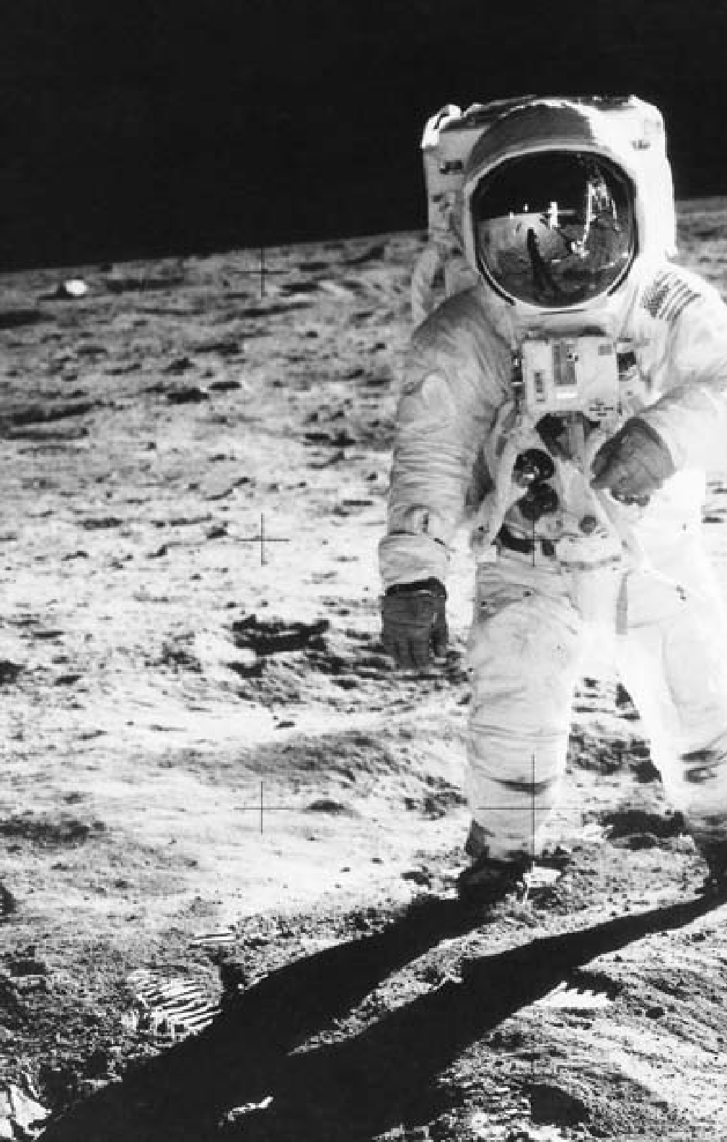

274

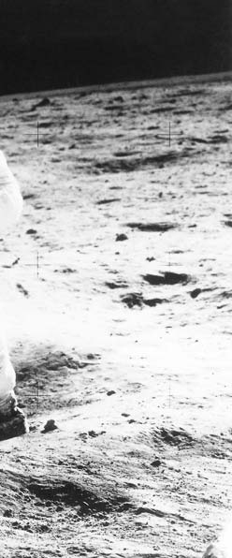

**C H A P T E R**

13

**DECADES OF CHANGE: 1960-1980**

Module Pilot Edwin Aldrin Jr. on the moon, July 20, 1969.

“I have a dream that one day on the red hills of Georgia, sons of former slaves and

the sons of former slave owners will be able to sit down together at the table of brotherhood.”

Martin Luther King Jr., 1963

By 1960, the United States was on the verge of a major social change. American society had always been more open and fluid than that of the nations in most of the rest of the world. Still, it had been dominated primarily by old-stock, white males. During the 1960s, groups that previ- ously had been submerged or sub- ordinate began more forcefully and successfully to assert themselves: Af- rican Americans, Native Americans, women, the white ethnic offspring of the “new immigration,” and Latinos. Much of the support they received came from a young population larg- er than ever, making its way through a college and university system that was expanding at an unprecedented pace. Frequently embracing “coun- tercultural” lifestyles and radical

politics, many of the offspring of the World War II generation emerged as advocates of a new America char- acterized by a cultural and ethnic pluralism that their parents often viewed with unease.

#### THE CIVIL RIGHTS MOVEMENT 1960-1980

**T**he struggle of African Americans for equality reached its peak in the mid-1960s. After progressive vic-

tories in the 1950s, African Ameri- cans became even more committed to nonviolent direct action. Groups like the Southern Christian Leader- ship Conference (SCLC), made up of African-American clergy, and the Student Nonviolent Coordinat- ing Committee (SNCC), composed

of younger activists, sought reform through peaceful confrontation.

In 1960 African-American col- lege students sat down at a segre- gated Woolworth’s lunch counter in North Carolina and refused to leave. Their sit-in captured media atten- tion and led to similar demonstra- tions throughout the South. The next year, civil rights workers organized “freedom rides,” in which African Americans and whites boarded bus- es heading south toward segregated terminals, where confrontations might capture media attention and lead to change.

They also organized rallies, the largest of which was the “March on Washington” in 1963. More than 200,000 people gathered in the na- tion’s capital to demonstrate their commitment to equality for all. The high point of a day of songs and speeches came with the address of Martin Luther King Jr., who had emerged as the preeminent spokes- man for civil rights. “I have a dream that one day on the red hills of Geor- gia the sons of former slaves and the sons of former slave owners will be able to sit down together at the table of brotherhood,” King proclaimed. Each time he used the refrain “I have a dream,” the crowd roared.

The level of progress initially achieved did not match the rhetoric of the civil rights movement. Presi- dent Kennedy was initially reluc- tant to press white Southerners for support on civil rights because he needed their votes on other issues. Events, driven by African Americans

themselves, forced his hand. When James Meredith was denied admis- sion to the University of Mississippi in 1962 because of his race, Kennedy sent federal troops to uphold the law. After protests aimed at the deseg- regation of Birmingham, Alabama, prompted a violent response by the police, he sent Congress a new civil rights bill mandating the integration of public places. Not even the March on Washington, however, could ex- tricate the measure from a congres- sional committee, where it was still bottled up when Kennedy was assas- sinated in 1963.

President Lyndon B. Johnson was more successful. Displaying negotiating skills he had so fre- quently employed during his years as Senate majority leader, Johnson persuaded the Senate to limit delay- ing tactics preventing a final vote on the sweeping Civil Rights Act of 1964, which outlawed discrimina- tion in all public accommodations. The next year’s Voting Rights Act of 1965 authorized the federal gov- ernment to register voters where local officials had prevented Afri- can Americans from doing so. By 1968 a million African Americans were registered in the deep South. Nationwide, the number of African- American elected officials increased substantially. In 1968, the Congress passed legislation banning discrimi- nation in housing.

Once unleashed, however, the civil rights revolution produced leaders impatient with both the pace of change and the goal of channel-

ing African Americans into main- stream white society. Malcolm X, an eloquent activist, was the most prominent figure arguing for Afri- can-American separation from the white race. Stokely Carmichael, a student leader, became similarly dis- illusioned by the notions of nonvio- lence and interracial cooperation. He popularized the slogan “black power,” to be achieved by “whatever means necessary,” in the words of Malcolm X.

Violence accompanied militant calls for reform. Riots broke out in several big cities in 1966 and 1967. In the spring of 1968, Martin Lu- ther King Jr. fell before an assassin’s bullet. Several months later, Senator Robert Kennedy, a spokesman for the disadvantaged, an opponent of the Vietnam War, and the brother of the slain president, met the same fate. To many these two assassina- tions marked the end of an era of in- nocence and idealism. The growing militancy on the left, coupled with an inevitable conservative backlash, opened a rift in the nation’s psyche that took years to heal.

By then, however, a civil rights movement supported by court de- cisions, congressional enactments, and federal administrative regula- tions was irreversibly woven into the fabric of American life. The major issues were about implementation of equality and access, not about the legality of segregation or disenfran- chisement. The arguments of the 1970s and thereafter were over mat- ters such as busing children out of

their neighborhoods to achieve ra- cial balance in metropolitan schools or about the use of “affirmative ac- tion.” These policies and programs were viewed by some as active mea- sures to ensure equal opportunity, as in education and employment, and by others as reverse discrimination.

The courts worked their way through these problems with deci- sions that were often inconsistent. In the meantime, the steady march of African Americans into the ranks of the middle class and once large- ly white suburbs quietly reflected a profound demographic change.

#### THE WOMEN’S MOVEMENT

**D**uring the 1950s and 1960s, in- creasing numbers of married wom- en entered the labor force, but in

1963 the average working woman earned only 63 percent of what a man made. That year Betty Friedan published *The Feminine Mystique*, an explosive critique of middle- class living patterns that articulated a pervasive sense of discontent that Friedan contended was felt by many women. Arguing that women often had no outlets for expression other than “finding a husband and bear- ing children,” Friedan encouraged her readers to seek new roles and re- sponsibilities and to find their own personal and professional identities, rather than have them defined by a male-dominated society.

The women’s movement of the 1960s and 1970s drew inspiration from the civil rights movement. It

was made up mainly of members of the middle class, and thus partook of the spirit of rebellion that affected large segments of middle-class youth in the 1960s.

Reform legislation also prompted change. During debate on the 1964 Civil Rights bill, opponents hoped to defeat the entire measure by pro- posing an amendment to outlaw dis- crimination on the basis of gender as well as race. First the amendment, then the bill itself, passed, giving women a valuable legal tool.

In 1966, 28 professional women, including Friedan, established the National Organization for Wom- en (NOW) “to take action to bring American women into full partici- pation in the mainstream of Ameri- can society now.” While NOW and similar feminist organizations boast of substantial memberships today, arguably they attained their greatest influence in the early 1970s, a time that also saw the journalist Gloria Steinem and several other wom- en found *Ms*. magazine. They also spurred the formation of counter- feminist groups, often led by women, including most prominently the po- litical activist Phyllis Schlafly. These groups typically argued for more “traditional” gender roles and op- posed the proposed “Equal Rights” constitutional amendment.

Passed by Congress in 1972, that amendment declared in part, “Equality of rights under the law shall not be denied or abridged by the United States or by any State on account of sex.” Over the next sever-

al years, 35 of the necessary 38 states ratified it. The courts also moved to expand women’s rights. In 1973 the Supreme Court in *Roe v. Wade* sanc- tioned women’s right to obtain an abortion during the early months of pregnancy — seen as a significant victory for the women’s movement

* but *Roe* also spurred the growth of an anti-abortion movement.

In the mid- to late-1970s, how- ever, the women’s movement seemed to stagnate. It failed to broaden its appeal beyond the middle class. Divisions arose between moderate and radical feminists. Conservative opponents mounted a campaign against the Equal Rights Amend- ment, and it died in 1982 without gaining the approval of the 38 states needed for ratification.

#### THE LATINO MOVEMENT

**I**n post-World War II America, Americans of Mexican and Puerto Rican descent had faced discrimina-

tion. New immigrants, coming from Cuba, Mexico, and Central Ameri- ca — often unskilled and unable to speak English — suffered from dis- crimination as well. Some Hispanics worked as farm laborers and at times were cruelly exploited while harvest- ing crops; others gravitated to the cities, where, like earlier immigrant groups, they encountered difficulties in their quest for a better life.

Chicanos, or Mexican-Ameri- cans, mobilized in organizations like the radical Asociación Nacio- nal Mexico-Americana, yet did

not become confrontational un- til the 1960s. Hoping that Lyndon Johnson’s poverty program would expand opportunities for them, they found that bureaucrats failed to respond to less vocal groups. The example of black activism in particular taught Hispanics the im- portance of pressure politics in a pluralistic society.

The National Labor Relations Act of 1935 had excluded agricultural workers from its guarantee of the right to organize and bargain col- lectively. But César Chávez, found- er of the overwhelmingly Hispanic United Farm Workers, demonstrat- ed that direct action could achieve employer recognition for his union. California grape growers agreed to bargain with the union after Chávez led a nationwide consumer boy- cott. Similar boycotts of lettuce and other products were also successful. Though farm interests continued to try to obstruct Chávez’s organiza- tion, the legal foundation had been laid for representation to secure higher wages and improved working conditions.

Hispanics became political- ly active as well. In 1961 Henry B. González won election to Congress from Texas. Three years later Eligio (“Kika”) de la Garza, another Texan, followed him, and Joseph Montoya of New Mexico went to the Sen- ate. Both González and de la Garza later rose to positions of power as committee chairmen in the House. In the 1970s and 1980s, the pace of Hispanic political involvement in-

creased. Several prominent Hispan- ics have served in the Bill Clinton and George W. Bush cabinets.

#### THE NATIVE-AMERICAN MOVEMENT

**I**n the 1950s, Native Americans struggled with the government’s pol- icy of moving them off reservations

and into cities where they might as- similate into mainstream America. Many of the uprooted often had dif- ficulties adjusting to urban life. In 1961, when the policy was discontin- ued, the U.S. Commission on Civil Rights noted that, for Native Ameri- cans, “poverty and deprivation are common.”

In the 1960s and 1970s, watch- ing both the development of Third World nationalism and the progress of the civil rights movement, Native Americans became more aggressive in pressing for their own rights. A new generation of leaders went to court to protect what was left of tribal lands or to recover those which had been taken, often illegally, in previ- ous times. In state after state, they challenged treaty violations, and in 1967 won the first of many victories guaranteeing long-abused land and water rights. The American Indian Movement (AIM), founded in 1968, helped channel government funds to Native-American-controlled organi- zations and assisted neglected Native Americans in the cities.

Confrontations became more common. In 1969 a landing party of 78 Native Americans seized Alca-

traz Island in San Francisco Bay and held it until federal officials removed them in 1971. In 1973 AIM took over the South Dakota village of Wound- ed Knee, where soldiers in the late 19th century had massacred a Sioux encampment. Militants hoped to dramatize the poverty and alcohol- ism in the reservation surrounding the town. The episode ended after one Native American was killed and another wounded, with a govern- ment agreement to re-examine trea- ty rights.

Still, Native-American activ- ism brought results. Other Amer- icans became more aware of Native-American needs. Govern- ment officials responded with measures including the Education Assistance Act of 1975 and the 1996 Native-American Housing and Self- Determination Act. The Senate’s first Native-American member, Ben Nighthorse Campbell of Colorado, was elected in 1992.

#### THE COUNTERCULTURE

**T**he agitation for equal opportuni- ty sparked other forms of upheaval. Young people in particular rejected

the stable patterns of middle-class life their parents had created in the decades after World War II. Some plunged into radical political activ- ity; many more embraced new stan- dards of dress and sexual behavior.

The visible signs of the coun- terculture spread through parts of American society in the late 1960s and early 1970s. Hair grew lon-

ger and beards became common. Blue jeans and tee shirts took the place of slacks, jackets, and ties. The use of illegal drugs increased. Rock and roll grew, proliferated, and transformed into many musi- cal variations. The Beatles, the Roll- ing Stones, and other British groups took the country by storm. “Hard rock” grew popular, and songs with a political or social commentary, such as those by singer-songwriter Bob Dylan, became common. The youth counterculture reached its apogee in August 1969 at Wood- stock, a three-day music festival in rural New York State attended by almost half-a-million persons. The festival, mythologized in films and record albums, gave its name to the era, the Woodstock Generation.

A parallel manifestation of the new sensibility of the young was the rise of the New Left, a group of young, college-age radicals. The New Leftists, who had close counterparts in Western Europe, were in many in- stances the children of the older gen- eration of radicals. Nonetheless, they rejected old-style Marxist rhetoric. Instead, they depicted university students as themselves an oppressed class that possessed special insights into the struggle of other oppressed groups in American society.

New Leftists participated in the civil rights movement and the strug- gle against poverty. Their greatest success — and the one instance in which they developed a mass follow- ing — was in opposing the Vietnam War, an issue of emotional interest

to their draft-age contemporaries. By the late 1970s, the student New Left had disappeared, but many of its activists made their way into main- stream politics.

#### ENVIRONMENTALISM

**T**he energy and sensibility that fu- eled the civil rights movement, the counterculture, and the New Left

also stimulated an environmental movement in the mid-1960s. Many were aroused by the publication in 1962 of Rachel Carson’s book *Silent Spring*, which alleged that chemical pesticides, particularly DDT, caused cancer, among other ills. Public concern about the environment continued to increase throughout the 1960s as many became aware of other pollutants surrounding them

* + automobile emissions, industrial wastes, oil spills — that threatened their health and the beauty of their surroundings. On April 22, 1970, schools and communities across the United States celebrated Earth Day for the first time. “Teach-ins” edu- cated Americans about the dangers of environmental pollution.

Few denied that pollution was a problem, but the proposed solutions involved expense and inconve- nience. Many believed these would reduce the economic growth upon which many Americans’ standard of living depended. Nevertheless, in 1970, Congress amended the Clean Air Act of 1967 to develop uniform national air-quality standards. It also passed the Water Quality Im-

provement Act, which assigned to the polluter the responsibility of cleaning up off-shore oil spills. Also, in 1970, the Environmental Protec- tion Agency (EPA) was created as an independent federal agency to spearhead the effort to bring abus- es under control. During the next three decades, the EPA, bolstered by legislation that increased its author- ity, became one of the most active agencies in the government, issuing strong regulations covering air and water quality.

#### KENNEDY AND THE RESURGENCE OF BIG GOVERNMENT LIBERALISM

**B**y 1960 government had become an increasingly powerful force in people’s lives. During the Great De-

pression of the 1930s, new execu- tive agencies were created to deal with many aspects of American life. During World War II, the number of civilians employed by the feder- al government rose from one mil- lion to 3.8 million, then stabilized at 2.5 million in the 1950s. Federal expenditures, which had stood at

$3,100-million in 1929, increased to

$75,000-million in 1953 and passed

$150,000-million in the 1960s.

Most Americans accepted gov- ernment’s expanded role, even as they disagreed about how far that expansion should continue. Democrats generally wanted the government to ensure growth and stability. They wanted to extend federal benefits for education, health,

and welfare. Many Republicans accepted a level of government responsibility, but hoped to cap spending and restore a larger measure of individual initiative. The presidential election of 1960 revealed a nation almost evenly divided between these visions.

John F. Kennedy, the Democratic victor by a narrow margin, was at 43 the youngest man ever to win the presidency. On television, in a series of debates with opponent Richard Nixon, he appeared able, articulate, and energetic. In the campaign, he spoke of moving aggressively into the new decade, for “the New Fron- tier is here whether we seek it or not.” In his first inaugural address, he concluded with an eloquent plea: “Ask not what your country can do for you — ask what you can do for your country.” Throughout his brief presidency, Kennedy’s special com- bination of grace, wit, and style — far more than his specific legislative agenda — sustained his popularity and influenced generations of politi- cians to come.

Kennedy wanted to exert strong leadership to extend economic ben- efits to all citizens, but a razor-thin margin of victory limited his man- date. Even though the Democrat- ic Party controlled both houses of Congress, conservative Southern Democrats often sided with the Re- publicans on issues involving the scope of governmental intervention in the economy. They resisted plans to increase federal aid to education, provide health insurance for the el-

derly, and create a new Department of Urban Affairs. And so, despite his lofty rhetoric, Kennedy’s policies were often limited and restrained.

One priority was to end the reces- sion, in progress when Kennedy took office, and restore economic growth. But Kennedy lost the confidence of business leaders in 1962, when he succeeded in rolling back what the administration regarded as an exces- sive price increase in the steel indus- try. Though the president achieved his immediate goal, he alienated an important source of support. Per- suaded by his economic advisers that a large tax cut would stimulate the economy, Kennedy backed a bill pro- viding for one. Conservative opposi- tion in Congress, however, appeared to destroy any hopes of passing a bill most congressmen thought would widen the budget deficit.

The overall legislative record of the Kennedy administration was meager. The president made some gestures toward civil rights leaders but did not embrace the goals of the civil rights movement until demonstrations led by Martin Luther King Jr. forced his hand in 1963. Like Truman before him, he could not secure congressional passage of federal aid to public education or for a medical care program limited to the elderly. He gained only a modest increase in the minimum wage. Still, he did secure funding for a space program, and established the Peace Corps to send men and women overseas to assist developing countries in meeting their own needs.

**KENNEDY AND THE COLD WAR**

# P

that Kennedy had risked nuclear di- saster when quiet diplomacy might have been effective. But most Ameri-

resident Kennedy came into of- fice pledging to carry on the Cold War vigorously, but he also hoped for accommodation and was reluc- tant to commit American power. During his first year-and-a-half in office, he rejected American in- tervention after the CIA-guided Cuban exile invasion at the Bay of Pigs failed, effectively ceded the landlocked Southeast Asian nation of Laos to Communist control, and acquiesced in the building of the Berlin Wall. Kennedy’s decisions reinforced impressions of weakness that Soviet Premier Nikita Khrush- chev had formed in their only per- sonal meeting, a summit meeting at Vienna in June 1961.

It was against this backdrop that Kennedy faced the most serious event of the Cold War, the Cuban missile crisis.

In the fall of 1962, the adminis- tration learned that the Soviet Union was secretly installing offensive nu- clear missiles in Cuba. After con- sidering different options, Kennedy decided on a quarantine to prevent Soviet ships from bringing addition- al supplies to Cuba. He demanded publicly that the Soviets remove the weapons and warned that an attack from that island would bring retali- ation against the USSR. After sever- al days of tension, during which the world was closer than ever before to nuclear war, the Soviets agreed to remove the missiles. Critics charged

cans and much of the non-Commu- nist world applauded his decisiveness. The missile crisis made him for the first time the acknowledged leader of the democratic West.

In retrospect, the Cuban mis- sile crisis marked a turning point in U.S.-Soviet relations. Both sides saw the need to defuse tensions that could lead to direct military con- flict. The following year, the United States, the Soviet Union, and Great Britain signed a landmark Limited Test Ban Treaty prohibiting nuclear weapons tests in the atmosphere.

Indochina (Vietnam, Laos, Cam- bodia), a French possession before World War II, was still another Cold War battlefield. The French effort to reassert colonial control there was opposed by Ho Chi Minh, a Viet- namese Communist, whose Viet Minh movement engaged in a guer- rilla war with the French army.

Both Truman and Eisenhower, eager to maintain French support for the policy of containment in Europe, provided France with economic aid that freed resources for the struggle in Vietnam. But the French suffered a decisive defeat in Dien Bien Phu in May 1954. At an international confer- ence in Geneva, Laos and Cambodia were given their independence. Viet- nam was divided, with Ho in power in the North and Ngo Dinh Diem, a Roman Catholic anti-Communist in a largely Buddhist population, head- ing the government in the South.

Elections were to be held two years later to unify the country. Persuaded that the fall of Vietnam could lead to the fall of Burma, Thailand, and In- donesia, Eisenhower backed Diem’s refusal to hold elections in 1956 and effectively established South Viet- nam as an American client state.

Kennedy increased assistance, and sent small numbers of military advisers, but a new guerrilla strug- gle between North and South con- tinued. Diem’s unpopularity grew and the military situation wors- ened. In late 1963, Kennedy secretly assented to a coup d’etat. To the president’s surprise, Diem and his powerful brother-in-law, Ngo Dien Nu, were killed. It was at this uncer- tain juncture that Kennedy’s presi- dency ended three weeks later.

#### THE SPACE PROGRAM

**D**uring Eisenhower’s second term, outer space had become an arena for U.S.-Soviet competition.

In 1957, the Soviet Union launched *Sputnik* — an artificial satellite — thereby demonstrating it could build more powerful rockets than the United States. The United States launched its first satellite, *Explorer I*, in 1958. But three months after Ken- nedy became president, the USSR put the first man in orbit. Kennedy responded by committing the Unit- ed States to land a man on the moon and bring him back “before this de- cade is out.” With Project Mercury in 1962, John Glenn became the first

U.S. astronaut to orbit the Earth.

After Kennedy’s death, President Lyndon Johnson enthusiastically supported the space program. In the mid-1960s, U.S. scientists devel- oped the two-person *Gemini* space- craft. *Gemini* achieved several firsts, including an eight-day mission in August 1965 — the longest space flight at that time — and in No- vember 1966, the first automatically controlled reentry into the Earth’s atmosphere. *Gemini* also accom- plished the first manned linkup of two spacecraft in flight as well as the first U.S. walks in space.

The three-person *Apollo* space- craft achieved Kennedy’s goal and demonstrated to the world that the United States had surpassed Soviet capabilities in space. On July 20, 1969, with hundreds of millions of television viewers watching around the world, Neil Armstrong became the first human to walk on the sur- face of the moon.

Other *Apollo* flights followed, but many Americans began to question the value of manned space flight. In the early 1970s, as other priorities became more pressing, the United States scaled down the space pro- gram. Some *Apollo* missions were scrapped; only one of two proposed *Skylab* space stations was built.

#### DEATH OF A PRESIDENT

**J**ohn Kennedy had gained world prestige by his management of the Cuban missile crisis and had won

great popularity at home. Many be- lieved he would win re-election eas-

ily in 1964. But on November 22, 1963, he was assassinated while rid- ing in an open car during a visit to Dallas, Texas. His death, amplified by television coverage, was a trau- matic event, just as Roosevelt’s had been 18 years earlier.

In retrospect, it is clear that Ken- nedy’s reputation stems more from his style and eloquently stated ideals than from the implementation of his policies. He had laid out an impres- sive agenda but at his death much re- mained blocked in Congress. It was largely because of the political skill and legislative victories of his suc- cessor that Kennedy would be seen as a force for progressive change.

#### LYNDON JOHNSON AND THE GREAT SOCIETY

**L**yndon Johnson, a Texan who was majority leader in the Senate before becoming Kennedy’s vice president,

was a masterful politician. He had been schooled in Congress, where he developed an extraordinary abil- ity to get things done. He excelled at pleading, cajoling, or threatening as necessary to achieve his ends. His liberal idealism was probably deep- er than Kennedy’s. As president, he wanted to use his power aggressively to eliminate poverty and spread the benefits of prosperity to all.

Johnson took office determined to secure the passage of Kennedy’s legislative agenda. His immediate priorities were his predecessor’s bills to reduce taxes and guarantee civil rights. Using his skills of persuasion

and calling on the legislators’ respect for the slain president, Johnson suc- ceeded in gaining passage of both during his first year in office. The tax cuts stimulated the economy. The Civil Rights Act of 1964 was the most far-reaching such legislation since Reconstruction.

Johnson addressed other issues as well. By the spring of 1964, he had begun to use the name “Great Soci- ety” to describe his socio-economic program. That summer he secured passage of a federal jobs program for impoverished young people. It was the first step in what he called the “War on Poverty.” In the presiden- tial election that November, he won a landslide victory over conservative Republican Barry Goldwater. Signif- icantly, the 1964 election gave liberal Democrats firm control of Congress for the first time since 1938. This would enable them to pass legisla- tion over the combined opposition of Republicans and conservative Southern Democrats.

The War on Poverty became the centerpiece of the administration’s Great Society program. The Office of Economic Opportunity, estab- lished in 1964, provided training for the poor and established vari- ous community-action agencies, guided by an ethic of “participatory democracy” that aimed to give the poor themselves a voice in housing, health, and education programs.

Medical care came next. Under Johnson’s leadership, Congress en- acted Medicare, a health insurance program for the elderly, and Med-

icaid, a program providing health- care assistance for the poor.

Johnson succeeded in the effort to provide more federal aid for el- ementary and secondary schooling, traditionally a state and local func- tion. The measure that was enacted gave money to the states based on the number of their children from low-income families. Funds could be used to assist public- and private- school children alike.

Convinced the United States con- fronted an “urban crisis” character- ized by declining inner cities, the Great Society architects devised a new housing act that provided rent supplements for the poor and estab- lished a Department of Housing and Urban Development.

Other legislation had an im- pact on many aspects of American life. Federal assistance went to art- ists and scholars to encourage their work. In September 1966, Johnson signed into law two transportation bills. The first provided funds to state and local governments for de- veloping safety programs, while the other set up federal safety standards for cars and tires. The latter program reflected the efforts of a crusading young radical, Ralph Nader. In his 1965 book, *Unsafe at Any Speed: The Designed-In Dangers of the Ameri- can Automobile*, Nader argued that automobile manufacturers were sac- rificing safety features for style, and charged that faulty engineering con- tributed to highway fatalities.

In 1965, Congress abolished the discriminatory 1924 national-origin

immigration quotas. This triggered a new wave of immigration, much of it from South and East Asia and Latin America.

The Great Society was the larg- est burst of legislative activity since the New Deal. But support weakened as early as 1966. Some of Johnson’s programs did not live up to expecta- tions; many went underfunded. The urban crisis seemed, if anything, to worsen. Still, whether because of the Great Society spending or because of a strong economic upsurge, poverty did decline at least marginally dur- ing the Johnson administration.

#### THE WAR IN VIETNAM

**D**issatisfaction with the Great So- ciety came to be more than matched by unhappiness with the situation in

Vietnam. A series of South Viet- namese strong men proved little more successful than Diem in mobi- lizing their country. The Viet Cong, insurgents supplied and coordinated from North Vietnam, gained ground in the countryside.

Determined to halt Communist advances in South Vietnam, Johnson made the Vietnam War his own. Af- ter a North Vietnamese naval attack on two American destroyers, John- son won from Congress on August 7, 1964, passage of the Gulf of Tonkin Resolution, which allowed the presi- dent to “take all necessary measures to repel any armed attack against the forces of the United States and to prevent further aggression.” After his re-election in November 1964, he

embarked on a policy of escalation. From 25,000 troops at the start of 1965, the number of soldiers — both volunteers and draftees — rose to 500,000 by 1968. A bombing cam- paign wrought havoc in both North and South Vietnam.

Grisly television coverage with a critical edge dampened support for the war. Some Americans thought it immoral; others watched in dismay as the massive military campaign seemed to be ineffective. Large pro- tests, especially among the young, and a mounting general public dis- satisfaction pressured Johnson to be- gin negotiating for peace.

#### THE ELECTION OF 1968

**B**y 1968 the country was in tur- moil over both the Vietnam War and civil disorder, expressed in ur-

ban riots that reflected African- American anger. On March 31, 1968, the president renounced any inten- tion of seeking another term. Just a week later, Martin Luther King Jr. was shot and killed in Memphis, Tennessee. John Kennedy’s younger brother, Robert, made an emotional anti-war campaign for the Demo- cratic nomination, only to be assas- sinated in June.

At the Democratic National Con- vention in Chicago, Illinois, protest- ers fought street battles with police. A divided Democratic Party nomi- nated Vice President Hubert Hum- phrey, once the hero of the liberals but now seen as a Johnson loyal- ist. White opposition to the civil

rights measures of the 1960s galva- nized the third-party candidacy of Alabama Governor George Wal- lace, a Democrat who captured his home state, Mississippi, and Arkan- sas, Louisiana, and Georgia, states typically carried in that era by the Democratic nominee. Republican Richard Nixon, who ran on a plan to extricate the United States from the war and to increase “law and order” at home, scored a narrow victory.

#### NIXON, VIETNAM, AND THE COLD WAR

**D**etermined to achieve “peace with honor,” Nixon slowly withdrew American troops while redoubling

efforts to equip the South Vietnam- ese army to carry on the fight. He also ordered strong American offen- sive actions. The most important of these was an invasion of Cambodia in 1970 to cut off North Vietnam- ese supply lines to South Vietnam. This led to another round of protests and demonstrations. Students in many universities took to the streets. At Kent State in Ohio, the National Guard troops who had been called in to restore order panicked and killed four students.

By the fall of 1972, however, troop strength in Vietnam was be- low 50,000 and the military draft, which had caused so much cam- pus discontent, was all but dead. A cease-fire, negotiated for the United States by Nixon’s national security adviser, Henry Kissinger, was signed in 1973. Although American troops

departed, the war lingered on into the spring of 1975, when Congress cut off assistance to South Vietnam and North Vietnam consolidated its control over the entire country.

The war left Vietnam devastated, with millions maimed or killed. It also left the United States trauma- tized. The nation had spent over

$150,000-million in a losing effort that cost more than 58,000 Ameri- can lives. Americans were no longer united by a widely held Cold War consensus, and became wary of fur- ther foreign entanglements.

Yet as Vietnam wound down, the Nixon administration took his- toric steps toward closer ties with the major Communist powers. The most dramatic move was a new rela- tionship with the People’s Republic of China. In the two decades since Mao Zedong’s victory, the United States had argued that the Nation- alist government on Taiwan rep- resented all of China. In 1971 and 1972, Nixon softened the American stance, eased trading restrictions, and became the first U.S. president ever to visit Beijing. The “Shanghai Communique” signed during that visit established a new U.S. policy: that there was one China, that Tai- wan was a part of China, and that a peaceful settlement of the dispute of the question by the Chinese them- selves was a U.S. interest.

With the Soviet Union, Nixon was equally successful in pursuing the policy he and his Secretary of State Henry Kissinger called détente. He held several cordial meetings with

Soviet leader Leonid Brezhnev in which they agreed to limit stockpiles of missiles, cooperate in space, and ease trading restrictions. The Stra- tegic Arms Limitation Talks (SALT) culminated in 1972 in an arms con- trol agreement limiting the growth of nuclear arsenals and restricting anti-ballistic missile systems.

#### NIXON’S ACCOMPLISHMENTS AND DEFEATS

**V**ice president under Eisenhower before his unsuccessful run for the presidency in 1960, Nixon was seen

as among the shrewdest of Ameri- can politicians. Although Nixon subscribed to the Republican value of fiscal responsibility, he accepted a need for government’s expanded role and did not oppose the ba- sic contours of the welfare state. He simply wanted to manage its programs better. Not opposed to African-American civil rights on principle, he was wary of large federal civil rights bureaucracies. Nonetheless, his administration vigorously enforced court orders on school desegregation even as it courted Southern white voters.

Perhaps his biggest domestic problem was the economy. He in- herited both a slowdown from its Vietnam peak under Johnson, and a continuing inflationary surge that had been a by-product of the war. He dealt with the first by becoming the first Republican president to endorse deficit spending as a way to stim- ulate the economy; the second by

imposing wage and price controls, a policy in which the Right had no long-term faith, in 1971. In the short run, these decisions stabilized the economy and established favorable conditions for Nixon’s re-election in 1972. He won an overwhelming vic- tory over peace-minded Democratic Senator George McGovern.

Things began to sour very quick- ly into the president’s second term. Very early on, he faced charges that his re-election committee had man- aged a break-in at the Watergate building headquarters of the Demo- cratic National Committee and that he had participated in a cover-up. Special prosecutors and congressio- nal committees dogged his presiden- cy thereafter.

Factors beyond Nixon’s control undermined his economic policies. In 1973 the war between Israel and Egypt and Syria prompted Saudi Arabia to embargo oil shipments to Israel’s ally, the United States. Other member nations of the Organization of the Petroleum Exporting Coun- tries (OPEC) quadrupled their pric- es. Americans faced both shortages, exacerbated in the view of many by over-regulation of distribution, and rapidly rising prices. Even when the embargo ended the next year, prices remained high and affected all areas of American economic life: In 1974, inflation reached 12 percent, causing disruptions that led to even higher unemployment rates. The unprec- edented economic boom America had enjoyed since 1948 was grinding to a halt.

Nixon’s rhetoric about the need for “law and order” in the face of ris- ing crime rates, increased drug use, and more permissive views about sex resonated with more Americans than not. But this concern was in- sufficient to quell concerns about the Watergate break-in and the economy. Seeking to energize and enlarge his own political constituen- cy, Nixon lashed out at demonstra- tors, attacked the press for distorted coverage, and sought to silence his opponents. Instead, he left an unfa- vorable impression with many who saw him on television and perceived him as unstable. Adding to Nix- on’s troubles, Vice President Spiro Agnew, his outspoken point man against the media and liberals, was forced to resign in 1973, pleading “no contest” to a criminal charge of tax evasion.

Nixon probably had not known in advance of the Watergate bur- glary, but he had tried to cover it up, and had lied to the American people about it. Evidence of his involve- ment mounted. On July 27, 1974, the House Judiciary Committee voted to recommend his impeachment. Facing certain ouster from office, he resigned on August 9, 1974.

#### THE FORD INTERLUDE

**N**ixon’s vice president, Gerald Ford (appointed to replace Agnew), was an unpretentious man who had

spent most of his public life in Con- gress. His first priority was to restore trust in the government. However,

feeling it necessary to head off the spectacle of a possible prosecution of Nixon, he issued a blanket pardon to his predecessor. Although it was per- haps necessary, the move was none- theless unpopular.

In public policy, Ford followed the course Nixon had set. Economic problems remained serious, as infla- tion and unemployment continued to rise. Ford first tried to reassure the public, much as Herbert Hoover had done in 1929. When that failed, he imposed measures to curb in- flation, which sent unemployment above 8 percent. A tax cut, coupled with higher unemployment ben- efits, helped a bit but the economy remained weak.

In foreign policy, Ford adopted Nixon’s strategy of détente. Perhaps its major manifestation was the Helsinki Accords of 1975, in which the United States and Western Euro- pean nations effectively recognized Soviet hegemony in Eastern Europe in return for Soviet affirmation of human rights. The agreement had little immediate significance, but over the long run may have made maintenance of the Sovi- et empire more difficult. Western nations effectively used periodic “Helsinki review meetings” to call attention to various abuses of hu- man rights by Communist regimes of the Eastern bloc.

#### THE CARTER YEARS

**J**immy Carter, former Democratic governor of Georgia, won the presi-

dency in 1976. Portraying himself during the campaign as an outsider to Washington politics, he promised a fresh approach to governing, but his lack of experience at the national level complicated his tenure from the start. A naval officer and engineer by training, he often appeared to be a technocrat, when Americans want- ed someone more visionary to lead them through troubled times.

In economic affairs, Carter at first permitted a policy of defi- cit spending. Inflation rose to 10 percent a year when the Federal Reserve Board, responsible for set- ting monetary policy, increased the money supply to cover deficits. Carter responded by cutting the budget, but cuts affected social pro- grams at the heart of Democratic domestic policy. In mid-1979, anger in the financial community prac- tically forced him to appoint Paul Volcker as chairman of the Federal Reserve. Volcker was an “inflation hawk” who increased interest rates in an attempt to halt price increases, at the cost of negative consequences for the economy.

Carter also faced criticism for his failure to secure passage of an ef- fective energy policy. He presented a comprehensive program, aimed at reducing dependence on foreign oil, that he called the “moral equiv- alent of war.” Opponents thwarted it in Congress.

Though Carter called himself a populist, his political priorities were never wholly clear. He endorsed government’s protective role, but

then began the process of dereg- ulation, the removal of govern- mental controls in economic life. Arguing that some restrictions over the course of the past century lim- ited competition and increased con- sumer costs, he favored decontrol in the oil, airline, railroad, and truck- ing industries.

Carter’s political efforts failed to gain either public or congressional support. By the end of his term, his disapproval rating reached 77 per- cent, and Americans began to look toward the Republican Party again.

Carter’s greatest foreign policy accomplishment was the negotiation of a peace settlement between Egypt, under President Anwar al-Sadat, and Israel, under Prime Minister Men- achem Begin. Acting as both medi- ator and participant, he persuaded the two leaders to end a 30-year state of war. The subsequent peace treaty was signed at the White House in March 1979.

After protracted and often emo- tional debate, Carter also secured Senate ratification of treaties ced- ing the Panama Canal to Panama by the year 2000. Going a step farther than Nixon, he extended formal dip- lomatic recognition to the People’s Republic of China.

But Carter enjoyed less success with the Soviet Union. Though he assumed office with détente at high tide and declared that the United States had escaped its “inordinate fear of Communism,” his insistence that “our commitment to human rights must be absolute” antagonized the Soviet government. A SALT II agreement further limiting nuclear stockpiles was signed, but not rati- fied by the U.S. Senate, many of whose members felt the treaty was unbalanced. The 1979 Soviet inva- sion of Afghanistan killed the treaty and triggered a Carter defense build- up that paved the way for the huge expenditures of the 1980s.

Carter’s most serious foreign pol- icy challenge came in Iran. After an Islamic fundamentalist revolution led by Shiite Muslim leader Ayatol- lah Ruhollah Khomeini replaced a corrupt but friendly regime, Carter admitted the deposed shah to the United States for medical treatment. Angry Iranian militants, supported by the Islamic regime, seized the American embassy in Tehran and held 53 American hostages for more than a year. The long-running hos- tage crisis dominated the final year of his presidency and greatly dam- aged his chances for re-election. 9

The digital revolution of the past decade has transformed the economy and the way Americans live, influencing work; interactions with colleagues, family, and friends; access to information; even shopping and leisure-time habits.

21ST CENTURY

A PICTURE PROFILE

N A T I O N

**The first years of the new century unleashed a new threat to peace and democracy: international terrorist attacks that killed and**

**maimed thousands in the United States and around the world. Just as it has with earlier dangers, the United States took up this formidable challenge in unison with its allies. At the same time, it coped with changes sparked by globalization, fast-paced technological developments, and new waves of immigration that have made American society more diverse than in the past.**

**The country sought to build upon the achievements of its history, and to honor those who have sacrificed for its cause.**

293

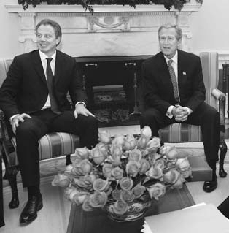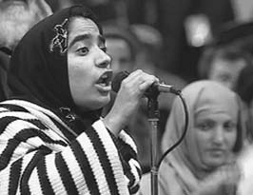Malalai Joya, one of about 100 women delegates to the constitutional council in Afghanistan, speaks to the council in Kabul, December 17, 2003.

Afghanistan has its first democratically elected government as a result of the U.S., allied, and Northern Alliance military action in 2001 that toppled the Taliban for sheltering Osama bin Laden, mastermind of the September 11, 2001, terrorist attacks against the United States.

294

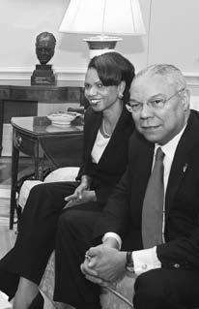President George W. Bush (center) meets with British Prime Minister Tony Blair (left), National Security Adviser Condoleezza Rice, and Secretary of State Colin Powell (right) at the White House during his first term. Great Britain has been a key

U.S. ally in the fight against terrorism.

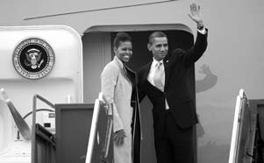

President Barack Obama and first lady Michelle Obama wave goodbye from Gardermoen Airport outside Oslo, Norway. President Obama was in Oslo to receive the Nobel Peace Prize on December 10, 2009.

295





Top, Microsoft chairman Bill Gates talks with Antwoinette Hayes, a participant in a Microsoft initiative to provide technology access to children and teens.

Above, Apple founder and chief executive officer Steve Jobs with his company’s iPod mini. Gates and Jobs are seen as the most powerful symbols of the creative and commercial talent that shaped the digital era.

296

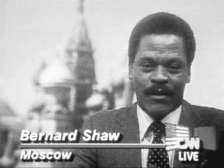

Cable News Network (CNN) report from Moscow: The combination of hundreds of cable television channels and 24-hour news services like CNN gives an unprecedented impact and immediacy to news developments around the world.

Combine youth, rock and hip hop music, and 24-hour television, and you get MTV, a television network whose influence extends beyond music videos to fashion, advertising, and sales.

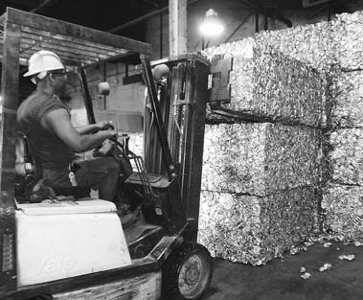Bales of sorted recyclables are stacked for processing at the Rumpke recycling center in Columbus, Ohio.

Growing environmental consciousness in the United States has led to huge recycling efforts for materials such as glass, paper, steel, and aluminum.

298

 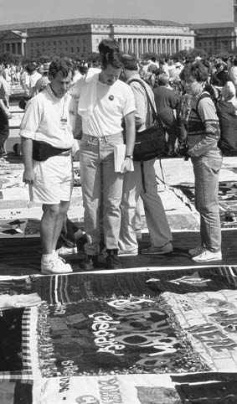

The massive AIDS quilt, with each square commemorating an individual who has died of the disease. The United States is a leading contributor to the fight against this global pandemic.

299

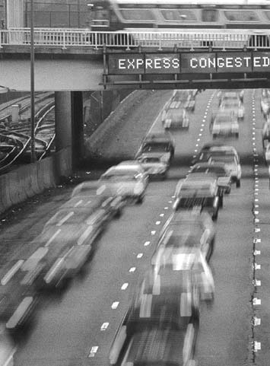

Americans’ love affair with the automobile continues, resulting in increased traffic congestion as well as considerable efforts by government and industry to reduce air pollution.

300

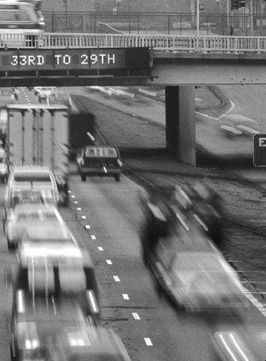

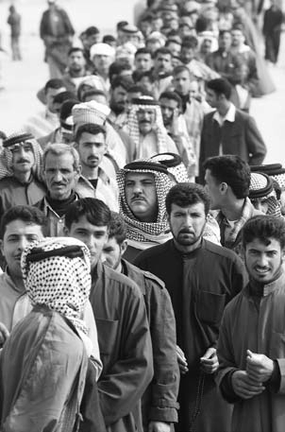

Iraqis queuing to vote for a Transitional National Assembly at a polling station in the center of Az Zubayr, Iraq, January 30, 2005. More than 8.5 million Iraqis braved threats of violence and terrorist attacks to participate in the elections. The vote followed the 2003 war, led by the United States and other coalition members, which rid Iraq of dictator Saddam Hussein.

302



With husbands and wives in the typical family both working outside the home, daycare centers for children are commonplace throughout the United States.



A new generation peers into its future.

303

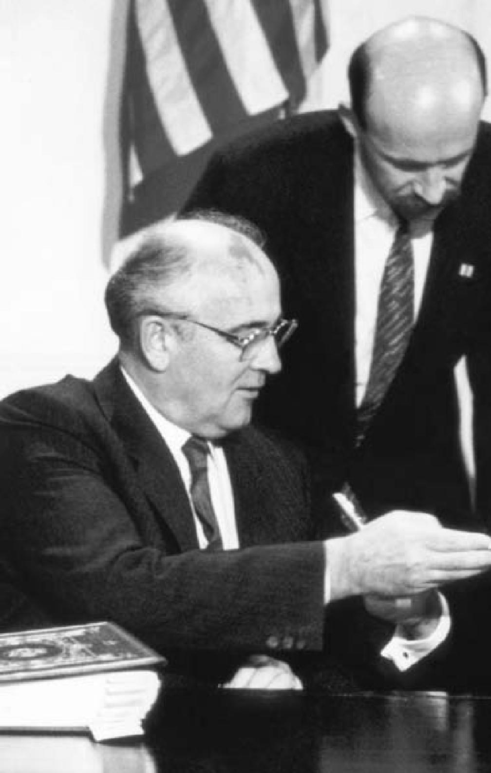

304

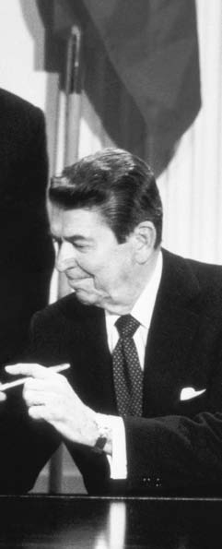

**C H A P T E R**

14

**THE NEW**

**CONSERVATISM AND**

## A NEW

**WORLD ORDER**

President Ronald Reagan and USSR President Mikhail Gorbachev after signing the Intermediate– Range Nuclear Forces (INF) Treaty, December 1987.

“I have always believed that there was some divine plan that placed this great continent

between two oceans to be sought out by those who were possessed of an abiding love of freedom and a special kind of courage.”

California Governor Ronald Reagan, 1974

#### A SOCIETY IN TRANSITION

**S**hifts in the structure of Ameri- can society, begun years or even de- cades earlier, had become apparent

by the time the 1980s arrived. The composition of the population and the most important jobs and skills in American society had undergone major changes.

The dominance of service jobs in the economy became undeniable. By the mid-1980s, nearly three-fourths of all employees worked in the ser- vice sector, for instance, as retail clerks, office workers, teachers, phy- sicians, and government employees. Service-sector activity benefited from the availability and increased use of the computer. The informa- tion age arrived, with hardware and

software that could aggregate previ- ously unimagined amounts of data about economic and social trends. The federal government had made significant investments in computer technology in the 1950s and 1960s for its military and space programs. In 1976, two young California en- trepreneurs, working out of a garage, assembled the first widely marketed computer for home use, named it the Apple, and ignited a revolution. By the early 1980s, millions of mi- crocomputers had found their way into U.S. businesses and homes, and in 1982, *Time* magazine dubbed the

computer its “Machine of the Year.” Meanwhile, America’s “smoke-

stack industries” were in decline. The U.S. automobile industry reeled under competition from highly ef-

ficient Japanese carmakers. By 1980 Japanese companies already manu- factured a fifth of the vehicles sold in the United States. American manufacturers struggled with some success to match the cost efficien- cies and engineering standards of their Japanese rivals, but their for- mer dominance of the domestic car market was gone forever. The gi- ant old-line steel companies shrank to relative insignificance as foreign steel makers adopted new technolo- gies more readily.

Consumers were the beneficiaries of this ferocious competition in the manufacturing industries, but the painful struggle to cut costs meant the permanent loss of hundreds of thousands of blue-collar jobs. Those who could made the switch to the service sector; others became unfor- tunate statistics.

Population patterns shifted as well. After the end of the postwar “baby boom” (1946 to 1964), the overall rate of population growth declined and the population grew older. Household composition also changed. In 1980 the percentage of family households dropped; a quar- ter of all groups were now classi- fied as “nonfamily households,” in which two or more unrelated per- sons lived together.

New immigrants changed the character of American society in other ways. The 1965 reform in im- migration policy shifted the focus away from Western Europe, facilitat- ing a dramatic increase in new arriv- als from Asia and Latin America. In

1980, 808,000 immigrants arrived, the highest number in 60 years, as the country once more became a haven for people from around the world.

Additional groups became active participants in the struggle for equal opportunity. Homosexuals, using the tactics and rhetoric of the civil rights movement, depicted them- selves as an oppressed group seeking recognition of basic rights. In 1975, the U.S. Civil Service Commission lifted its ban on employment of ho- mosexuals. Many states enacted an- ti-discrimination laws.

Then, in 1981, came the discov- ery of AIDS (Acquired Immune Deficiency Syndrome). Transmitted sexually or through blood transfu- sions, it struck homosexual men and intravenous drug users with par- ticular virulence, although the gen- eral population proved vulnerable as well. By 1992, over 220,000 Ameri- cans had died of AIDS. The AIDS ep- idemic has by no means been limited to the United States, and the effort to treat the disease now encompasses physicians and medical researchers throughout the world.

#### CONSERVATISM AND THE RISE OF RONALD REAGAN

**F**or many Americans, the eco- nomic, social, and political trends of the previous two decades — crime

and racial polarization in many ur- ban centers, challenges to traditional values, the economic downturn and inflation of the Carter years — en- gendered a mood of disillusionment.

It also strengthened a renewed sus- picion of government and its ability to deal effectively with the country’s social and political problems.

Conservatives, long out of power at the national level, were well po- sitioned politically in the context of this new mood. Many Americans were receptive to their message of limited government, strong national defense, and the protection of tradi- tional values.

This conservative upsurge had many sources. A large group of fun- damentalist Christians were partic- ularly concerned about crime and sexual immorality. They hoped to return religion or the moral precepts often associated with it to a central place in American life. One of the most politically effective groups in the early 1980s, the Moral Majority, was led by a Baptist minister, Jerry Falwell. Another, led by the Reverend Pat Robertson, built an organization, the Christian Coalition, that by the 1990s was a significant force in the Republican Party. Using television to spread their messages, Falwell, Rob- ertson, and others like them devel- oped substantial followings.

Another galvanizing issue for conservatives was divisive and emo- tional: abortion. Opposition to the 1973 Supreme Court decision, *Roe v. Wade*, which upheld a woman’s right to an abortion in the early months of pregnancy, brought together a wide array of organizations and individ- uals. They included, but were not limited to, Catholics, political con- servatives, and religious evan-

gelicals, most of whom regarded abortion under virtually any cir- cumstances as tantamount to mur- der. Pro-choice and pro-life (that is, pro- and anti-abortion rights) dem- onstrations became a fixture of the political landscape.

Within the Republican Party, the conservative wing grew dominant once again. They had briefly seized control of the Republican Party in 1964 with its presidential candidate, Barry Goldwater, then faded from the spotlight. By 1980, however, with the apparent failure of liberalism un- der Carter, a “New Right” was poised to return to dominance.

Using modern direct mail tech- niques as well as the power of mass communications to spread their message and raise funds, drawing on the ideas of conservatives like econ- omist Milton Friedman, journalists William F. Buckley and George Will, and research institutions like the Heritage Foundation, the New Right played a significant role in defining the issues of the 1980s.

The “Old” Goldwater Right had favored strict limits on government intervention in the economy. This tendency was reinforced by a signifi- cant group of “New Right” “liber- tarian conservatives” who distrusted government in general and opposed state interference in personal behav- ior. But the New Right also encom- passed a stronger, often evangelical faction determined to wield state power to encourage its views. The New Right favored tough measures against crime, a strong national de-

fense, a constitutional amendment to permit prayer in public schools, and opposition to abortion.

The figure that drew all these disparate strands together was Ron- ald Reagan. Reagan, born in Illi- nois, achieved stardom as an actor in Hollywood movies and television before turning to politics. He first achieved political prominence with a nationwide televised speech in 1964 in support of Barry Goldwater. In 1966 Reagan won the governorship of California and served until 1975. He narrowly missed winning the Re- publican nomination for president in 1976 before succeeding in 1980 and going on to win the presidency from the incumbent, Jimmy Carter.

President Reagan’s unflagging optimism and his ability to celebrate the achievements and aspirations of the American people persisted throughout his two terms in office. He was a figure of reassurance and stability for many Americans. Whol- ly at ease before the microphone and the television camera, Reagan was called the “Great Communicator.”

Taking a phrase from the 17th- century Puritan John Winthrop, he told the nation that the United States was a “shining city on a hill,” invest- ed with a God-given mission to de- fend the world against the spread of Communist totalitarianism.

Reagan believed that government intruded too deeply into American life. He wanted to cut programs he contended the country did not need, and to eliminate “waste, fraud, and abuse.” Reagan accelerated the

program of deregulation begun by Jimmy Carter. He sought to abol- ish many regulations affecting the consumer, the workplace, and the environment. These, he argued, were inefficient, expensive, and detrimen- tal to economic growth.

Reagan also reflected the belief held by many conservatives that the law should be strictly applied against violators. Shortly after becoming president, he faced a nationwide strike by U.S. air transportation controllers. Although the job action was forbidden by law, such strikes had been widely tolerated in the past. When the air controllers refused to return to work, he ordered them all fired. Over the next few years the system was rebuilt with new hires.

#### THE ECONOMY IN THE 1980s

**P**resident Reagan’s domestic pro- gram was rooted in his belief that the nation would prosper if the power of

the private economic sector was un- leashed. The guiding theory behind it, “supply side” economics, held that a greater supply of goods and services, made possible by measures to increase business investment, was the swiftest road to economic growth. Accordingly, the Reagan administration argued that a large tax cut would increase capital in- vestment and corporate earnings, so that even lower taxes on these larger earnings would increase gov- ernment revenues.

Despite only a slim Republican majority in the Senate and a House

of Representatives controlled by the Democrats, President Reagan suc- ceeded during his first year in office in enacting the major components of his economic program, including a 25-percent tax cut for individu- als to be phased in over three years. The administration also sought and won significant increases in defense spending to modernize the nation’s military and counter what it felt was a continual and growing threat from the Soviet Union.

Under Paul Volcker, the Federal Reserve’s draconian increases in in- terest rates squeezed the runaway inflation that had begun in the late 1970s. The recession hit bottom in 1982, with the prime interest rates approaching 20 percent and the economy falling sharply. That year, real gross domestic product (GDP) fell by 2 percent; the unemployment rate rose to nearly 10 percent, and almost one-third of America’s indus- trial plants lay idle. Throughout the Midwest, major firms like General Electric and International Harvester released workers. Stubbornly high petroleum prices contributed to the decline. Economic rivals like Ger- many and Japan won a greater share of world trade, and U.S. consump- tion of goods from other countries rose sharply.

Farmers also suffered hard times. During the 1970s, American farm- ers had helped India, China, the Soviet Union, and other countries suffering from crop shortages, and had borrowed heavily to buy land and increase production. But the

rise in oil prices pushed up costs, and a worldwide economic slump in 1980 reduced the demand for agri- cultural products. Their numbers declined, as production increasingly became concentrated in large opera- tions. Those small farmers who sur- vived had major difficulties making ends meet.

The increased military budget — combined with the tax cuts and the growth in government health spend- ing — resulted in the federal gov- ernment spending far more than it received in revenues each year. Some analysts charged that the deficits were part of a deliberate adminis- tration strategy to prevent further increases in domestic spending sought by the Democrats. However, both Democrats and Republicans in Congress refused to cut such spend- ing. From $74,000-million in 1980, the deficit soared to $221,000-mil- lion in 1986 before falling back to

$150,000-million in 1987.

The deep recession of the early 1980s successfully curbed the run- away inflation that had started dur- ing the Carter years. Fuel prices, moreover, fell sharply, with at least part of the drop attributable to Rea- gan’s decision to abolish controls on the pricing and allocation of gasoline. Conditions began to im- prove in late 1983. By early 1984, the economy had rebounded. By the fall of 1984, the recovery was well along, allowing Reagan to run for re-election on the slogan, “It’s morning again in America.” He de- feated his Democratic opponent,

former Senator and Vice President Walter Mondale, by an overwhelm- ing margin.

The United States entered one of the longest periods of sustained economic growth since World War

1. Consumer spending increased in response to the federal tax cut. The stock market climbed as it reflected the optimistic buying spree. Over a five-year period following the start of the recovery, gross national prod- uct grew at an annual rate of 4.2 percent. The annual inflation rate remained between 3 and 5 percent from 1983 to 1987, except in 1986 when it fell to just under 2 percent, the lowest level in decades. The na- tion’s GNP grew substantially dur- ing the 1980s; from 1982 to 1987, its economy created more than 13 mil- lion new jobs.

Steadfast in his commitment to lower taxes, Reagan signed the most sweeping federal tax-reform measure in 75 years during his sec- ond term. This measure, which had widespread Democratic as well as Republican support, lowered income tax rates, simplified tax brackets, and closed loopholes.

However, a significant percentage of this growth was based on defi- cit spending. Moreover, the national debt, far from being stabilized by strong economic growth, nearly tri- pled. Much of the growth occurred in skilled service and technical ar- eas. Many poor and middle-class families did less well. The adminis- tration, although an advocate of free trade, pressured Japan to agree to a

voluntary quota on its automobile exports to the United States.

The economy was jolted on Octo- ber 19, 1987, “Black Monday,” when the stock market suffered the great- est one-day crash in its history, 22.6 percent. The causes of the crash in- cluded the large U.S. international trade and federal-budget deficits, the high level of corporate and personal debt, and new computerized stock trading techniques that allowed in- stantaneous selling of stocks and fu- tures. Despite the memories of 1929 it evoked, however, the crash was a transitory event with little impact. In fact, economic growth continued, with the unemployment rate drop- ping to a 14-year low of 5.2 percent in June 1988.

#### FOREIGN AFFAIRS

**I**n foreign policy, Reagan sought a more assertive role for the nation, and Central America provided an

early test. The United States pro- vided El Salvador with a program of economic aid and military training when a guerrilla insurgency threat- ened to topple its government. It also actively encouraged the transition to an elected democratic government, but efforts to curb active right-wing death squads were only partly suc- cessful. U.S. support helped stabi- lize the government, but the level of violence there remained undimin- ished. A peace agreement was finally reached in early 1992.

U.S. policy toward Nicaragua was more controversial. In 1979

revolutionaries calling themselves Sandinistas overthrew the repres- sive right-wing Somoza regime and established a pro-Cuba, pro-Soviet dictatorship. Regional peace efforts ended in failure, and the focus of administration efforts shifted to support for the anti-Sandinista re- sistance, known as the contras.

Following intense political debate over this policy, Congress ended all military aid to the contras in Oc- tober 1984, then, under administra- tion pressure, reversed itself in the fall of 1986, and approved $100 mil- lion in military aid. However, a lack of success on the battlefield, charges of human rights abuses, and the rev- elation that funds from secret arms sales to Iran (see below) had been di- verted to the contras undercut con- gressional support to continue this aid.

Subsequently, the administration of President George H.W. Bush, who succeeded Reagan as president in 1989, abandoned any effort to secure military aid for the contras. The Bush administration also exerted pressure for free elections and supported an opposition political coalition, which won an astonishing upset election in February 1990, ousting the Sandini- stas from power.

The Reagan administration was more fortunate in witnessing a re- turn to democracy throughout the rest of Latin America, from Guate- mala to Argentina. The emergence of democratically elected governments was not limited to Latin America; in Asia, the “people power” campaign

of Corazon Aquino overthrew the dictatorship of Ferdinand Marcos, and elections in South Korea ended decades of military rule.

By contrast, South Africa re- mained intransigent in the face of

U.S. efforts to encourage an end to racial apartheid through the contro- versial policy of “constructive en- gagement,” quiet diplomacy coupled with public endorsement of reform. In 1986, frustrated at the lack of progress, the U.S. Congress overrode Reagan’s veto and imposed a set of economic sanctions on South Afri- ca. In February 1990, South African President F.W. de Klerk announced Nelson Mandela’s release and began the slow dismantling of apartheid.

Despite its outspoken anti-Com- munist rhetoric, the Reagan ad- ministration’s direct use of military force was restrained. On October 25, 1983, U.S. forces landed on the Ca- ribbean island of Grenada after an urgent appeal for help by neighbor- ing countries. The action followed the assassination of Grenada’s leftist prime minister by members of his own Marxist-oriented party. After a brief period of fighting, U.S. troops captured hundreds of Cuban mili- tary and construction personnel and seized caches of Soviet-supplied arms. In December 1983, the last American combat troops left Grena- da, which held democratic elections a year later.

The Middle East, however, presented a far more difficult situ- ation. A military presence in Leb- anon, where the United States was

attempting to bolster a weak, but moderate pro-Western government, ended tragically, when 241 U.S. Ma- rines were killed in a terrorist bomb- ing in October 1983. In April 1986,

U.S. Navy and Air Force planes struck targets in Tripoli and Beng- hazi, Libya, in retaliation for Libyan- instigated terrorist attacks on U.S. military personnel in Europe.

In the Persian Gulf, the earlier breakdown in U.S.-Iranian relations and the Iran-Iraq War set the stage for U.S. naval activities in the region. Initially, the United States responded to a request from Kuwait for pro- tection of its tanker fleet; but even- tually the United States, along with naval vessels from Western Europe, kept vital shipping lanes open by es- corting convoys of tankers and oth- er neutral vessels traveling up and down the Gulf.

In late 1986 Americans learned that the administration had secretly sold arms to Iran in an attempt to resume diplomatic relations with the hostile Islamic government and win freedom for American hostages held in Lebanon by radical organizations that Iran controlled. Investigation also revealed that funds from the arms sales had been diverted to the Nicaraguan contras during a period when Congress had prohibited such military aid.

The ensuing Iran-contra hearings before a joint House-Senate commit- tee examined issues of possible ille- gality as well as the broader question of defining American foreign poli- cy interests in the Middle East and

Central America. In a larger sense, the hearings were a constitutional debate about government secrecy and presidential versus congressio- nal authority in the conduct of for- eign relations. Unlike the celebrated Senate Watergate hearings 14 years earlier, they found no grounds for impeaching the president and could reach no definitive conclusion about these perennial issues.

#### U.S.-SOVIET RELATIONS

**I**n relations with the Soviet Union, President Reagan’s declared policy was one of peace through strength.

He was determined to stand firm against the country he would in 1983 call an “evil empire.” Two early events increased U.S.-Soviet tensions: the suppression of the Soli- darity labor movement in Poland in December 1981, and the destruction with 269 fatalities of an off-course civilian airliner, Korean Airlines Flight 007, by a Soviet jet fighter on September 1, 1983. The United States also condemned the continuing So- viet occupation of Afghanistan and continued aid begun by the Carter administration to the mujahedeen resistance there.

During Reagan’s first term, the United States spent unprecedented sums for a massive defense build- up, including the placement of in- termediate-range nuclear missiles in Europe to counter Soviet deploy- ments of similar missiles. And on March 23, 1983, in one of the most hotly debated policy decisions of his

presidency, Reagan announced the Strategic Defense Initiative (SDI) re- search program to explore advanced technologies, such as lasers and high-energy projectiles, to defend against intercontinental ballistic missiles. Although many scientists questioned the technological feasi- bility of SDI and economists pointed to the extraordinary sums of money involved, the administration pressed ahead with the project.

After re-election in 1984, Rea- gan softened his position on arms control. Moscow was amenable to agreement, in part because its econ- omy already expended a far greater proportion of national output on its military than did the United States. Further increases, Soviet leader Mikhail Gorbachev felt, would crip- ple his plans to liberalize the Soviet economy.

In November 1985, Reagan and Gorbachev agreed in principle to seek 50-percent reductions in stra- tegic offensive nuclear arms as well as an interim agreement on inter- mediate-range nuclear forces. In December 1987, they signed the Intermediate-Range Nuclear Forces (INF) Treaty providing for the de- struction of that entire category of nuclear weapons. By then, the So- viet Union seemed a less menac- ing adversary. Reagan could take much of the credit for a greatly di- minished Cold War, but as his ad- ministration ended, almost no one realized just how shaky the USSR had become.

#### THE PRESIDENCY OF GEORGE H. W. BUSH

**P**resident Reagan enjoyed unusu- ally high popularity at the end of his second term in office, but under

the terms of the U.S. Constitution he could not run again in 1988. The Republican nomination went to Vice President George Herbert Walker Bush, who was elected the 41st presi- dent of the United States.

Bush campaigned by promising voters a continuation of the pros- perity Reagan had brought. In ad- dition, he argued that he would support a strong defense for the United States more reliably than the Democratic candidate, Michael Dukakis. He also promised to work for “a kinder, gentler America.” Du- kakis, the governor of Massachu- setts, claimed that less fortunate Americans were hurting economi- cally and that the government had to help them while simultaneously bringing the federal debt and de- fense spending under control. The public was much more engaged, however, by Bush’s economic mes- sage: No new taxes. In the balloting, Bush finished with a 54-to-46-per- cent popular vote margin.

During his first year in office, Bush followed a conservative fiscal program, pursuing policies on taxes, spending, and debt that were faithful to the Reagan administration’s eco- nomic program. But the new presi- dent soon found himself squeezed between a large budget deficit and a deficit-reduction law. Spending cuts

seemed necessary, and Bush pos- sessed little leeway to introduce new budget items.

The Bush administration ad- vanced new policy initiatives in ar- eas not requiring major new federal expenditures. Thus, in November 1990, Bush signed sweeping legisla- tion imposing new federal standards on urban smog, automobile exhaust, toxic air pollution, and acid rain, but with industrial polluters bear- ing most of the costs. He accepted legislation requiring physical access for the disabled, but with no fed- eral assumption of the expense of modifying buildings to accommo- date wheelchairs and the like. The president also launched a campaign to encourage volunteerism, which he called, in a memorable phrase, “a thousand points of light.”

#### BUDGETS AND DEFICITS

**B**ush administration efforts to gain control over the federal budget deficit, however, were more problem-

atic. One source of the difficulty was the savings and loan crisis. Savings banks — formerly tightly regulated, low-interest safe havens for ordinary people — had been deregulated, al- lowing these institutions to com- pete more aggressively by paying higher interest rates and by making riskier loans. Increases in the gov- ernment’s deposit insurance guaran- teed reduced consumer incentive to shun less-sound institutions. Fraud, mismanagement, and the choppy economy produced widespread in-

solvencies among these thrifts (the umbrella term for consumer-orient- ed institutions like savings and loan associations and savings banks). By 1993, the total cost of selling and shuttering failed thrifts was stagger- ing, nearly $525,000-million.

In January 1990, President Bush presented his budget proposal to Congress. Democrats argued that administration budget projections were far too optimistic, and that meeting the deficit-reduction law would require tax increases and sharper cuts in defense spending. That June, after protracted negotia- tions, the president agreed to a tax increase. All the same, the combi- nation of economic recession, losses from the savings and loan indus- try rescue operation, and escalating health care costs for Medicare and Medicaid offset all the deficit-reduc- tion measures and produced a short- fall in 1991 at least as large as the previous year’s.

#### END TO THE COLD WAR

**W**hen Bush became president, the Soviet empire was on the verge of collapse. Gorbachev’s efforts to

open up the USSR’s economy ap- peared to be floundering. In 1989, the Communist governments in one Eastern European country af- ter another simply collapsed, after it became clear that Russian troops would not be sent to prop them up. In mid-1991, hard-liners attempted a coup d’etat, only to be foiled by Gorbachev rival Boris Yeltsin, presi-

dent of the Russian republic. At the end of that year, Yeltsin, now domi- nant, forced the dissolution of the Soviet Union.

The Bush administration adeptly brokered the end of the Cold War, working closely with Gorbachev and Yeltsin. It led the negotiations that brought the unification of East and West Germany (September 1990), agreement on large arms reductions in Europe (November 1990), and large cuts in nuclear arsenals (July 1991). After the liquidation of the Soviet Union, the United States and the new Russian Federation agreed to phase out all multiple-warhead missiles over a 10-year period.

The disposal of nuclear materi- als and the ever-present concerns of nuclear proliferation now super- seded the threat of nuclear conflict between Washington and Moscow.

#### THE GULF WAR

**T**he euphoria caused by the draw- ing down of the Cold War was dramatically overshadowed by the

August 2, 1990, invasion of the small nation of Kuwait by Iraq. Iraq, under Saddam Hussein, and Iran, under its Islamic fundamentalist regime, had emerged as the two major military powers in the oil-rich Persian Gulf area. The two countries had fought a long, inconclusive war in the 1980s. Less hostile to the United States than Iran, Iraq had won some support from the Reagan and Bush adminis- trations. The occupation of Kuwait, posing a threat to Saudi Arabia,

changed the diplomatic calculation overnight.

President Bush strongly con- demned the Iraqi action, called for Iraq’s unconditional withdrawal, and sent a major deployment of U.S. troops to the Middle East. He assem- bled one of the most extraordinary military and political coalitions of modern times, with military forces from Asia, Europe, and Africa, as well as the Middle East.

In the days and weeks follow- ing the invasion, the U.N. Security Council passed 12 resolutions con- demning the Iraqi invasion and imposing wide-ranging economic sanctions on Iraq. On November 29, it approved the use of force if Iraq did not withdraw from Kuwait by January 15, 1991. Gorbachev’s Soviet Union, once Iraq’s major arms sup- plier, made no effort to protect its former client.

Bush also confronted a major constitutional issue. The U.S. Con- stitution gives the legislative branch the power to declare war. Yet in the second half of the 20th century, the United States had become involved in Korea and Vietnam without an official declaration of war and with only murky legislative authoriza- tion. On January 12, 1991, three days before the U.N. deadline, Congress granted President Bush the author- ity he sought in the most explicit and sweeping war-making power given a president in nearly half a century.

The United States, in coalition with Great Britain, France, Italy, Saudi Arabia, Kuwait, and other

countries, succeeded in liberating Kuwait with a devastating, U.S.-led air campaign that lasted slightly more than a month. It was followed by a massive invasion of Kuwait and Iraq by armored and airborne in- fantry forces. With their superior speed, mobility, and firepower, the allied forces overwhelmed the Iraqi forces in a land campaign lasting only 100 hours.

The victory, however, was incom- plete and unsatisfying. The U.N. res- olution, which Bush enforced to the letter, called only for the expulsion of Iraq from Kuwait. Saddam Hussein remained in power, savagely repress- ing the Kurds in the north and the Shiites in the south, both of whom the United States had encouraged to rebel. Hundreds of oil-well fires, de- liberately set in Kuwait by the Iraqis, took until November 1991 to extin- guish. Saddam’s regime also appar- ently thwarted U.N. inspectors who, operating in accordance with Secu- rity Council resolutions, worked to locate and destroy Iraq’s weapons of mass destruction, including nuclear facilities more advanced than had previously been suspected and huge stocks of chemical weapons.

The Gulf War enabled the United States to persuade the Arab states, Israel, and a Palestinian delegation to begin direct negotiations aimed at resolving the complex and inter- locked issues that could eventually lead to a lasting peace in the region.

The talks began in Madrid, Spain, on October 30, 1991. In turn, they set the stage for the secret negotiations in Norway that led to what at the time seemed a historic agreement between Israel and the Palestine Lib- eration Organization, signed at the White House on September 13, 1993.

#### PANAMA AND NAFTA

**T**he president also received broad bipartisan congressional backing for the brief U.S. invasion of Panama

on December 20, 1989, that deposed dictator General Manuel Antonio Noriega. In the 1980s, addiction to crack cocaine reached epidemic pro- portions, and President Bush put the “War on Drugs” at the center of his domestic agenda. Moreover, Norie- ga, an especially brutal dictator, had attempted to maintain himself in power with rather crude displays of anti-Americanism. After seek- ing refuge in the Vatican embassy, Noriega turned himself over to U.S. authorities. He was later tried and convicted in U.S. federal court in Miami, Florida, of drug trafficking and racketeering.

On the economic front, the Bush administration negotiated the North America Free Trade Agreement (NAFTA) with Mexico and Canada. It would be ratified after an intense debate in the first year of the Clinton administration. 9

CHAPTER 14: THE NEW CONSERVATISM AND A NEW WORLD ORDER

**THIRD-PARTY AND INDEPENDENT CANDIDATES**

**T**he United States is often thought of as functioning under a two-party sys- tem. In practical effect this is true: Either a Democrat or a Republican has

occupied the White House every year since 1852. At the same time, however, the country has produced a plethora of third and minor parties over the years. For example, 58 parties were represented on at least one state ballot during the 1992 presidential elections. Among these were obscure parties such as the Apathy, the Looking Back, the New Mexico Prohibition, the Tish Independent Citizens, and the Vermont Taxpayers.

Third parties organize around a single issue or set of issues. They tend to fare best when they have a charismatic leader. With the presidency out of reach, most seek a platform to publicize their political and social concerns.

**Theodore Roosevelt.** The most successful third-party candidate of the 20th century was a Republican, Theodore Roosevelt, the former presi- dent. His Progressive or Bull Moose Party won 27.4 percent of the vote in the 1912 election. The progressive wing of the Republican Party, having grown disenchanted with President William Howard Taft, whom Roosevelt had

hand-picked as his successor, urged Roosevelt to seek the party nomination in 1912. This he did, defeating Taft in a number of primaries. Taft controlled the party machinery, however, and secured the nomination.

Roosevelt’s supporters then broke away and formed the Progressive Party.

Declaring himself as fit as a bull moose (hence the party’s popular name), Roosevelt campaigned on a platform of regulating “big business,” women’s suffrage, a graduated income tax, the Panama Canal, and conservation. His effort was sufficient to defeat Taft. By splitting the Republican vote, however, he helped ensure the election of the Democrat Woodrow Wilson.

**Socialists.** The Socialist Party also reached its high point in 1912, attaining 6 percent of the popular vote. Perennial candidate Eugene Debs won nearly 900,000 votes that year, advocating collective ownership of the trans- portation and communication industries, shorter working hours, and public works projects to spur employment. Convicted of sedition during World War I, Debs campaigned from his cell in 1920.

**Robert La Follette.** Another Progressive was Senator Robert La Fol- lette, who won more than 16 percent of the vote in the 1924 election. Long a champion of farmers and industrial workers, and an ardent foe of big business, La Follette was a prime mover in the recreation of the Progressive movement following World War I. Backed by the farm and labor vote, as well as by Socialists and remnants of Roosevelt’s Bull Moose Party, La Follette ran on

a platform of nationalizing railroads and the country’s natural resources. He

318

OUTLINE OF U.S. HISTORY

also strongly supported increased taxation on the wealthy and the right of col- lective bargaining. He carried only his home state of Wisconsin.

**Henry Wallace.** The Progressive Party reinvented itself in 1948 with the nomination of Henry Wallace, a former secretary of agriculture and vice president under Franklin Roosevelt. Wallace’s 1948 platform opposed the Cold War, the Marshall Plan, and big business. He also campaigned to end discrimination against African Americans and women, backed a minimum wage, and called for the elimination of the House Committee on Un-Ameri- can Activities. His failure to repudiate the U.S. Communist Party, which had endorsed him, undermined his popularity and he wound up with just over 2.4 percent of the popular vote.

**Dixiecrats.** Like the Progressives, the States Rights or Dixiecrat Party, led by South Carolina Governor Strom Thurmond, emerged in 1948 as a spin-off from the Democratic Party. Its opposition stemmed from Truman’s civil rights platform. Although defined in terms of “states’ rights,” the party’s goal was continuing racial segregation and the “Jim Crow” laws that sustained it.

**George Wallace.** The racial and social upheavals of the 1960s helped bring George Wallace, another segregationist Southern governor, to national attention. Wallace built a following through his colorful attacks against civil rights, liberals, and the federal government. Founding the American Indepen- dent Party in 1968, he ran his campaign from the statehouse in Montgomery, Alabama, winning 13.5 percent of the overall presidential vote.

**H. Ross Perot.** Every third party seeks to capitalize on popular dis- satisfaction with the major parties and the federal government. At few times in recent history, however, has this sentiment been as strong as it was during the 1992 election. A hugely wealthy Texas businessman, Perot possessed a knack for getting his message of economic common sense and fiscal responsibility across to a wide spectrum of the people. Lampooning the nation’s leaders and reducing his economic message to easily understood formulas, Perot found little difficulty gaining media attention. His campaign organization, United We Stand, was staffed primarily by volunteers and backed by his personal fortune. Far from resenting his wealth, many admired Perot’s business success and the freedom it brought him from soliciting campaign funds from special interests. Perot withdrew from the race in July. Re-entering it a month before the elec- tion, he won over 19 million votes as the Reform Party standard-bearer, nearly 19 percent of the total cast. This was by far the largest number ever tallied by a third-party candidate and second only to Theodore Roosevelt’s 1912 show- ing as a percentage of the total. ◆

319

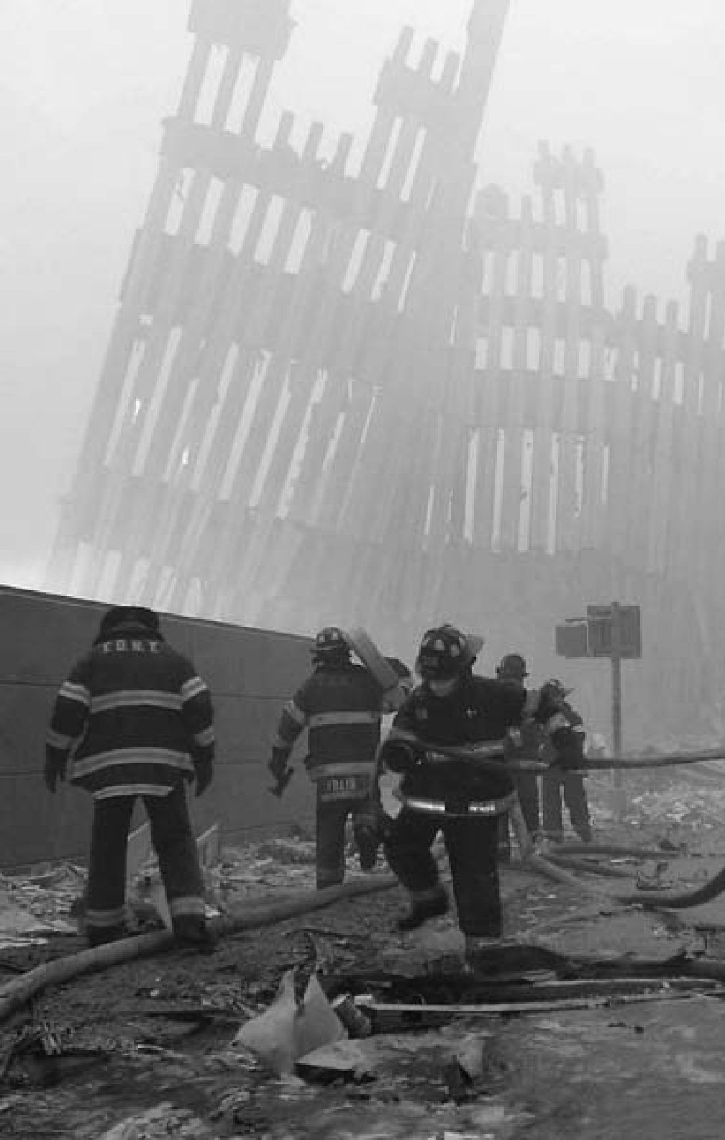

320



**C H A P T E R**

15

## BRIDGE TO THE

**21st CENTURY**

Firefighters beneath the destroyed vertical

struts of the World Trade Center’s twin towers after the September 11, 2001, terrorist attacks in New York and Washington, D.C.

“As we look ahead into the next century,

leaders will be those who empower others.”

Microsoft co-founder and chairman

Bill Gates, 2007

For most Americans the 1990s would be a time of peace, prosper- ity, and rapid technological change. Some attributed this to the “Rea- gan Revolution” and the end of the Cold War, others to the return of a Democrat to the presidency. During this period, the majority of Ameri- cans—political affiliation aside— asserted their support for tradi- tional family values, often ground- ed in their faiths. *New York Times* columnist David Brooks suggested that the country was experienc- ing “moral self-repair,” as “many of the indicators of social breakdown, which shot upward in the late 1960s and 1970s, and which plateaued at high levels in the 1980s,” were now in decline.

Improved crime and other social statistics aside, American politics re- mained ideological, emotional, and characterized by intense divisions. Shortly after the nation entered the new millennium, moreover, its post- Cold War sense of security was jolted by an unprecedented terrorist attack that launched it on a new and difficult international track.

#### THE 1992 PRESIDENTIAL ELECTION

**A**s the 1992 presidential elec- tion approached, Americans found themselves in a world transformed

in ways almost unimaginable four years earlier. The familiar land- marks of the Cold War—from the

Berlin Wall to intercontinental mis- siles and bombers on constant high alert—were gone. Eastern Europe was independent, the Soviet Union had dissolved, Germany was unit- ed, Arabs and Israelis were engaged in direct negotiations, and the threat of nuclear conflict was great- ly diminished. It was as though one great history volume had closed and another had opened.

Yet at home, Americans were less sanguine, and they faced some fa- miliar problems. The United States found itself in its deepest recession since the early 1980s. Many of the job losses were occurring among white-collar workers in middle management positions, not solely, as earlier, among blue-collar workers in the manufacturing sector. Even when the economy began recover- ing in 1992, its growth was virtu- ally imperceptible until late in the year. Moreover, the federal deficit continued to mount, propelled most strikingly by rising expenditures for health care.

President George Bush and Vice President Dan Quayle easily won re- nomination by the Republican Party. On the Democratic side, Bill Clin- ton, governor of Arkansas, defeated a crowded field of candidates to win his party’s nomination. As his vice presidential nominee, he selected Senator Al Gore of Tennessee, gen- erally acknowledged as one of the Congress’s strongest advocates of environmental protection.

The country’s deep unease over the direction of the economy also

sparked the emergence of a remark- able independent candidate, wealthy Texas entrepreneur H. Ross Perot. Perot tapped into a deep wellspring of frustration over the inability of Washington to deal effectively with economic issues, principally the fed- eral deficit. He possessed a colorful personality and a gift for the telling one-line political quip. He would be the most successful third-party can- didate since Theodore Roosevelt in 1912.

The Bush re-election effort was built around a set of ideas tradi- tionally used by incumbents: expe- rience and trust. George Bush, 68, the last of a line of presidents who had served in World War II, faced a young challenger in Bill Clinton who, at age 46, had never served in the military and had participated in protests against the Vietnam War. In emphasizing his experience as presi- dent and commander-in-chief, Bush drew attention to Clinton’s inexperi- ence at the national level.

Bill Clinton organized his cam- paign around another of the oldest and most powerful themes in elec- toral politics: youth and change. As a high school student, Clinton had once met President Kennedy; 30 years later, much of his rhetoric con- sciously echoed that of Kennedy in the 1960 presidential campaign.

As governor of Arkansas for 12 years, Clinton could point to his ex- perience in wrestling with the very issues of economic growth, educa- tion, and health care that were, ac- cording to public opinion polls,

among President Bush’s chief vul- nerabilities. Where Bush offered an economic program based on lower taxes and cuts in government spend- ing, Clinton proposed higher taxes on the wealthy and increased spend- ing on investments in education, transportation, and communica- tions that, he believed, would boost the nation’s productivity and growth and thereby lower the deficit. Simi- larly, Clinton’s health care proposals called for much heavier involvement by the federal government than Bush’s.

Clinton proved to be a highly effective communicator, not least on television, a medium that high- lighted his charm and intelligence. The incumbent’s very success in handling the end of the Cold War and reversing the Iraqi thrust into Kuwait lent strength to Clinton’s implicit argument that foreign af- fairs had become relatively less im- portant, given pressing social and economic needs at home.

On November 3, Clinton won election as the 42nd president of the United States, with 43 percent of the popular vote against 37 percent for Bush and 19 percent for Perot.

#### A NEW PRESIDENCY

**C**linton was in many respects the perfect leader for a party divided be- tween liberal and moderate wings.

He ran as a pragmatic centrist who could moderate the demands of various Democratic Party interest groups without alienating them.

Avoiding ideological rhetoric that declared big government to be a positive good, he proposed a num- ber of programs that earned him the label “New Democrat.” Control of the federal bureaucracy and ju- dicial appointments provided one means of satisfying political claims of organized labor and civil rights groups. On the ever-controversial abortion issue, Clinton supported the *Roe v. Wade* decision, but also declared that abortion should be “safe, legal, and rare.”

President Clinton’s closest col- laborator was his wife, Hillary Rod- ham Clinton. In the campaign, he had quipped that those who voted for him “got two for the price of one.” As energetic and as activist as her husband, Ms. Clinton assumed a more prominent role in the admin- istration than any first lady before her, even Eleanor Roosevelt. Her first important assignment would be to develop a national health program. In 2000, with her husband’s adminis- tration coming to a close, she would be elected a U.S. senator from New York.

#### LAUNCHING A NEW DOMESTIC POLICY

**I**n practice, Clinton’s centrism demanded choices that sometimes elicited vehement emotions. The

president’s first policy initiative was designed to meet the demands of gays, who, claiming a group status as victims of discrimination, had

become an important constituency for the Democratic Party.

Immediately after his inaugu- ration, President Clinton issued an executive order rescinding the long-established military policy of dismissing known gays from the service. The order quickly drew fu- rious criticism from the military, most Republicans, and large seg- ments of American society. Clinton quickly modified it with a “don’t ask, don’t tell” order that effectively restored the old policy but discour- aged active investigation of one’s sexual practices.

The effort to achieve a national health plan proved to be a far larg- er setback. The administration set up a large task force, chaired by Hillary Clinton. Composed of prominent policy intellectuals and political activists, it labored in se- crecy for months to develop a plan that would provide medical cover- age for every American citizen.

The working assumption be- hind the plan was that a govern- ment-managed “single-payer” plan could deliver health services to the entire nation more efficiently than the current decentralized system with its thousands of insurers and disconnected providers. As finally delivered to Congress in September 1993, however, the plan mirrored the complexity of its subject. Most Republicans and some Democrats criticized it as a hopelessly elaborate federal takeover of American medi- cine. After a year of discussion, it died without a vote in Congress.

President Clinton was more successful on another matter with great repercussions for the domes- tic economy. The previous presi- dent, George Bush, had negotiated the North American Free Trade Agreement (NAFTA) to establish fully open trade between Canada, the United States, and Mexico. Key Democratic constituencies opposed the agreement. Labor unions be- lieved it would encourage the export of jobs and undermine American labor standards. Environmentalists asserted that it would lead Ameri- can industries to relocate to coun- tries with weak pollution controls. These were the first indications of a growing movement on the left wing of American politics against the vision of an integrated world eco- nomic system.

Clinton nonetheless accepted the argument that open trade was ultimately beneficial to all parties because it would lead to a greater flow of more efficiently produced goods and services. His adminis- tration not only submitted NAFTA to the Senate, it also backed the es- tablishment of a greatly liberalized international trading system to be administered by the World Trade Organization (WTO). After a vig- orous debate, Congress approved NAFTA in 1993. It would approve membership in the WTO a year later.

Although Clinton had talked about a “middle-class tax cut” dur- ing the presidential campaign, he submitted to Congress a budget

calling for a general tax increase. It originally included a wide tax on energy consumption designed to promote conservation, but that was quickly replaced by a nomi- nal increase in the federal gasoline tax. It also taxed social security benefits for recipients of moderate income and above. The big empha- sis, however, was on increasing the income tax for high earners. The subsequent debate amounted to a rerun of the arguments between tax cutters and advocates of “fiscal re- sponsibility” that had marked the Reagan years. In the end, Clinton got his way, but very narrowly. The tax bill passed the House of Repre- sentatives by only one vote.

By then, the congressional elec- tion campaigns of 1994 were under way. Although the administration already had made numerous foreign policy decisions, issues at home were clearly most important to the voters. The Republicans depicted Clinton and the Democrats as un- reformed tax and spenders. Clinton himself was already beleaguered with charges of past financial im- propriety in an Arkansas real estate project and new claims of sexual impropriety.

In November, the voters gave the Republicans control of both houses of Congress for the first time since the election of 1952. Many observers believed that Bill Clinton would like- ly be a one-term president. Appar- ently making a decision to conform to new political realities, Clinton in-

stead moderated his political course. Policy initiatives for the remainder of his presidency were few. Contrary to Republican predictions of doom, the tax increases of 1993 did not get in the way of a steadily improving economy.

The new Republican leadership in the House of Representatives, by contrast, pressed hard to achieve its policy objectives, a sharp con- trast with the administration’s new moderate tone. When right-wing extremists bombed an Oklahoma City federal building in April 1995, Clinton responded with a tone of moderation and healing that height- ened his stature and implicitly raised some doubts about his conservative opponents. At the end of the year, he vetoed a Republican budget bill, shutting down the government for weeks. Most of the public seemed to blame the Republicans.

The president also co-opted part of the Republican program. In his State of the Union address of January 1996, he ostentatiously declared, “The era of big govern- ment is over.” That summer, on the eve of the presidential campaign, he signed a major welfare reform bill that was essentially a Republican product. Designed to end perma- nent support for most welfare re- cipients and move them to work, it was opposed by many in his own party. By and large, it would prove successful in operation over the next decade.

#### THE AMERICAN ECONOMY IN THE 1990s

**B**y the mid-1990s, the country had not simply recovered from the brief, but sharp, recession of the

Bush presidency. It was entering an era of booming prosperity, and do- ing so despite the decline of its tradi- tional industrial base. Probably the major force behind this new growth was the blossoming of the personal computer (PC).

Less than 20 years after its intro- duction, the PC had become a fa- miliar item, not simply in business offices of all types, but in homes throughout America. Vastly more powerful than anyone could have imagined two decades earlier, able to store enormous amounts of data, available at the cost of a good refrig- erator, it became a common appli- ance in American homes.

Employing prepackaged software, people used it for bookkeeping, word processing, or as a depository for music, photos, and video. The rise of the Internet, which grew out of a previously closed defense data network, provided access to in- formation of all sorts, created new shopping opportunities, and estab- lished e-mail as a common mode of communication. The popularity of the mobile phone created a huge new industry that cross-fertilized with the PC.

Instant communication and lightning-fast data manipulation speeded up the tempo of many busi-

nesses, greatly enhancing productiv- ity and creating new opportunities for profit. Fledgling industries that fed demand for the new equipment became multi-billion-dollar compa- nies almost overnight, creating an enormous new middle class of soft- ware technicians, managers, market- ers, and publicists.

A final impetus was the turn of the millennium. A huge push to up- grade outdated computing equip- ment that might not recognize the year 2000 brought data technology spending to a peak.

These developments began to take shape during Clinton’s first term. By the end of his second one they were fueling a surging economy. When he had been elected presi- dent, unemployment was at 7.4 per- cent. When he stood for re-election in 1996, it was at 5.4 percent. When voters went to the polls to choose his successor in November 2000, it was 3.9 percent. In many places, the issue was less one of taking care of the jobless than of finding employ- able workers.

No less a figure than Federal Re- serve Chairman Alan Greenspan viewed a rapidly escalating stock market with concern and warned of “irrational exuberance.” Investor exuberance, at its greatest since the 1920s, continued in the conviction that ordinary standards of valu- ation had been rendered obsolete by a “new economy” with unlim- ited potential. The good times were rolling dangerously fast, but most

Americans were more inclined to enjoy the ride while it lasted than to plan for a coming bust.

#### THE ELECTION OF 1996 AND THE POLITICAL AFTERMATH

**P**resident Clinton undertook his campaign for re-election in 1996 under the most favorable of circum-

stances. If not an imposing person- ality in the manner of a Roosevelt, he was a natural campaigner, whom many felt had an infectious charm. He presided over a growing econom- ic recovery. He had positioned him- self on the political spectrum in a way that made him appear a man of the center leaning left. His Republi- can opponent, Senator Robert Dole of Kansas, Republican leader in the upper house, was a formidable leg- islator but less successful as a presi- dential candidate.

Clinton, promising to “build a bridge to the 21st century,” easily defeated Dole in a three-party race,

49.2 percent to 40.7 percent, with

8.4 percent to Ross Perot. He thus became the second American pres- ident to win two consecutive elec- tions with less than a majority of the total vote. (The other was Woodrow Wilson in 1912 and 1916.) The Re- publicans, however, retained control of both the House of Representatives and the Senate.

Clinton never stated much of a domestic program for his second term. The highlight of its first year was an accord with Congress de-

signed to balance the budget, fur- ther reinforcing the president’s standing as a fiscally responsible moderate liberal.

In 1998, American politics en- tered a period of turmoil with the revelation that Clinton had car- ried on an affair inside the White House with a young intern. At first the president denied this, telling the American people: “I did not have sexual relations with that woman.” The president had faced similar charges in the past. In a sexual ha- rassment lawsuit filed by a woman he had known in Arkansas, Clinton denied under oath the White House affair. This fit most Americans’ defi- nition of perjury. In October 1998, the House of Representatives began impeachment hearings, focusing on charges of perjury and obstruction of justice.

Whatever the merits of that ap- proach, a majority of Americans seemed to view the matter as a pri- vate one to be sorted out with one’s family, a significant shift in public attitude. Also significantly, Hillary Clinton continued to support her husband. It surely helped also that the times were good. In the midst of the House impeachment debate, the president announced the largest budget surplus in 30 years. Public opinion polls showed Clinton’s ap- proval rating to be the highest of his six years in office.

That November, the Republicans took further losses in the midterm congressional elections, cutting their majorities to razor-thin mar-

gins. House Speaker Newt Gingrich resigned, and the party attempted to develop a less strident image. Nev- ertheless, in December the House voted the first impeachment resolu- tion against a sitting president since Andrew Johnson (1868), thereby handing the case to the Senate for a trial.

Clinton’s impeachment trial, presided over by the Chief Justice of the United States, held little sus- pense. In the midst of it, the presi- dent delivered his annual State of the Union address to Congress. He never testified, and no serious ob- server expected that any of the sev- eral charges against him would win the two-thirds vote required for re- moval from office. In the end, none got even a simple majority. On Feb- ruary 12, 1999, Clinton was acquit- ted of all charges.

#### AMERICAN FOREIGN RELATIONS IN THE CLINTON YEARS

**B**ill Clinton did not expect to be a president who emphasized foreign policy. However, like his immediate

predecessors, he quickly discovered that all international crises seemed to take a road that led through Washington.

He had to deal with the messy af- termath of the 1991 Gulf War. Hav- ing failed to depose Saddam Hussein, the United States, backed by Britain, attempted to contain him. A Unit- ed Nations-administered economic sanctions regime, designed to allow

Iraq to sell enough oil to meet hu- manitarian needs, proved relatively ineffective. Saddam funneled much of the proceeds to himself, leaving large masses of his people in misery. Military “no-fly zones,” imposed to prevent the Iraqi government from deploying its air power against rebel- lious Kurds in the north and Shiites in the south, required constant U.S. and British air patrols, which regu- larly fended off anti-aircraft missiles. The United States also provided the main backing for U.N. weapons inspection teams, whose mission was to ferret out Iraq’s chemical, biological, and nuclear programs, verify the destruction of existing weapons of mass destruction, and suppress ongoing programs to man- ufacture them. Increasingly ob- structed, the U.N. inspectors were finally expelled in 1998. On this, as well as earlier occasions of provo- cation, the United States responded with limited missile strikes. Sad- dam, Secretary of State Madeline Albright declared, was still “in his

box.”

The seemingly endless Israeli- Palestinian dispute inevitably en- gaged the administration, although neither President Clinton nor former President Bush had much to do with the Oslo agreement of 1993, which established a Palestinian “authority” to govern the Palestinian population within the West Bank and the Gaza Strip and obtained Palestinian rec- ognition of Israel’s right to exist.

As with so many past Middle Eastern agreements in principle,

however, Oslo eventually fell apart when details were discussed. Pales- tinian leader Yasser Arafat rejected final offers from peace-minded Is- raeli leader Ehud Barak in 2000 and January 2001. A full-scale Palestin- ian insurgency, marked by the use of suicide bombers, erupted. Barak fell from power, to be replaced by the far tougher Ariel Sharon. U.S. identification with Israel was con- sidered by some a major problem in dealing with other issues in the region, but American diplomats could do little more than hope to contain the violence. After Arafat’s death in late 2004, new Palestinian leadership appeared more receptive to a peace agreement, and Ameri- can policy makers resumed efforts to promote a settlement.

President Clinton also became closely engaged with “the troubles” in Northern Ireland. On one side was the violent Irish Republican Army, supported primarily by those Catholic Irish who wanted to incor- porate these British counties into the Republic of Ireland. On the other side were Unionists, with equally vi- olent paramilitary forces, supported by most of the Protestant Scots-Irish population, who wanted to remain in the United Kingdom.

Clinton gave the separatists greater recognition than they ever had obtained in the United States, but also worked closely with the British governments of John Major and Tony Blair. The ultimate result, the Good Friday peace accords of 1998, established a political pro-

cess but left many details to be worked out. Over the next several years, peace and order held better in Northern Ireland than in the Mid- dle East, but remained precarious. The final accord continued to elude negotiators.

The post-Cold War disintegra- tion of Yugoslavia—a state ethni- cally and religiously divided among Serbs, Croats, Slovenes, Bosnian Muslims, and Albanian Kosovars

—also made its way to Washing- ton after European governments failed to impose order. The Bush administration had refused to get involved in the initial violence; the Clinton administration finally did so with great reluctance after being urged to do so by the Euro- pean allies. In 1995, it negotiated an accord in Dayton, Ohio, to estab- lish a semblance of peace in Bosnia. In 1999, faced with Serbian mas- sacres of Kosovars, it led a three- month NATO bombing campaign against Serbia, which finally forced a settlement.

In 1994, the administration re- stored ousted President Jean-Ber- trand Aristide to power in Haiti, where he would rule for nine years before being ousted again. The inter- vention was largely a result of Aris- tide’s carefully cultivated support in the United States and American fears of waves of Haitian illegal im- migrants.

In sum, the Clinton adminis- tration remained primarily inward looking, willing to tackle interna- tional problems that could not be

avoided, and, in other instances, forced by the rest of the world to do so.

#### INTIMATIONS OF TERRORISM

**N**ear the close of his administra- tion, George H.W. Bush sent Ameri- can troops to the chaotic East African

nation of Somalia. Their mission was to spearhead a U.N. force that would allow the regular movement of food to a starving population.

Somalia became yet another leg- acy for the Clinton administration. Efforts to establish a representative government there became a “na- tion-building” enterprise. In Oc- tober 1993, American troops sent to arrest a recalcitrant warlord ran into unexpectedly strong resistance, losing an attack helicopter and suf- fering 18 deaths. The warlord was never arrested. Over the next sev- eral months, all American combat units were withdrawn.

From the standpoint of the ad- ministration, it seemed prudent enough simply to end a marginal, ill-advised commitment and con- centrate on other priorities. It only became clear later that the Somalian warlord had been aided by a shad- owy and emerging organization that would become known as al-Qaida, headed by a fundamentalist Muslim named Osama bin Laden. A fanati- cal enemy of Western civilization, bin Laden reportedly felt confirmed in his belief that Americans would not fight when attacked.

By then the United States had already experienced an attack by Muslim extremists. In February 1993, a huge car bomb was explod- ed in an underground parking ga- rage beneath one of the twin towers of the World Trade Center in lower Manhattan. The blast killed seven people and injured nearly a thou- sand, but it failed to bring down the huge building with its thousands of workers. New York and federal au- thorities treated it as a criminal act, apprehended four of the plotters, and obtained life prison sentences for them. Subsequent plots to blow up traffic tunnels, public buildings, and even the United Nations were all discovered and dealt with in a similar fashion.

Possible foreign terrorism was nonetheless overshadowed by do- mestic terrorism, primarily the Oklahoma City bombing. The work of right-wing extremists Timo- thy McVeigh and Terry Nichols, it killed 166 and injured hundreds, a far greater toll than the 1993 Trade Center attack. But on June 25, 1996, another huge bomb exploded at the Khobar Towers U.S. military hous- ing complex in Saudi Arabia, kill- ing 19 and wounding 515. A federal grand jury indicted 13 Saudis and one Lebanese man for the attack, but Saudi Arabia ruled out any ex- traditions.

Two years later, on August 7, 1998, powerful bombs exploding simultaneously destroyed U.S. em- bassies in Kenya and Tanzania, kill- ing 301 people and injuring more

than 5,000. In retaliation Clinton ordered missile attacks on terrorist training camps run by bin Laden in Afghanistan, but they appear to have been deserted. He also ordered a missile strike to destroy a suspect chemical factory in Sudan, a coun- try which earlier had given sanctu- ary to bin Laden.

On October 12, 2000, suicide bombers rammed a speedboat into the U.S. Navy destroyer *Cole*, on a courtesy visit to Yemen. Heroic ac- tion by the crew kept the ship afloat, but 17 sailors were killed. Bin Lad- en had pretty clearly been behind the attacks in Saudi Arabia, Afri- ca, and Yemen, but he was beyond reach unless the administration was prepared to invade Afghanistan to search for him.

The Clinton administration was never willing to take such a step. It even shrank from the possibility of assassinating him if others might be killed in the process. The attacks had been remote and widely separated. It was easy to accept them as unwel- come but inevitable costs associated with superpower status. Bin Laden remained a serious nuisance, but not a top priority for an administration that was nearing its end.

#### THE PRESIDENTIAL ELECTION OF 2000 AND THE WAR ON TERROR

**T**he Democratic Party nominated Vice President Al Gore to head its ticket in 2000. To oppose him, the

Republicans chose George W. Bush,

the governor of Texas and son of for- mer president George H.W. Bush.

Gore ran as a dedicated liberal, intensely concerned with damage to the environment and determined to seek more assistance for the less privileged sectors of American soci- ety. He seemed to position himself to the left of President Clinton.

Bush established a position on the right wing of the Republican Party, closer to the heritage of Ron- ald Reagan than to that of his father. He softened this image by display- ing a special interest in education and calling himself a “compassion- ate conservative.” His embrace of evangelical Christianity, which he declared had changed his life after a misspent youth, was of particular note. It underscored an attachment to traditional cultural values that contrasted sharply to Gore’s techno- cratic modernism. Corporate critic Ralph Nader ran well to Gore’s left as the candidate of the Green Par- ty. Conservative Republican Patrick Buchanan mounted an independent candidacy.

The final vote was nearly evenly divided nationally; so were the elec- toral votes. The pivotal state was Florida, where a razor-thin margin separated Bush and Gore and thou- sands of ballots were disputed. Af- ter a series of court challenges at the state and federal levels, the U.S. Su- preme Court handed down a nar- row decision that effectively gave the election to Bush. The Republicans maintained control of both houses of Congress by a small margin.

The final totals underscored the tightness of the election: Bush won 271 electoral votes to Gore’s 266, but Gore led him in the national popu- lar vote 48.4 percent to 47.9 percent. Nader polled 2.1 percent and Bu- chanan .4 percent. Gore, his states colored blue in media graphics, swept the Northeast and the West Coast; he also ran well in the Mid- western industrial heartland. Bush, whose states were colored red, beat his opponent in the South, the rest of the Midwest, and the mountain states. Commentators everywhere commented on the vast gap between “red” and “blue” America, a divide characterized by cultural and social, rather than economic, differences, and all the more deep-seated and emotional for that reason. George W. Bush took office in a climate of ex- treme partisan bitterness.

Bush expected to be a president primarily concerned with domestic policy. He wanted to meld tradition- al Republican Party belief in private enterprise, low taxation, and small government with a sense of social responsibility for the less fortunate groups in American society. He had talked during his campaign about reforming the Social Security sys- tem. Impressed by Reagan’s supply- side economics, he advocated lower taxes to stimulate economic growth. The economy was beginning to slip back from its lofty peak of the late 1990s. This helped Bush secure passage of a tax cut in May 2001. Lower taxes would indeed buoy the economy, but at the cost of an omi-

nously growing federal budget defi- cit. At the end of the year, Bush also obtained the “No Child Left Behind” Act, which required public schools to test reading and mathematical proficiency on an annual basis; it prescribed penalties for schools unable to achieve a specified stan- dard. Social Security remained un- addressed despite Bush’s efforts to make it a priority in his second term. The Bush presidency changed irrevocably on September 11, 2001, as the United States suffered the most devastating foreign attack ever against its mainland. That morn- ing, Middle Eastern terrorists simul- taneously hijacked four passenger airplanes and used two of them as suicide vehicles to destroy the twin towers of the World Trade Center in New York City. A third crashed into the Pentagon building, the Defense Department headquarters just out- side of Washington, D.C. The fourth, probably aimed at the U.S. Capitol, dived into the Pennsylvania coun- tryside as passengers fought the hi-

jackers.

The death toll, most of it consist- ing of civilians at the Trade Center, was approximately 3,000, exceeding that of the Japanese attack on Pearl Harbor. The economic costs were also heavy. Several other buildings near the Trade Center also were de- stroyed, shutting down the financial markets for several days. The effect was to prolong the already develop- ing recession.

As the nation began to recover from the attack, an unknown person

or group sent out letters containing small amounts of anthrax bacteria. Some went to members of Congress and administration officials, others to obscure individuals. No notable person was infected. But five victims died, and several others suffered se- rious illness. The mailings touched off a wave of national hysteria, then stopped as suddenly as they had be- gun, and remained a mystery. In 2008, the Federal Bureau of Inves- tigation announced that the likely culprit was a troubled government scientist who had committed suicide. The administration obtained pas- sage of the USA Patriot Act in Octo- ber 2001. Designed to fight domestic terrorism, the new law considerably broadened the search, seizure, and detention powers of the federal gov- ernment. Its opponents argued that it violated constitutionally protected individual rights. Its backers re- sponded that a country at war need-

ed to protect itself.

After initial hesitation, the Bush administration also decided to sup- port the establishment of the De- partment of Homeland Security. Authorized in November 2002 and designed to coordinate the fight against domestic terrorist attack, the new department consolidated 22 federal agencies.

The administration, like its pre- decessor, had been unprepared for the unimaginable. However, it re- taliated quickly. Determining that the attack had been an al-Qaida operation, it launched a military of- fensive against Osama bin Laden

and the fundamentalist Muslim Taliban government of Afghanistan that had provided him refuge. The United States secured the passive cooperation of the Russian Federa- tion, established relationships with the former Soviet republics that bor- dered Afghanistan, and, above all, resumed a long-neglected alliance with Pakistan, which provided polit- ical support and access to air bases.

Utilizing U.S. Army Special Forces and Central Intelligence Agency paramilitary operatives, the ad- ministration allied with long-mar- ginalized Afghan rebels. Given effective air support the coalition ousted the Taliban government in two months. Bin Laden, Taliban leaders, and many of their fighters, however, escaped into remote, semi- autonomous areas of Northeastern Pakistan. From there they would try to regroup and attack the new Af- ghan government.

In the meantime, the Bush admin- istration was looking elsewhere for sources of enemy terrorism. In his 2002 State of the Union address, the president identified an “axis of evil” that he thought threatened the na- tion: Iraq, Iran, and North Korea. Of these three, Iraq seemed to him and his advisers the most troublesome and probably easiest to bring down.

Saddam Hussein had ejected United Nations weapons inspectors. The economic sanctions against Iraq were breaking down, and, although the regime was not believed to be involved in the 9/11 attacks, it had engaged in some contacts with al-

Qaida. It was widely believed, not just in the United States but through- out the world, that Iraq had large stockpiles of chemical and biologi- cal weapons and might be working to acquire a nuclear capability. Why else throw out the inspection teams and endure continuing sanctions?

Throughout the year, the admin- istration pressed for a United Nations resolution demanding resumption of weapons inspection with full and free access. In October 2002, Iraq declared it would comply. Nonethe- less, the new inspectors complained of bad faith. In January, their chief, Hans Blix, presented a report to the UN declaring that Iraq had failed to account for its weapons of mass destruction, although he recom- mended a resumption of weapons inspections before withdrawing.

Bush in the meantime had re- ceived a Senate authorization by a vote of 77–23 for the use of mili- tary force. The U.S. military began a buildup of personnel and materiel in Kuwait.

The American plans for war with Iraq encountered unusually strong opposition in much of Eu- rope. France, Russia, and Germany all were against the use of force. Even in those nations whose governments supported the United States, there was strong popular hostility to co- operation. Britain became the major

U.S. ally in the war that followed; most of the newly independent East- ern European nations contributed assistance. The governments of Ita- ly and (for a time) Spain also lent

their backing. Turkey, long a reliable American ally, declined to do so.

Nevertheless, on March 19, 2003, American and British troops, sup- ported by small contingents from several other countries, began an in- vasion of Iraq from the South. Groups airlifted into the North coor- dinated with Kurdish militia. On both fronts, resistance was occasion- ally fierce, but usually melted away. Baghdad fell on April 8. On April 14, the military campaign in Iraq was declared over.

Taking Iraq turned out to be far easier than administering it. In the first days after the end of major com- bat, the country experienced perva- sive looting. Hit-and-run attacks on allied troops followed and became increasingly organized, despite the capture of Saddam Hussein and the deaths of his two sons and heirs. Dif- ferent Iraqi factions seemed on the verge of war with each other.

New weapons inspection teams were unable to find the expected stockpiles of chemical and biological weaponry. It became clear that Iraq had never restarted the nuclear pro- gram it had been pursuing before the first Gulf War. After his apprehen- sion, Saddam Hussein admitted that he had engaged in a gigantic bluff to forestall attack from abroad or in- surrection at home.

In the year and a quarter after the fall of Baghdad, the United States and the United Kingdom, with increas- ing cooperation from the United Nations, moved ahead with estab- lishment of a provisional govern-

ment that would assume sovereignty over Iraq. The effort occurred amidst increasing violence that included at- tacks not only on allied troops, but also on Iraqis connected in any way with the new government. Most of the insurgents appeared to be Sad- dam loyalists; some were indigenous Muslim sectarians; others likely were foreign fighters.

#### THE 2004 PRESIDENTIAL ELECTION AND GEORGE W. BUSH’S SECOND TERM

**B**y mid-2004, with the United States facing a violent insurgency in Iraq, considerable foreign oppo-

sition to the war there, and increas- ingly sharp divisions about the conflict at home, the country faced another presidential election. The Democrats nominated Senator John Kerry of Massachusetts, a decorated Vietnam veteran in his fourth Senate term. Kerry’s dignified demeanor and speaking skills made him a for- midable candidate. A reliable liberal on domestic issues, he was a critic of the Iraq war. Bush, renominated without opposition by the Republi- cans, portrayed himself as frank and consistent in speech and deed, a man of action willing to take all necessary steps to protect the United States.

Marked by intense feelings on both sides about the war and the cultural conflicts that increasingly defined the differences between the two major parties, the campaign re- vealed a nation nearly as divided as in 2000. The strong emotions of the

race fueled a voter turnout 20 per- cent higher than four years earlier. Bush won a narrow victory, 51 per- cent to 48 percent with the remain- der of the vote going to Ralph Nader and other independents. The Repub- licans scored small but important gains in Congress.

George W. Bush began his sec- ond term in January 2005, facing challenges aplenty: Iraq, increasing federal budget deficits, a chronic international balance-of-payments shortfall, the escalating cost of social entitlements, and a shaky currency. None were susceptible to quick or easy solutions.

Iraq was the largest and most vis- ible problem. The country had ad- opted a new constitution and held parliamentary elections in 2005. Saddam Hussein, tried by an Iraqi tribunal, was executed in December 2006. All the same, American forces and the new government faced a mounting insurgency. Composed of antagonistic factions—among them Sunni supporters of Saddam and dissident Shiites aided by Iran—the insurgency could be contained, but not quelled without using harsh tac- tics that would be unacceptable at home and would alienate the Iraqi population. The constitutional Iraqi government lacked the power and stability needed to impose order, yet the costs—human and financial—of the American occupation eroded support at home.

In January 2007, the president adopted an anti-insurgency strat- egy advocated by General David Pe-

traeus—one of outreach and support for Sunni leaders willing to accept a new democratic order in Iraq, along with continued backing of the pre- dominantly Shiite government in Baghdad. He accompanied this with a “surge” of additional troops. Over the next year, the strategy appeared to calm the country. The United States began to turn over increased security responsibilities to the Iraq- is and negotiated an agreement for complete withdrawal by 2011. None- theless, Iraq remained very unstable, its fragile peace regularly disrupted by bombings and assassinations, its Sunni-Shiite conflict complicated by Kurdish separatists. It was not clear whether a liberal-democratic nation could be created out of such chaos, but certain that the United States could not impose one if the Iraqis did not want it.

As Iraq progressed uncertainly toward stability, Afghanistan moved in the other direction. The post-Tal- iban government of Hamid Karzai proved unable to establish effective control over the historically decen- tralized country. Operating from the Pakistani tribal areas to which they had escaped in 2001, the Taliban and al-Qaida began to filter back into Afghanistan and establish signifi- cant areas of control in the southern provinces. Using remote-controlled drone aircraft equipped with guided missiles, U.S. forces staged attacks against enemy encampments and leaders within Pakistan. In 2009, the new American president, Barack Obama, approved a U.S. military

buildup and anti-insurgency effort similar to the Iraq surge. As with Iraq, the outcome remained in doubt.

As the first decade of the 21st cen- tury drew to a close, the United States found itself adjusting to a world considerably more complex than that of the Cold War. The bi- polar rivalry of that era, for all its dangers and challenges, had im- posed an unprecedented simplicity on international affairs. The newer, messier world order (or disorder) featured the rapid rise of China as a major economic force. India and Brazil were not far behind. Post-So- viet Russia re-emerged as an oil and natural gas power seeking to regain lost influence in Eastern Europe. The United States remained the pre- eminent power in the world, but was now first in a complex multipolar in- ternational system.

At home, the nation remained generally prosperous through most of the Bush years. After a weak first year, gross domestic product grew at a relatively steady, if unspectacu- lar, rate and unemployment held at fairly low levels. Yet the prosperity was fragile. Most noticeable was the rapid decline of American manufac- turing, a trend that was well along by the time George W. Bush became president and was in sharp contrast to the rise of China as an industrial power. Increasingly, the economy was sustained by consumer spending, finance, and a construction boom led by residential housing. Federal policy, reflecting the American ideal

that every person should have an opportunity to own a home, encour- aged the extension of mortgage loans to individuals whose prospects for repayment were dim. The financial institutions in turn repackaged these loans into complex securities, repre- sented them as sound investments, and sold them to institutional inves- tors. These ultimately unsustainable investments were fueled to excess by an easy-money policy as the nation’s central bank, the Federal Reserve System, held interest rates at low lev- els. Similar economic currents flowed in much of the rest of the de- veloped Western world, but the Unit- ed States was the pacesetter.

In line with the theme of compas- sionate conservatism, Bush proposed a major overhaul of the Social Secu- rity system that would allow individ- uals some discretion in investing the taxes they paid into it. The plan aroused nearly unanimous Demo- cratic opposition, generated little public enthusiasm, and never got to a vote in Congress. Bush’s other major project—the enhancement

of Medicare by the addition of a vol- untary prescription drug program— proved much more popular. It ap- peased conservative qualms about big government by subsidizing qualified private insurance plans, required fairly large out-of-pocket payments from those who bought into it, but still provided real savings to elderly patients who required mul- tiple medications. Yet, as was the case with already existing Medicare provisions, the costs of the drug program were not fully covered. It added substantially to a federal defi- cit that seemed uncontrollable.

The growing deficit became a major issue among not simply oppo- sition Democrats but many Republi- can conservatives, who thought their party was spending too freely. In ad- dition, the difficult war in Iraq was increasingly unpopular. In the 2006 midterm elections, Republicans lost control of Congress to the opposition Democrats, who more than ever looked with confidence to the next presidential election. 9

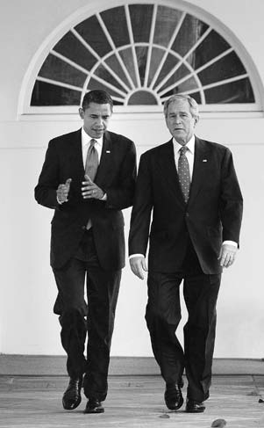

President George W. Bush walks down the White House Colonnade with his successor, Barack Obama, on November 10, 2008, six days after Obama’s election as 44th president of the United States.

339

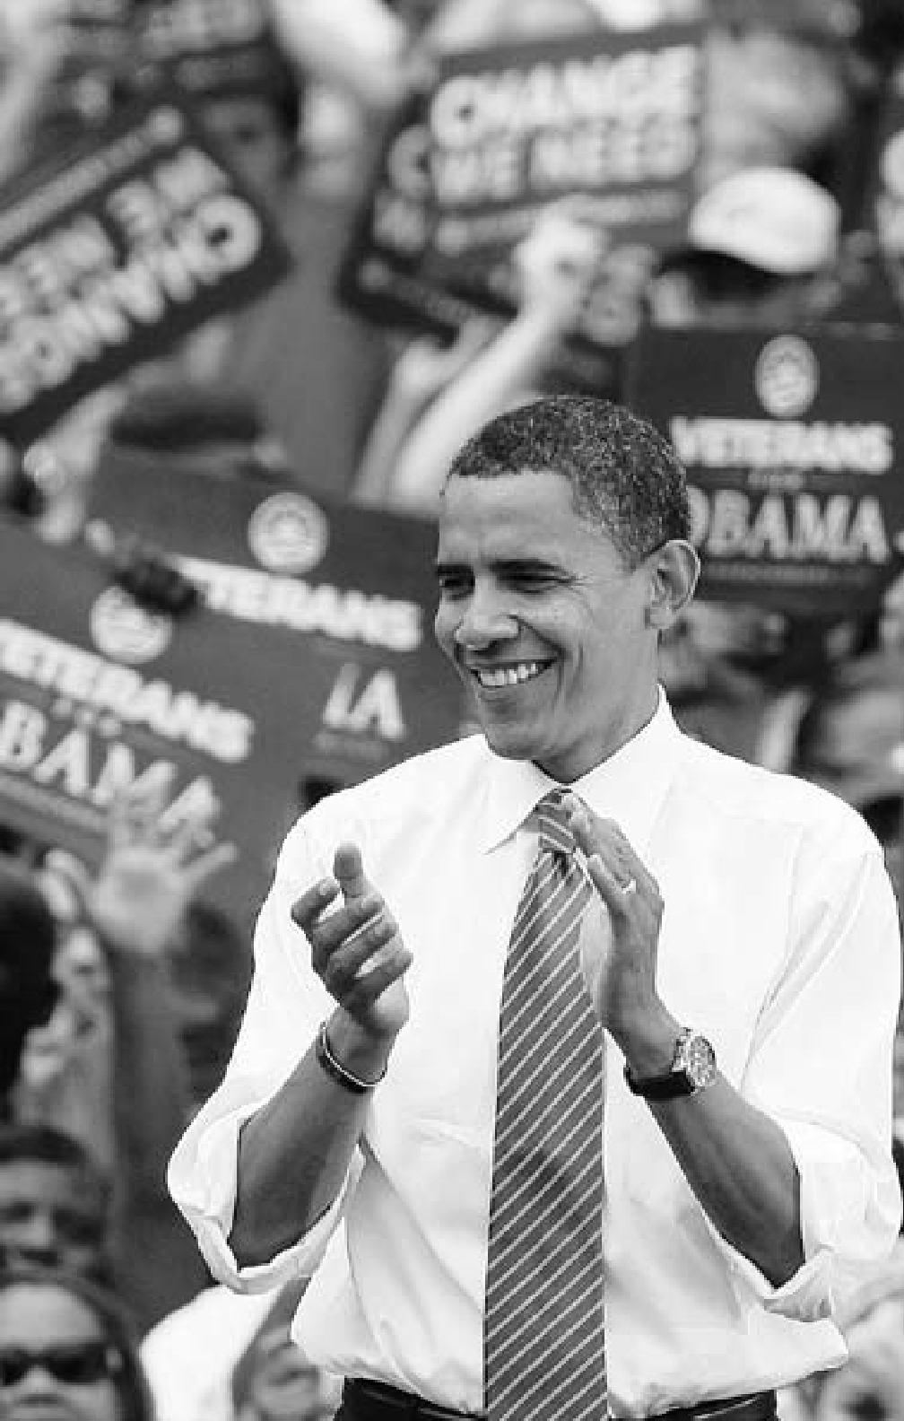

340

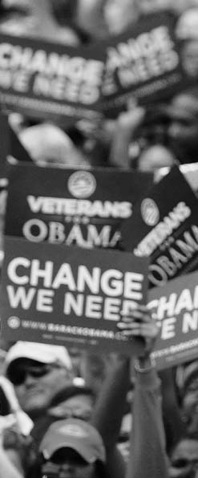

**C H A P T E R**

16

**POLITICS OF**

**HOPE**

Democratic presidential candidate Senator Barack Obama (Illinois) at a campaign rally in

Charlotte, North Carolina, September, 2008.

“The strongest democracies flourish from frequent and lively debate, but they endure when people of every background and

belief find a way to set aside smaller differences in service of a greater purpose.”

President Barack Obama, 2009

#### THE ELECTION OF 2008 AND THE EMERGENCE OF BARACK OBAMA

**H**aving served two terms, Presi- dent George W. Bush was constitu- tionally prohibitedfrombeing elected

again to the presidency. After a spir- ited preconvention campaign, the Republicans chose as their candi- date Senator John McCain of Ari- zona. A Vietnam veteran respected for his heroic resistance as a prison- er of war, McCain possessed strong foreign policy credentials and was a relatively moderate conservative on domestic issues. He chose as his running mate Governor Sarah Palin of Alaska. Much admired by Chris- tian evangelicals and cultural conser- vatives, she drew almost as much attention as McCain himself.

In late 2007, it seemed nearly cer- tain that the Democratic nomination would go to Senator Hillary Rodham Clinton of New York. The wife of former president Bill Clinton, she had quickly established herself as a leading member of Congress and possessed a strong national con- stituency among women and liberal Democrats. However, she faced a phe- nomenon not unusual in democratic societies—a relatively unknown, but charismatic, challenger whose ap- peal rested not on ideological or pro- grammatic differences but on style and personal background.

Barack Hussein Obama was only in his second year as a U.S. senator from Illinois, but his comparative youth and freshness were assets in a year when the electorate was weary of politics as usual. So was his multi-

cultural background. His father was from Kenya; his mother was a white American sociologist. Born in Ha- waii, he had spent his early years in Indonesia, where he attended a Mus- lim school. After his father left the family and his mother died at an ear- ly age, he had been raised by his grandmother. These family crises notwithstanding, he became a suc- cessful student at two of the best universities in the United States— Columbia and Harvard. His person- al style mixed a rare speaking talent with a hip informality that had great appeal to younger voters. Americans of all ages could consider him an emblematic representative of their society’s tradition of providing oppor- tunity for all.

After a close, hard-fought six months of party caucuses and pri- mary elections, Obama eked out a narrow victory over Clinton. He made Senator Joseph Biden of Dela- ware his vice-presidential selection. Most measures of popular sentiment indicated that the public wanted a change. The two candidates were ahead in many public opinion polls as the fall campaign season began.

Any chance that McCain and Palin could pull ahead was ended by the sharp financial crisis that be- gan in the last half of September and sent the economy crashing. Caused by excessive speculation in risky mortgage-backed securities and other unstable investment vehicles, the crash led to the bankruptcy of the venerable Lehman Brothers in- vestment house and momentarily

imperiled the entire financial super- structure of the nation. The Federal Deposit Insurance Corporation (FDIC), created during the New Deal, shut down numerous banks without loss to depositors, but had no jurisdiction over the giant finan- cial investment companies that did not engage in commercial banking. Moreover, it had only limited capa- bilities to deal with those corpora- tions that did both.

Fearing a general financial melt- down reminiscent of the darkest days of the Great Depression, the

U.S. Treasury and the Federal Re- serve engineered a Troubled Assets Relief Program (TARP) that was funded by a $700 billion congres- sional appropriation. The TARP program kept the endangered invest- ment banks afloat. What it could not do was stave off a sharp economic collapse in which millions of Ameri- cans lost their jobs.

That November, the voters elect- ed Obama president of the United States, with approximately 53 per- cent of the vote to McCain’s 46.

#### OBAMA: THE FIRST YEAR

**O**bama was inaugurated president of the United States on January 20, 2009, in an atmosphere of hope and

high expectations. In his inaugural address, he declared: “The time has come to reaffirm our enduring spir- it; to choose our better history; to carry forward that precious gift, that noble idea, passed on from genera- tion to generation: the God-given

promise that all are equal, all are free, and all deserve a chance to pur- sue their full measure of happiness.” He proclaimed an agenda of “remak- ing America” by reviving and trans- forming the economy in ways that would provide better and less-expen- sive health care for all, foster envi- ronmentally friendly energy, and develop an educational system better suited to the needs of a new century. Speaking to the international community, he pledged U.S. coop- eration in facing the problem of global warming. He also delivered a general message of international engagement based on compassion for poorer, developing countries and respect for other cultures. “To the Muslim world,” Obama said, “we seek a new way forward, based on mutual interest and mutual respect.” The speech revealed the wide scope of Obama’s aspirations. His rhetoric and his strong personal presence won wide approval—so much so that in October, he was awarded the Nobel Peace Prize in recognition of his goals. But, as always in the complex system of American representative govern- ment, it was easier to state large

ambitions than to realize them.

At home, the administration ad- dressed the mounting economic crisis with a $787 billion stimulus act designed to bring growing un- employment down to manageable levels. The legislation doubtless saved or created many jobs, but it failed to

prevent unemployment—officially estimated at 7.7 percent of the labor force when Obama took office— from increasing to a high of 10.1 per- cent, then receding just a bit. The loans to large investment and com- mercial banks begun during the Bush administration with the objec- tive of restoring a stable financial system were mostly repaid with a profit to the government, but a few remained outstanding as the presi- dent began his second year in office. In addition, the government invested heavily in two giant auto makers

—General Motors and Chrysler— shepherding them through bank- ruptcy and attempting to reestablish them as major manufacturers.

Obama’s other major objective— the establishment of a national health care system—had long been a goal of American liberalism. With large Democratic majorities in both houses of Congress, it seemed achievable. However, developing a plan that had to meet the medical needs of more than 300 million Americans proved extraordinarily difficult. The con- cerns of numerous interests had to be dealt with—insurance companies, hospitals, physicians, pharmaceuti- cal companies, and the large majori- ty of Americans who were already covered and reasonably satisfied. In addition, a comprehensive national plan had to find some way to control skyrocketing costs. In the spring of 2010, the president signed complex legislation that mandated health in-

surance for every American, with implementation to take place over several years.

In foreign policy, Obama sought to reach out to the non-Western world, and especially to Muslims who might interpret the Ameri- can military actions in Iraq and Afghanistan as part of a general war on Islam. “America and Islam are not exclusive and need not be in competition,” he told an audi- ence at Cairo University. In Tokyo, he reassured Asians that America would remain engaged with the world’s fastest-growing region. While hoping to distinguish itself in tone from the Bush administra- tion, the Obama government found itself following the broad outlines of Bush’s War on Terror. It affirmed the existing agreement to withdraw American troops from Iraq in 2011 and reluctantly accepted military plans for a surge in Afghanistan. In his Nobel acceptance speech, Pres- ident Obama quoted the celebrat- ed American theologian Reinhold Niebuhr to the effect that evil ex- isted in the world and could be de- feated only by force.

At the conclusion of his first year in office, Obama remained, for many Americans, a compelling per- sonification of their ideals of liberty and equal opportunity.

#### AFTERWORD

**F**rom its origins as a set of obscure colonies hugging the Atlantic coast, the United States has undergone a

remarkable transformation into what political analyst Ben Watten- berg has called “the first universal nation,” a population of almost 300 million people representing virtu- ally every nationality and ethnic group in the world. It is also a na- tion where the pace and extent of change—economic, technological, cultural, demographic, and social

—is unceasing. The United States is often the harbinger of the modern- ization and change that inevitably sweep up other nations and societies in an increasingly interdependent, interconnected world.

Yet the United States also main- tains a sense of continuity, a set of core values that can be traced to its founding. They include a faith in individual freedom and democratic government, and a commitment to economic opportunity and prog- ress for all. The continuing task of the United States will be to ensure that its values of freedom, democ- racy, and opportunity—the legacy of a rich and turbulent history—are protected and flourish as the nation, and the world, move through the 21st century. 9

**BI B L IO G R A P H Y**

##### RECENT PRIZE-WINNING BOOKS

**The Bancroft Prize for American History** *Awarded by the Trustees of Columbia University*

2010

*Dorothea Lange: A Life Beyond Limits*

By Linda Gordon

W.W. Norton & Company

*Abigail Adams*

By Woody Holton Free Press

*White Mother to a Dark Race: Settler Colonialism, Maternalism, and the Removal of Indigenous Children in the American West and Australia, 1880-1940.*

By Margaret D. Jacobs University of Nebraska Press

2009

*Killing for Coal: America’s Deadliest Labor War*

By Thomas G. Andrews Harvard University Press

*This Republic of Suffering: Death and the American Civil War*

By Drew Gilpin Faust Alfred A. Knopf

*The Comanche Empire* By Pekka Hämäläinen Yale University Press

2008

*The Cigarette Century: The Rise, Fall, and Deadly Persistence of the Product That Defined America* By Allan M. Brandt

Basic Books

*The Populist Vision*

By Charles Postel Oxford University Press

*Our Savage Neighbors: How Indian War Transformed Early America* By Peter Silver

W.W. Norton & Company

2007

*Mockingbird Song: Ecological Landscapes of the South*

By Jack Temple Kirby

University of North Carolina Press

*William James: In the Maelstrom of American Modernism*

By Robert D. Richardson Houghton Mifflin Company

2006

*Dwelling Place: A Plantation Epic*

By Erskine Clarke Yale University Press

*The Global Cold War: Third World Interventions and the Making of Our Times*

By Odd Arne Westad Cambridge University Press

*The Rise of American Democracy: Jefferson to Lincoln*

By Sean Wilentz

W.W. Norton & Company

**Pulitzer Prize for a distinguished book upon the history of the United States**

*Awarded by Columbia University Graduate School of Journalism*

2010

*Lords of Finance: The Bankers Who Broke the World*

By Liaquat Ahamed The Penguin Press

2009

*The Hemingses of Monticello: An American Family*

By Annette Gordon-Reed

W.W. Norton & Company

2008

*What God Hath Wrought:*

*The Transformation of America, 1815-1848*

By Daniel Walker Howe Oxford University Press

2007

*The Race Beat: The Press, the Civil Rights Struggle, and the Awakening of a Nation* By Gene Roberts and

Hank Klibanoff Alfred A. Knopf

2006

*Polio: An American Story* By David Oshinsky Oxford University Press

##### SELECTED INTERNET RESOURCES

American Historical Association [http://www.historians.org](http://www.historians.org/)

American History: A Documentary Record

1492–Present <http://avalon.law.yale.edu/subject_> menus/chrono.asp

The Avalon Project at the Yale Law School: Major Collections <http://avalon.law.yale.edu/subject_> menus/major.asp

Biography of America <http://www.learner.org/> biographyofamerica/

Digital History <http://www.digitalhistory.uh.edu/>

Documents for the Study of American History <http://www.vlib.us/amdocs/>

Gilder Lehrman Institute of American History [http://www.gilderlehrman.org](http://www.gilderlehrman.org/)

Historicalstatistics.org <http://www.historicalstatistics.org/> index2.html

History Matters <http://historymatters.gmu.edu/>

The Library of Congress American Memory: Historical Collections for the National Digital Library <http://memory.loc.gov/ammem/>

The Library of Congress American Memory: Timeline <http://lcweb2.loc.gov/ammem/> ndlpedu/features/timeline/ index.html

National Archives and Records Administration

[http://www.nara.gov](http://www.nara.gov/)

National Archives and Records Administration: Digital Classroom <http://www.archives.gov/digital_> classroom/

National Archives and Records Administration: Our Documents: A National Initiative on American History, Civics, and Service <http://www.ourdocuments.gov/> index.php?flash=true&

National Archives and Records Administration: Presidential Libraries

<http://www.archives.gov/> presidential-libraries

National Atlas of the United States [http://nationalatlas.gov](http://nationalatlas.gov/)

National Endowment for

the Humanities: We the People [http://www.wethepeople.gov](http://www.wethepeople.gov/)

National Park Service:

Discover History

<http://www.nps.gov/history/>

Organization of American Historians

<http://www.oah.org/>

Smithsonian <http://www.si.edu/>

The Historical Society <http://www.bu.edu/historic/>

U.S. Department of State Office of the Historian <http://history.state.gov/>

WWW Virtual Library History: United States <http://vlib.iue.it/history/USA/>

*The U.S. Department of State assumes no responsibility for the content and availability of the resources from other agencies and organizations listed above. All Internet links were active as of fall 2010.*

### I N DE X

*Page references in* ***boldface*** *type refer to illustrations.*

**A**

Abolition of slavery

Brown’s raid at Harper’s Ferry (1859), 139

constitutional amendment (13th), 148

Democratic Party and, 152 Douglass as abolitionist leader, **91** Emancipation Proclamation, 144-

145

Freedmen’s Bureau, 148, 151 Garrison and *The Liberator* on, **91**, 122, 133-134

Missouri Compromise (1820), 80,

114, 132, 135, 137

Northwest Ordinance slavery ban, 71, 73, 113, 135

religious social activism and, 87 as a sectional conflict/divided nation, 128-139

as sharecroppers and tenant farmers, 190-191

southern statesmen on, 113 Underground Railroad, 91, 134, 136 *See also* Slavery

Adams, John, 52, 64, 72, 82-83

Adams, John Quincy, 115, 116, 134

Adams, Samuel, 56-57

Adamson Act, 199

Addams, Jane, 196

*Adventures of Huckleberry Finn*

(Twain), **97**

Afghanistan, U.S. relations, **294**, 334, 345

AFL. *See* American Federation of Labor (AFL)

African Americans

bus boycott (Montgomery,

Alabama), **240**

civil rights movement, 240, 258,

271-272

color barrier broken in sports, **237**, 271

Colored Farmers National Alliance, 191

culture, 210-211

Freedmen’s Bureau and, 148, 151

“Harlem Renaissance,” 211

jazz musicians, 211 labor unions and, 193

lynchings and violence against, 150, 178, 271

members of Congress, **96** as sharecroppers and tenant farmers, 190-191

U.S. Colored Troops in Union Army, 145

*See also* Abolition of slavery;

Civil rights; Racial discrimination; Slavery

Agnew, Spiro, 290 Agricultural Adjustment Act (AAA), 216

Agriculture

farm-relief act, 216

Farmers’ Alliances, 191

Grange movement, 191

land grant and technical colleges, 152, 177

New Deal programs, 216-217 Patrons of Husbandry (Grange), 191 plantation settlements, 26, 28,

113-114, **128**-**129**

post-Revolutionary period, 70

Republican policy, 79, 208

scientific research, 177

sharecroppers and tenant farmers, 190-191

small farmers and agricultural consolidation, 267

technological revolution, **110**-**111**,

160, 177

westward expansion and, 125 AIDS (Acquired Immune Deficiency Syndrome)

epidemic, 307

quilt (Washington, D.C.), **299** AIM. *See* American Indian Movement Alaska

gold rush, 192

purchase, known as “Seward’s Folly,” 182

Albany Plan of Union, 33, 69

Albright, Madeleine, 329

Alien Act, 82, 117

Amalgamated Association of Iron, Steel, and Tin Workers, 194 American Bible Society, 87 American Civil Liberties Union, 209

American Federation of Labor (AFL), 194, 209, 227

American Independent Party, 319 American Indian Movement (AIM), 281 American Philosophical Society, 28 American Railway Union, 194 American Revolution, 50-65

Boston Tea Party (1773), **50**-**51**, 57 British move through the South, 63-64

colonial declaration of war, 60 Concord and Lexington battles (1775), 59-60

economic aftermath, 70 factors leading to, 50-59

first shots fired at Lexington,

**44**-**45**, 59

Franco-American alliance, 62-63

Long Island, battle of (1776), 61

Loyalists and, 60, 65 Olive Branch Petition, 60

significance of, 65

Treaty of Paris (1783), **47**, 64 Yorktown, British surrender at, **47**-**48**, 64

American Sugar Refining Company, 197

American Telephone and Telegraph (AT&T), 158

American Temperance Union, 121 Amity and Commerce, Treaty of (France-American colonies), 63

Amnesty Act (1872), 150

Anasazi, 8, 20

Andros, Sir Edmund, 31 Anthony, Susan B., **90**, 122

Antifederalists, 76

Antitrust legislation, 160, 187,

196-197, 199

Apache Indians, 180, 181

Aquino, Corazon, 312

Arafat, Yasser, 330

Aristide, Jean-Bertrand, 330 Arlington Cemetery (Virginia), **174** Armour, Philip, 158

Arms control. *See* Nuclear weapons Armstrong, Louis, 211

Armstrong, Neil, 285

Arnaz, Desi, **239**

Arnold, Benedict, 62

Articles of the Confederation, 69-70 Asia, Cold War, 263-264

Atlantic Charter (U.S.-Britain), 220 Automobile industry

auto worker strikes, 228, **230** automobile safety crusade, 287 environmental issues/traffic congestion, 282, **300-301**

unemployment, 227

**B**

Babcock, Stephen, 177

Ball, Lucille, **239**

Banking Act, 218

Banking and finance

currency question and gold standard, 192

Federal Reserve Board, 199, 218

Federal Reserve System, 119, 187,

198-199

financial panic (1893), 192

First Bank of the United States, 79 insured savings (FDIC), 215 national bank, 79-80

New Deal program reforms, 214-215 regional and local bank charters, 119 Second Bank of the United States, 118-119

state banking system, 119 stock market crash (1929), 211

Baptists, 87, 88

Barak, Ehud, 330

Beard, Charles, 75

“Beat Generation” (1950s), 270 Begin, Menachim, 292

Bell, Alexander Graham, **107**, 156 Bell, John C., 139

Bell Telephone System, 158 Bellamy, Edward, 160

Biddle, Nicholas, 119

Biden, Joseph, 343 Bill of Rights, 77

bin Laden, Osama, 331, 332, 334 Blaine, James G., 185

Blair, Tony, **294-295**, 330

Blix, Hans, 335

Bolívar, Simon, 114 Booth, John Wilkes, 147 Borglum, Gutzon, 171

Bosnia, 330

Boston Massacre (1770), 56

Boston Tea Party (1773), **50**-**51**, 57 Breckenridge, John C., 139 Brezhnev, Leonid, 289

British colonization. *See* English colonization

Brooks, David, 322

Brown, John, 139

*Brown v. Board of Education* (1954), 240, 244, 272

Bryan, William Jennings, 192, 195,

198, 209-210

Buchanan, Pat, 332 Buckley, William F., 308 Bull Moose Party, 318 Burbank, Luther, 177

Burgoyne, John, 62

Bush, George Herbert Walker, **255** budgets and deficits, 315 domestic policy, 314-315

end of Cold War, 315-316 foreign policy, 312, 316-317

presidential election (1998), 314;

(1992), 322, 324

“war on drugs,” 317 Bush, George W.

Afghanistan invasion, 334 with Barack Obama, **339**

as a “compassionate conservative,” 332

domestic and foreign policy, 332- 336

on freedom, 322

Iraq War, 334-336

on peace, 322

presidential elections (2000), 333;

(2004), 336-337

with Tony Blair, **294**-**295**

**C**

Cable News Network, **297**

Cabot, John, 9

Cady Stanton, Elizabeth, **90**, 122-123

Calhoun, John C., 112, 116, 117, 125 California

as a free state, 136

gold rush, 131, 136, 179 migrant farm workers’ unions, 279-280

territory, 135

Calvinism, 13, 29, 34, 65 Campbell, Ben Nighthorse, 281

Capitalism, 187, 193, 214

Carleton, Mark, 177

Carmichael, Stokely, 278

Carnegie, Andrew, **97**, 156-157,

187, 194

Carson, Rachel, 282

Carter, Jimmy, 291-292

Cartier, Jacques, 10

Carver, George Washington, 177 Cattle ranching, 179-180 Central Pacific Railroad, 179

*A Century of Dishonor* (Jackson), 181 Chambers, Whittaker, 266

Charles I (British king), 12, 13, 15

Charles II (British king), 17, 18, 31

Chase, Salmon P., 138

Chávez, César, **250**, 280

Cherokee Indians, 125

Chiang Kai-shek, 224, 263, 264 Chicanos. *See* Latino movement Child labor, **102-103**, 177, 193, 196 China, People’s Republic of

Boxer Rebellion (1900), 186

Taiwan relations, 263, 265, 289

U.S. diplomatic relations, 186, 289, 292

Christian Coalition, 308 Churchill, Winston

on the “iron curtain,” 260-261

U.S. support for war effort, 220 at Yalta, 224, **234**

CIO. *See* Committee for Industrial Organization (CIO); Congress of Industrial Organizations (CIO) Citizenship, 82, 148-149, 178

Civil rights

bus boycott (Montgomery, Alabama), 240, 273

desegregation, 272-273

desegregation of schools, 240, 241,

244, 272-273, 277

desegregation of the military, 269, 272

Jesse Jackson’s “Rainbow

Coalition,” 253

Truman 10-point civil rights program, 271-272

*See also* Civil rights movement; Individual rights; Racial discrimination

Civil Rights Act (1957), 273

Civil Rights Act (1960), 273

Civil Rights Act (1964), 277, 286 Civil rights movement (1960-80), 276-278

“black power” activists, 277-278 “freedom rides,” 277

“March on Washington” (1963), 277 origins of the, 271-272

riots (1960s), 278

sit-ins, 277

Civil Service Commission, 307 Civil War (1861-65)

African Americans in U.S. Colored Troops in Union Army, 145 Alexandria, Union troop encampment, **94**

Antietam campaign (1862), 141, 144 Bull Run (First Manassas), 143 Bull Run (Second Manassas), 144 casualties, 92, 144, 145

Chancellorsville campaign (1863),

**92**-**93**, 145

Chattanooga and Lookout Mountain campaigns (1863), 146 Gettysburg address, by Lincoln, 142, 145

Gettysburg campaign (1863), 92,

145, 146

Petersburg campaign (1865), 146

postwar politics, 152-153 secession from the Union, 142-143 Sherman’s march through the South, 146

Shiloh campaign, 144 Spotsylvania (Battle of the Wilderness, 1864), 146 surrender at Appomattox

Courthouse, 146

Vicksburg campaign (1863), 145, 146

*See also* Reconstruction Era Civil Works Administration (CWA), 215-216

Civilian Conservation Corps (CCC), 215 Clark, William, **47**

Clay, Henry

compromise agreements, 114, 136

portrait of, **90**

presidential elections, 116, 119

protective tariffs, 112, 117, 118

Whig Party statesman, 120, 152 Clayton Antitrust Act, 199

Clean Air Act (1967), 282

Clemenceau, Georges, **108**

Clemens, Samuel Langhorne, **97**, 196

Cleveland, Grover, 159, 182, 183,

192, 194

Clinton, Hillary Rodham, 324, 325,

328, 342

Clinton, William “Bill” Arkansas real estate investigation, 326

Cabinet appointments, 280

domestic policy, 324-326

foreign policy, 329-331 impeachment hearings/trial, 328, 329

presidential election (1992),

322-324; (1996), 328

presidential inaugural address (1993), **255**

sexual impropriety/intern scandal, 326, 328

Coercive or Intolerable Acts (England), 57-59

Cold War, 258-267

in Asia, 263-264 Eisenhower Administration, 264-265

end of, 255, 315-316, 324

in the Middle East, 264

Kennedy Administration, 284-285

origins of, 260-261

Truman Administration, 261, 265 College of William and Mary, 27 Colonial period

cultural developments, 27-29

Dutch colonies, 14, 15, 17, 24

early settlements, 10-12, 24

English settlers, 10-12, 13-15, 17, 24 French and Indian Wars, 32-33 German settlers, 24, 25, 26 government of the colonies, 29-32 Jamestown colony (Virginia), 10,

12-13, 16

Massachusetts colonies, 13-14, 24-25

middle colonies, 25-26

Native American relations, 15-17, 18, 39

New Amsterdam, 14, 15, 26 New England colonies, 24-25 New England Confederation, 17

Pennsylvania colony, 18, 25, 27-28,

30, 39, 69

rural country daily life, 26-27 Scots and Scots-Irish settlers, 24, 25, 26

southern colonies, 26-27

Swedish colonies, 15, 24

Virginia colonies, 10, 12-13, 16, 26,

28-30, 68-69

Colored Farmers National Alliance, 191

Columbus, Christopher, 9 Commission on Civil Rights, 280 Committee for Industrial Organization (CIO), 228

Committees of Correspondence, 56-57

Commodity Credit Corporation, 216 *Common Sense* (Paine), 60 Communism, 206-207

Cold War and, 258-267, 315-316 Eisenhower containment policy, 264-265

Federal Employee Loyalty

Program, 266

House Committee on

Un-American Activities, 266 McCarthy Senate hearings on, **236**, 266

Red Scare (1919-20), 207, 265

spread of, 263

Truman Doctrine of containment, 261-263

Communist Party, 206, 263, 265, 266

Compromise of 1850, 90, 135-136

Confederation Congress, 71 Congress of Industrial Organizations (CIO), 228

Congress, U.S.

African-American members, 96 first Native American member, 281 Hispanic members, 280

power to make laws, 75 representation in House and Senate, 73

Conservatism, 307-309

Constitution, state constitutions, 68-69 Constitution, U.S.

amendments

1st thru 12th, 77

13th (abolishing slavery), 148 14th (citizenship rights), 148- 149, 178

15th (voting rights), 149, 273 16th (federal income tax), 198 17th (direct election of senators), 198

18th (prohibition), 210

19th (voting rights for women), 207

amendments process, 74 Bill of Rights, 77 Congressional powers, 75

debate and compromise, 73-75 declaration of war powers, 316-317 on display at National Archives, **174**

motivations of Founding Fathers, 75

ratification, 75-76

separation of powers principle, 74 signing of, at Constitution Hall (Philadelphia), **164**

Constitutional Convention (Philadelphia, 1787), **66**-**67**, 71-77 Constitutional Union Party, 139 Continental Association, 58-59

Continental Congress, First (1774), 58 Continental Congress, Second (1775), 60, 61, 69, 71

Coolidge, Calvin, 204, 207

Cornwallis, Lord Charles, **46**-**47**, 64 Coronado, Francisco Vázquez de, 9 Corporations, 158-159

Coughlin, Charles, 217

Counterculture (1960s), 281-282

New Leftists, 281-282

Vietnam War demonstrations, 281 “Woodstock Generation,” **249**, 281

Cox, James M., 207 Crawford, William, 116

Crazy Horse (Sioux chief), 180 Creek Indians, 125

Cromwell, Oliver, 12, 17, 31

Cuba, Spanish-American War and, 182-183

Cuban missile crisis (1962), 284

Cullen, Countee, 211 Culture

of the 1950s, 270-271 in the colonies, 27-29

counterculture of the 1960s, 281-282 *See also* Libraries; Literary works; Music, American

Currency Act (England, 1764), 53

Custer, George, 98-99, 180

**D**

Dakota Sioux, 98, 180, 281

Darrow, Clarence, 209-210 Darwinian theory

Scopes trial, 209-210 “survival of the fittest,” 193

Davis, Jefferson, 142

Dawes (General Allotment) Act (1887), 181

De Soto, Hernando, 9

Declaration of Independence, 61, 68 burial site for three signers of, **162**-**163**

Declaratory Act (England), 55 Delaware Indians, 18, **39**

*Democracy in America* (Tocqueville), 130

Democratic Party, 116, 137, 152, 153,

192, 218-219

Depression. *See* Great Depression Dewey, George, 183

Dewey, Thomas, 235, 269

Dickens, Charles, 130-131

Dickinson, Emily, **96**

Dickinson, John, 55, 69

Digital revolution, **293**, **296**

e-mail communication, 327

mobile phones, 327

personal computer (PC) growth, 306, 327

Dix, Dorothea, 121

Dixiecrats, 319

Dole, Robert, 328

Doolittle, James “Jimmy,” 223 Dorset, Marion, 177

Douglas, Stephen A., 136, 137, 138-139

Douglass, Frederick, **91**, 122, 134, 145

Drake, Francis, 10

Dred Scott decision, 138, 149

Dreiser, Theodore, 196

DuBois, W.E.B., 178, 211

Dukakis, Michael, 314 Dulles, John Foster, 265 Dunmore, Lord, 60

Dutch colonization, 14, 15, 17

patroon system, 14-15 Dutch East India Company, 14 Dylan, Bob, 281

**E**

East India Company, 57 Eastman, George, 106, 157 Economic crisis bailout, 344 Edison, Thomas, **106**, 157 Education

in the colonies, 27-29 computer technology and, **303** day care centers, **303**

No Child Left Behind Act, 333 private schools, 27

private tutors, 28

public school systems, 121 school desegregation, 240, 244,

272-273, 277

Edwards, Jonathan, 29 Eisenhower, Dwight David

civil rights supporter, 272, 273 Cold War and foreign policy, 264-265 domestic policy of “dynamic conservatism,” 269-270

portrait of, **236**

as president of U.S., 264-265, 269-270 as Supreme Commander of Allied Forces, 223, **232**, 264

Electoral College, 116, 117

Elkins Act (1903), 196

Ellington, Duke, 211

Ellis Island Monument, **102**, 103, 200

Emancipation Proclamation, 144-145

Embargo Act (1807), 84 Emerson, Ralph Waldo, 59 Enforcement Acts (1870 and 1871), 150

English Civil War (1642-49), 31 English colonization

early settlements, 10-12

French and Indian War and, 32-33 map of, **36**-**37**

in Maryland, 15

in Massachusetts, 13-14

New England Confederation, 17 English common law, 30

*Enola Gay* (U.S. bomber), attacks on

Hiroshima and Nagasaki, 226 Environmental movement, 282,

**298**, 344

Environmental Protection Agency (EPA), 282

Equal Rights Amendment (ERA), 279 Erik the Red, 9

**F**

Falwell, Jerry, 308

Farragut, David, 143

Faubus, Orval, 272

Federal Aid Road Act (1916), 113 Federal Artists Project, 218 Federal Deposit and Insurance Corporation (FDIC), 215, 343 Federal Emergency Relief Administration (FERA), 215

Federal Employee Loyalty Program, 266

Federal Reserve Act (1913), 198

Federal Reserve Board, 199, 218,

291, 310, 343

Federal Reserve System, 119, 187,

198-199

Federal Theatre Project, 218 Federal Trade Commission, 199

Federal Workingman’s Compensation Act (1916), 199

Federal Writers Project, 218

*The Federalist Papers*, 43, 76

Federalists, 76, 78, 81, 82, 86, 116

*The Feminine Mystique* (Friedan), 278

*The Financier* (Dreiser), 196 Finney, Charles, Grandison, 87 Firefighters, **321**

“First universal nation,” 345 Fitzgerald, F. Scott, 210 Force Act, 118

Ford, Gerald, 290-291

Ford, Henry, **109**

Fordney-McCumber Tariff (1922), 207 Foreign policy. *See* U.S. foreign policy France

Louisiana Territory sold to U.S., 83-84

New World exploration, 9-10

U.S. diplomatic relations, 82-83 XYZ Affair, 82

Franco-American Treaty of Alliance (1778), 62-63, 80, 82

Franklin, Benjamin, 28, 33, **43**, 63,

64, 72, 75

Free Soil Party, 136, 137, 138

Freedmen’s Bureau, 148, 151

Fremont, John, 138

French and Indian War, 32-33 French exploration, 10

French Huguenots, 24

French Revolution, 34, 79, 80, 81

Friedan, Betty, 278, 279

Friedman, Milton, 308

Fugitive Slave Act, 136, 137

Fundamentalism, religious, 209,

210, 308

**G**

Gage, Thomas, 59

Gallatin, Albert, 83

Garrison, William Lloyd, **91**, 122,

133-134

Garza, Eligio “Kika” de la, 280 Gates, Bill, **296**

Gates, Horatio, 62, 63-64

Gay rights, 307, 324-325 Genet, Edmond Charles, 80-81 George, Henry, 160

George III (British king), 55, 59 Georgia

colonial royal government, 31 early settlement, 18

Native American tribes relocated, 118

German unification, 316 Germany

Berlin Airlift, 262

Kennedy speech in West Berlin,

**242-243**

postwar period, 262 reparations, World War I, 224

Germany in World War II Holocaust (Jewish genocide), 226 Nazism, 219, 224, 226

North African campaign, 222 Nuremberg war crime trials, 226 reparations, 206

submarine warfare, 204-205 Geronimo (Apache chief), 181 Gerry, Elbridge, 72, 73

Ghent, Treaty of (1814), 85

Gilbert, Humphrey, 10

*The Gilded Age* (Twain), 196 Ginsberg, Allen, 271

Glenn, John, 285

Global warming, 344

Glorious Revolution (1688-89), 31, 32

Goethals, George W., 185

Goldwater, Barry, 286, 308, 309

Gompers, Samuel, 194 González, Henry B., 280

Gorbachev, Mikhail, **304**-**305**, 314,

315, 316

Gore, Al, 323, 332, 333

Gould, Jay, 194

Grange movement, 191 Grant, Ulysses S.

as president of U.S., 150, 153

as Union Army general, 144, 145

portrait of, **95**

Great Depression (1929-40) decline in immigration, 201 “Dust Bowl” migration, 216 New Deal programs, 214-218 soup lines, **202**-**203**

stock market crash (1929), 211

“Great Society,” 286-287

Greeley, Horace, 112, 124

Green Party, 332

Greenspan, Alan, 327

Grey, Zane, 180

Guadalupe Hidalgo, Treaty of, 135 Guam, U.S. relations, 184

**H**

Haiti, political situation, 330 Hamilton, Alexander

and Bank of the United States, 79, 118

Constitutional Convention delegate, 71, 72

*Federalist Papers* and, 43, 76

as first Secretary of the Treasury (Department of the Treasury), 77 portrait of, **48**

and Republican Party, 152 vs. Jefferson, 48, 78-80

Hamilton, Andrew, 28 Harding, Warren G., 207 Harrison, Benjamin, 160

Harrison, William Henry, 85, 120

Hartford Convention (1814), 117

Harvard College, 27

Hawaii, statehood (1959), 184 Hawaiian Islands, U.S. policy of annexation, 183-184

Hawley-Smoot Tariff Act (1930), 207

Hay, John, 184, 186

Hayes, Rutherford B., 150-151, 153 Haymarket Square incident, 194 Health care, 344

Health insurance, 344-345

Helsinki Accords (1975), 291

Hemingway, Ernest, 109, 210

Henry, Patrick, **42**, 54, 76, 77

Hepburn Act (1906), 197 Hidalgo, Miguel de, 114 Highway Act (1956), 268 Hispanics

in politics, 280

*See also* Latino movement Hiss, Alger, 266

Hitler, Adolf, 201, 219 Ho Chi Minh, 284 Hohokam settlements, 7

Holy Alliance, 115

Homeland Security Department, 334 Homestead Act (1862), 124, 152,

179, 180

Hoover, Herbert, 185, 211

Hopewellians, 7

Hopi Indians, 8

Housing and Urban Development Department, 287

Houston, Sam, 134

Howe, William, 61-62

Hudson, Henry, 14

Hughes, Langston, 211

Hull, Cordell, 221

Humphrey, Hubert, 288

Hungary, rebellion (1956), 265

Hutchinson, Anne, 14

**I**

Immigrants and immigration diversity of immigrants, 200-201 Ellis Island Monument, **102**, 103, 200

illegal immigrants, 201

immigration quotas, 201, 209 “Little Italy” in New York City, **104**-**105**

Nativists and, 209

policy reform, 307 restrictions on immigration, 208-209

Immigration Restriction League, 201 Imperialism, 181-182

Indentured servants, 18-19

Indian Removal Act (1830), 125

Indian Reorganization Act (1934), 181 Indian Wars

Apache wars, 180, 181 Custer’s Last Stand at Little Bighorn, **98**-**99**, 180

French and Indian War, 32-33 Pequot War (1637), 16

and westward expansion, 124, 180-181

Indians of North America. *See* Native Americans

Individual rights, 34, 65, 76-77

*See also* Civil rights

Industrial development. *See under names of industry*

Industrial Workers of the World (IWW), **194**

Interstate Commerce Commission (ICC), 159, 197, 198

Inventions

adding machine, 157

airplane, **107**

cash register, 157

cotton gin, 114, 133

light bulb/incandescent lamp, 106, 157

linotype machine, 157

motion picture projector, **106**, 157 reaper (farm machine), 131,

158, 160

telegraph, 156

telephone, **107**, 156

television, 268

typewriter, 157 Iran, U.S. relations, 292

Axis of evil, 334 Iraq

elections (2005), **302**

provisional government, 335

U.N. weapons inspections, 329, 334-335

U.S.-led invasion, 335

Iron and steel industry, 157, 187

strikes, 194, 228

Iroquois Indians, 14, 16-17, 33

Islam, 345

Isolationism, 78, 206, 220 Israel

Egypt invasion, 265

Palestinian relations, 330

U.S. policy, 264

**J**

Jacinto, Battle of, 134 Jackson, Andrew

conflicts with Indians, 125

as general in War of 1812, 86 portrait of, **89**

as president of U.S., 89, 117-118

presidential election (1824), 116

presidential election (1828), 117 Jackson, Helen Hunt, 181

Jackson, Jesse, **253**

Jackson, Thomas J. (“Stonewall”), 144, 145

James I (British king), 12 James II (British king), 31

Jamestown colony (Virginia), 10, 12-13, 16

Japan

attack on Pearl Harbor, **212**-**213**, 221, 222

Kamikaze suicide missions, 225 surrender (1945), 226

U.S. attacks on Hiroshima and Nagasaki, 226

U.S. relations, 186

Japanese-Americans, internment camps, 222, **233**

Jay, John, 43, 64, 76, 81, 82

Jay Treaty (Britain-U.S.), 81, 82

Jazz Age, 210

Jefferson Memorial (Wash., D.C.), **161**

Jefferson, Thomas

on abolition of slavery, 114 as drafter of Declaration of Independence, 61

face of (Mount Rushmore),

**170**-**171**

as first Secretary of State (U.S. Department of State), 77 portrait of, **46**

as president of U.S., 83

on right of self-government, 68 on slavery, 114

as U.S. minister to France, 72, 79-80 vs. Adams, 82

vs. Hamilton, 48, 78-80

“Jim Crow” laws (separate but equal segregation), 151, 240, 272, 319

Jobs, Steve, **296**

Johnson, Andrew impeachment trial, 149-150

as president of U.S., 147-149, 153 Johnson, Lyndon B.

civil rights supporter, 273, 277 Great Society programs, 286-287 portrait of, **245**

space program, 285

Vietnam War policy, 287-288 “War on Poverty,” 286

Johnson-Reed National Origins Act (1924), 201, 209

*The Jungle* (Sinclair), 196

**K**

Kansas

slavery issue and, 138

territory (“bleeding Kansas”), 137, 138

Kansas-Nebraska Act, 137

Kennan, George, 261 Kennedy, John F.

assassination of, 277, 286 Bay of Pigs invasion, 284 civil rights policy, 277, 283 Cold War and, 284-285 Cuban missile crisis, 284

as president of U.S., 282-285 space program, 285-286 Vietnam War policy, 284-285 West Berlin speech during Cold War, **242**-**243**

Kennedy, Robert, assassination of, 278, 288

Kentucky

Resolutions (1798), 117

statehood (1792), 7-8

Kerouac, Jack, 270 Kerry, John F., 336-337

Khomeini, Ayatollah, 292

Khrushchev, Nikita, 284

Kim Il-sung, 263

King, Martin Luther, Jr.

assassination of, 278, 288

civil rights movement and, 240,

**241**, 273, 283

“I have a dream” speech, 276, 277 King, Rufus, 72

Kissinger, Henry, 289

Know-Nothing Party, 120

Korean War, **235**, 263, 264

Kosciusko, Thaddeus, 65

Ku Klux Klan, 150, 201, 209

**L**

La Follette, Robert, 196, 318-319

Labor unions, 121, 193-195 air controllers strike, 309 auto workers strikes, 228 collective bargaining, 217

Haymarket Square incident, 194 membership in U.S., 227-228 migrant farm workers, 250, 279-280 mine workers membership/strikes, 194-195, 227-228

New Deal programs, 217 post-World War I strikes, 206

post-World War II strikes, 269 railway worker strikes, 193, 194

steel worker strikes, 194, 228 textile worker strikes, 195 “Wobblies,” 194-195

*See also under names of specific unions*

Lafayette, Marquis de, 65 Landon, Alf, 218

Latin America, U.S. intervention, 184-185

Latin American Revolution, 114-116 Latino movement, 279-280

League of Nations, 205-206, 226

Lee, Richard Henry, 61, 64 Lee, Robert E.

capture of John Brown at Harper’s Ferry, 139

commander of Confederate Army, 144

declines command of Union Army, 143

portrait of, **95**

surrender at Appomattox Courthouse, 146

Leif (son of Erik the Red), 9 Lenin, V.I., 259

Levitt, William J., 268

Lewis and Clark expedition, bicentennial commemorative stamp, **46**

Lewis, John L., 227-228 Lewis, Meriwether, 47

Lewis, Sinclair, 210

*The Liberator*, 91, 133 Libraries

American Philosophical Society (Philadelphia), 28

in the colonies, 27, 28 public libraries endowed by Carnegie, 97

subscription, 28 Lincoln, Abraham

assassination of, 147, 153

at Civil War Union encampment,

**140**-**141**

Emancipation Proclamation, 144-145

face of (Mount Rushmore), **170**-**171**

Free-Soil Party and, 138 Gettysburg address, 142, 145

on Grant, 95

as president during Civil War, 142-147

presidential election (1860), 139

presidential election (1864),

147, 153

presidential inaugural address, 142 senatorial campaign (1858),

138-139

on slavery and the Union, 130, 138 Lincoln, Benjamin, 63, 70

Lincoln-Douglas debates (1858), 138-139 Literary works

“Beat Generation” (1950s), 270-271 colonial period, 28-29

“Harlem Renaissance,” 211

“Lost Generation” (1920s), 109, 211 New Deal programs and, 218

*See also names of individual authors or works*

Lloyd George, David, **108**

Locke, John, 17, 32, 34, 61, 65, 73

Lodge, Henry Cabot, 181, 184

Logan, James, 28

*The Lonely Crowd* (Riesman), 270 Long, Huey P., assassination of, 217 “Lost Generation” (1920s), 109, 211

Louis XVI (French king), 64, 80

Louisiana Purchase, 83-84

Lovejoy, Elijah P., 134 Lowell, James Russell, 147 Luce, Henry, 258

Lundestad, Geir, 262

**M**

MacArthur, Douglas, 225, **232**, 263

Macdonough, Thomas, 85

Madison, James, **43**, 72, 75, 76,

84-86, 113

as “Father of the Constitution,” 72 Mahan, Alfred Thayer, 184

*Maine* (U.S. warship) incident, 182 Major, John, 330

Malcolm X, 277 Manhattan. *See* New York

Manhattan project (atomic bomb development), 225

Mann, Horace, 121

Mao Zedong, 263, 289

*Marbury v. Madison* (1803), 113

Marcos, Ferdinand, 312 Marshall, George C., 262 Marshall, John

as chief justice of the Supreme Court, 49, 113

funeral of, 168

portrait of, **49**

Marshall Plan, 262

Marshall, Thurgood, **244**

Martin, Josiah, 60 Maryland

Calvert family charter, 15, 30

Catholic settlements, 15 St. Mary’s, first town in, 15

Toleration Act and religious freedom, 17

Mason, George, 76 Massachusetts

Boston Massacre (1770), 56 Boston Port Bill, 57

Boston Tea Party (1773), **50**-**51**, 57 colonial government charter, 30-31 early settlements, 13-14

Old Granary Cemetery (Boston),

**162**-**163**

Salem witch trials, 35 schools and education, 27 Shays Rebellion, 70

trade and economic development, 24-25

Massachusetts Bay Colony, 25, 31 Massachusetts Bay Company, 18 Mather, Cotton, 28, **40**

Mayflower Compact, 13, **22**-**23**, 30

*Mayflower* (ship), 13 McCain, John

(2008) presidential election 342-343

McCarran-Walter Act (1952), 201

McCarthy, Joseph R., **236**, 266

McClellan, George, 144, 147

McCormick, Cyrus, 131, 158, 160

*McCulloch v. Maryland* (1819), 113

McGovern, George, 290 McGrath, J. Howard, 266 McKinley, William

assassination of, 195

Hawaii annexation treaty, 184 *Maine* (U.S. warship) incident, 182 Open Door foreign policy, 195

as president of U.S., 182, 184,

192, 195

McVeigh, Timothy, 331 Meat Inspection Act, 197

Meat-packing industry, 158, 196, 197

Mellon, Andrew, 207

Mencken, H.L., 210

Menéndez, Pedro, 10

Merchant Marine, 208

Meredith, James, 277

Methodists, 87, 88

Mexican-Americans. *See* Latino movement

Mexican War, 134-135 Mexico

conquest of, 9

revolution, 185

Spanish colonization, 11

Middle colonies, 25-26 Middle East

Palestinians, 329-330

peace negotiations, 329-330 Persian Gulf War, 316-317

U.S. policy, 264, 292, 313, 329-330

Millet, Kate, **248**

Mining industry strikes, 194-195 Miranda, Francisco, 114

Missouri Compromise (1820), 90, 114,

132, 135, 137

Mohler, George, 177

Molasses Act (England, 1733), 53

Molotov, Vyacheslav, 260

Mondale, Walter, 311

Monetary policy. *See* U.S. monetary policy

Monroe Doctrine, 114-116

Monroe, James, 113, 115, 116

Montgomery, Bernard, 222

Montoya, Joseph, 280

Monuments and memorials, 161-176 *See also under names of individual memorials*

Moral Majority, 308

Morgan, John Pierpoint (J.P.), 187 Morrill Land Grant College Act (1862), 152, 177

Morris, Gouverneur, 72 Morse, Samuel F.B., 156 Mott, Lucretia, 122

Mound builders, 7

Mount Rushmore Monument (South Dakota), **170**-**171**

Mount Vernon (Virginia), Washington’s plantation home, **170**-**171** *Ms*. (feminist magazine), 279

MTV, **297**

Murray-Philip, 228 Music, American

Beatles, 281

“hard rock,” 281

Jazz Age (1920s), 210 Jazz musicians, 211

rock and roll (1950s), 271, 281

Rolling Stones, 271, 281 Woodstock (outdoor rock concert, 1969), **249**, 281

Muslims, 344, 345

Mussolini, Benito, 219, 223 Mutual Board of Defense (U.S.- Canada), 220

**N**

NAACP. *See* National Association for the Advancement of Colored People (NAACP)

Nader, Ralph, 287, 332, 336 NAFTA. *See* North American Free Trade Agreement (NAFTA) Napoleon, 82, 83, 84

National Association for the Advancement of Colored People (NAACP), 211, 244, 272, 273

National health care system, 344-345 National Industrial Recovery Act (NIRA), 217, 227

National Labor Relations Act (NLRA), 217, 218, 228, 280

National Labor Relations Board (NLRB), 217

National Organization for Women

(NOW), 279

National Recovery Administration (NRA), 217

National Security Council (NSC), NSC-68 security report on Soviet Union, 262-263, 265

National Woman Suffrage Association (NWSA), 123

National Youth Administration, 218 Native-American movement, 280-281

American Indian Movement (AIM), 281

Wounded Knee (South Dakota) incident, 180, 281

Native Americans

cultural groups, map of, **21** demonstration in Washington (1978), **252**

effect of European disease on, 8 European contact, 9-10

Great Serpent Mound, Ohio, **168**

Indian uprisings, 16-17, 180-181

Mesa Verde cliff dwellings, **4**-**5**, 8 migration across Beringia land bridge, 6

mound builders of Ohio, 7 Northwest Passage and, 9, 10

oral tradition, 8

Pacific Northwest potlatches, 8 population, 8

Pueblo Indians, 8, 20

relations with European settlers, 15-17, 18, 39

religious beliefs, 8

slave trade, 18

Trail of Tears (Cherokee forced relocation), 125

U.S. policy, 181

Westward expansion and, 178

*See also* Indian Wars; *and see under names of individual tribes*

Nativists, 209

Naturalization Act, 82

Nebraska, territory, 137

New Amsterdam. *See under* New York New Deal programs, 214-218

New England colonies, 17, 24-25, 30-31

New England Confederation, 17 New Mexico territory, 136

New World exploration, 9-11

New World settlements. *See* Colonial period

New York

colonial royal government, 31 Dutch settlers, 14, 15, 25-26

Manhattan, early settlement, 14, 15,

25-26

New Amsterdam/New Netherland settlement, 14, 15, 26

polyglot of early settlers, 25-26

*New York Weekly Journal*, 28 Ngo Dien Nu, 285

Ngo Dinh Diem, 285 Nichols, Terry, 331

Niebuhr, Reinhold, 345 NIRA. *See* National Industrial Recovery Act (NIRA)

Nixon, Richard M.

China-U.S. diplomatic relations, 289

at Great Wall of China, **250**-**251** impeachment and resignation, 290 as president of U.S., 288-290 presidential elections (1960, 1968,

1972), 283, 288, 290

Soviet Union détente policy, 289 Watergate affair, 290

NLRA. *See* National Labor Relations Act (NLRA)

No Child Left Behind Act, 333 Nobel Peace Prize, 344, 345

Noble Order of the Knights of Labor (1869), 193

Non-Intercourse Act (1809), 84 Noriega, Manuel Antonio, 317 Norris, Frank, 196

North American Free Trade

Agreement (NAFTA), 317, 325 North Atlantic Treaty Organization (NATO), 262

North Carolina colony, 17, 30 Northern Securities Company, 187 Northwest Ordinance (1787), 71, 73,

113, 135

Northwest Passage, 9, 10

Northwest Territory, 71, 113

NOW. *See* National Organization for Women (NOW)

Nuclear weapons

Intermediate-Range Nuclear Forces (INF) Treaty, **304**-**305**, 314

Limited Nuclear Test Ban Treaty (1963), **243**, 284

Manhattan Project (atomic bomb development), 225

SALT I (Strategic Arms Limitation Talks), 289

SALT II agreement, 292

Soviet atomic bomb testing, 266 Strategic Defense Initiative (SDI), 313-314

test bans, 284

U.S. attacks on Hiroshima and Nagasaki, 226

U.S. defense buildup, 314

U.S. military defense buildup, 314

U.S. nuclear testing, **234**

U.S. policy during Cold War, 265 Nullification doctrine, 83, 117-118

**O**

Oath of office, presidential, 77 Obama, Barack H.

background, 342-343 at Cairo University, 345 on democracies, 342

financial crisis, 343-344

health care, 344-345

inaugural address, 343-344 Nobel Peace Prize, 344-345 parents, 343

as presidential candidate, **341** presidential campaign (2008), 343 with George W. Bush, **339**

with Michelle Obama, **295**

*The Octopus* (Norris), 196

Office of Economic Opportunity, 286 Oglethorpe, James, 18

Oklahoma Territory, City, homestead claims, **101**

Oliver, King, 211

Olney, Richard, 194

*On the Road* (Kerouac), 270 Organization of American States (*formerly* Pan American Union), 185 Organization of the Petroleum Exporting Countries (OPEC), 290 Organized labor. *See* Labor unions Orlando, Vittorio, **108**

**P**

Pacific Railway Acts (1862-64), 152

Paine, Thomas, 60

Palin, Sarah, 342

Palmer, A. Mitchell, 206-207 Panama, U.S. invasion, 317 Panama Canal

Gatun locks, **100-101**

treaties, 101, 184-185, 292

Paris Peace Conference (1919), 108

Paris, Treaty of (1783), 47, 64

Parker, John, 59

Parks, Rosa, **240**, 273

Patroon system, 14-15

Peace Democrats or “Copperheads,” 152 Peace of Paris (1763), 33

Penn, William, 18, 25, 30, 39 Pennsylvania colony

colonial government, 30

cultural developments, 27-28

German settlers, 25

population, 25

Quakers as early settlers, 18, 25, 27 relations with Native Americans, 18, 39

schools and education, 27-28 state constitution, 69

*See also* Philadelphia Pequot Indian War (1637), 16

Perkins, Frances, 227

Perot, H. Ross, 319, 323, 328

Perry, Oliver Hazard, 85 Pershing, John J., 205 Persian Gulf War, 316-317

Desert Storm campaign, **252**-**253**

Philadelphia

American Philosophical Society, 28 as “City of Brotherly Love,” 18 colonial period in, 18, 25

Friends Public School, 27 Independence Hall, **164**-**165**

Liberty Bell, **168**

private schools, 27

subscription libraries, 28 Philippine Islands

elections, 312

MacArthur’s return, **232**

U.S. relations, 183, 184

World War II battles, 224-225, 232

Pierce, Franklin, 137

Pilgrims, 13, **22**-**23**, 30, 65

Pinckney, Charles, 81 *The Pit* (Norris), 196 Pitcairn, John, 59

Pizarro, Francisco, 9

Plains Indians, 10, 98, 180-181

*Plessy v. Ferguson* (1896), 178, 272 Political parties

American Independent, 319 Bull Moose Party, 318 Constitutional Union Party, 139 Democrats, 116, 137, 152, 153,

192, 218-219

Dixiecrats, 319

Federalists, 76, 78, 81, 82, 86, 116

Free Soil Party, 136, 137, 138

Green Party, 332

Know-Nothings, 120

Populists, 191-192

Progressive, 318-319

Radical Republicans, 148-151

Reform Party, 319 Republicans (or Democratic- Republicans), 78, 81, 138, 139,

152, 153, 218

Socialists, 206, 318

Southern Democrats, 139

States Rights, 272

third-party and independent candidates, 318-319

Whigs, 119-121, 137-138, 152, 153

Polk, James K., 134, 135 Ponce de Léon, Juan, 9 Population growth

in cities and towns, 159 household composition, 307

postwar migrations, 267-268 Population, U.S.

in 1690, 24

in 1775, 24

1790 census, 200

1812 to 1852, 124

1860 census, 132

Populist Party, 191-192

Powell, Colin, **294-295**

Presidency, U.S.

Cabinet, 77-78, 280

impeachment, 149-150, 290,

328, 329

oath of office, 77 role of first lady, 324

*See also names of individual presidents*

Presidential elections

1789 (Washington, first), 77

1797 (Adams), 82

1800 (Jefferson), 83

1824 (Jackson), 116

1828 (Jackson), 117

1860 (Lincoln), 139

1864 (Lincoln), 147, 153

1868 (Grant), 150

1884 (Cleveland), 159

1892 (Cleveland), 160

1896 (McKinley), 192

1900 (McKinley), 195

1904 (Roosevelt), 197

1908 (Taft), 197-198

1912 (Wilson), 318, 328

1916 (Wilson), 205, 328

1920 (Harding), 207

1924 (Coolidge), 318-319

1932 (Roosevelt), 211

1936 (Roosevelt), 218

1940 (Roosevelt), 220

1948 (Truman), **235**, 269, 319

1960 (Kennedy), 283

1964 (Johnson), 286, 308, 309

1968 (Nixon), 288, 319

1972 (Nixon), 290

1976 (Carter), 291

1980 (Reagan), 309

1984 (Reagan), 310-311

1988 (Bush), 314

1992 (Clinton), 319, 322-324

1996 (Clinton), 328-329

2000 (Bush), 332-333

2004 (Bush), 336-337

2008 (Obama), 342-343

Presley, Elvis, **238**, 271 Press

Cable News Network (CNN), 297 first newspaper, 28

first printing press in colonies, 27 freedom of the, 28-29

Progressive Party, 318-319

Progressivism, 195, 196

Prohibition, 121, 210 Protestant religion

Baptists, 87, 88

Great Awakening, 29

Methodists, 87, 88

revivals in “Burned-Over District,” 87 Second Great Awakening and, 87-88 *See also* Pilgrims; Puritans

Public Utility Holding Company Act, 218

Public Works Administration (PWA), 215

Pueblo Indians, 8, 20 Puerto Rico

ceded to U.S., 182-183

as U.S. commonwealth, 184 Pulitzer Prize, 347

Pure Food and Drug Act (1906), 197 Puritans, 13-14, 40, **40**, 65

**Q**

Quakers

abolition movement and, 133

and British government relations, 59 Pennsylvania settlements, 18, 25 schools and education, 27

Quartering Act (England, 1765), 53-54, 58

Quayle, Dan, 323

Quebec Act (England), 58 Quotations, notable

“Ask not what your country can do for you — ask what you can do for your country” (Kennedy), 283 “axis of evil” (Bush), 334

“The Buck Stops Here,” 260 “city upon a hill” (Winthrop), 13, 309

“Damn the torpedoes! Full speed ahead” (Farragut), 143

“a day that will live in infamy” (Roosevelt), 221

“Give me liberty, or give me death” (Henry), 42

“Go west, young man” (Greeley), 112, 124

“A house divided against itself cannot stand” (Lincoln), 130, 138 “I have a dream…” (King, Jr.), 276 “I shall return” (MacArthur), 232 “Ich bin ein Berliner” (I am a Berliner) (Kennedy), 242

“iron curtain” (Churchill), 260-261 “shot heard round the world”

(Emerson), 59

“thousand points of light” (Bush), 315

“tyranny over the mind of man” (Jefferson), 161

“With malice towards none” (Lincoln), 147

**R**

as “Great Communicator,” 309 Grenada invasion, 312-313

Iran-Contra affair, 312-313

with Mikhail Gorbachev, **304**-**305**

Reconstruction Act (1867), 148

Reconstruction Era, 148-151 African-American members in Congress during, **96**

Lincoln’s program, 147-148

Race riots, 152, 206 Racial discrimination

bus segregation, 240, 273 color barrier broken by Jackie Robinson, 237, 271

in federal government employment, 269, 272

“Jim Crow” laws (segregation), 151, 272, 319

lynchings and violence against African Americans, 150, 178, 271

military segregation, 269, 272

school segregation, 240, 244 separate but equal accommodations, 178, 240, 272 South African apartheid, 312

white supremacy and belief in black inferiority, 178

Radical Republicans, 148-151

Railroad industry, 131-132

Great Rail Strike (1877), 194

nationalization of, 192

Pullman Company, 194

regulation, 159, 197 transcontinental link at Promontory Point (1869), 179

transcontinental railroad, **154**-**155** westward expansion and, 179 workers’ hours, 199

workers’ strikes, 193, 194

Raleigh, Walter, 10 Reagan, Ronald

conservatism and, 307-309

economic policy, 309-311

foreign policy, 311-313

Reconstruction Finance Corporation, 211

Red Cloud (Sioux chief), 180 Reform Party, 319

Refugee Act (1980), 201 Religion

camp meetings and revivals, 87-88 Christian Coalition, 308

Christian evangelicals, 332, 336

circuit riders, 88

fundamentalism, 209, 210, 308

Great Awakening, 29

Moral Majority, 308 Salem witch trials, 35

Second Great Awakening, 87-88 Religious freedom

Coercive or Intolerable Acts and, 58 freedom of worship, 32

and tolerance, 17, 29, 32

“Remaking America,” 344

Republicanism, 65, 68 Republicans (or Democratic-

Republicans), 78, 81, 138, 139, 152,

153, 218

Reuther, Walter, 228

Revels, H.R., **96**

Revolution. *See* American Revolution; French Revolution; Latin American Revolution

Revolutionary War. *See* American Revolution

Rhode Island colony, 14, 31, 41

Rice, Condoleeza, **295** Ridgway, Matthew B., 264 Riesman, David, 270

“Roaring Twenties,” 109, 210

Robertson, Pat, 308

Robinson, Jackie, **237**, 271 Rochambeau, Comte Jean de, 64 Rockefeller, John D., 158

*Roe v. Wade* (1973), 279, 308, 324

Rogers, William, **251**

Rolfe, John, 12

Rommel, Erwin, 222

Roosevelt, Eleanor, 324 Roosevelt, Franklin D.

death of, 224

on democracy, 214, 219

foreign policy, 185

Good Neighbor Policy, 185 labor unions and, 227

New Deal programs, 214-218 presidential elections (1932, 1936,

1940), 207, 211, 218, 220

Social Security Act, signing of, **230** Social Security program, 218, 230 World War II and, 219-220

World War II peace negotiations, 224

at Yalta (1945), 224, **234**

Roosevelt, Theodore

accession to the presidency, 195 on democracy, 190

face of (Mount Rushmore),

**170**-**171**

foreign policy, 181, 184, 186 Nobel Peace Prize recipient (1906), 186

Panama Canal treaty, 184-185 presidential election (1912), 318 “Rough Riders” in the Spanish-

American War, 183

“Square Deal,” 196

as “trust-buster” and antitrust laws, 160, 187, 196-197

Root, Elihu, 181

Rose, Ernestine, 122

Rosenberg, Julius and Ethel, 266 “Rosie the Riveter,” 222

Royal Proclamation (England, 1763), 53 Rural Electrification Administration, 218 Russian Revolution (1917), 206, 259

Russo-Japanese War (1904-05), 186

**S**

Sadat, Anwar al-, 292

Saddam Hussein, 316, 317, 329,

334-335

San Martin, José de, 114

Santa Anna, Antonio López de, 134 Scopes, John, 209

Scopes trial, 209-210

Scott, Dred, 138

Scott, Winfield, 135

Seamen’s Act (1915), 199 *Second Treatise on Government* (Locke), 32, 61

Sectionalism, and slavery issue, 128-139

Sedition Act, 82, 117

Seminole Indians, 125

Separation of church and state, 14 Separation of powers principle, 74 Separatists, 13

Seven Years’ War, 33, 63, 83 Seventh Day Adventists, 87 Seward, William, 138, 182

Seymour, Horatio, 152

*The Shame of the Cities* (Steffens), 196 Sharon, Ariel, 330

Shays, Daniel, 70

Shays’s Rebellion (1787), 70, 73 Sherman Antitrust Act (1890), 160, 187

Sherman, Roger, 72, 73 Sherman, William T., 146 *Silent Spring* (Carson), 282 Sinclair, Upton, 196

Sioux Indians, 98, 180, 281 Sitting Bull (Sioux chief), **98** Slave family, **128**-**129**

Slave owners, 132

Slave population, 132

Slave trade, 19, 25, 133, 136 Slavery

African slaves, 19, 24 constitutional amendment (13th) abolishing, 148

Dred Scott decision, 138, 149 Emancipation Proclamation, 144-145

equal rights and, 69 extension of, 113-114

free vs. slave states, 114, 123

Fugitive Slave Laws, 136, 137

Indian slaves, 17-18

Missouri Compromise (1820), 90,

114, 132, 135, 137

Northwest Ordinance ban on, 71, 73, 113, 135

as the “peculiar institution,” 132 plantations in the south and, 113- 114, **128**-**129**

revolt in Haiti, 83

as a sectional conflict/divided nation, 128-139

in the territories, 71, 73, 113, 135,

136-138

*See also* Abolition of slavery Smith, Capt. John, 6, 12, **36**

Smith-Lever Act (1914), 199

Social activism, 87

Social-contract (theory of government), 61

Social liberalism, 34

Social reforms, 121-122, 195-196 Great Society programs, 286-287 Medicaid program, 287

Medicare program, 286 mental health care, 121-122 New Deal programs, 214-218 prison reform, 121

progressivism, 195

prohibition and the temperance movement, 121, 210

Social Security, 218

Truman Fair Deal programs,

268-269

War on Poverty, 286 welfare state and, 219

Social Security Act (1935), 218, 230

Socialist Party, 206, 318 Society for the Promotion of Temperance, 87, 121

Soil Conservation Service, 216 Somalia, 331

Sons of Liberty, 54 Soule, John, 124

South Africa, racial apartheid, 312 South Carolina

colonial government, 30

during American Revolution, 63-64 early settlements, 17, 26

French Huguenots, 24

nullification crisis, 117-118

protective tariffs, 117 secession from the Union, 142

Southern Christian Leadership Conference (SCLC), 276

Southern colonies, 26-27

Southern Democrats, 139 Soviet Union

Cold War, 258-265

Sputnik and the space program, 285

U.S. containment doctrine, 261-263

U.S. détente policy, 289, 291, 292

U.S. relations, 284, 313-314 Space program, **254**, **274**-**275**, 285 Spain, and American Revolution, 63 Spanish-American War (1898),

182, 183

Spanish exploration

European settlement, 9, 11, **169** missions in California, **169** Seven Cities of Cibola and, 9 St. Augustine (Florida), first St.

John de Crèvecoeur, J. Hector, 24 St. Mary’s (Maryland), 15

Stalin, Joseph, at Yalta, 224, **234**

Stamp Act (England), 54, 55

Standard Oil Company, 158, 196, 197

Stanton, Edwin, 153

State constitutions, 68-69

Statehood, 78

States’ rights, 79, 80

nullification doctrine, 83, 117-118 States Rights Party, 272

Statue of Liberty (New York City),

**167**, 201

Steel industry. *See* Iron and steel industry

Steel Workers Organizing Committee (SWOC), 228

Steffens, Lincoln, 196

Steinem, Gloria, **248**, 279 Steuben, Friedrich von, 65 Stevens, Thaddeus, 148 Stowe, Harriet Beecher, 137

Student Nonviolent Coordinating Committee (SNCC), 276

Sugar Act (England, 1764), 53, 55

Sunday, Billy, 209

Supreme Court Building (Wash., D.C.), **166**

Supreme Court, U.S. cases

*Brown v. Board of Education*, 241, 244, 272

*Marbury v. Madison*, 113 *McCulloch v. Maryland*, 113 *Plessy v. Ferguson*, 178, 272

*Roe v. Wade*, 279, 308, 324

decisions, 113

Court’s right of judicial review, 49 Dred Scott, 138, 149

enlargement proposal, 218-219 *See also* Marshall, John; Marshall, Thurgood

Swedish colonization, 15, 200

Swift, Gustavus, 158

**T**

Taft, William Howard, 197-198, 318

Taiwan, 263, 265, 289

Talleyrand, Charles Maurice de, 82

Tarbell, Ida M., 196

TARP, see Troubled Assets Relief Program

Taxation

Boston Tea Party (1773), **50**-**51**, 57 British right to tax colonies (Declaratory Act), 55

colonial period, 33, 53-59 Committees of Correspondence, 56-57

“without representation,” 53, 54-55

*See also names of individual acts*

Taylor, Zachary, 135 Technology. *See* Inventions Television

Cable News Network (CNN), **297**

growth of, 268

impact of, 268, 297

MTV, **297**

programming, 239, 268

Temperance movement, 87, 121

Tennessee, statehood (1796), 78 Tennessee Valley Authority (TVA), 215 Tenure of Office Act, 149

Terrorism

anthrax poisoning scare, 333-334 *Cole* (U.S. Navy destroyer) bombing (Yemen), 332

Khobar Towers U.S. military housing (Saudi Arabia, 1996), 331 Oklahoma City bombing (1995), 326, 331

Palestinian suicide bombings, 330 September 11, 2001 attacks on U.S.,

**320**-**321**, 333

U.S. embassies (Kenya and Tanzania, 1998), 331-332 World Trade Center bombings (1993), 331

Texas

Alamo, battle of, 134 Battle of San Jacinto, 134 territory of, 134

and War with Mexico, 134-135

Textile industry strikes, 195 Thorpe, Jim, 181

Thurmond, Strom, 272, 319

*The Titan* (Dreiser), 196

*To Secure These Rights*, 271-272 Tocqueville, Alexis de, 126, 130

Tojo, Hideki, 221, 225

Toleration Act (England, 1689), 31 Toleration Act (Maryland), 17 Townsend, Francis E., 217 Townshend Acts (England), 55-56 Townshend, Charles, 55

Trade policy. *See* U.S. trade policy Transportation Act (1920), 208 Treaties. *See under name of individual treaty*

Troubled Assets Relief Program (TARP), 343

Truman Doctrine, 261 Truman, Harry S.

accession to the presidency, 224 civil rights program, 271-272 Fair Deal domestic program, 268-269

Hiroshima and Nagasaki atomic bomb attacks, 226

labor unions and, 269

NSC-68 defense policy, 262, 265

as president of U.S., 258, 260

presidential election (1948), **235**, 269

Trusts, 158

Tubman, Harriet, **91**

Turner, Frederick Jackson, 126 Twain, Mark. *See* Clemens, Samuel Langhorne

Tyler, John, 120

**U**

*Uncle Tom’s Cabin* (Stowe), 137 Underground Railroad, 91, 134, 136

Unemployment, 344-345

Union Army of the Potomac, 145 Union Pacific Railroad, 179 United Auto Workers, 228

United Mine Workers (UMW), 227-228

United Nations, 224, 226 United States Steel Corporation, 157-158, 187

U.S. economy

in the 1980s, 309-311 in the 1990s, 327-328 in the 2000s, 344-345

“Black Monday” (stock market crash, 1987), 311

federal budget deficits, 310-311, 315 migration patterns in U.S., 267

post-World War II period, 267-268 stock market crash (1929), 211 suburban development and, 268 “supply side” economics, 309 unemployment, 215-216, 227, 327 *See also* Banking and finance; Great Depression

U.S. foreign policy, 80-82, 181-186 in Asia, 185-186

Bush (George W.) Administration, 332-337

Clinton Administration, 328-331 Cold War and, 258-267 imperialism and “Manifest Destiny,” 181-182

Iran-Contra affair, 312-313

isolationism, 78, 206, 220 Jay Treaty with Britain, 81 in Latin America, 185 Monroe Doctrine, 115-116

Obama administration, 345

Open Door policy, 186, 195 in the Pacific area, 183-184 Panama Canal treaty, 184-185

Reagan Administration, 313-314 Truman Doctrine of containment, 261-263

XYZ Affair with France, 82

U.S. monetary policy, 79-80, 343 currency question, 192

gold standard, 192

*See also* Banking and finance; Federal Reserve Board

U.S. trade policy

economic impact of War of 1812, 86 Embargo Act (1807), 84

Fordney-McCumber Tariff (1922), 207

Hawley-Smoot Tariff (1930), 207 Massachusetts Bay Company “triangular U.S. trade policy,” 25 McKinley tariff, 160, 191

Native Americans with European settlers, 15-16

Non-Intercourse Act (1809), 84 North American Free Trade Agreement, 317, 325

protective tariffs, 112, 117, 152, 159

slave trade, 19, 25, 133

Underwood Tariff (1913), 198 World Trade Organization (WTO), 325

U.S. Treasury (Department of), 343 USA Patriot Act, 334

Utah territory, 136

**V**

Van Buren, Martin, 120 Vanderbilt, Cornelius, 158

Vermont, statehood (1791), 78 Verrazano, Giovanni da, 10 Versailles, Treaty of, 206 Vespucci, Amerigo, 9 Vietnam

French involvement, 284-285

U.S. involvement, 285

Viet Minh movement, 284 Vietnam Veterans Memorial (Wash., D.C.), **172**-**173**

Vietnam War

antiwar demonstrations, **248**, 258,

281, 288-289

Gulf of Tonkin Resolution, 287 Kent State (Ohio) student demonstration, 288

military draft, 288

U.S. forces in, **246**-**247** Villa, Francisco “Pancho,” 185 Virginia

Antifederalists, 76

colonial government, 29-30 Declaration of Rights, 77 education by private tutors, 28 Jamestown colony, 10, 12-13, 16

Resolutions (1798), 117

secession from the Union, 142-143 state constitution, 68-69

Tidewater region plantation settlements, 26, 28

Virginia Company, 12, 18, 29-30

Volcker, Paul, 291, 310 Voting rights

for African Americans, 273, 277 church membership requirement, 14 Pennsylvania constitution, 69

for women, 122

Voting Rights Act (1965), 277

**W**

Wallace, George, 288, 319

Wallace, Henry, 319

Wampanoag Indians, 13

War of 1812, 85-86, 112

War on terror, 345 Warren, Earl, 272

Washington, Booker T., 178 Washington, George

on abolition of slavery, 113 as commander in American Revolution, 60-62 Constitutional Convention

presiding officer (1787), **66**-**67**, 71

crossing the Delaware (1776), 62 face of (Mount Rushmore), **170**- **171**

as first U.S. president, 77-78 Long Island, battle of (1776), 61

Mount Vernon plantation, home of,

**170**-**171**

presidential oath of office, 77 retirement from presidency, 82

at Valley Forge (Pennsylvania), 62 as Virginia militia commander, 33 Yorktown, British surrender, **46**-**47**

Washington Monument (Wash., D.C.),

**175**

Water Quality Improvement Act, 282 Wattenberg, Ben, 337, 345

Webster, Daniel, 120, 136

Welch, Joseph, **236**

Weld, Theodore Dwight, 134 Welfare state. *See* Social reforms Welles, Gideon, 143

“The West.” *See* Westward expansion West, Benjamin, 39

Western Union, 158 Westward expansion

cowboy life and “The Wild West,” 180

frontier settlers’ life, 123-124 Homestead Act (1862), 124, 152,

179, 180

homesteading in the last frontier/ “The West,” 126, 179-180

Louisiana Purchase and, 83-84 map of, **127**

Northwest Ordinance (1787), 71,

73, 135

in Oklahoma Territory, 101 problems of, 53, 70-71

Whig Party, 119-121, 137-138, 152,

153

Whitefield, George, 29

Whitney, Eli, 114 Wigglesworth, Rev. Michael, 28 Will, George, 308

Williams, Roger, 14, **41**

Wilson, James, 72 Wilson, Woodrow

Fourteen Points for WWI armistice, 205

League of Nations and, 205-206 portrait of, **108**

as president of U.S., 198-199, 204-206

presidential elections (1912 and 1916), 205, 328

relations with Mexico, 185

U.S. neutrality policy, 204-205 Winthrop, John, 13, 309

“Witch hunt,” origin of the term, 35 Women

constitutional council (Afghanistan) delegates, **294** education in the home arts, 27, 122 labor unions and, 193

no political rights, 69 role of first lady, 324

role of Native American, 8 workers in war production (“Rosie the Riveter”), 222

working conditions, 193

Women’s rights, 122-123

abortion issue, 308

Equal Rights Amendment (ERA), 279

feminism and, 278-279

Married Women’s Property Act, 122 in Pennsylvania colony, 18

state constitutions and, 69 Women’s rights movement, 90, 248,

278-279

Women’s suffrage, 90, 122

march on Washington (1913),

**188**-**189**

“Woodstock Generation” (1960s),

**249**, 281

Works Progress Administration (WPA), 218

World Trade Center Memorial (New York City), **176**

World Trade Organization (WTO), 325

World War I

American infantry forces, **108** “Big Four” at Paris Peace Conference (1919), **108**

German submarine warfare, 204-205 postwar unrest, 206-207

U.S. involvement, 205

U.S. neutrality policy, 204-205 Wilson’s Fourteen Points for armistice, 205

World War II

Atlantic Charter, 220

Coral Sea, Battle of the (1942), 223 Doolittle’s Tokyo bombing raid, 223 Eastern Front, 222

G.I. Bill (veterans benefits), 268-269

Guadalcanal, Battle of, 223, **231** Hiroshima and Nagasaki atomic bomb attacks, 225, 226 Holocaust (Jewish genocide), 226

in the Pacific arena, 223-224, 224-

225, **231**

Iwo Jima campaign, 225 Japanese-American internment camps, 222, **233**

Japanese Kamikaze suicide missions, 225

Lend-Lease Program, 220 Leyte Gulf, Battle of, 225 Manhattan Project, 225 Midway, Battle of, 223

Normandy allied invasion, 223, **232** North African campaign, 222-223 Nuremberg war crime trials, 226 Okinawa campaign, 225

peace-time conscription bill, 220 Pearl Harbor, Japanese attack on (1941), **212**-**213**, 221

politics of, 224

postwar economy, 267-268

postwar period, 258

Potsdam Declaration, 225 Roosevelt call for “unconditional surrender,” 224

Russian defense of Leningrad and Moscow, 222

U.S. mobilization, 221-222

U.S. neutrality policy, 219-220 World War II Memorial (Wash., D.C.), **176**

Wright, Frances, 122

Wright, Orville (and Wilbur), **107**

**X**

XYZ Affair, 82

**Y**

Yale University (formerly Collegiate School of Connecticut), 27

Yalta Conference (1945), 224, **234**, 260

Yeltsin, Boris, 315-316

Yorktown, British surrender at, **46-47**, 64

Yugoslavia, post-Cold War, 330

**Z**

Zenger, John Peter, 28

**ACKNOWLEDGMENTS**

*Outline of U.S. History* is a publication of the U.S. Department of State. The first edition (1949-50) was produced under the editorship of Francis Whitney, first of the State Department Office of International Information and later of the U.S. Information Agency. Richard Hofstadter, professor of history at Columbia University, and Wood Gray, professor of American history at The George Washington University,

served as academic consultants. D. Steven Endsley of Berkeley, California, prepared additional material. It has been updated and revised extensively over the years by, among others, Keith W. Olsen, professor of American history at the University of Maryland, and Nathan Glick, writer and former editor of the USIA

journal, *Dialogue*. Alan Winkler, professor of history at Miami University (Ohio), wrote the post-World War II chapters for previous editions.

This new edition was completely revised and updated by Alonzo L. Hamby, Distinguished Professor of History at Ohio University in 2005. Chapter 16

was added in 2010-11. Professor Hamby has written extensively on American politics and society. Among his books are *Man of the People: A Life of Harry S. Truman* and *For the Survival of Democracy: Franklin Roosevelt and the World Crisis of the 1930s*. He lives and works in Athens, Ohio.

*Executive Editor:* **Michael Jay Friedman**

*Editorial Director:* **Mary T. Chunko** *Managing Editor:* **Chandley McDonald** *Cover Design:* **Lisa Jusino**

*Photo Research:* **Maggie Johnson Sliker**

**Ann Monroe Jacobs**

**PHOTO CREDITS:**

*Credits from left to right are separated by semicolons, from top to bottom by dashes.*

Cover design: Lisa Jusino. Cover images, left column, from top: Photos 1-2: AP/Wide World Photo. Photo 3: Virginia Museum of Fine Arts, Richmond. Photos 4-5:

© Bettmann/CORBIS. Photo 6: LOC. Photo 7: California State Railroad Museum Library. Center photo: Mario Tama/AFP/ Getty Images. Right column, from top: Photo 1: AP/Wide World Photo.

Photo 2: The American History Slide Collection, © (IRC). Photos 3-4: AP/Wide World Photo. Photo 5: NASA. Photo 6: Dirck Halstead/Time Life Pictures/Getty Images. Photo 7: AP/Wide World Photo.

Pages 4, 5: © Russ Finley/Finley-Holiday Films. 21: National Atlas of the United States. 22-38: Library of Congress (3).

39: Courtesy The Pennsylvania Academy of Fine Arts. 40, 41: USIA Library – Library of Congress (2). 42, 43: Library of Congress (LOC); Time Life Pictures/Getty Images

– The American History Slide Collection,

© Instructional Resources Corporation (IRC). 44, 45: Painting by Don Troiani, [www.](http://www/) historicalprints.com. 46, 47: AP/Wide World Photo; LOC – courtesy www.texasphilatelic. org. 48: National Portrait Gallery, Smithsonian Institution. 49: AP/Wide World Photo. 50, 51: LOC. 66, 67: Virginia Museum of Fine Arts, Richmond. Gift of Edgar William and Bernice Chrysler Garbisch.

89, 90: LOC (3). 91-93: The National Archives

(NARA) – LOC (3). 94, 95: American History Slide Collection, © IRC (2), top right, LOC. 96: LOC – Amherst College Archives

and Special Collections, by permission of the Trustees of Amherst College. 97: LOC – AP/Wide World Photo. 98, 99:

LOC; NARA. 100, 101: courtesy Oklahoma Historical Society – AP/Wide World Photo. 102, 103: Culver – LOC. 104, 105: LOC.

106, 107: Edison Birthday Committee;

© Bettmann/CORBIS – Fox Photos/Getty Images. 108: The National Archives (2).

109: Hulton Archive/Getty Images – AP/ Wide World Photo. 110, 111: © Bettmann/ CORBIS. 127: Courtesy Bureau of Census, Perry-Castaneda Library Map Collection, University of Texas. 128, 129: © Bettmann/

CORBIS. 140, 141: LOC. 154, 155: California

State Railroad Museum Library. 161-166:

© Robert Llewellyn. 167: © James Casserly. 168: Mark C. Burnett/Photo Researchers, Inc. – Interior Department/National Park Service. 169: © Miles Ertman/Masterfile

– © Chuck Place. 170, 171: AP/Wide World Photo – Cameron Davidson/FOLIO, Inc. 172, 173: Shawn Thew/AFP/Getty Images.

174: PhotoSpin, Inc. – Michael Ventura/FOLIO, Inc. 175: Mario Tama/AFP/Getty Images. 176: Joe Raedle/Getty Images – AP/Wide World Photo. 188, 189: LOC. 202, 203: The American History Slide Collection, © (IRC). 212, 213:

The National Archives. 229: New York Daily News. 230: AP/Wide World (2).

231: The National Archives. 232: U.S. Army – The National Archives. 233: Lockheed – American History Slide Collection, © IRC. 234: U.S. Army

* LOC. 235: © Bettmann/CORBIS – U.S. Army. 236: © Bettmann/CORBIS – Yousuf Karsh. 237: AP/Wide World Photo. 238: AP/Wide World Photo. 239: Culver. 240: © Bettmann/ CORBIS. 241: AP/Wide World Photo.

242, 243: USIS Berlin – © Bettmann/CORBIS. 244: Ebony Magazine. 245: AP/Wide World

Photo. 246, 247: U.S. Army. 248, 249: CORBIS

* AP/Wide World Photo; Culver. 250, 251: Arthur Schatz/Time Life Pictures/Getty Images; © Bettmann/CORBIS. 252, 253: Barbara Ann Richards; Carol Hightower
* John Wicart. 254: National Aeronautics and Space Administration (NASA). 255: David Valdez/The White House – Dwight Somers. 256, 257: J.R. Eyerman/Time Life

Pictures/Getty Images. 274, 275: NASA.

293: Chris Honduras/Newsmakers/Getty

Images. 294: AP/Wide World Photo (2). 295: © AP Images/Heiko Junge. 296: Jeff Christensen/AFP/Getty Images – AP/Wide World Photos. 297: Courtesy CNN – Courtesy MTV. 298, 299: AP/Wide World Photo; © John Harrington/Black Star. 300, 301: Kevin Horan. 302: AP/Wide World Photo. 303. Ken White – © Steve Krongard.

304, 305: Dirck Halstead/Time Life Pictures/

Getty Images. 320, 321: AP/Wide World Photo. 339: © AP Images/Gerald Herber. 340, 341: © AP Images/Chris Carlson.

**GPS** Printed by Global Publishing Solutions (A/GIS/GPS) © (11-0150-E-2.0)

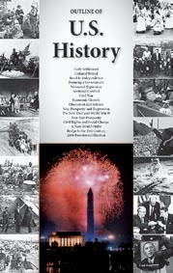

Bureau of International Information Programs

U.S. DEPARTMENT OF STATE 2011